APPLICATION FOR A
WORKS ON WATERWAYS PERMIT

24 Darlot Street, Horsham, 3400 Water Act 1989
(Gleed Street Entrance) (Sections 160, 219 & 287ZC)
Ph: (03) 5382 1544
Fax. (03) 5382 6076
www.wcma.vic.gov.au

THE APPLICANT MUST COMPLETE ALL THE DETAILS ON THIS FORM
APPLICANT DETAILS (PLEASE PRINT):
Full Name
Organisation Name
(If applicable)
Postal Address
Contact Phone Number

Landowner Name

Contact Phone Number

DETAILS OF LAND WHICH THE WORKS ARE PROPOSED:
Address/Location
Lot No: | Section: | Plan of Subdivision (LP) No:
Crown Allotment: | Parish:
CFA Map Reference:
GPS Co-ordinates (If known):

Is the site situated on Crown/Private Land (please circle)? | Private | Crown
Is waterway separated from property by Crown Reserve (please circle)? | Yes | No

WATERWAY DETAILS

Name of Waterway

Tributary of

Regional Locality Plan
Can be a copy of Vicroads Directory or CFA map

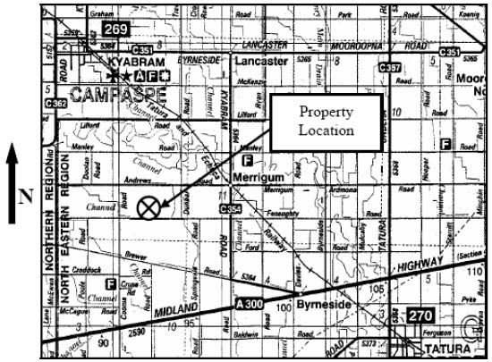

Sample Regional Locality Plan

Locality Plan

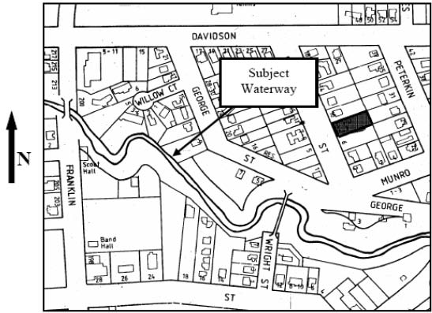

Sample Locality Plan

PROPOSED WORK DETAILS
What is the purpose of the proposed works?

Describe the proposed works and provide sketch of proposed works on following page.

How wide is the Waterway? ________________________________ metres
How deep is the Waterway? ________________________________ metres
Is there evidence of erosion in the bed and banks of the waterway (please circle)? YES NO
Comment:

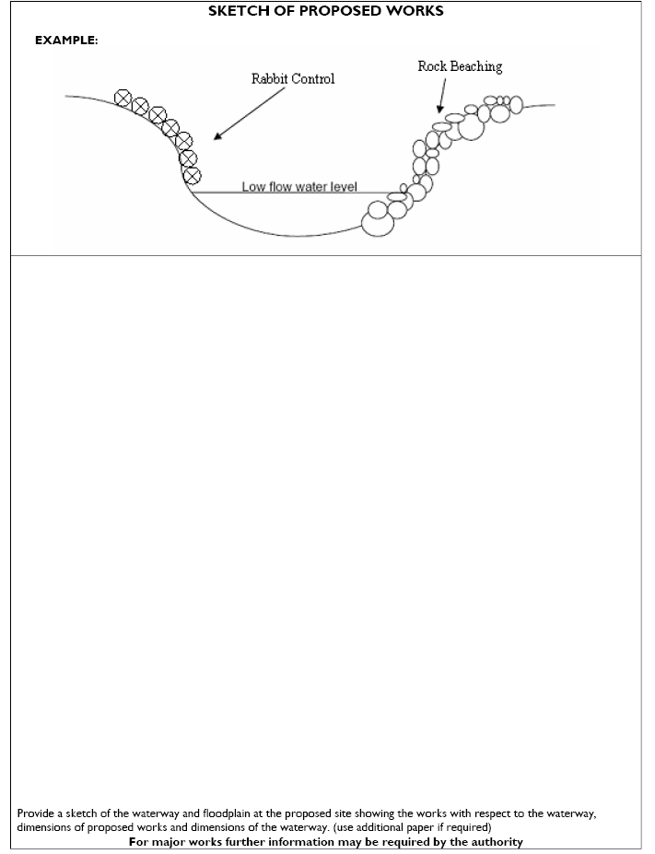

I acknowledge that the Wimmera Catchment Management Authority may issue a permit for the construction of the works on a waterway but that the Wimmera Catchment Management Authority shall not be responsible for any claims, suits or actions, arising from injury, loss, damage or death, to any person or property which may arise from the construction, maintenance, existence, or use of the works.
I hereby indemnify the Wimmera Catchment Management Authority and its employees against all claims, suits or actions arising from injury, loss, damage or death, to any person or property which may arise from the construction, maintenance, existence or use of the works described in this application.
Signed: ________________________________ Date: ____________________
Name: __________________________________________________________________

Send the completed form to: Wimmera CMA
24 Darlot Street (Gleed Street entrance)
PO Box 479
HORSHAM VIC 3402
Ph: (03) 5382 1544
Fax: (03) 5382 6076
Email: planning@wcma.vic.gov.au

