Wimmera River 2022
Wimmera region

This report card summarises the 2022 Native Fish Report Card (NFRC) survey in the Wimmera River
Sites 8, Electrofishing

Fish found in Wimmera River for NFRC
Target species
Freshwater Catfish
Golden Perch

Non-target species captured since 2017*
Large-bodied native species
Silver Perch

Small-bodied native species
Australian Smelt
Common Galaxias
Carp Gudgeon
Flatheaded Gudgeon

Exotic species
Common Carp
Eastern Gambusia
Goldfish
Redfin
Roach

* These non-target species were incidentally captured during NFRC surveys since 2017 but not measured as for target species

LOGOS – ARI, DELWP

Wimmera River 2022
Fish Community

NFRC target species
The NFRC Program began in 2017, with a focus on targeting the monitoring of population dynamics of key iconic fish species that have high recreational and/or conservation values, in large rivers across Victoria. In the Wimmera River, the target species are Freshwater Catfish and Golden Perch. Surveys occur in February/March each year, at eight sites from Gross Bridge at Drung Drung to just upstream Lake Hindmarsh, Jeparit. The equipment and habitats surveyed are focused on these species, which are measured to determine population structures. Other fish species that are incidentally captured are recorded, but not measured to determine their population structures.

Summary of key health indicators for target species in 2022
Species | Key Health Indicators
 | Recent recruitment | Multiple size classes | Mature fish present
Freshwater Catfish | - | - | -
Golden Perch | Yes | Yes | Yes

Recent recruitment means young-of-year fish
*- cannot be determined due to low abundances

Both Freshwater Catfish and Golden Perch are considered translocated populations in the Wimmera River.

Non-target species
The non-target fish species that have been incidentally recorded in the Wimmera River during NFRC surveys since 2017 are:

Large-bodied native species
Other large-bodied native species recorded in fish surveys are Murray Cod and Silver Perch. Both Murray Cod and Silver Perch are considered a translocated species in the Wimmera River. Small numbers (5,000- 15000) of Murray cod were stocked annually between 1997 and 2004. Silver Perch have been stocked annually since 1997 with numbers stocked increasing recently from less than 20,000 pre 2020 to 50,000 in 2020 and 2021 and 100,000 in 2022.

Small-bodied native species
Some of the small-bodied species recorded within the Wimmera River include Australian Smelt and Flatheaded Gudgeon. Carp Gudgeon are a lowland species and are more common in slower flowing habitats, often hard to detect via boat electrofishing. The Common Galaxias is considered a translocated species and is likely to have entered the system via water transfers from the Glenelg River system.

Exotic fish species
Common Carp, Eastern Gambusia, Goldfish and Redfin are widely distributed across sampling sites, and have been detected in all sampling years. Roach were detected in 2018 and this is the first confirmed record of this species in the Wimmera River system.

Other native species known from the Wimmera River
Some fish species known to occur in the Wimmera River have never been recorded during NFRC surveys. For example, no Obscure Galaxias, River Blackfish and Southern Pygmy Perch have been detected in the surveys. Southern Pygmy Perch are more common in offstream habitats such as billabongs, wetlands and lagoons. Southern Pygmy Perch and River Blackfish are still present is the Wimmera River system upstream of the areas where NFRC surveys occur. Obscure Galaxias are difficult to detect using the NFRC sampling methods.

Other notable species
Surveys have also recorded Yabbies and Eastern Long-necked Turtles.

LOGOS – ARI, DELWP, NFRC

Wimmera River 2022
Environmental and Management Context

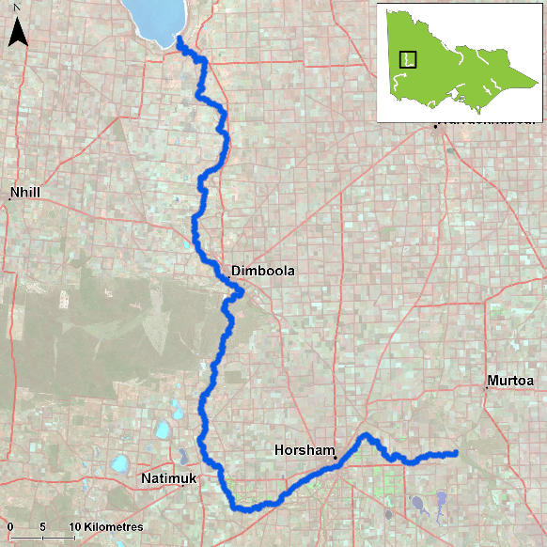
Figure 1. Map showing the section of Wimmera River where NFRC sampling occurs

Environment
Low flow conditions were present in all six sampling seasons.

River rehabilitation efforts in the Wimmera River
Many rehabilitation actions have occurred, and are underway, to improve the health of the Wimmera River and its fish community. The WCMA has commissioned Arthur Rylah Institute to produce a Wimmera Native Fish Management Plan. The plan’s principal objectives are to guide strategic management, environmental flow regimes, cost-effective investment and recovery of native fish communities in the region. The overarching vision of the plan is that “The waterways of the Wimmera River catchment have abundant and diverse native fish populations than enhance the region’s environmental, cultural and socio-economic values.”

A range of activities to improve river and fish health are informed in particular by the Wimmera Waterway Strategy 2014-2022. These include actions to improve water quality, manage erosion and sedimentation, improve riparian habitats through revegetation, weed control and fencing of riparian areas, installation of fish habitat and angler access platforms, allocations of water for the environment, fish stockings and control of Carp.

Some monitoring of the fish community occurs including as part of the Victorian Environmental Flows Monitoring and Assessment Program (VEFMAP). The Wimmera Catchment Management Authority, DELWP and VFA support rehabilitation and management of the Wimmera River and its fish community.

PHOTOS
LOGOS – ARI, DELWP, NFRC

Golden Perch

Wimmera River, Wimmera region

Key Health Indicators
Recent recruitment Yes
Multiple size classes Yes
Mature fish present Yes

Monitoring Results
Total number of fish caught 39
Fish per 1km of waterway 3.55
Largest fish by length (cm) 58
Largest fish by weight (kg) 3.97
% of the catch that is legal size 69.2

Abundances of Golden Perch were similar in all years, except in 2020 where they were lower (Figure 4). The sampling methodology included fyke nets and electrofishing in 2017-19, but electrofishing only from 2020-22. Recruits of this species are difficult to catch using electrofishing sampling methods. Recruits were detected in 2018 and 2019 (Figure 4) via fyke netting and by electrofishing in 2022 for the first time. Juveniles and adults have been recorded in all six sampling years, though the population is dominated by adult fish. A higher proportion of juveniles were detected in 2021 sampling (Figure 4). A wide size range from recruits to large adults was recorded in 2022 (Figure 5). All Golden Perch in the Wimmera River are a result of stockings (ARI unpublished data).

Stocking
Eighty thousand Golden Perch were stocked in 2016; 110,000 in 2017; 150,000 in 2019; 80,000 in 2020; 100,000 in 2021 and 167,000 in February and March 2022.
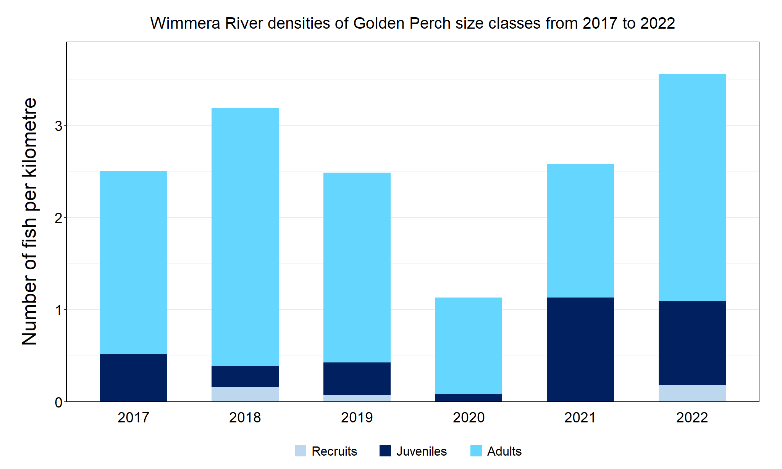
Figure 4. The densities of recruits, juveniles and adult Golden Perch in the Wimmera River from 2017 to 2022

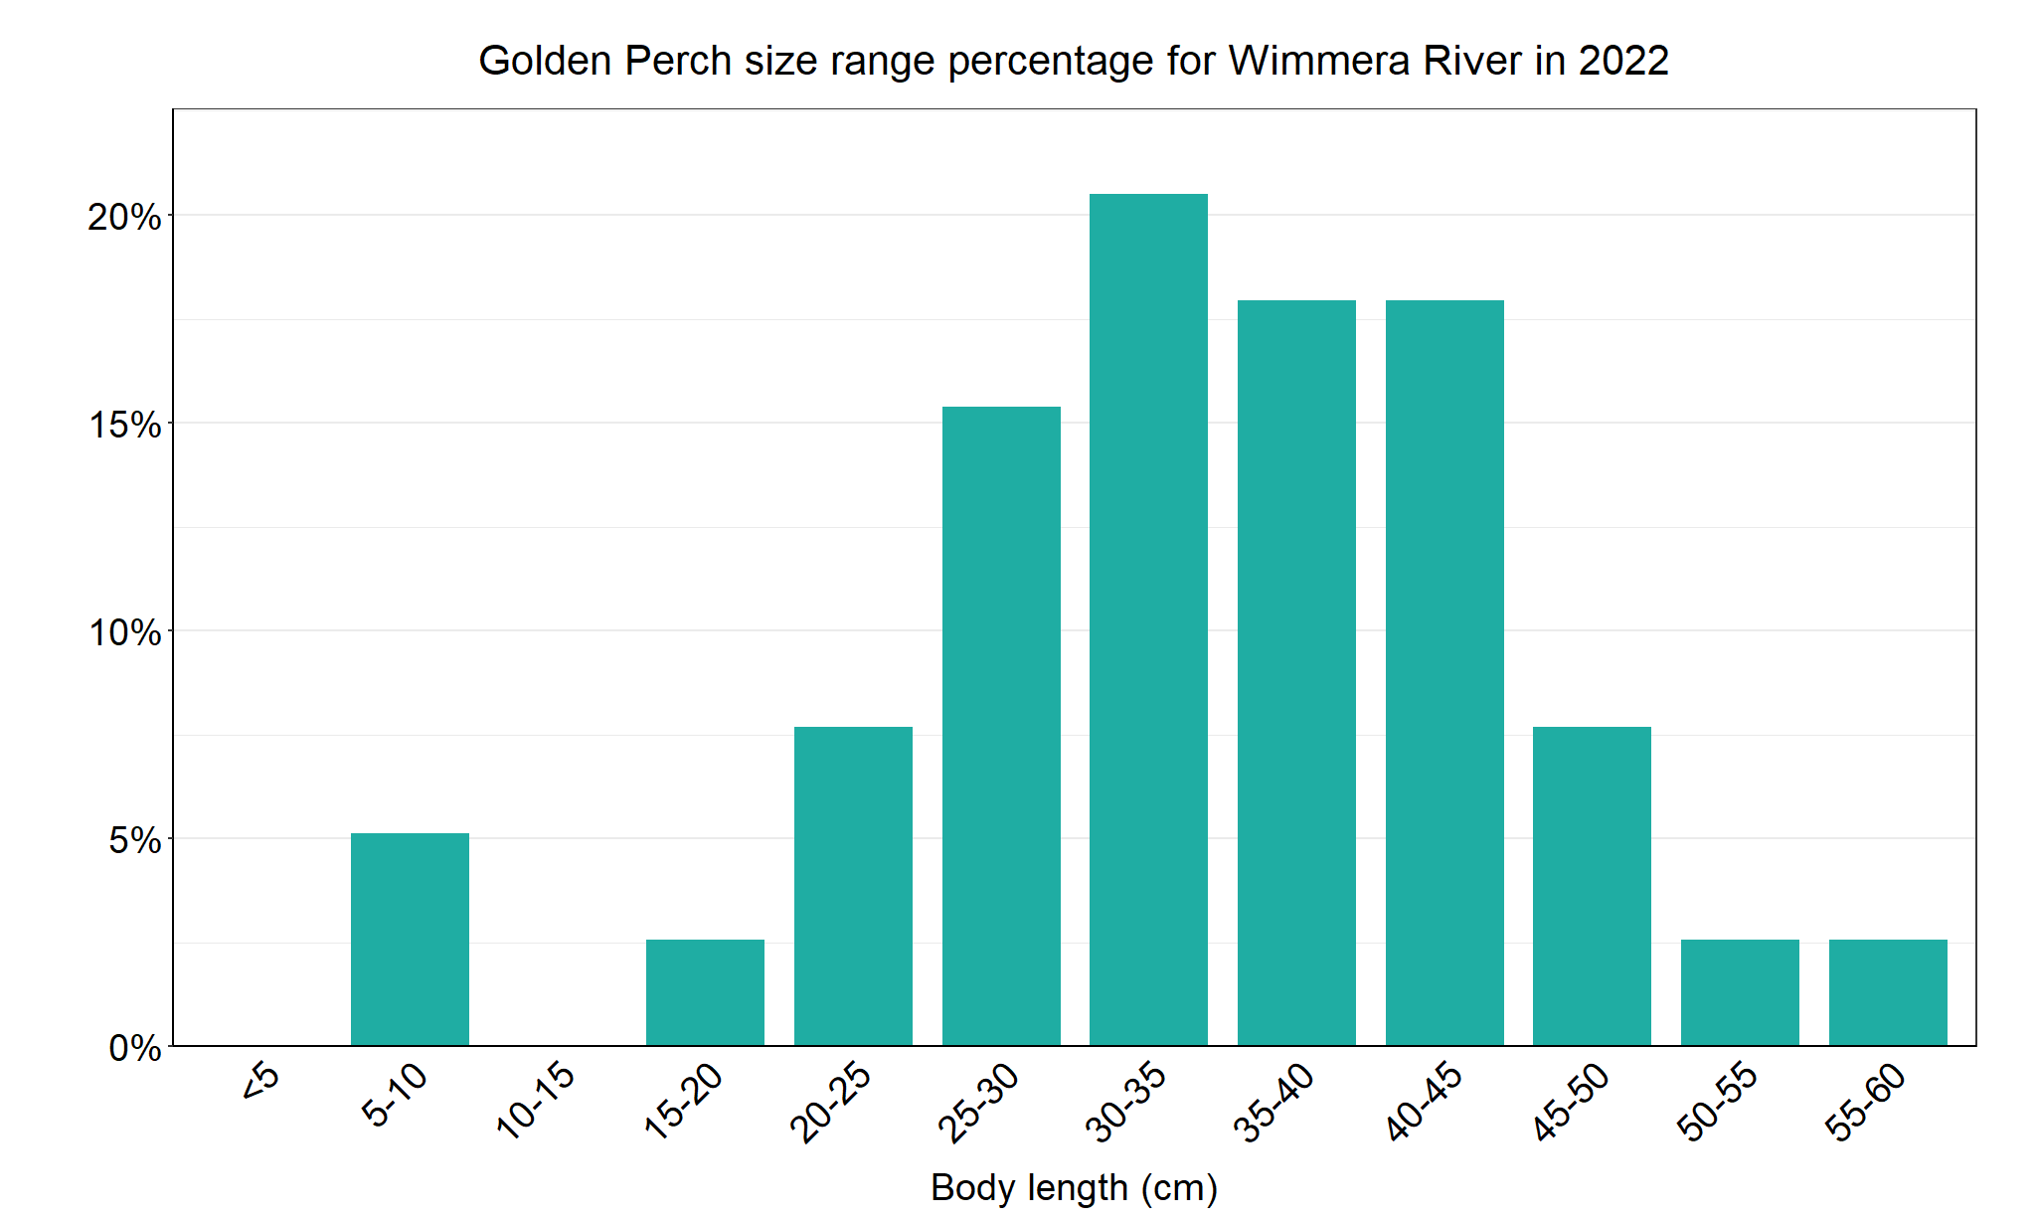
Figure 5. The size range percentage of Golden Perch in the Wimmera River in 2022

Freshwater Catfish

Wimmera River, Wimmera region

Key Health Indicators
Recent recruitment Cannot be determined
Multiple size classes Cannot be determined
Mature fish present Cannot be determined

Monitoring Results
Total number of fish caught 1
Fish per 1km of waterway 0.09
Largest fish by length (cm) 44.3
Largest fish by weight (kg) 1.78
% of the catch that is legal size 100

The NFRC does not expect to capture enough Freshwater Catfish to measure key health indicators. However collecting data for translocated species including Freshwater Catfish allows a greater understanding of the current status of the populations providing essential information to the management on this species. Although low numbers of Freshwater Catfish were caught in all six years of sampling, there has been a mix of recruits (2017-19), juveniles (2017 and 2021) and adults (2018-22) (Figure 6). The sampling methods included fyke nets and electrofishing in 2017-19, but electrofishing only from 2020-22. Recruits of this species are difficult to catch using electrofishing sampling methods with recruits primarily detected via fyke netting. Only a single recruit was detected via electrofishing in 2019. In 2022 only a single adult Freshwater Catfish was collected (Figure 7).

Stocking
No stocking has occurred.
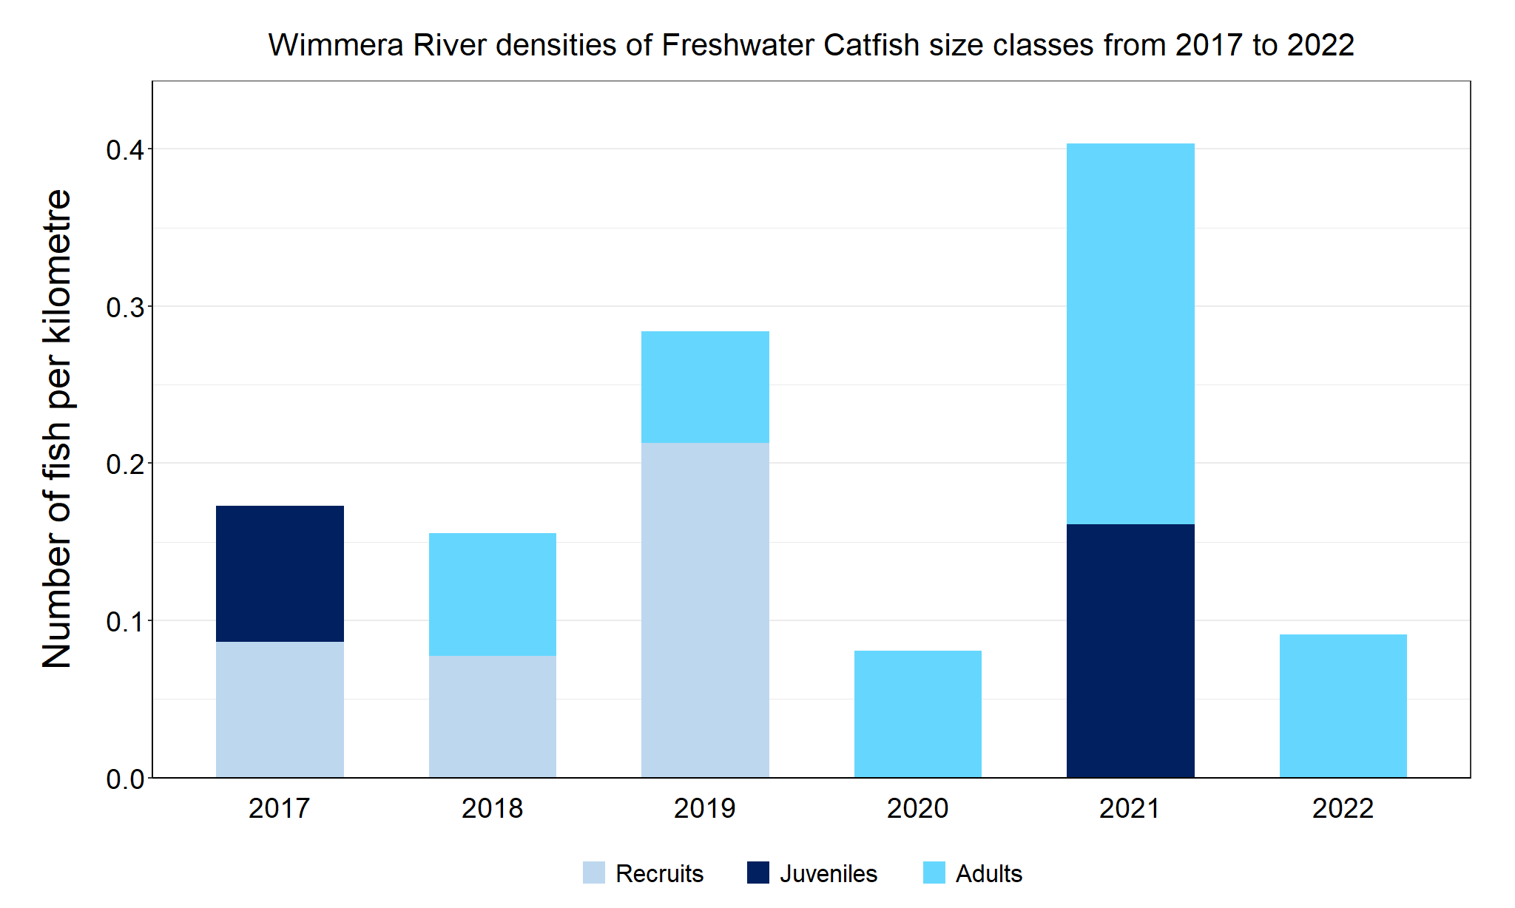
Figure 6. The densities of recruits, juveniles and adult Freshwater Catfish in the Wimmera River from 2017 to 2022

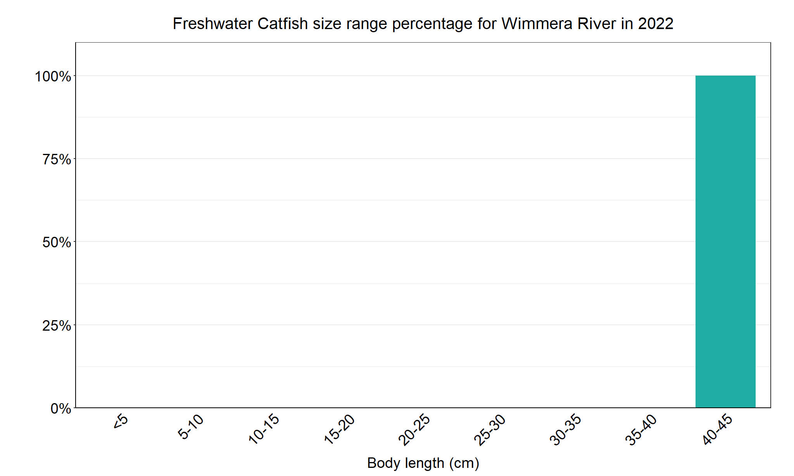
Figure 7. The size range percentage of Freshwater Catfish in the Wimmera River in 2022

We acknowledge and respect Victorian Traditional Owners as the original custodians of Victoria’s land and waters, their unique ability to care for Country and deep spiritual connection to it. We honour Elders past and present whose knowledge and wisdom has ensured the continuation of culture and traditional practices.

