Employment with Wimmera CMA
Thank you for your interest in working for Wimmera Catchment Management Authority. This recruitment information kit will provide you with:
- Information about the Wimmera region
- Information about Wimmera CMA - objectives, organisational chart
- Wimmera CMA staff - values and behaviour
- Benefits of working at Wimmera CMA
- Outline of the employment process to recruit staff
- How to lodge your application.
- Contact

Wimmera Region
The Wimmera region is made up of seven local government regions in the far west of Victoria. The Wimmera is three and a half hours’ drive from Melbourne and five hours from Adelaide. The region has a population of around 50,000 with almost 20,000 in and around its largest city, Horsham.
Horsham offers many of the amenities of city living, couched in a relaxed, safe, friendly and community-oriented setting.
The region boasts many natural highlights including state and national parks, including the Grampians, Mount Arapiles, and the Big and Little deserts.

The region’s primary industry is agriculture, which supports 23% of employment. Many business and services support the agricultural sector, with 15.5% employed in the retail trade and the third largest employer being the health and community
services sector. There is a range of employment opportunities for spouses and partners.
The area offers a multitude of lifestyle choices, from urban living to peaceful rural blocks or affordable homes in the region’s smaller communities. Major retailers operate throughout the region providing variety and excellent customer service.

Horsham

Victoria
Melbourne

Wimmera CMA

recruitment information
1

Horsham is the major Wimmera centre for regional administration of state and federal government agencies, including GWMWater,
Department of Energy, Environment and Climate Action (DEECA), Department of Jobs, Skills, Industry and Regions (DJSIR), Department of Human Services (DHS), CentreLink, Victoria Police and VicRoads. It is also home to the Grains Innovation Park (GIP).
Other services include:
- Modern health-care services and hospital, with excellent aged-care facilities and an accommodation option for the families and carers of patients
- State secondary college and a private Catholic secondary college and Lutheran College
- Three state primary schools and Lutheran and Catholic schools
- Three privately operated day-care centres, family day-care and occasional-care services
- Federation University, Longerenong Agricultural College and Centre for Participation
- Horsham has 15 motels, seven hotels, two caravan parks and bed and breakfast facilities
- More than 60 eating places include restaurants, cafes, hotels and bakeries
- Significant development with the building trade constructing 100 new homes a year
Further details about Horsham and surrounding areas are available online:
www.visithorsham.com.au

About Wimmera CMA
Wimmera CMA is based in the rural city of Horsham and is committed to developing programs, incentives and initiatives that provide private land managers with resources, information and support to improve the sustainability and viability of the region’s asset- productive soils; wetlands; groundwater; riparian zones and biodiversity.
Wimmera CMA aims to be at the forefront of delivering on- ground environmental improvement and change in Victoria. It was established in July 1997 under the Water Act 1989 and the Catchment and Land Protection Act 1994 to achieve effective integration and delivery of Wimmera land and water
management programs. Wimmera CMA is a Statutory Authority and is directed by a locally based community Board.

Operational activities are delivered through four programs:

Corporate Services Strategy and Statutory Community Delivery Operational Delivery
Wimmera CMA objectives
- Involve the community in decisions relating to natural- resource management in the Wimmera catchment
- Promote sustainable development of natural resource- based industries
- Collaborate with industry and economic development organisations in achieving sustainable and profitable development of catchment communities
- Maintain and improve the quality of water and condition of rivers, streams and wetlands
- Prevent and where possible reverse land degradation including salinity
- Conserve and protect the diversity and extent of natural ecosystems
- Minimise damage to natural ecosystems and natural resource-based industries caused by pest plants and animals
- Minimise damage to public and private assets from flooding and erosion

Wimmera CMA works in partnership with many stakeholders to protect and enhance the condition of the region’s natural resources. Key partners include GWMWater, Department of
Energy, Environment and Climate Action (DEECA), Department of Jobs, Skills, Industry and Regions (DJSIR), Environment Protection Authority (EPA), local government, Landcare groups, landholders and the Wimmera community. It also has responsibility for advising the government on catchment issues and the condition of the catchment and its natural resources.

Corporate governance structure

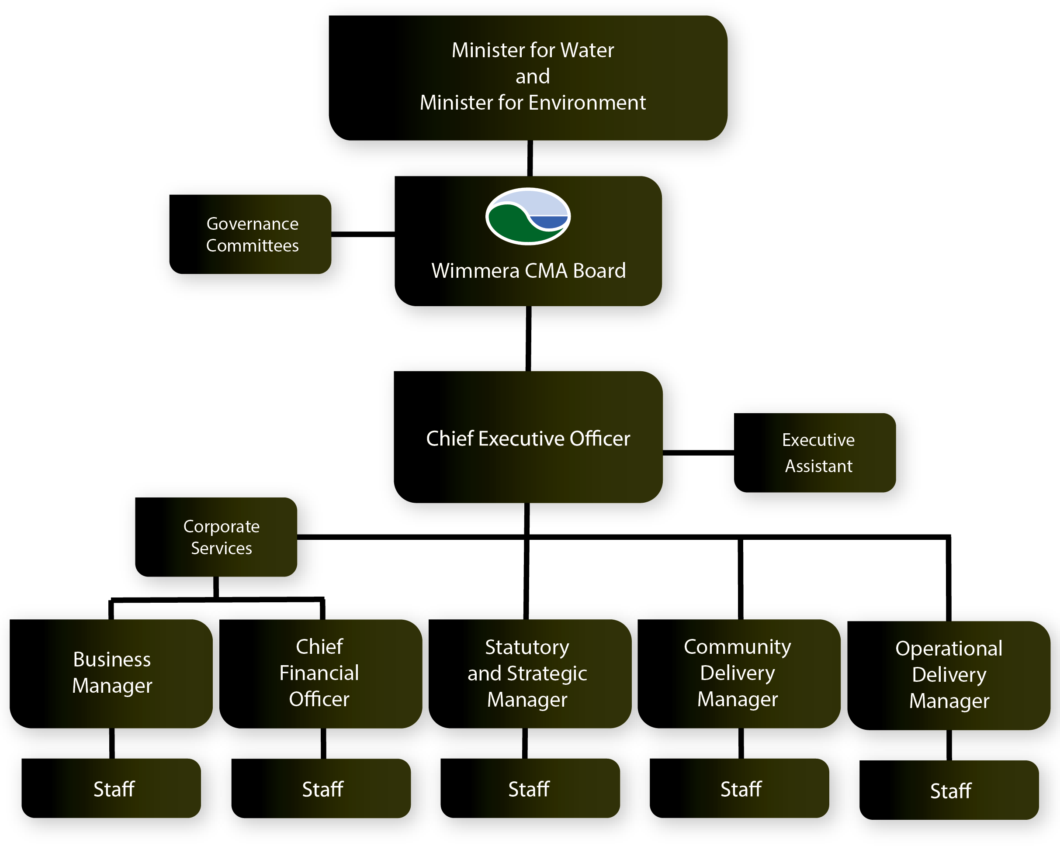

Wimmera CMA staff

Our strength is our staff
Wimmera CMA features a diverse range of staff members. A consistent theme when asked why they work at Wimmera CMA is: looking after our environment and creating more community awareness.

“Working with like-minded people, contributing to a healthier catchment & creating a more environmentally aware community and the location – living next door to places like Mt Arapiles and the Grampians National Park means you can spend lots of time outdoors. The pace of life is a lot less stressful than Melbourne too! It’s been a great tree change!”
There are a total of 23 staff, this includes both full-time and part time staff. The staff has an average age of 46 and a 43-57% male to female ratio.
Over the years, many staff have been attracted to the region for the climbing challenges offered by Mt Arapiles, some for the challenging ‘next step’ in their careers. The farming sector is well represented within our team, which rounds out lunch-room conversation.

Organisational values and behaviours
The values and behaviours at Wimmera CMA represent an understanding between all staff about how they conduct themselves both professionally and personally. Staff members expect these values and behaviours to be demonstrated internally and externally.

“Wimmera CMA allows a flexible work environment that can fit in with
family life.”

Staff testimonials
Why I like working at Wimmera CMA

“I get to go climbing at Australia’s premier rock-climbing area, Mount Arapiles after work during the day- light savings period. I also get to do interesting and challenging work with the aim of looking after our natural environment.”
+ Commitment
+ Integrity
+ Respect
+ Teamwork

The values and behaviours form part of the formal annual work plan review process undertaken by all staff and senior management members at the Authority. Adherence to and demonstration of the values and behaviours is an important
part of our culture; with all staff working together to achieve the outcomes for their roles.

Benefits of working at Wimmera CMA
There are many benefits of working at Wimmera CMA. Employment opportunities vary from administration, engineering, planning, engagement programs, monitoring, works and management roles.
Some of the key benefits include:
  - Family-friendly and flexible working arrangements including time-in-lieu
  - Personal leave and parental leave
  - Holiday leave with 17.5 percent loading
  - 14 weeks of paid primary carer leave
  - Three week paid secondary carer leave
  - Purchased leave arrangements, up to four weeks
  - Long-service leave at 10 years - accessible at 7 years
  - Study leave and study assistance
  - Employment support program – access to counseling
  - Professional development available through annual work plan reviews
  - Modern work premises
  - Corporate and field uniforms provided
  - An active social club (optional)

Employment process
Wimmera CMA is committed to providing equal employment opportunity to all employees and potential employees, and adopts the principles outlined in the Public Administration Act 1994.
In the application of these principles we aim to employ a workforce that reflects the diversity of the community by making employment decisions that are free of extraneous considerations such as age, religion, gender, ethnicity, seniority or affiliation and by providing a workplace that is free from discrimination and harassment.

Key elements of our selection process
- The recruitment process will be outlined for each position on our website.
- Applications are scored against how well their experience, qualifications, skills and knowledge meet key selection criteria outlined in the attached position description. As your application will be one of many read by the selection committee, it needs to be clear, concise and relevant to the specific requirements of the job.

Expressions of interest are viewed against the requested information with identified potential applicants invited in for a face to face meeting to further discuss the role. A list of topics or questions will be provided prior to the meeting.
- You will be asked to complete and sign a medical declaration.
- An employment working with children check is a condition of employment (with evidence of lodgement provided upon acceptance of the role; and successful receipt during the probationary period.)
- You will be required to declare and have approved any outside employment and potential conflict of interest (in accordance with Public Sector Policy).
- Any interviews are conducted by an internal panel.
- Referee checks are conducted prior to positions being offered. We recommend you advise your referees that you are applying for a position with the CMA, and that they may be contacted.
- The preferred applicant will be contacted and verbally offered the position.
If accepted a formal offer will then be prepared for their signing.
- Once the successful candidate has accepted the position, unsuccessful applicants will be advised in writing. Feedback on your application is available at this stage.

How to lodge your application
Applications should be emailed to jobs@wcma.vic.gov.au
Refer to our website for instructions on how to apply for each position.
Applications should contain the following:

A covering letter
The covering letter should be approximately one page in length and state the position you are applying for. It should summarise your overall application and it should contain information about how we can contact you.
This may also be referred to as a letter of introduction where you will be prompted to include certain information.

A key selection criteria statement
When asked to address the key selection criteria;
This is a one to two-page statement, stating how you best meet the key selection criteria in the position description. If your application does not contain a key selection criteria statement it might be ruled ineligible.

An up-to-date resume
This should outline your previous work history, your qualifications and your previous experience.
Where qualifications are requested, please attach a scanned copy.
Good luck. Any further inquiries contact the program manager on the final page of the position descriptions.

Contact
For further information please contact: Wimmera CMA
PO Box 479, Horsham, 3400
24 Darlot Street, Horsham, 3400
Phone: (03) 5382 1544
Email: jobs@wcma.vic.gov.au

