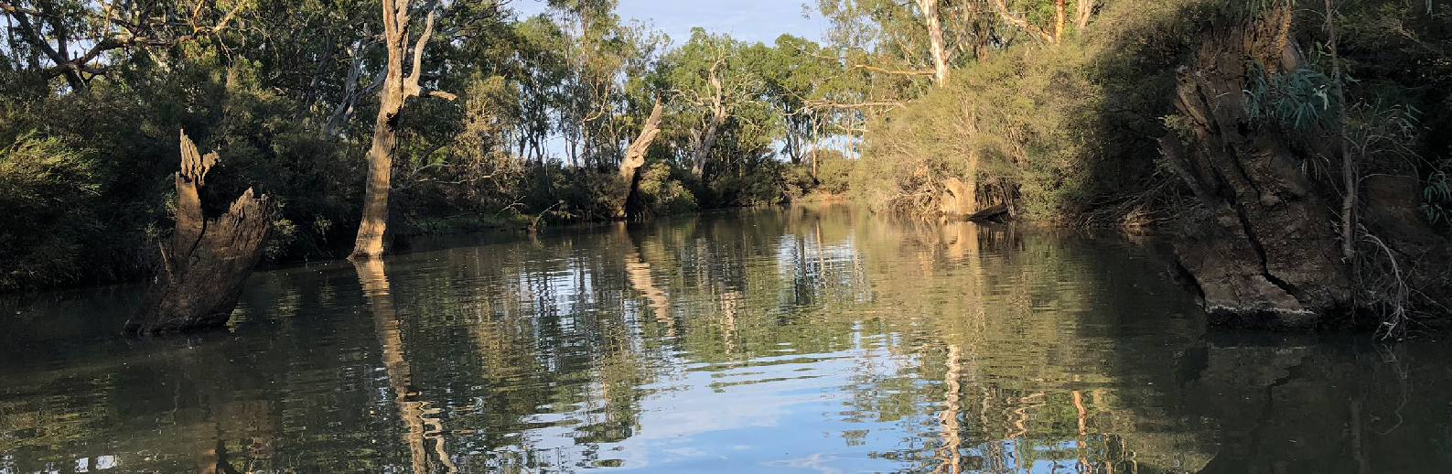



Native Fish Report Card
Wimmera River 2024
Wimmera Region

This report card summarises the 2024 Native Fish Report Card (NFRC) survey in the Wimmera River
SITES: 8
ELECTROFISHING

Fish found in the Wimmera River in our 2024 surveys
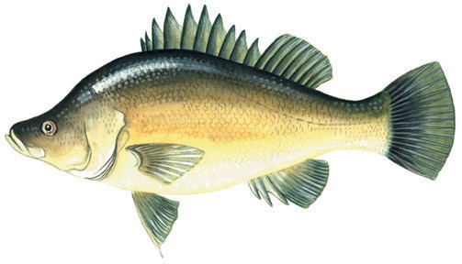
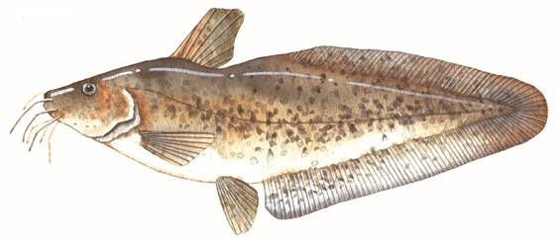

recorded in 2024
Golden Perch
Macquaria ambigua#
Freshwater Catfish
Tandanus tandanus#
recorded since 2017*

Large-bodied native species
Murray Cod# Silver Perch#

Small-bodied native species
Australian Smelt Common Galaxias# Carp Gudgeon Flatheaded Gudgeon
Exotic species
Common Carp Eastern Gambusia Goldfish
Redfin
Roach

* These non-target species were incidentally captured during NFRC surveys since 2017 but not measured as for target species.
# Native species translocated outside its natural range.
Non-target species
Target Species

Fish community

Wimmera River 2024
The NFRC Program began in 2017 to monitor population dynamics of key iconic fish species that have high recreational and/or conservation values, in large
rivers across Victoria. In the Wimmera River, the target species are Freshwater Catfish and Golden Perch. Surveys occur in January-March each year, at nine sites from Gross Bridge at Drung Drung
to just upstream of Lake Hindmarsh, Jeparit. The equipment used and habitats surveyed target these species, which are measured to determine their population structures. Other fish species that are incidentally captured are counted, but not measured.

Summary of key health indicators for target
species in 2024

Species | Key Health Indicators
 | Recent recruitment | Multiple  size classes | Mature  fish  present
Golden Perch | No | Yes | Yes
Freshwater  Catfish* | - | - | -

Recent recruitment means young-of-year fish
* - cannot be determined due to low abundances
Both Freshwater Catfish and Golden Perch are considered translocated populations in the Wimmera River.

Non-target species
The non-target fish species that have been incidentally recorded in the Wimmera River during NFRC surveys since 2017 are:
Large-bodied native species
Silver Perch and Murray Cod were recorded in the NFRC 2024 survey. Both species are considered as translocated to the Wimmera River. Silver Perch has been recorded
in all eight NFRC surveys. It has been stocked annually since 1997 with numbers stocked increasing recently from less than 20,000 pre 2020 to 50,000 in 2020 and
2021, 100,000 in 2022, 161,000 in 2023 and 50,100 in 2024
(after NFRC sampling). Prior to 2024, Murray Cod had only been recorded once (2022) in NFRC surveys. Small numbers (5000 - 15,000) of Murray Cod were stocked annually between 1997 and 2004, and 10,000 in 2022,
2023 and 2024.
Small-bodied native species
Australian Smelt and Flatheaded Gudgeon were the only small-bodied species recorded in the 2024 survey and have been recorded in all eight surveys. Carp Gudgeon and Common Galaxias have been recorded in two previous NFRC surveys. Carp Gudgeon is a lowland species, being more common in slower flowing habitats, and often hard to detect via boat electrofishing. The Common Galaxias is considered a translocated species and is likely to have entered the system via water transfers from the Glenelg River system.
Exotic fish species
Common Carp, Goldfish and Redfin were recorded in the 2024 survey and have been recorded in all eight NFRC surveys. These species are widely distributed across sampling sites. Eastern Gambusia has been recorded in the seven preceding NFRC surveys. Roach was detected in 2018 which was the first confirmed record of this species in the Wimmera River system.

Other native fish species known from the
Wimmera River
Some fish species known to occur in the Wimmera River have never been recorded during NFRC surveys. For example, no Obscure Galaxias, River Blackfish and Southern Pygmy Perch have been detected in the surveys. Southern Pygmy Perch are more common in offstream habitats such as billabongs, wetlands and
lagoons. Southern Pygmy Perch and River Blackfish are still present in the Wimmera River system upstream of the areas where NFRC surveys occur. Obscure Galaxias are difficult to detect using the NFRC sampling methods.

Other notable species
Surveys have also recorded Yabbies and Long-necked
Turtles.

Environmental and Management Context

Environment
Low flow conditions were present in all eight sampling
years.

Waterway and fisheries management efforts in the
Wimmera River
Many rehabilitation actions have occurred, and are underway, to improve the health of the Wimmera River and its fish community.
The WCMA collaborated with the Arthur Rylah Institute
to produce the 2022 Wimmera Native Fish Management Plan. The plan’s principal objectives are to guide strategic management, environmental flow regimes, cost-effective investment and recovery of native fish communities in the region. The overarching vision of the plan is that
“The waterways of the Wimmera River catchment have abundant and diverse native fish populations that enhance the region’s environmental, cultural and socio- economic values.” WCMA has responded to priorities in the plan and is leading major translocation projects to protect both Wimmera and Murray-Darling small-bodied species in the Wimmera catchment. Ongoing recovery efforts have so far targeted River Blackfish – Wimmera strain, Southern Pygmy Perch – Murray-Darling Basin lineage, Southern Purple Spotted Gudgeon and Olive Perchlet.
Water in the Wimmera catchment after extensive 2022 flows has provided opportunities to progress implementation of this plan. Options for enhanced
management of native fish in the Wimmera system are
being investigated.
A range of activities to improve river and fish health are also informed by the Wimmera Waterway Strategy 2014- 2022. These include actions to improve water quality, manage erosion and sedimentation, improve riparian habitats through revegetation, weed control and fencing of riparian areas, installation of fish habitat and angler access platforms, allocations of water for the environment, fish stockings and control of Carp.
Some monitoring of the fish community occurs, including as part of the Victorian Environmental Flows Monitoring and Assessment Program (VEFMAP). The Wimmera Catchment Management Authority, DEECA and the Victorian Fisheries Authority support rehabilitation and management of the Wimmera River and its fish community.

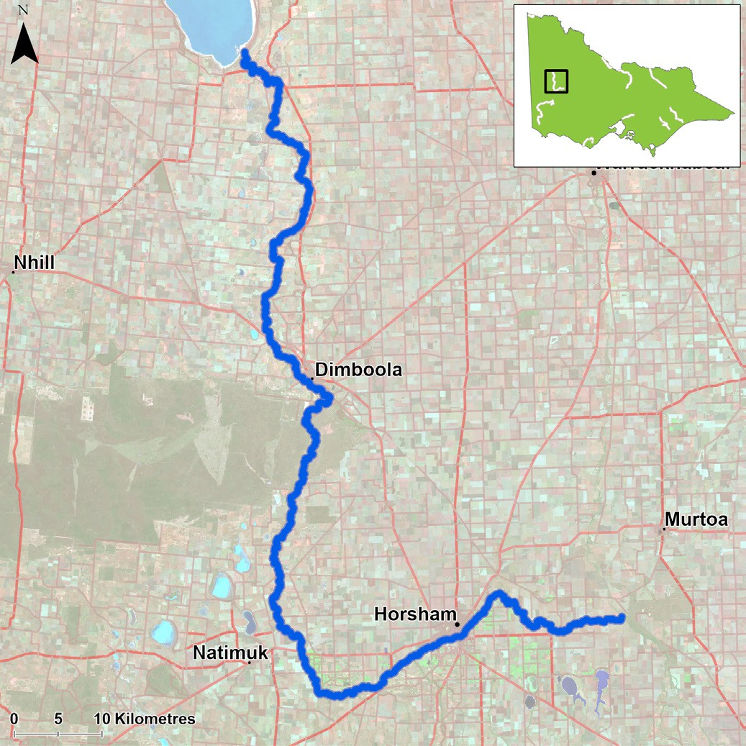
Figure 1. Map showing the section of Wimmera River where NFRC sampling occurs.
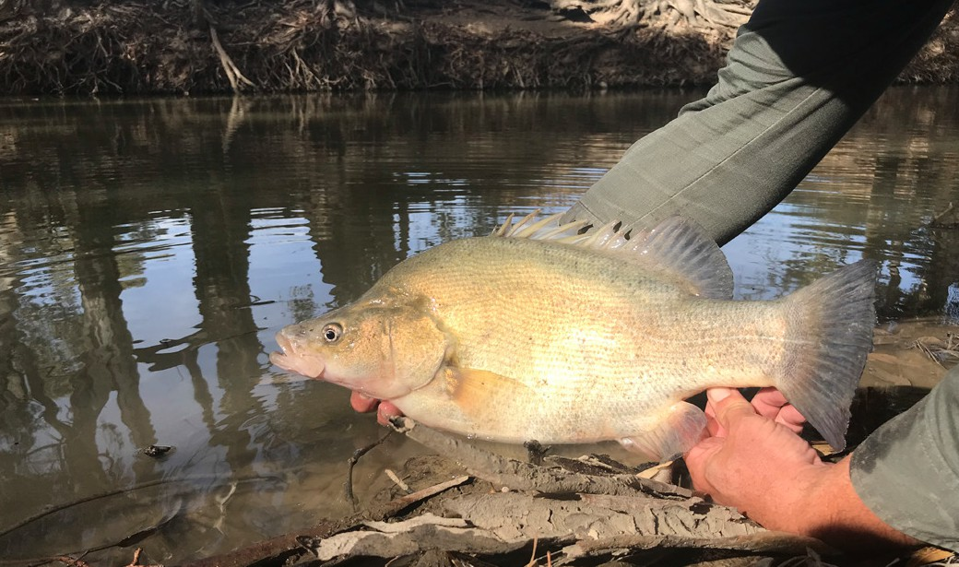
Figure 2. A Golden Perch

Wimmera River 2024

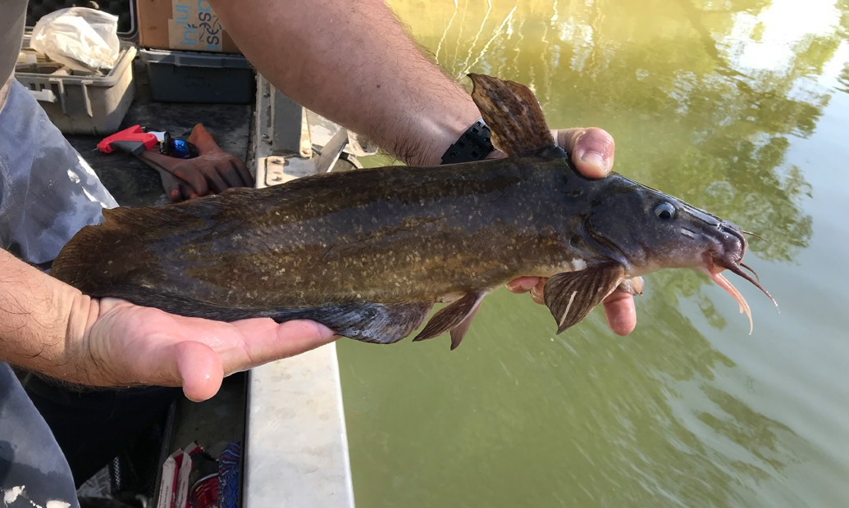
Figure 3. A Freshwater Catfish

The NFRC program, and related monitoring initiatives, provide improved understanding of the structure of fish communities and how rivers can be best managed.


RECREATIONAL SPECIES
WIMMERA RIVER
All Golden Perch (Macquaria ambigua) in
the Wimmera River are a result of stockings1. Abundances of Golden Perch have been variable within the Wimmera system, with the lowest abundances recorded in 2020 and the highest abundance recorded in 2024 after a two-fold increase in numbers captured (Figure 4). This increase in abundance may reflect the increasing stocking activity in recent years. The sampling methodology included fyke nets and electrofishing in 2017-19, but electrofishing only from 2020-24.
Recruits were detected by fyke netting in 2018 and 2019 (Figure 4) and by electrofishing in 2022 and 2023. Recruits of this species are difficult to catch using electrofishing sampling methods. Detections via electrofishing in 2022 and 2023 may indicate higher survival of stocking in those years and/
or the stockings which occurred at the sampling sites. Juveniles and adults have been recorded in all eight sampling years, although the captured fish were predominantly adults. A higher proportion
of juveniles were detected in 2021 sampling (Figure 4). Although juveniles were detected in 2024, their abundances were low (Figure 5).
Stocking
Eighty thousand Golden Perch were stocked in 2016; 110,000 in 2017; 150,000 in 2019; 80,000 in 2020;
100,000 in 2021; 167,000 in 2022; 170,000 in 2023; and
123,300 in 2024 (after NFRC surveys).
1. Trueman, W. T. (2012) True tales of the Trout Cod. River histories of the Murray-Darling Basin. Chapter 22 - Wimmera and Avoca river catchments. MDBA Publication (07/12).

Golden Perch
Macquaria ambigua

Recent recruitment Multiple size classes Mature fish present
Key Health Indicators

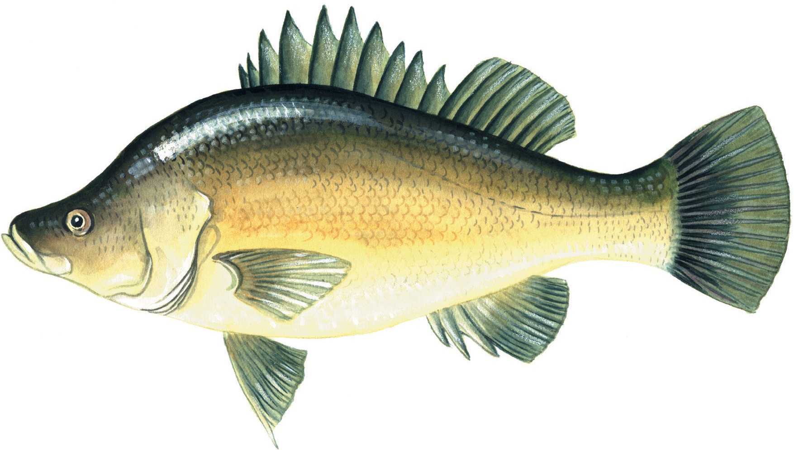

Monitoring Results
Total number of fish caught | 110
Fish per 1km of waterway | 10
Largest fish by length (cm) | 57
Largest fish by weight (kg) | 5.45
% of the catch that is legal size | 72.7

Golden Perch
Macquaria ambigua

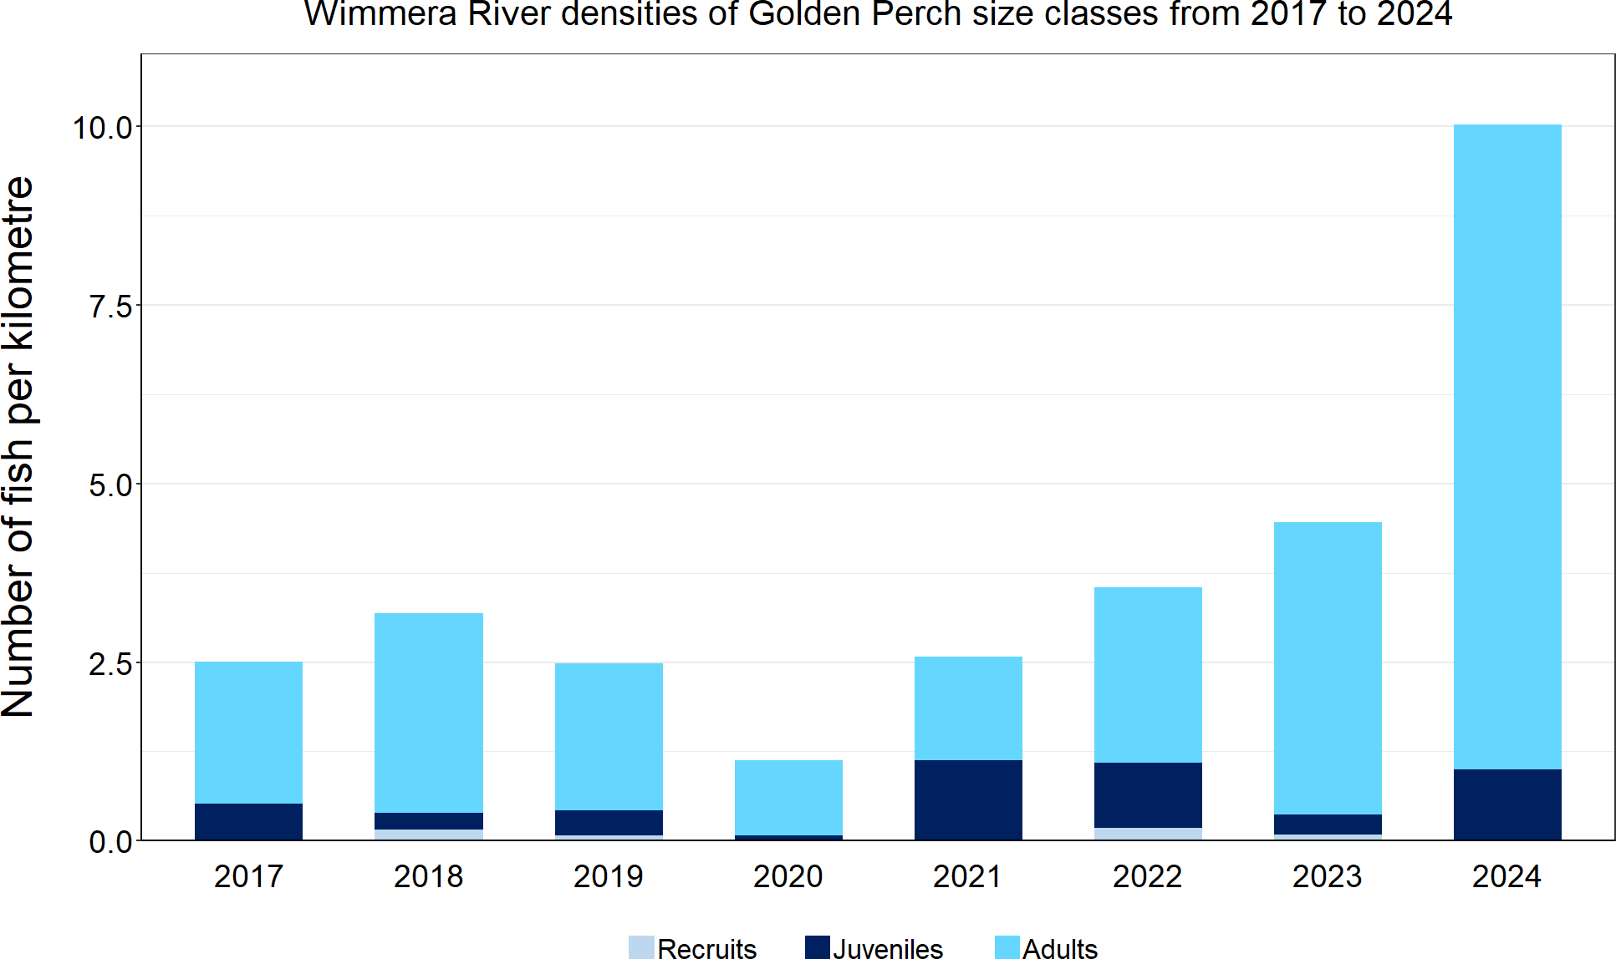
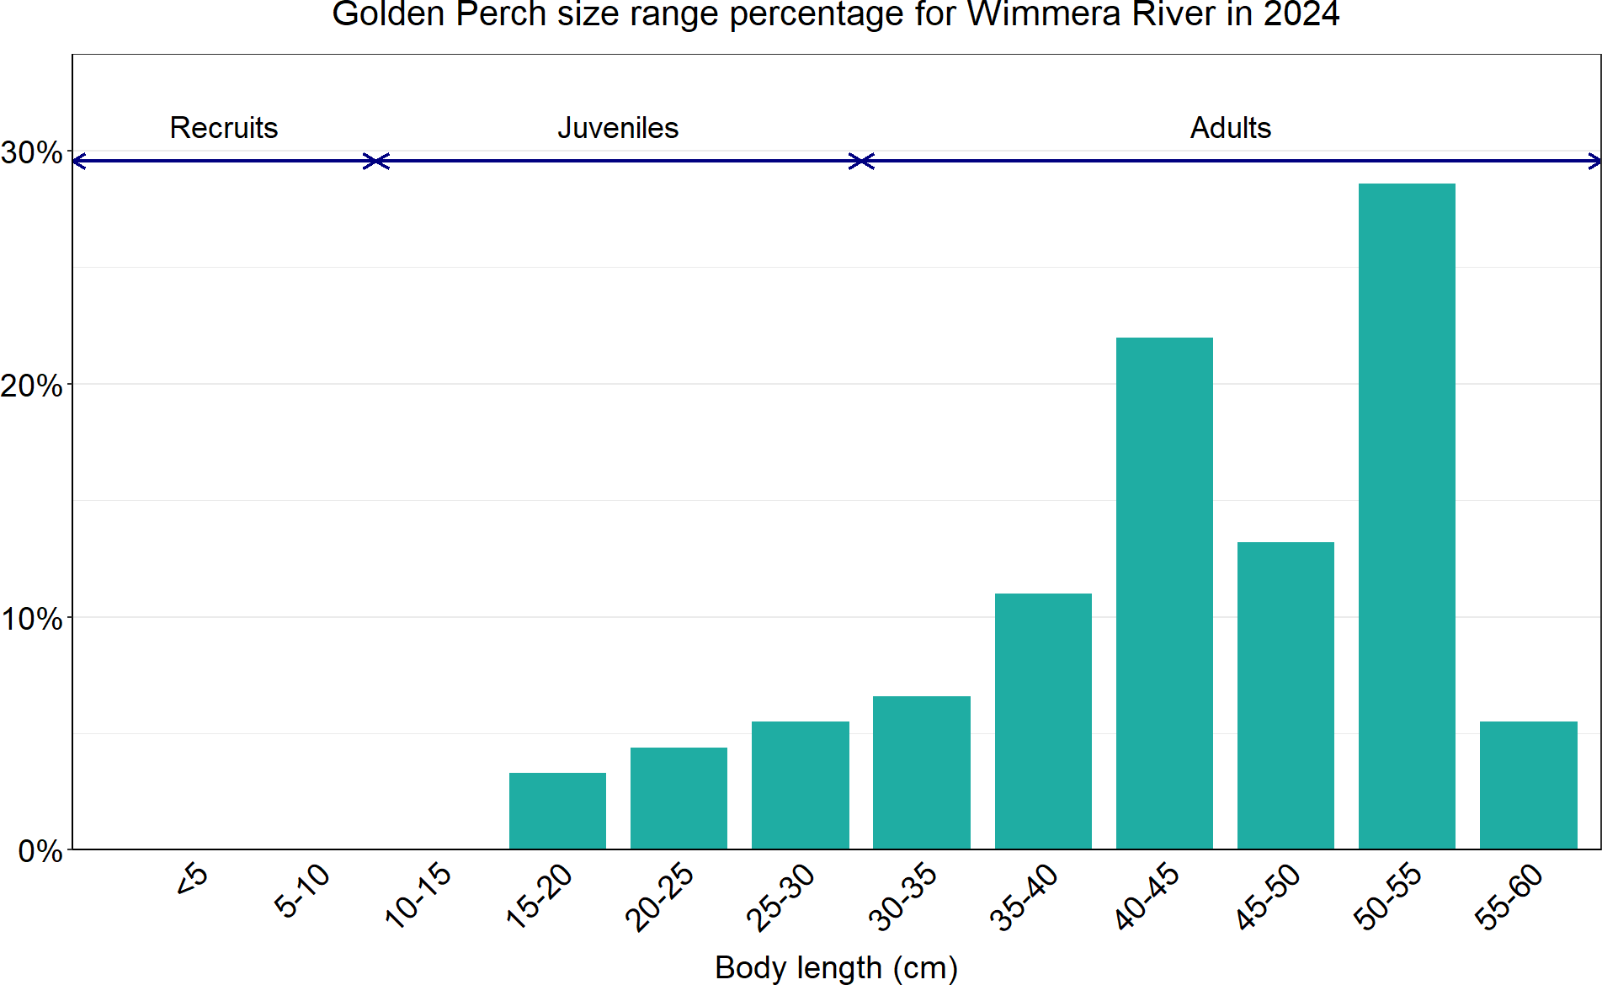
Figure 4. The densities of recruits, juveniles and adult Golden Perch for NFRC surveys in the Wimmera River from 2017 to 2024

Figure 5. The size range percentage of Golden Perch measured from the Wimmera River during NFRC surveys in 2024

Freshwater Catfish
Tandanus tandanus

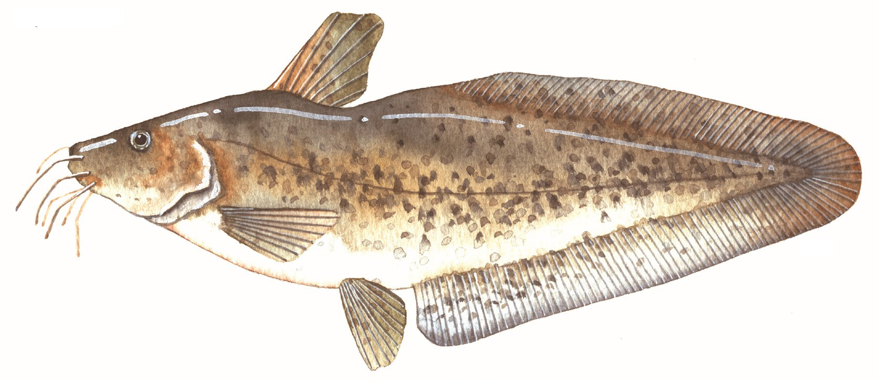

Key Health Indicators
- Cannot be determined
- Cannot be determined
- Cannot be determined
Monitoring Results
Total number of fish caught | 7
Fish per 1km of waterway | 0.64
Largest fish by length (cm) | 50.2
Largest fish by weight (kg) | 1.35
% of the catch that is legal size | 85.7

RECREATIONAL SPECIES
WIMMERA RIVER
The NFRC does not expect to capture enough Freshwater Catfish (Tandanus tandanus) to measure key health indicators. However, collecting data for translocated species including Freshwater Catfish allows a greater understanding of the current status of the populations providing essential information
to the management on this species. In 2024, the highest abundances were detected, with the majority of fish being adults (Figure 6; Figure 7). Although
low numbers of Freshwater Catfish were caught in all eight years of sampling, there has been a mix of recruits (2017-19), juveniles (2017, 2021 and
2024) and adults (2018-24) (Figure 6). The sampling methods included fyke netting and electrofishing in 2017-19, but electrofishing only from 2020-24.
Recruits of this species are difficult to catch using electrofishing sampling methods with recruits primarily detected via fyke netting. Only a single recruit was detected via electrofishing in 2019.
Stocking
No stocking has occurred.

Freshwater Catfish
Tandanus tandanus

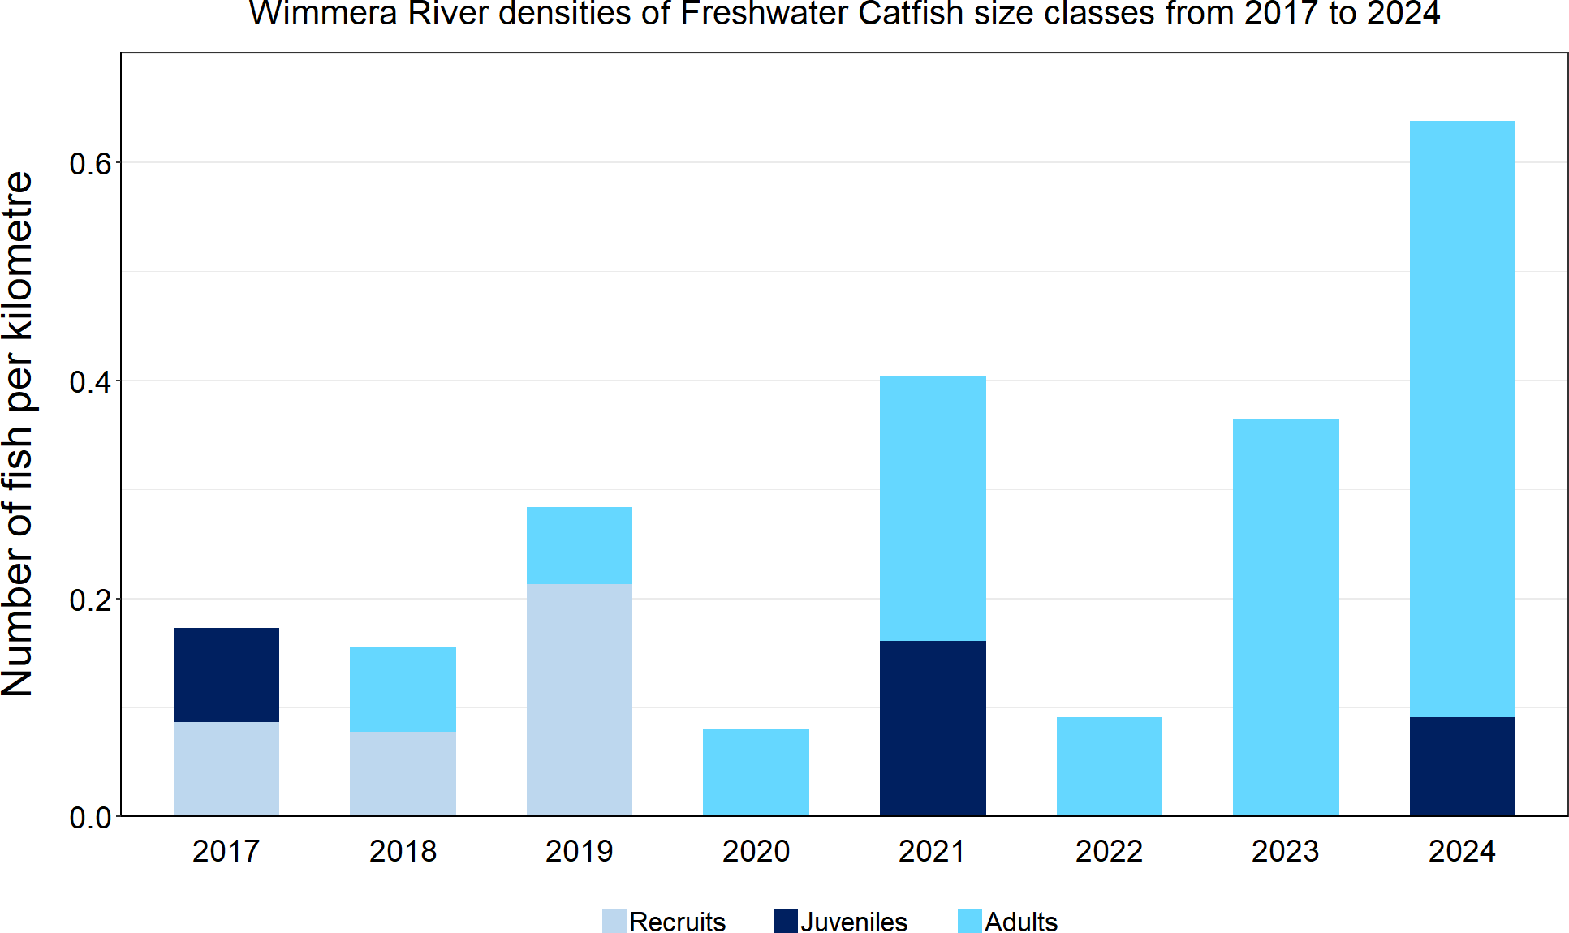
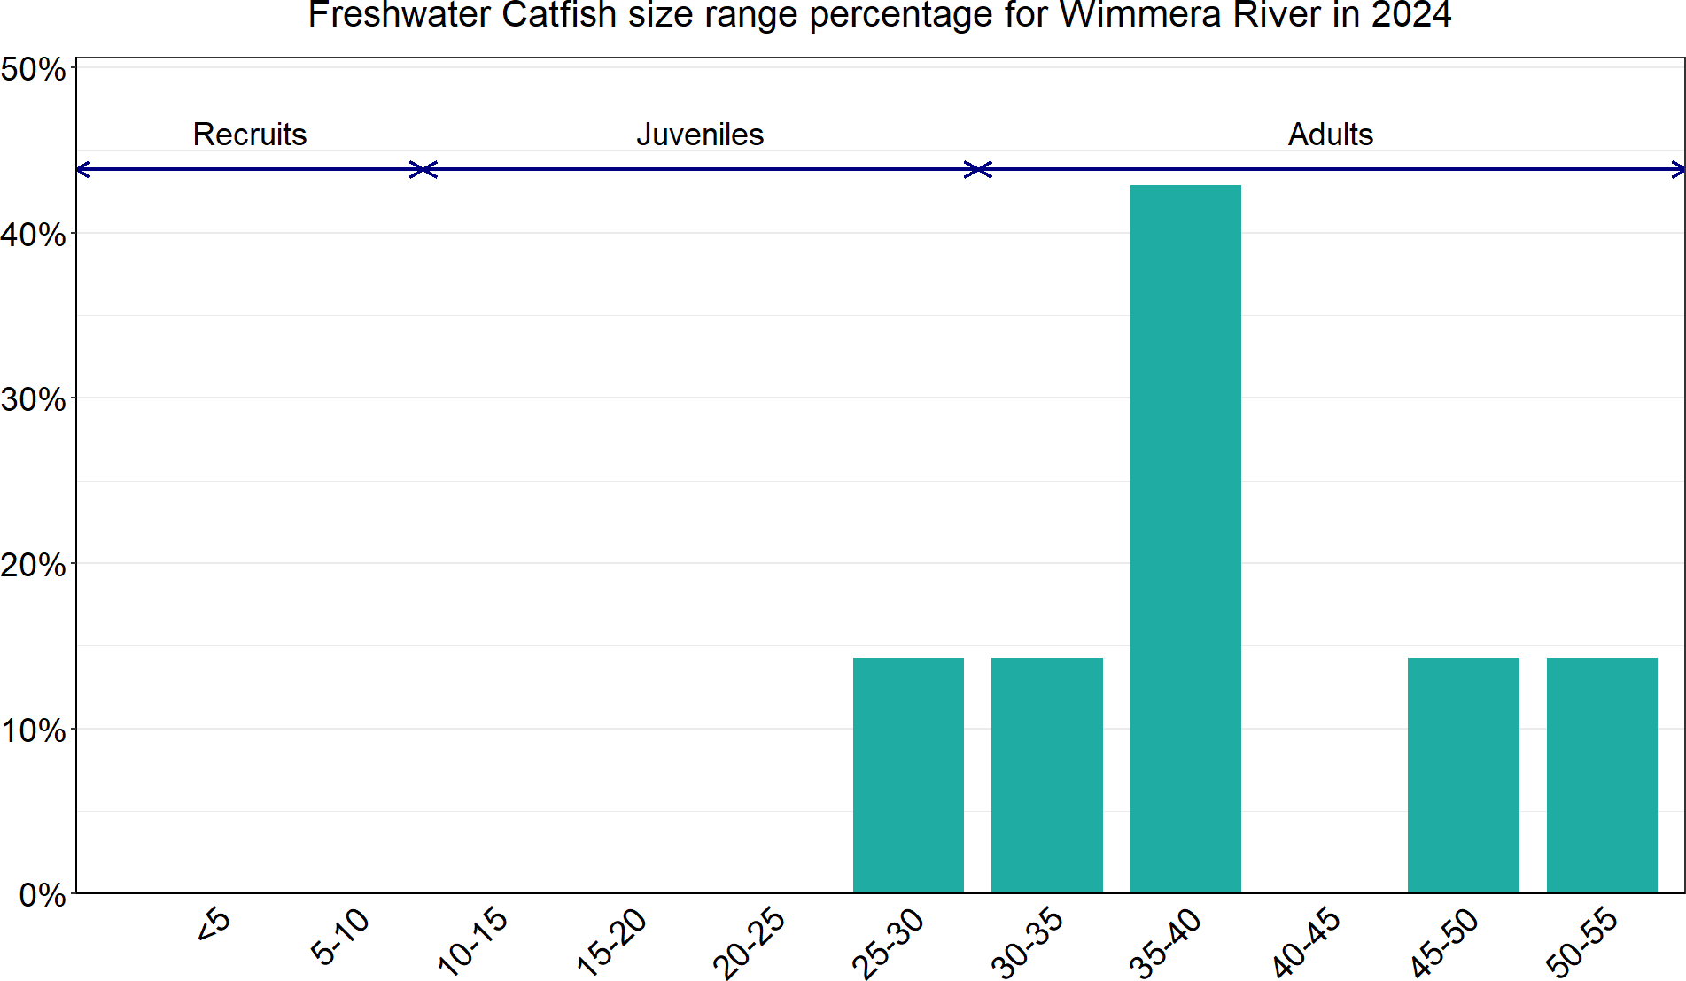
Figure 6. The densities of recruits, juveniles and adult Freshwater Catfish for NFRC surveys in the Wimmera River from 2017 to 2024

Figure 7. The size range percentage of Freshwater Catfish in the Wimmera River during NFRC surveys in 2024

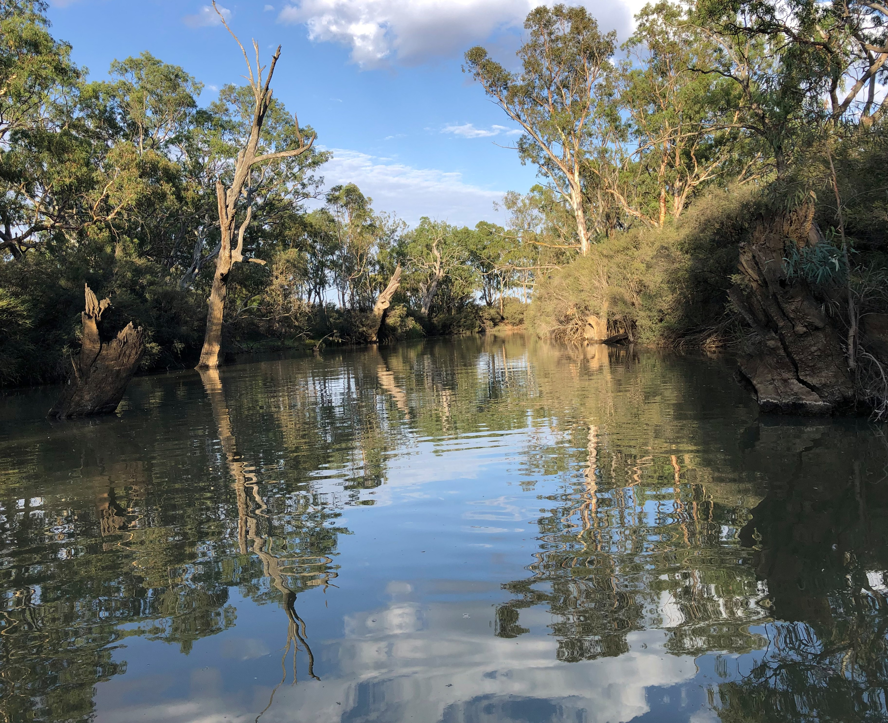


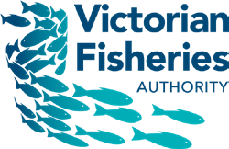



We acknowledge and respect Victorian Traditional Owners as the original custodians of Victoria’s land and waters, their unique ability to care for Country and deep spiritual connection to it.
We honour Elders past and present whose knowledge and wisdom has ensured the continuation of culture and traditional practices.
DEECA is committed to genuinely partnering with Victorian Traditional Owners and Victoria’s Aboriginal community to progress their aspirations.


© The State of Victoria Department of Energy, Environment and Climate Action 2024. This work is licensed under a Creative Commons Attribution 4.0 International licence. To view a copy of this licence, visit creativecommons.org/ licenses/by/4.0/
ISSN 2981-9091 Online (pdf/word)

