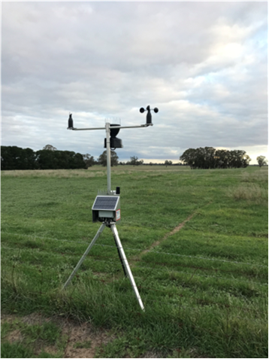

Interpreting soil moisture graphs and calculating Plant Available Water (PAW)

Dr Cassandra Schefe

## Key messages

* Soil moisture probes are a valuable management tool as they can be used to understand the total soil moisture content, the proportion of that moisture which is available to plants, and how well the plant roots are extracting moisture from each depth.
* An understanding of current plant available water contents (PAW), aligned with weather forecasts, can be helpful in making management decisions.
* Accurate interpretation of soil moisture graphs requires an understanding of the soil type, including any physical and chemical constraints that may restrict root and/or water movement to depth.

## How to interpret soil moisture graphs?

The key reason why we install soil moisture probes is to quantify the amount of stored water in the soil that may be accessed by plants. However, sometimes when we look at soil moisture graphs, they can be a bit overwhelming with all the different data lines.

Note, for this article the focus is on the 20-70cm depth zones for illustration purposes, however the deeper probes will also show the same characteristics.

## 

Two of the weather stations feeding data into the Wimmera CMA Soil Moisture portal.

## Impact of soil type on the size of the soil moisture lines

The variation in the amount of fluctuation in the soil moisture data line is due to differences in clay content. Water can infiltrate faster through a sandy soil than a clay soil, with most of the water being stored in a sandy soil able to be extracted for plant use. This means that a soil moisture data line of a sandy soil will fluctuate quickly.

An example of this is the Goroke site (Figure 1), which has a surface soil Cation Exchange Capacity (CEC) of 4.9 meq/100g, which reflects low clay content, and a similar pattern of relative soil moisture for all probes in the 20-70cm depth layers. Scale is important to note, as the stacked graphs can be deceptive. At April 1 2024, all layers had between 60-75mm moisture, which decreased to between 35-55mm by March 10, 2025. It is the relative change within a line/depth, that is important to note, not the positioning of the lines on the graph.

The dark blue line (SM020) shows high fluctuation of soil moisture, with some evaporation pre sowing, and then active extraction of moisture from sowing onwards. Evapotranspiration (ET) is shown by the slight ‘wiggle’ of the blue line in April 2024 (evaporation), with stronger draw down or ‘wiggle’ from sowing through to mid-July due to the diurnal (day/night) flux of plant transpiration.

Following the various colours on Figure 1, it is easy to pick up that roots started to actively extract from the 30cm depth in mid-August, followed closely by the other depth layers in a cascading pattern, with root extraction from the 70cm zone being seen by mid-September. While there were significant rain events in late September, this didn’t result in a large water peak as it was quickly utilised, just reducing the rate of water extraction. As the wheat plants reached maturity in November and roots senesced, the lines flattened out. A rain event in December recharged the surface 20-40cm layers, with their moisture content decreasing through December (shown by down steps) as the deep layers recharged (shown by up steps).

Figure Goroke soil moisture probe data, from 20-70cm depth, displayed as “SM Upper stacked”

In comparison, water can only slowly infiltrate through a clay soil, as the complex clay structures have smaller pathways for water flow than a sandy soil. However, clay soils have a greater water-holding capacity than a sandy soil, with greater amounts of water being stored, or *absorbed* in all the small pore spaces around the clay particles. The challenge with clay soils is that while they can hold a lot of water, most of this water is only slowly available for plant use, with a portion being unavailable, due to the high affinity of the clay particles for this water. This explains why a soil moisture data line of a clay soil will only change slowly, with a slower, and lower rate of extraction than a sandy soil.

An example of a heavy clay soil is the Natimuk 3 site (Figure 2). This soil has a surface CEC value of 33 meq/100g, reflecting a clay soil, likely a cracking clay soil, with the decreasing range of fluctuation of each soil moisture probe indicating increasing clay content with depth.

Figure Natimuk 3 soil moisture probe data, from 20-70cm depth, displayed as “SM Upper stacked”.

While Figures 1 and 2 are extremes, it is quite common to for soils to have a lighter surface soil, above a heavier clay subsoil, known as a duplex soil, and likely to reflect more of the red-brown earths in the Wimmera. An example is Figure 3, the Deep Lead pasture site.

The soil moisture probe data in Figure 3 shows large fluctuations in soil moisture down to about 40cm, with these fluctuations smoothing out at lower depths, indicating a sharp increase in soil texture about the 40cm depth, with increasing clay content below that. The impact of a pasture phase can be easily seen with the strong drawdown of moisture all year through all depths, albeit with less range of fluctuation at deeper depths as the clay content increases.

The Deep Lead pasture site (Figure 3) also provides an example of a common anomaly with soil moisture probes, which is preferential flow down the side of the tube. This is dramatically shown by a large spike in soil moisture on November 26, 2024, due to a high intensity rain event on dry soil, resulting in a simultaneous increase in soil moisture at all depths – not the gradual cascading of soil water down the profile over time which would be expected. This caused a reset in soil moisture at all depths at a higher level, the extent of which may or may not be ‘real’, especially at the lower depths.

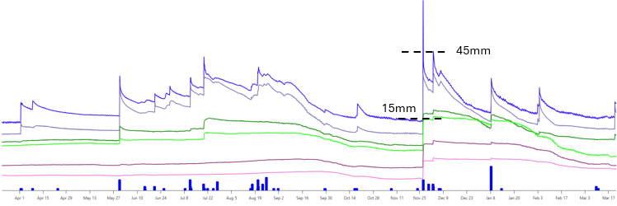

Figure Deep Lead soil moisture probe data (pasture), from 20-70cm depth, displayed as “SM Upper stacked”. The dotted lines represent the upper and lower limits for the 20cm soil moisture probe.

## How to calculate plant-available water?

The difference in the water stored vs extractable soil water is explained by the Plant-Available Water (PAW) value, which is a calculated value unique to each soil type. The PAW value is described as:

**Drained Upper Limit** - the amount of water stored in the soil after free draining of excess water, otherwise known as Field Capacity *minus* the **Crop Lower Limit** - the point where plants cannot extract any further water from the soil, otherwise known as Permanent Wilting Point.

On a stacked soil moisture graph, this can be calculated by identifying the highest point on each data line on the graph (excluding sharp peaks that indicate preferential flow down the side of the probe), and the lowest point on each line on the graph, and then calculating the difference.

An example is shown for the 20cm moisture probe for the Deep Lead site (Figure 3), where the dotted lines show the upper and lower limits as 45mm and 15mm. The difference between these two values is 30 mm, which is the PAW value for that depth. Note, if the probe has not been in the ground long enough to be subjected to the minimum (driest) and maximum (wettest) for each depth, do these calculations with caution.

The Summed Soil Moisture Graph can be used to calculate the size of the PAW bucket through the whole profile. However, a caveat with this; only calculate to the depth of root exploration, confirmed through observed extraction of soil moisture by roots shown through declining soil moisture data lines over the growing season. For example, if root depth is limited due to soil constraints at 60cm (eg Boron toxicity), then estimation of PAW to the full depth (130cm) would give a false prediction of available water.

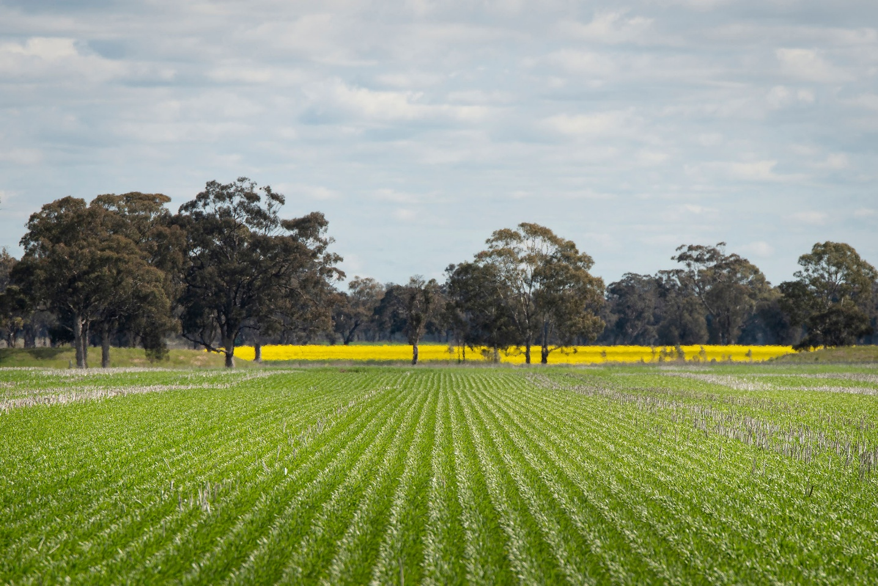

In the Deep Lead Summed soil moisture graph (Figure 4), the green line is the sum of all the soil moisture values for the 20 – 70cm depth probes (SM Sum 20-70cm). The red line is the sum of the lower 80-130cm probes (SM Sum 80-130cm) and the blue line is the sum of all probes 20-130cm (SM Sum 20-130cm). The dotted lines are an overlay of the Upper and Lower limits for the PAW for the 20-130cm depth, and the axis on the right-hand side is the soil moisture content, aligned with the 20-130cm depth (blue line). In this instance, as the red line (deep probes) is showing depletion in soil moisture in alignment with the green line (shallow probes) it is likely that roots are extracting water to depth, and so it is appropriate to calculate the PAW for the whole 20-130cm zone. While the Upper and Lower limits demonstrate the total *potential* bucket as 685mm – 550mm = 135mm, the *actual* plant available water at 21 April 2025 is 576mm – 550mm = 26mm. This is calculated from the blue line value minus the Lower limit.

Figure Summed Soil Moisture Graph for Deep Lead – pasture. Note the dotted lines for the Upper and Lower Limits for the summed 20-130cm soil moisture.

## How do I use this information?

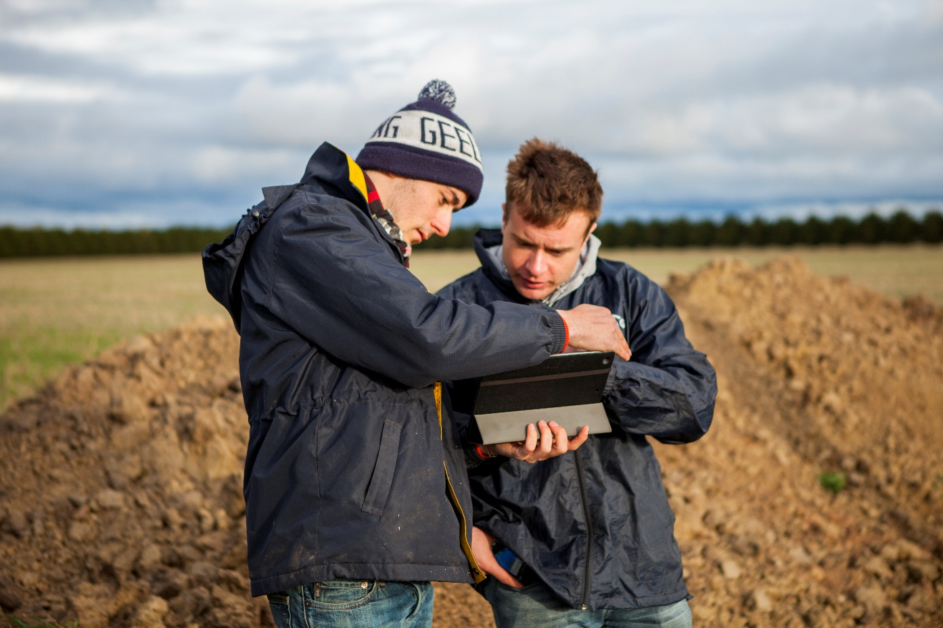An understanding of current soil moisture status, especially PAW, can assist in de-risking management decisions. For example, if soil moisture levels are depleted at sowing, and weather forecasts are showing minimal rain, a more conservative agronomy strategy may be adopted.

Sign in to Wimmera CMAs Soil Moisture Probe Portal to see real-time data, tracking everything from soil moisture and temperature to wind direction, rainfall, and harvest fire danger index.