
Native Fish Report Card 2025
Wimmera River
Wimmera Region

This report card summarises the 2025 Native Fish Report Card (NFRC) survey in the Wimmera River
Sites: 9, Electrofishing

Fish found in Wimmera River for NFRC
Target species
Freshwater Catfish#
Golden Perch#

Non-target species captured since 2017*
Large-bodied native species
Murray Cod#
Silver Perch#

Small-bodied native species
Australian Smelt
Common Galaxias#
Carp Gudgeon
Flatheaded Gudgeon

Exotic species
Common Carp
Eastern Gambusia
Goldfish
Redfin
Roach

* These non-target species were incidentally captured during NFRC surveys since 2017 but not measured as for target species. # Native species translocated outside of its natural range.

Wimmera River 2025
Fish Community

NFRC target species
The NFRC Program began in 2017 to monitor population dynamics of key iconic fish species that have high recreational and/or conservation values, in large rivers across Victoria. In the Wimmera River, the target species are Freshwater Catfish and Golden Perch. Surveys occur in January-March each year, at nine sites from Gross Bridge at Drung Drung to just upstream of Lake Hindmarsh, Jeparit. The equipment used and habitats surveyed target these species, which are measured to determine their population structures. Other fish species that are incidentally captured are counted, but not measured.

Summary of key health indicators for target species in 2025
Species | Key Health Indicators
 | Recent recruitment | Multiple size classes | Mature fish present
Freshwater Catfish | - | - | -
Golden Perch | Yes | Yes | Yes

Recent recruitment means young-of-year fish
*- cannot be determined due to low abundances

Both Freshwater Catfish and Golden Perch are considered translocated populations in the Wimmera River.

Non-target species
The non-target fish species that have been incidentally recorded in the Wimmera River during NFRC surveys since 2017 are:

Large-bodied native species
Silver Perch and Murray Cod were recorded in the 2025 survey. Both species are considered as translocated to the Wimmera River. Silver Perch has been recorded in eight of nine NFRC surveys. It has been stocked annually since 1997 with numbers stocked increasing recently from less than 20,000 pre 2020 to 50,000 in 2020 and 2021, 100,000 in 2022, 161,000 in 2023, 50,300 in 2024 and 78,000 in 2025. Murray Cod has been recorded in three of nine NFRC surveys (2025, 2024 and 2022), albeit only a single individual on each occasion. Small numbers (5000 - 15,000) of Murray Cod were stocked annually between 1997 and 2004, 10,000 in 2022, 2023 and 2024 and 51,000 in 2025.

Small-bodied native species
Australian Smelt, Flatheaded Gudgeon and Common Galaxias were recorded in the 2025 survey. Australian Smelt and Flatheaded Gudgeon have been recorded in all nine surveys. Common Galaxias has been recorded in three of the nine surveys. The Common Galaxias is considered a translocated species and is likely to have entered the system via water transfers from the Glenelg River system. Carp Gudgeon have been recorded in two previous NFRC surveys (2017 and 2018) but have not been recorded since. Carp Gudgeon is a lowland species, being more common in slower flowing habitats, and is often hard to detect via boat electrofishing.

Exotic fish species
Common Carp, Goldfish, and Redfin were recorded in the 2025 survey and have been recorded in all nine NFRC surveys. These species are widely distributed across sampling sites. Eastern Gambusia was also recorded in the 2025 survey and has been recorded in the eight of the nine NFRC surveys, except in 2024. Roach was detected in 2018 which was the first confirmed record of this species in the Wimmera River system.

Other native species known from the Wimmera River
Some fish species known to occur in the Wimmera River have never been recorded during NFRC surveys (e.g. Obscure Galaxias, River Blackfish and Southern Pygmy Perch). Southern Pygmy Perch are more common in offstream habitats such as billabongs, wetlands and lagoons. Southern Pygmy Perch and River Blackfish are present in the Wimmera River system upstream of the areas where NFRC surveys occur. Obscure Galaxias are difficult to detect using the NFRC sampling methods.

Other notable species
Surveys have also recorded Yabbies, Eastern Long-necked Turtles.

Wimmera River 2025
Environmental and Management Context

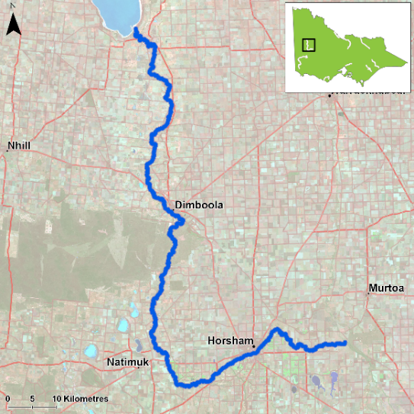
Figure 1. Map showing the section of Wimmera River where NFRC sampling occurs

Environment
Low flow conditions were present in all nine sampling years, with some locations such as Lake Road extremely low in 2025.

Waterway and fisheries management efforts in the Wimmera River
Many rehabilitation actions have occurred, and are underway, to improve the health of the Wimmera River and its fish community.
The future of threatened River Blackfish populations in the Wimmera River and beyond have greater security because of the Wimmera Catchment Management Authority’s (WCMA) River Blackfish Recovery Project, a collaboration with the Victorian Fisheries Authority (VFA), Arthur Rylah Institute, Barengi Gadjin Land Council, Native Fish Australia and the Horsham Angling Club. In an Australian first, VFA’s Snob’s Creek Conservation Hatchery bred River Blackfish, which the WCMA subsequently released into Wimmera River tributaries in March 2025. WCMA is investigating other potential Wimmera waterway release sites for juvenile River Blackfish. The project represents a priority of the Wimmera Native Fish Management Plan to increase the presence and range of diminishing River Blackfish populations in the Wimmera catchment.

Ongoing recovery efforts have also targeted Southern Pygmy Perch and other small-bodied native species, including salvage and translocation operations in drying sections of the MacKenzie River.
The WCMA has been exploring what combination of conditions might stimulate breeding of Golden Perch in the Wimmera River, following observations of breeding activity at Horsham in 2022. Golden Perch is a native species translocated to the Wimmera River for recreational angling, and it was previously believed that conditions in Wimmera waterways did not support its breeding.

Golden Perch

Wimmera River, Wimmera region

Key Health Indicators
Recent recruitment Yes
Multiple size classes Yes
Mature fish present Yes

Monitoring Results
Total number of fish caught 116
Fish per 1km of waterway 11.12
Largest fish by length (cm) 57.4
Largest fish by weight (kg) 4.16
% of the catch that is legal size 84

All Golden Perch (Macquaria ambigua) in the Wimmera River are a result of stockings¹. Abundances of Golden Perch have been variable within the Wimmera system, with the lowest abundance recorded in 2020 and the highest in the 2025 survey (Figure 2). The increase in abundance since 2021 may reflect the increasing stocking activity in recent years. However, in 2025, there was an accumulation of Golden Perch at the Lake Road site, presumably because of Golden Perch seeking deeper water as Lake Hindmarsh dried out. The sampling methodology included fyke nets and electrofishing in 2017-19, but electrofishing only from 2020-25. Recruits were detected by fyke netting in 2018 and 2019 (Figure 2) and by electrofishing in 2022, 2023 and 2025. Recruits of this species are difficult to catch using electrofishing sampling methods. Detections via electrofishing in 2022, 2023 and 2025 may indicate higher survival of stocking in those years and/or stockings. Juveniles and adults have been recorded in all nine surveys, although the fish captured were predominantly adults. A higher proportion of juveniles was detected in 2021 (Figure 2). Juveniles were detected in 2024 and 2025, although in low abundances (Figure 3).

Stocking
Eighty thousand Golden Perch were stocked in 2016; 110,000 in 2017; 150,000 in 2019; 80,000 in 2020; 100,000 in 2021; 167,000 in 2022; 170,000 in 2023; 123,300 in 2024 and 240,750 in 2025, although 65,000 of these were post 2025 NFRC surveys.

¹ Trueman, W.T., 2012. True Tales of the Trout Cod: River Histories of the Murray–Darling Basin. Chapter 22, Wimmera & Avoca River Catchments. MDBA Publication, (07/12).
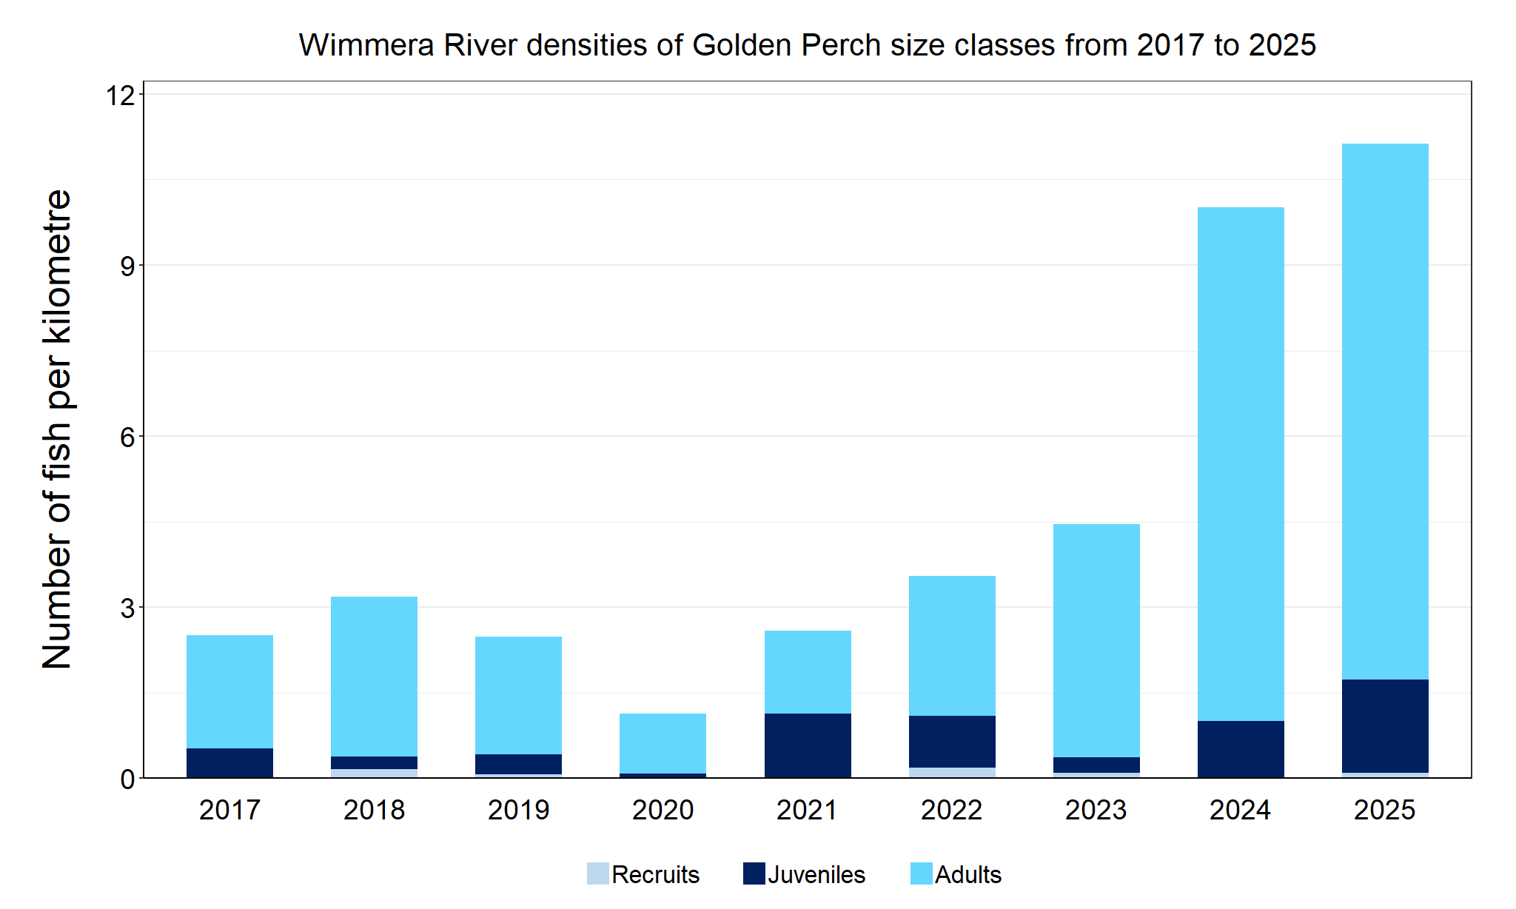
Figure 2. The densities of recruits, juveniles and adult Golden Perch in the Wimmera River from 2017 to 2025

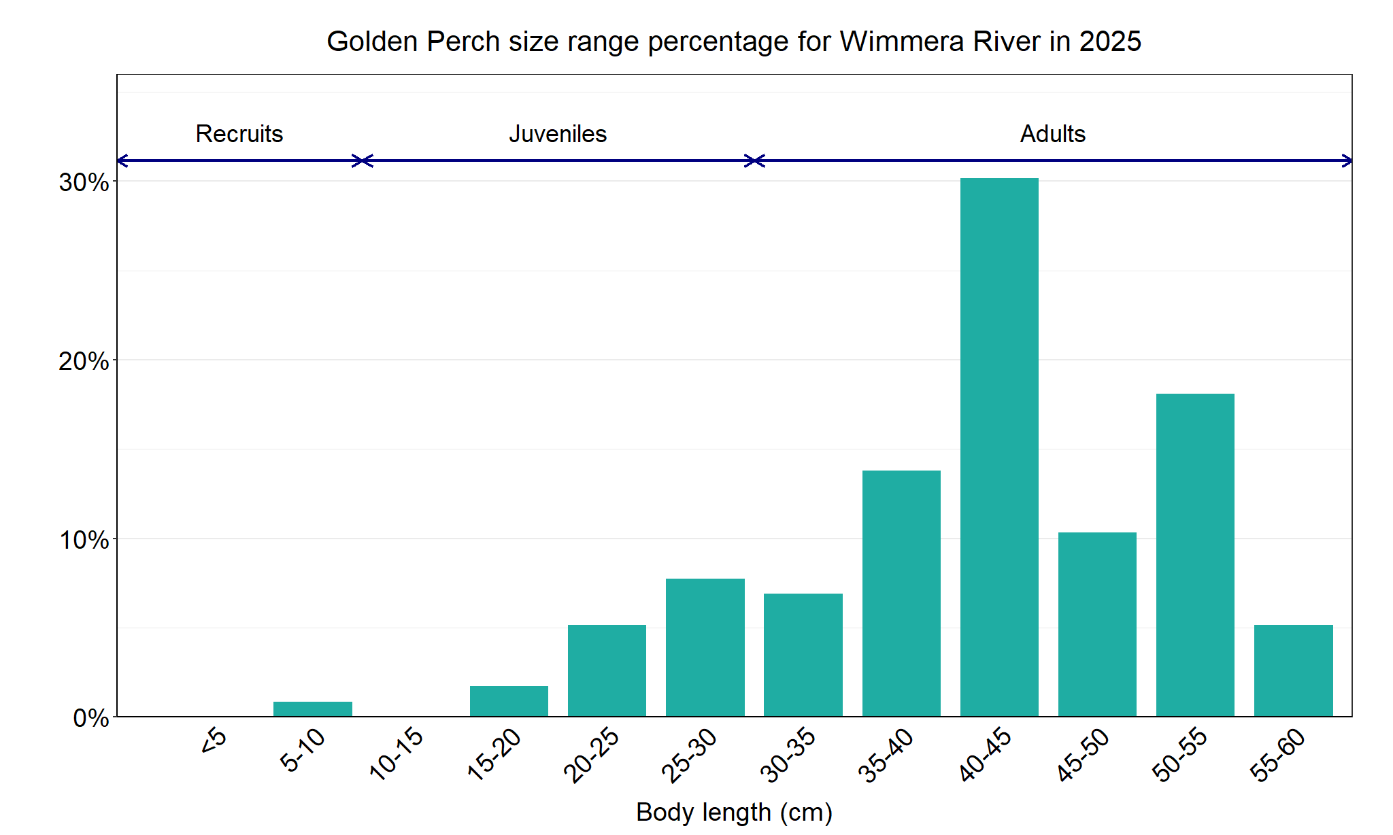
Figure 3. The size range percentage of Golden Perch in the Wimmera River in 2025

Freshwater Catfish

Wimmera River, Wimmera region

Key Health Indicators
Recent recruitment Cannot be determined
Multiple size classes Cannot be determined
Mature fish present Cannot be determined

Monitoring Results
Total number of fish caught 2
Fish per 1km of waterway 0.19
Largest fish by length (cm) 42.2
Largest fish by weight (kg) 0.87
% of the catch that is legal size 100

The NFRC does not expect to capture enough Freshwater Catfish (Tandanus tandanus) to measure key health indicators. However, collecting data for translocated species including Freshwater Catfish allows a greater understanding of the current status of the populations providing essential information to the management of this species.
In the 2025 survey two adults were detected (Figure 4; Figure 5). Although low numbers of Freshwater Catfish have been caught in all nine years of sampling, there has been a mix of recruits (2017-19), juveniles (2017, 2021 and 2024) and adults (2018-25) (Figure 4). The sampling methods included fyke netting and electrofishing in 2017-19, but electrofishing only from 2020-25. Recruits of this species are difficult to catch using electrofishing sampling methods, with recruits primarily detected via fyke netting. Only a single recruit was detected via electrofishing in 2019.

Stocking
No stocking has occurred.
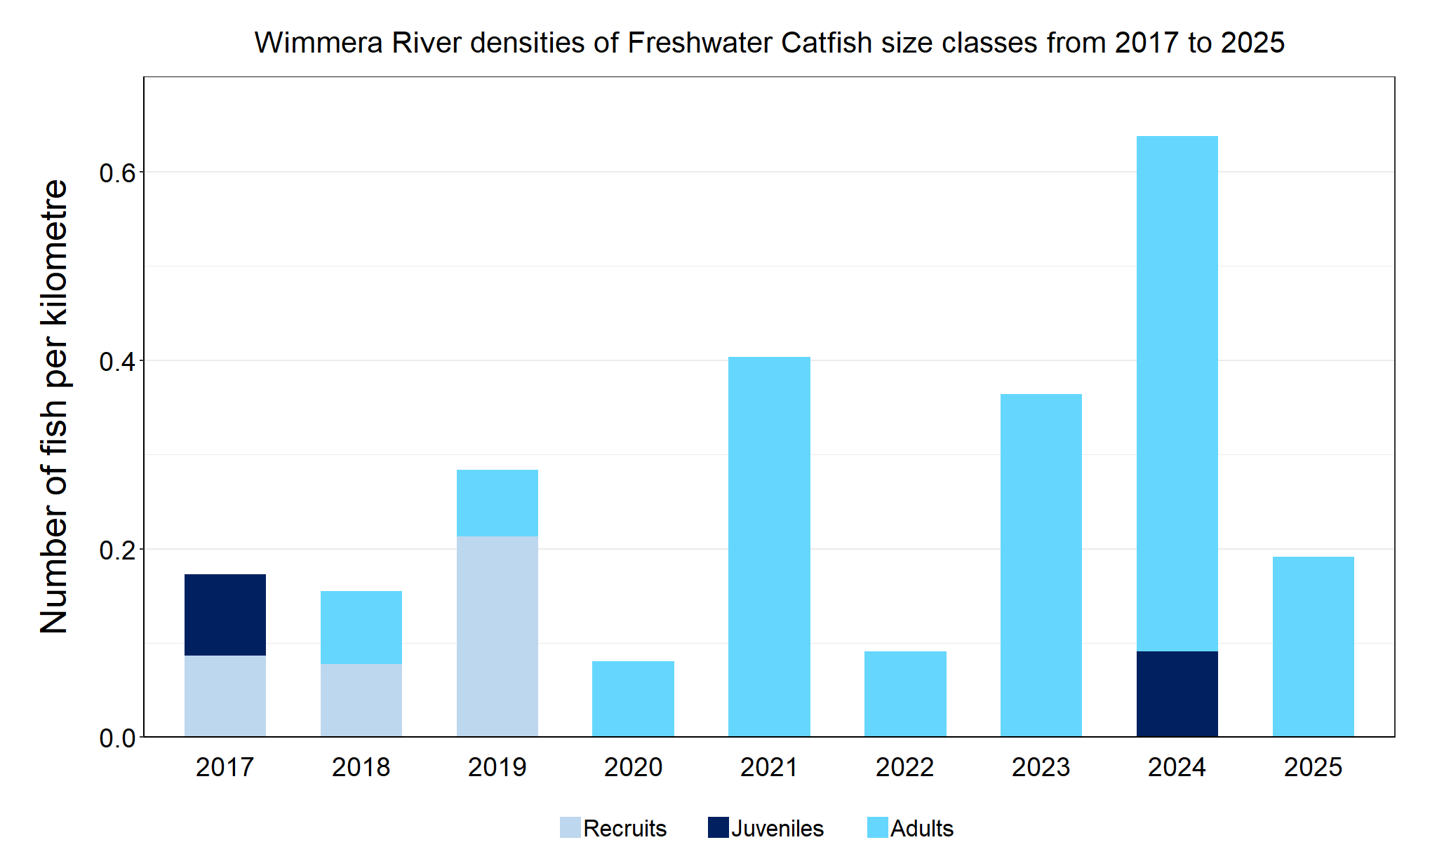
Figure 4. The densities of recruits, juveniles and adult Freshwater Catfish in the Wimmera River from 2017 to 2025

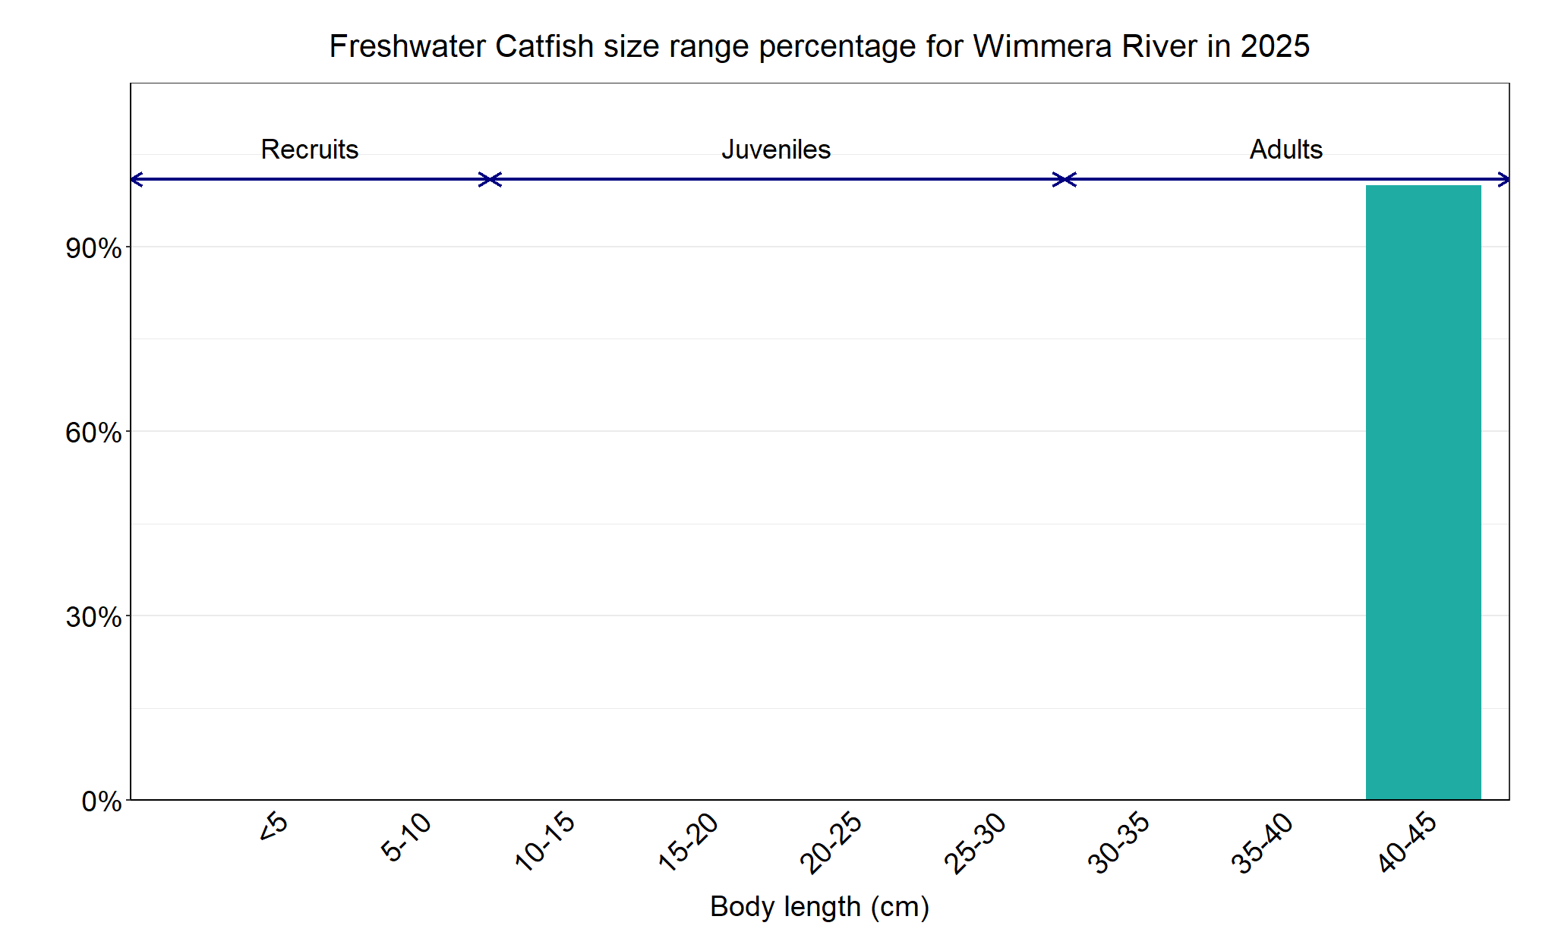
Figure 5. The size range percentage of Freshwater Catfish in the Wimmera River in 2025

We acknowledge and respect Victorian Traditional Owners as the original custodians of Victoria’s land and waters, their unique ability to care for Country and deep spiritual connection to it. We honour Elders past and present whose knowledge and wisdom has ensured the continuation of culture and traditional practices.
© The State of Victoria Department of Energy, Environment and Climate Action 2025. This work is licensed under a Creative Commons Attribution 4.0 International licence. To view a copy of this licence, visit creativecommons.org/licenses/by/4.0/
ISSN 2981-9091 Online (pdf/word)

