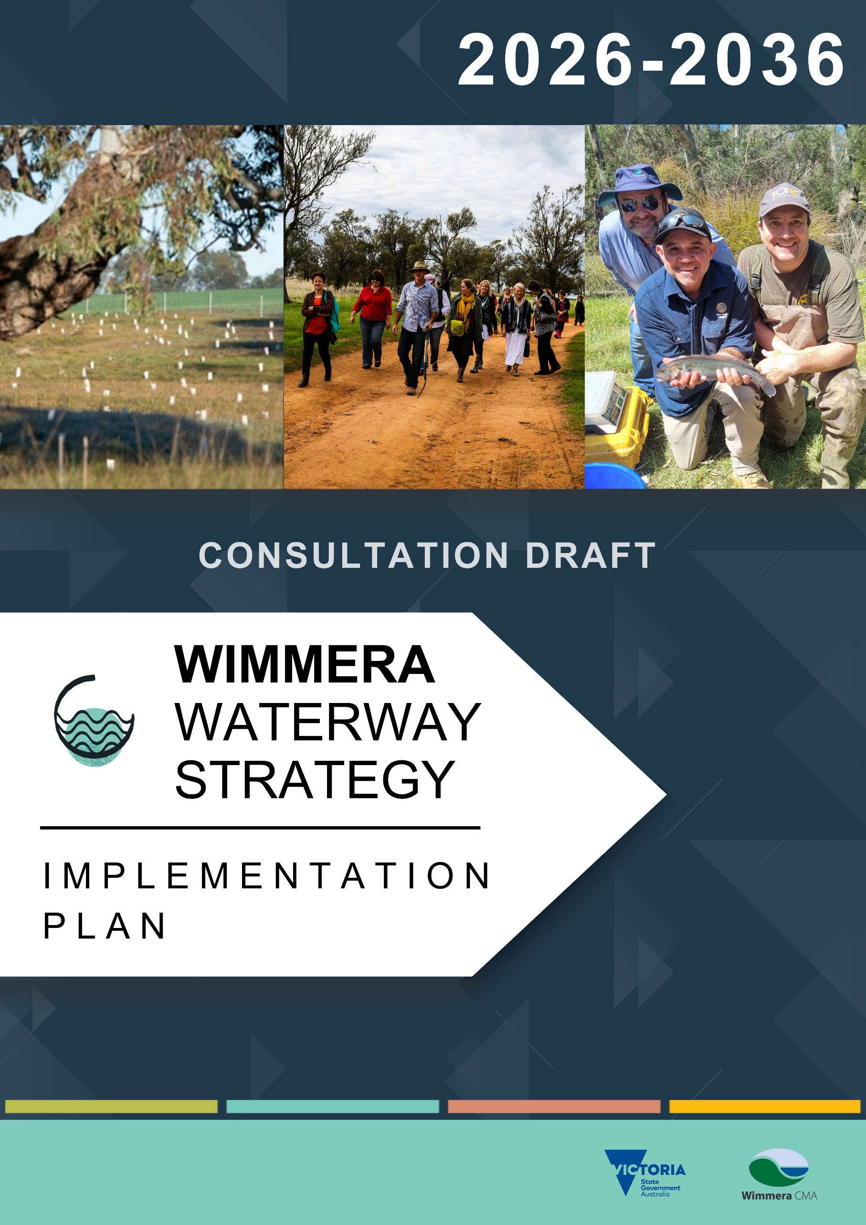
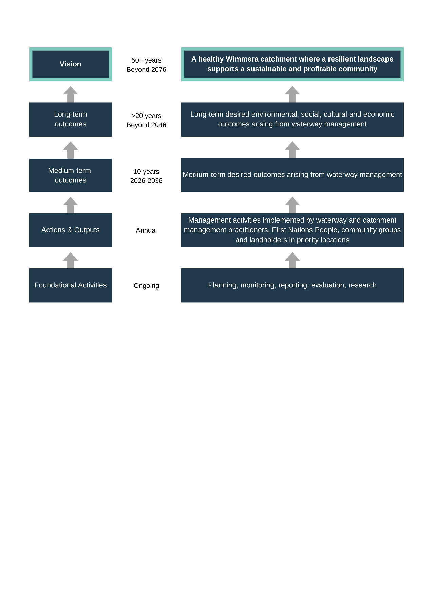
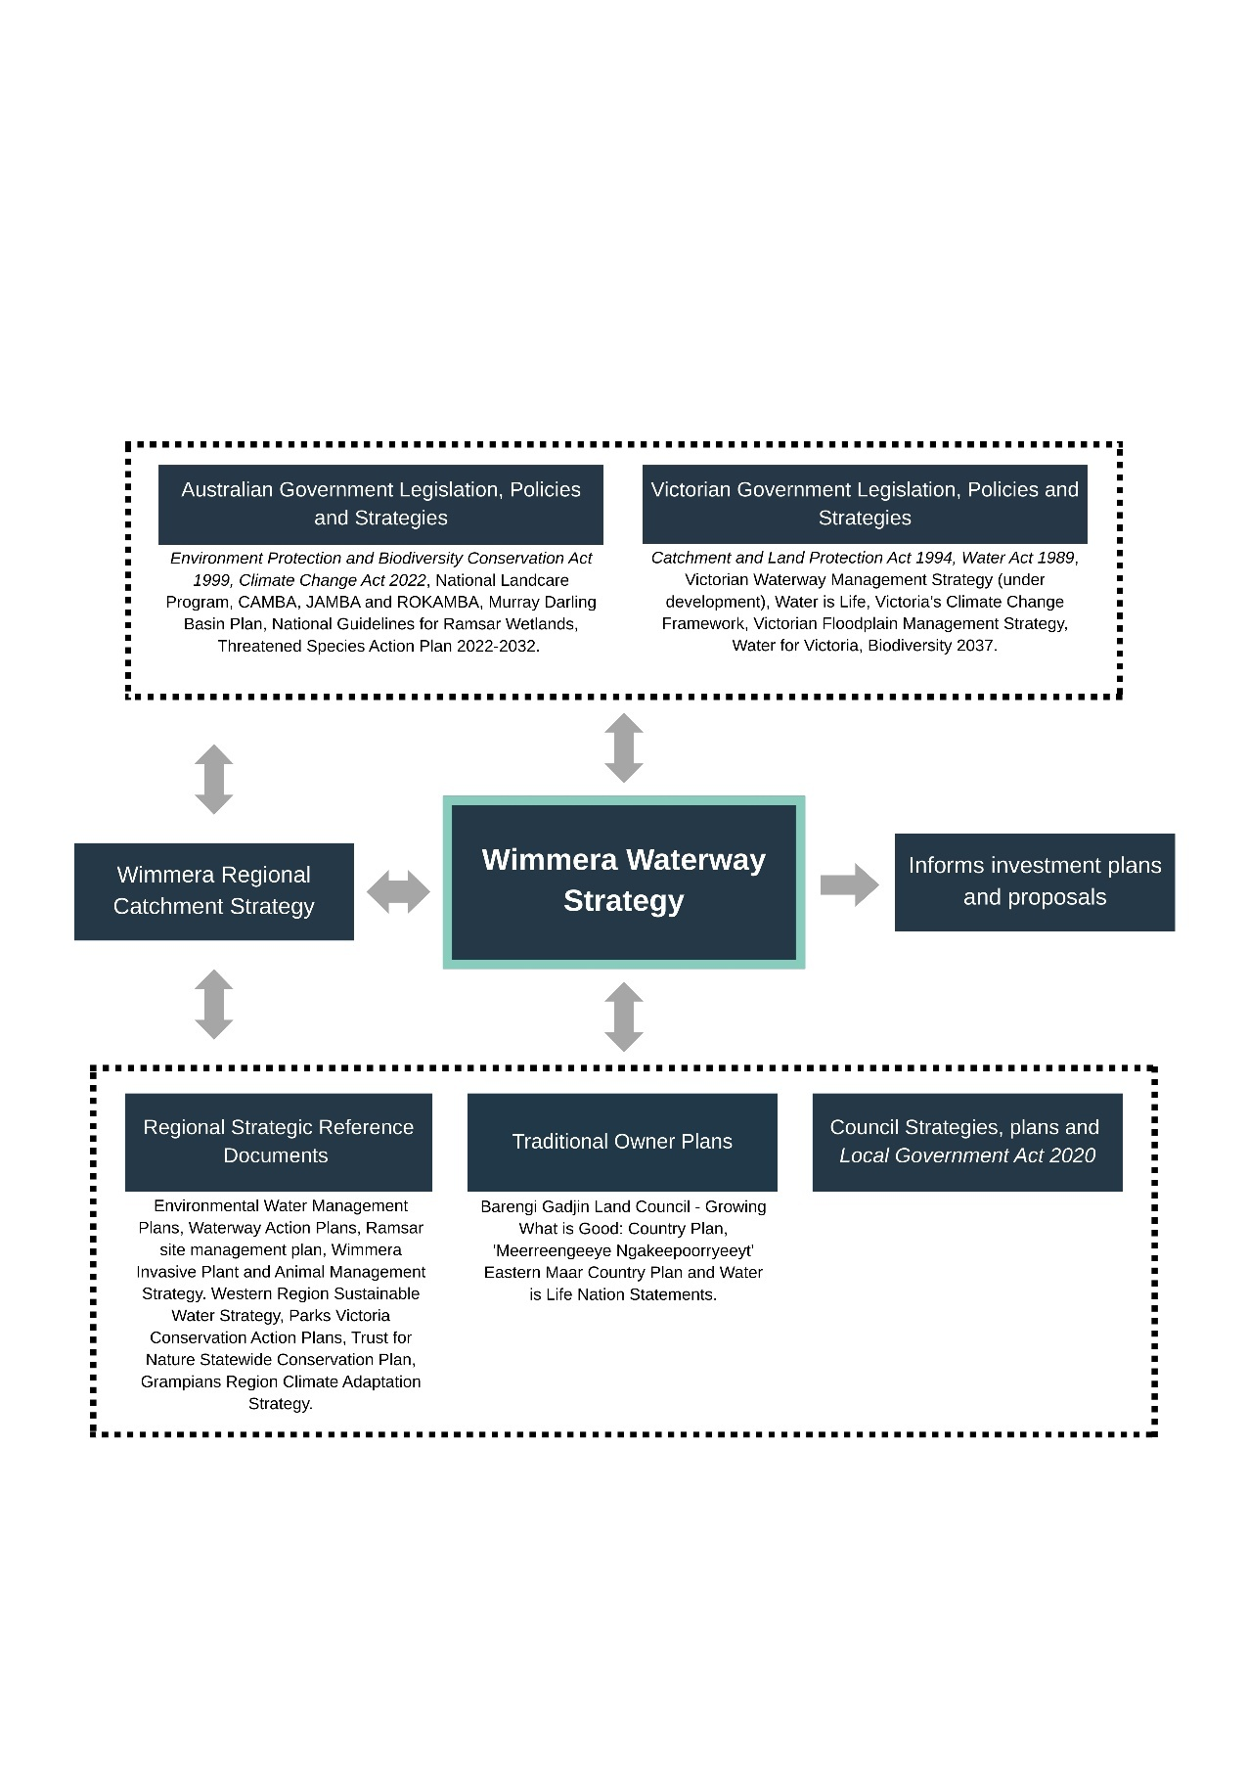

Table of Contents
Introduction 3
Roles and responsibilities 7
Funding and cost-sharing 13
Desired outcomes 15
Local areas 16
Whole of catchment - implementation 96
Resources and budget 105
Risk management 105
Monitoring and evaluation 106
Review and update 106
Conclusion 106
References 107

Publication details
Implementation Plan for the Wimmera Waterway Strategy – consultation draft

Wimmera CMA
24 Darlot Street
HORSHAM VIC 3400
03 5382 1544
wcma@wcma.vic.gov.au
www.wcma.vic.gov.au
Pictures supplied by Wimmera CMA, Geomorphe, and Marty Schoo.

Copyright
© Wimmera Catchment Management Authority 2026

Acknowledgements
Wimmera CMA thanks the many regional stakeholders, groups and individuals whose contributions assisted with the preparation of this public consultation draft of the Wimmera Waterway Strategy.
We acknowledge the Traditional Owners and other Aboriginal and Torres Strait Islander Peoples across the region and pay respect to Elders past, present and emerging.

Disclaimer
Wimmera CMA and its employees do not guarantee that the publication is without flaw of any kind or is wholly appropriate for your particular purpose and therefore disclaims all liability for any error, loss or other consequence which may arise from you relying on any information in any Wimmera CMA publication.

Acronyms
BGLC Barengi Gadjin Land Council
CMA Catchment Management Authority
DEECA Victorian Government Department of Energy, Environment and Climate Action
EPBC Act Environment, Protection and Biodiversity Conservation Act 1999
EMAC Eastern Maar Aboriginal Corporation
EVC Ecological Vegetation Class
FFG Act Flora and Fauna Guarantee Act 1988
GWMWater Grampians Wimmera Mallee Water
MERI Monitoring, Evaluation, Reporting and Implementation
PV Parks Victoria
RCS Regional Catchment Strategy
RWS Regional Waterway Strategy
The Plan Implementation Plan for the Wimmera Waterway Strategy
The Strategy Wimmera Waterway Strategy
VFA Victorian Fisheries Authority
Wimmera CMA Wimmera Catchment Management Authority

Introduction
The draft Implementation Plan for the Wimmera Waterway Strategy (the Plan) outlines the practical steps required to support the region’s vision for:
“A healthy Wimmera catchment where a resilient landscape supports a sustainable and profitable community.”
Building on the desired outcomes and strategic priorities identified in the consultation draft of the Wimmera Waterway Strategy (the Strategy), this Plan translates them into actions and initiatives for delivery over the next decade.
The plan focuses on:
- Improving waterway condition and habitat through targeted actions such as riparian restoration, environmental water delivery, erosion control, and habitat enhancement.
- Embedding Traditional Owner values by supporting cultural connections to waterways and self-determination.
- Enhancing stewardship of waterways by engaging communities and fostering partnerships with landholders, councils, local groups, First Nations People and other stakeholders.
- Addressing key threats including invasive species, altered flow regimes, and climate variability.
- Aligning with statewide policy frameworks, including the Victorian Waterway Management Strategy (draft under development) and the Wimmera Regional Catchment Strategy.
The Implementation Plan provides a roadmap for investment, collaboration, and adaptive management, enabling the region to respond effectively to emerging challenges while delivering long-term benefits for waterways and communities.

Overview
This document presents a practical roadmap for translating the Wimmera Waterway Strategy’s vision, outcomes, and priorities into coordinated on‑ground actions.
Specifically, the Plan aims to:
- Explain how the priorities identified in the Wimmera Waterway Strategy will be delivered.
- Outline management actions to achieve the Strategy’s medium‑term (less than 10‑year) in the highest‑priority locations, while also establishing clear steppingstones toward the long‑term (20‑plus year) outcomes.
- Identify the lead organisations responsible for each action, along with partner and supporting organisations, detailing the relationships and partnerships necessary to achieve the outcomes.
- Set out what can be achieved with currently anticipated funding and describe the additional actions that could be delivered if further funding becomes available.
- Provide links to supporting documentation, including evidence and justification for each action.
The Plan supports delivery of the Wimmera Waterway Strategy by defining the activities required to achieve its medium‑ and long‑term outcomes. It enables a flexible and adaptive management approach that can respond to new information, emerging issues, and changing conditions throughout implementation.
All implementation activities will be guided by the best available science, knowledge, and evidence.
Successful implementation relies on the collaborative effort of all parties involved in caring for Wimmera waterways - waterway managers, First Nations People, community, industry, landholders, and other stakeholders.
Progress will be measured through performance indicators and regular reporting set out in a Monitoring, Evaluation, Reporting and Improvement Plan (MERI, under development), ensuring transparency and accountability. MERI will inform learning and adaptive management throughout implementation.

Policy Context
Preparing a Regional Waterway Strategy is required under the Water Act 1989, which recognises nine Catchment Management Authorities and Melbourne Water as responsible for developing these strategies within their waterway management districts.
The Wimmera Waterway Strategy provides a 10-year plan to guide strategic and coordinated investment in waterway management. It outlines actions to balance waterway values and uses, achieve regional outcomes, and align with broader frameworks such as government legislation and policy, the Wimmera Regional Catchment Strategy, Western Region Sustainable Water Strategy, and Traditional Owner Nation Statements and Country Plans.
Key Victorian legislation and policy frameworks informing the Strategy are:
- Water Act 1989 – requires catchment management authorities to develop regional waterway strategies and work programs.
- Victorian Waterway Management Strategy (in development) – provides the statewide policy framework for waterway management and guides regional strategies.
- Water is Life: Traditional Owner Access to Water Roadmap – supports Traditional Owner self-determination in water access and management while balancing stakeholder rights and entitlements.
Appendix 1 of the Wimmera Waterway Strategy lists relevant policies and legislation.
Figure 1 shows how the Strategy and Implementation Plan connect to national, state, and regional plans. As a sub-strategy of the Regional Catchment Strategy, they provide direction for achieving waterway outcomes in collaboration with stakeholders and the community.
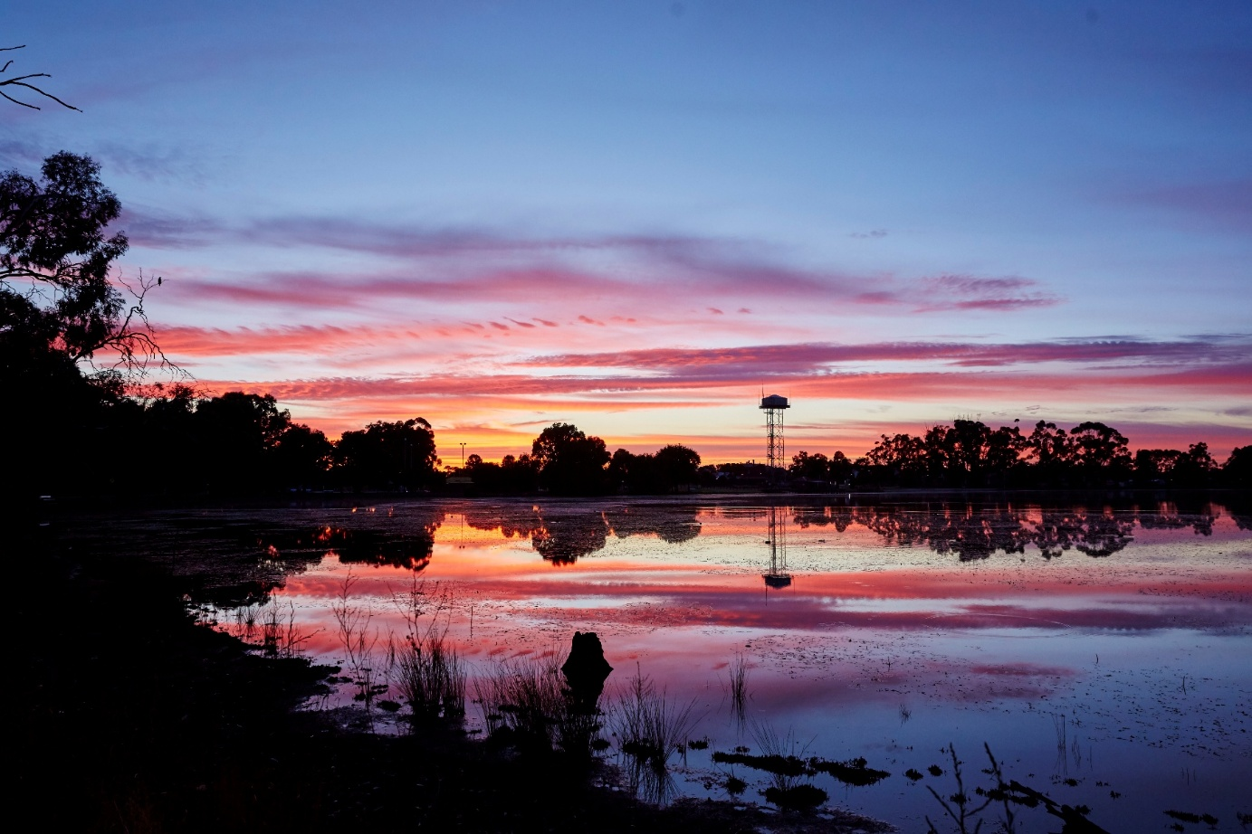
Lake Marma at Murtoa
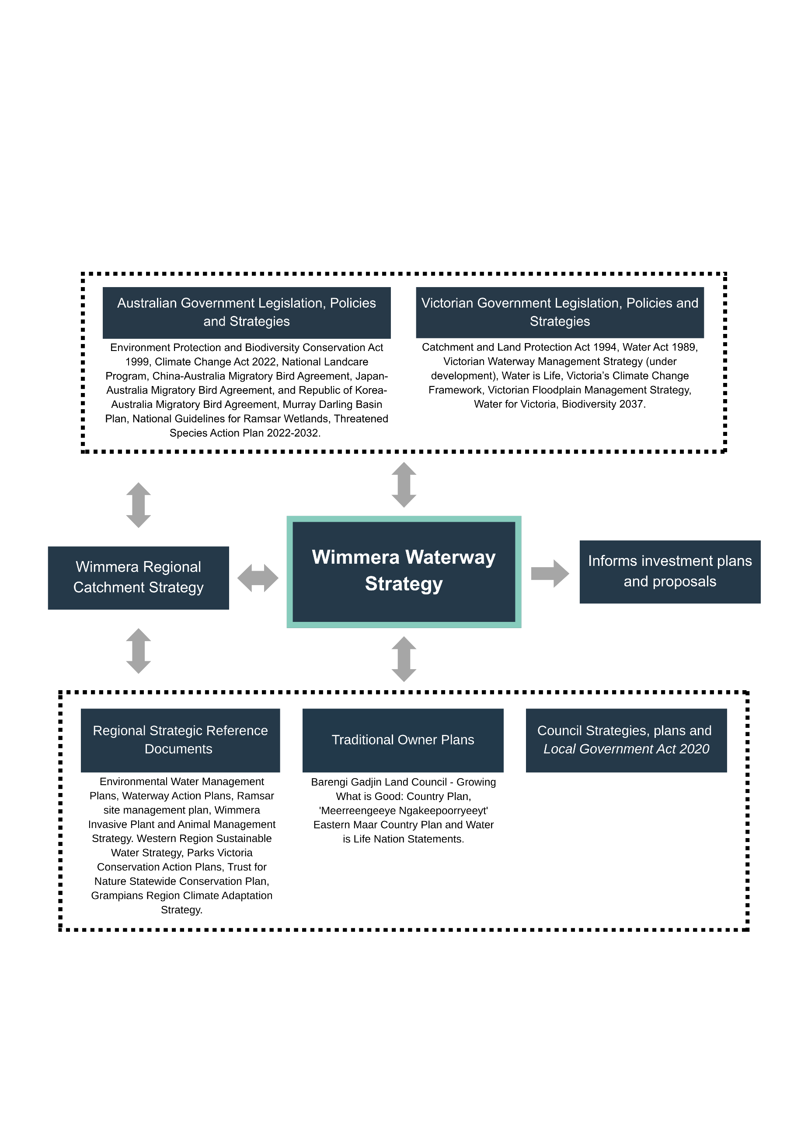
Figure 1. National, state and local policies, legislation and documents that guide, complement and align with the Wimmera Waterway Strategy.

Guiding principles
A set of principles guides the Strategy’s implementation, providing direction that assists with planning and decision-making. These principles provide guidance that ensures a consistent approach to decision-making and management actions supported by the Strategy. They can support waterway managers when faced with trade-offs, contrasting views from stakeholders or unclear evidence.
Waterway managers and partners are best placed to apply these principles given their understanding of local and broader contexts.
The principles align with the Victorian Waterway Management Strategy (in development), adapted to meet the Wimmera’s regional circumstances and needs.
The following principles guided the Strategy’s development and will inform its implementation:
- Integrated catchment management – Integrated management of waterways will occur in a broader framework of integrated and coordinated catchment management. This recognises the importance of waterways as part of connected systems, contributing to greater resilience of waterways, land, biodiversity, and communities.
- Partnership approach – Waterway management is a partnership between government, First Nations People, stakeholder organisations and groups, industry and communities. Waterway managers will provide opportunities for partners and community to:
    - Participate in decision making.
    - Build regional capacity and knowledge to effectively manage waterways.
    - Facilitate appropriate community care of, use and benefits from waterways.
    - Use partnerships to generate additional support.
    - Secure long-term outcomes by developing a collective or shared responsibility for waterway management.
- First Nations Peoples’ self-determination – Waterway managers are committed to partnering with First Nations People to improve the management of waterways on Country. Waterway managers will seek to collaborate with First Nations groups where opportunities exist. The Strategy acknowledges and respects First Nations Peoples’ obligations and rights to care for water and country and to increase the role of traditional ecological knowledge, provided with consent, to inform waterway management activities on Country.
- Climate change and waterway planning - Waterway management will apply a climate change adaptation lens, that considers predicted climate change impacts within the context of other pressures on the environment and other socio-economic drivers.
- Value for money - Public investment in waterway management will be directed to actions, activities and approaches that provide the most efficient and cost-effective progress towards long-term outcomes for the greatest public benefit, considering opportunities for multiple benefits.
- Evidence-based decision making - Waterway management will be informed by the best available knowledge and the precautionary principle. Management action will be risk-based and proportionate. Ongoing monitoring and evaluation will facilitate adaptive management.
- Good governance - Waterway management activities will be delivered effectively and strategically using a transparent, coordinated, and integrated framework.
- Maintain outcomes of previous investment - Previous effective on-ground waterway management activities that align with government policy and priorities will be considered within future strategies and work programs to ensure that outcomes are consolidated.
- Quadruple bottom-line decision making - Decision making will integrate considerations for environmental, social, cultural and economic values of waterways and seek to maximise overall benefits of management actions that maintain and improve condition in priority areas.
- Adaptive management - Effective monitoring, reporting, evaluation and research will support continuous improvement in managing waterways.

Roles and responsibilities
Under this Plan, waterway managers will implement the Wimmera Waterway Strategy in partnership with First Nations People, local communities, landholders, relevant statewide and regional agencies and boards, and other key stakeholders.
Wimmera CMA will work with partner organisations to coordinate implementation, monitoring, evaluation, review, and updates to this Plan so it remains current and effective over time.
Table 1 outlines the key organisations involved in developing and implementing the Strategy and Plan, along with their core roles and responsibilities.
Table 1. Wimmera Waterway Strategy development and implementation partners.
 | Partners | Waterway roles, responsibilities and interests
First Nations Community Partners | Registered Aboriginal Parties:  Barengi Gadjin Land Council  Eastern Maar Aboriginal Corporation | Local First Nations communities have a deep connection with waters and waterways. They are essential to Spiritual and Cultural practices, as well as environmental management, food production, language and (Lore) law. Water connects People and communities to land, and to each other. ⁽¹⁾  Barengi Gadjin Land Council Aboriginal Corporation and Eastern Maar Aboriginal Corporation are Traditional Owner Groups legally recognised under the Aboriginal Heritage Act 2006, with responsibilities for managing and protecting Aboriginal Cultural Heritage on Country that overlaps with specific areas of the Wimmera CMA region, including waterways.  Barengi Gadjin Land Council Aboriginal Corporation represents Traditional Owners from the Wotjobaluk, Jaadwa, Jadawadjali, Wergaia and Jupagulk Peoples of the Wotjobaluk Nations, who were recognised in a 2005 Native Title Consent Determination, the first in south-eastern Australia.  Eastern Maar Aboriginal Corporation represents the Eastern Maar People of southwest Victoria and manages their rights and interests.
Federal Government Agencies and Statutory Authorities | Murray-Darling Basin Authority | The Murray-Darling Basin Authority was established under the federal Water Act 2007 as an independent, expertise based statutory agency. The Wimmera Basin is a southern section of the greater Murray Darling Basin.  The primary roles of the Authority as outlined in the Water Act 2007 (Cth) include:  - Preparing and reviewing the Murray-Darling Basin Plan (Basin Plan).  - Measuring, monitoring, and recording the quality and quantity of the Basin's Water resources.  - Supporting, encouraging, and conducting research and investigations about the Basin's Water Resources.  - Developing equitable and sustainable use of Basin water resources.  - Disseminating information about the Basin's water resources.  The Regional Waterway Strategy complements and informs the Wimmera’s contribution to the Basin Plan and contributes to meeting Victoria’s obligation under the Basin Plan.
Federal Government Agencies and Statutory Authorities | Department of Climate Change, Energy, the Environment and Water  (DCCEEW) | Key responsibilities of the Australian Government include:  - Designating Australian sites for addition to the List of Wetlands of International Importance (Ramsar List).  - Leading the development of national guidance and approaches on implementing the Ramsar Convention in Australia.  - Participating in partnerships and agreements that seek to protect migratory species and their flyways.  - Working with state and territory governments to promote the conservation of Ramsar sites and wise use of all wetlands, and review Ramsar wetland site condition.  - Collaborating with the Australian Government Department of Agriculture, Fisheries and Forestry to develop and implement and conserve marine ecosystems and biodiversity while maintaining a profitable, competitive and sustainable fishing industry.  The Wimmera includes the Lake Albacutya Ramsar Site and contains waterways visited by migratory species.
Federal Government Agencies and Statutory Authorities | Commonwealth Environmental Water Holder (CEWH) | The CEWH is appointed under the Commonwealth Water Act 2007 to manage the Commonwealth’s environmental water holdings and protect and improve the environmental assets of the Murray-Darling Basin. The Commonwealth Environmental Water Holder:  - Makes decisions about the use of Commonwealth water holdings, including providing water to the VEWH for use in Victoria.  - Liaises with the VEWH to ensure co-ordinated use of environmental water in Victoria.  - Reports on management of Commonwealth water holdings.  In the Wimmera, the CEWH is an environmental water holder of an entitlement for the Wimmera River.
State Government Agencies and Statutory Bodies | Catchment Management Authorities (CMA) | The Wimmera CMA, along with nine other CMAs, was established in 1997 by the Victorian Government, under the Catchment and Land Protection Act 1994, with the aim of creating a whole of catchment approach to natural resource management in the state.  The primary goal of Victorian CMAs is to ensure the protection and restoration of land and water resources, the sustainable development of natural resources-based industries and the conservation of natural and cultural heritage.  Under Part 10 of the Water Act 1989, CMAs are designated with specific responsibility for the management of waterways, drainage and floodplains. The range of functions that CMAs undertake include:  - Developing a Regional Waterway Strategy and associated action plans.  - Developing and implementing work programs.  - Authorising works on waterways, and acting as a referral body for planning applications, licences to take and use water and Construct dams, for water use and other waterway health issues.  - Identifying regional priorities for environmental watering and facilitating water delivery.  - Providing input into water allocation processes.  - Developing and co-ordinating regional floodplain management plans.
State Government Agencies and Statutory Bodies | Department of Environment, Energy and Climate Change  (DEECA) | DEECA is a Victorian Government department that develops and implements statewide policy for waterway management, including environmental water, and water resource allocation and oversees Victoria’s compliance with international and national water obligations and intergovernmental agreements, for example the Murray-Darling Basin Plan, Living Murray, and Ramsar Convention for wetlands. The department also develops and implements related policy and programs for Crown frontage management, biodiversity, biosecurity, climate action and emergency management.
State Government Agencies and Statutory Bodies | Environment Protection Authority Victoria (EPA) | EPA is Victoria’s environmental regulator. As an independent statutory authority under the Environment Protection Act 2017, EPA’s regulatory role is to prevent and reduce harm to human health and the environment from pollution and waste. EPA Victoria uses a range of tools available under the Act to deliver improved outcomes for Victorian communities and the environment. These include the provision of guidance on how to minimise harm to waterways from pollution and waste.
State Government Agencies and Statutory Bodies | Parks Victoria (PV) | Parks Victoria manages parks and conservation reserves in which many waterways are located, including national, state, wilderness, metropolitan and regional parks, marine national parks and sanctuaries and conservation and natural features reserves. They play a role in vegetation protection from fire. They create, manage, and maintain visitor sites and manage a range of assets, including visitor facilities and access points, piers and jetties, sporting facilities and navigation aids, many of which are associated with waterways.
State Government Agencies and Statutory Bodies | Victorian Environmental Water Holder (VEWH) | The Victorian Environmental Water Holder is appointed under the Water Act 1989 to manage Victoria’s environmental water entitlements.  The Victorian Environmental Water Holder works with the waterway managers, Commonwealth Environmental Water Holder, Murray–Darling Basin Authority, storage operators and land managers to ensure environmental water entitlements are used to achieve the best environmental outcomes.
State Government Agencies and Statutory Bodies | Victorian Fisheries Authority (VFA) | The Victorian Fisheries Authority (VFA) is an independent statutory authority with responsibility of managing Victoria's fisheries resources in a coordinated and strategic way to ensure their ongoing sustainability, while supporting the value they deliver to the commercial, recreational and Aboriginal fishing, aquaculture sectors, and the broader community.  The VFA works with government and stakeholders to optimise the social, cultural and economic benefits of Victoria’s fisheries and aquaculture industry, while promoting sustainable and responsible practices.
State Government Agencies and Statutory Bodies | Landcare Victoria Incorporated | Independent representative body for Landcare in Victoria. Exists to secure increased recognition, resourcing and support for Landcare. Serves the broader Landcare community within Victoria and represents paid members.
State Government Agencies and Statutory Bodies | Trust for Nature | Responsible for helping people protect biodiversity on private land, including wetlands and riparian areas. This includes conservation covenants, land management stewardship, Revolving Fund program, land ownership and management and assistance in arranging native vegetation offsets.
Water Corporations | Grampians Wimmera Mallee Water (GWMWater) Corporation | Water corporations in Victoria are established under the Water Act 1989 and provide a range of water services to customers within their service areas.  GWMWater Corporation provides a combination of domestic and stock services, bulk water supply services and urban water and wastewater services in the Wimmera region.  Their link with the RWS includes:  - Broader catchment health and improved water quality links to water supply.  - Water reform, operational role in environmental water management.  - Management of large storages and surrounding recreational areas.
Local Government | Horsham Rural City  Ararat Rural City  Pyrenees Shire  Hindmarsh Shire  Northern Grampians Shire  West Wimmera Shire  Yarriambiack Shire  Buloke Shire | Councils are involved in the management of waterways in Victoria through their role as responsible planning authorities, managers of stormwater drainage and onsite domestic wastewater systems, users of integrated water systems, land managers, emergency management bodies, litter authorities, and supporters of community groups.  Specifically regarding waterways, local government have the following roles and responsibilities:  - Incorporate waterway restoration and catchment management objectives, priorities, and actions into statutory planning processes.  - Undertake floodplain management and flood warning in accordance with the Victoria Flood Management Strategy.  - Develop and implement integrated water management plans  - Regulate on-site domestic wastewater systems.  - Manage waterway lands as committees of management under the Crown Land (Reserves) Act 1978.  - Manage rural drainage schemes where appropriate.  - Prepare municipal emergency management plans, including for the protection of environmental assets that consider the cultural, biodiversity and social values including impact on waterways.  - As a litter authority, oversee litter enforcement within the local government area.  - Work with local community groups and individuals on the amenity and social values of waterways.
Community | Community Groups and volunteers | Community and volunteer groups and programs such as Landcare, ‘Friends of’ groups, and recreational fishing groups participate in regional planning, priority setting and the implementation of regional works programs, participate in monitoring waterway condition and undertake projects in priority areas.  Community groups undertake voluntary advocacy and on-ground management activities. They provide essential local insights and knowledge to inform waterway management priorities and actions. Volunteers also contribute through citizen science programs.
Community | Landcare Networks including:  Horsham and District Landcare Network  Project Platypus  Yarrilinks Landcare Network | Landcare Networks are community-based organisations that provide support to Landcare Groups and landholders in their local areas through leadership, planning and provision of resources.
Community | Committees of management of Crown land reserves (delegated responsibility by the government to manage crown land) | Voluntary committees whose role under the Victorian Crown Land Reserves Act 1978 is to “manage, improve, maintain and control” Crown land reserves that have been set aside for the benefit of the people of Victoria. Reserves support amenities and uses such as public halls, showgrounds, gardens, bushland, caravan parks, foreshores, sporting facilities, playgrounds, swimming pools, walking tracks and rail trails.
Community | Landholders | Landholders are vital to successful implementation of this strategy, as most works are on privately owned land or affect areas that require private co-operation, and their land management practices have a vital role in catchment health. Under the Catchment and Land Protection Act 1994 landholders are required to:  - Protect water resources.  - Avoid causing or contributing to land degradation which causes or may cause damage to land of another owner.  - Conserve soil.  - Eradicate regionally prohibited weeds and prevent the growth and spread of regionally controlled weeds.  - Prevent the spread of, and as far as possible eradicate, established pest animals.
Community | Individuals | Community members have an important role in protecting waterway health by avoiding and reporting pollution, reducing resource consumption, and contributing to environmental management processes.
Community | Industry | Industry can assist in the protection and improvement of waterways by managing its activities in accordance with the principles of ecologically sustainable development and minimising impact on the environment. Industry has obligations to prevent harm to the waterway environment under the Environment Protection Act 2017. Industry can assist in the maintenance and improvement of waterway condition by managing its activities to prevent harm to the environment in accordance with the General Environmental Duty, by staying informed of best practices and guidance to minimise harm and good corporate citizenship.
Research organisations | Commonwealth Scientific and Industrial Research Organisation  Arthur Rylah Institute of Environmental Science  OneBasin CRC  Universities  Ecological contractors | Continue to improve the state of knowledge for waterway management and provide advice to continue to inform adaptive management particularly considering climate change and two-way learning with First Nations People.
Not-for-profit organisations | Conservation Volunteers Australia | Recruits and volunteers around Australia and across the world to support participation in diverse projects to protect and enhance the natural environment.
Not-for-profit organisations | Greening Australia | Engages the community in vegetation management to protect and restore the health, diversity, and productivity of Australian landscapes.

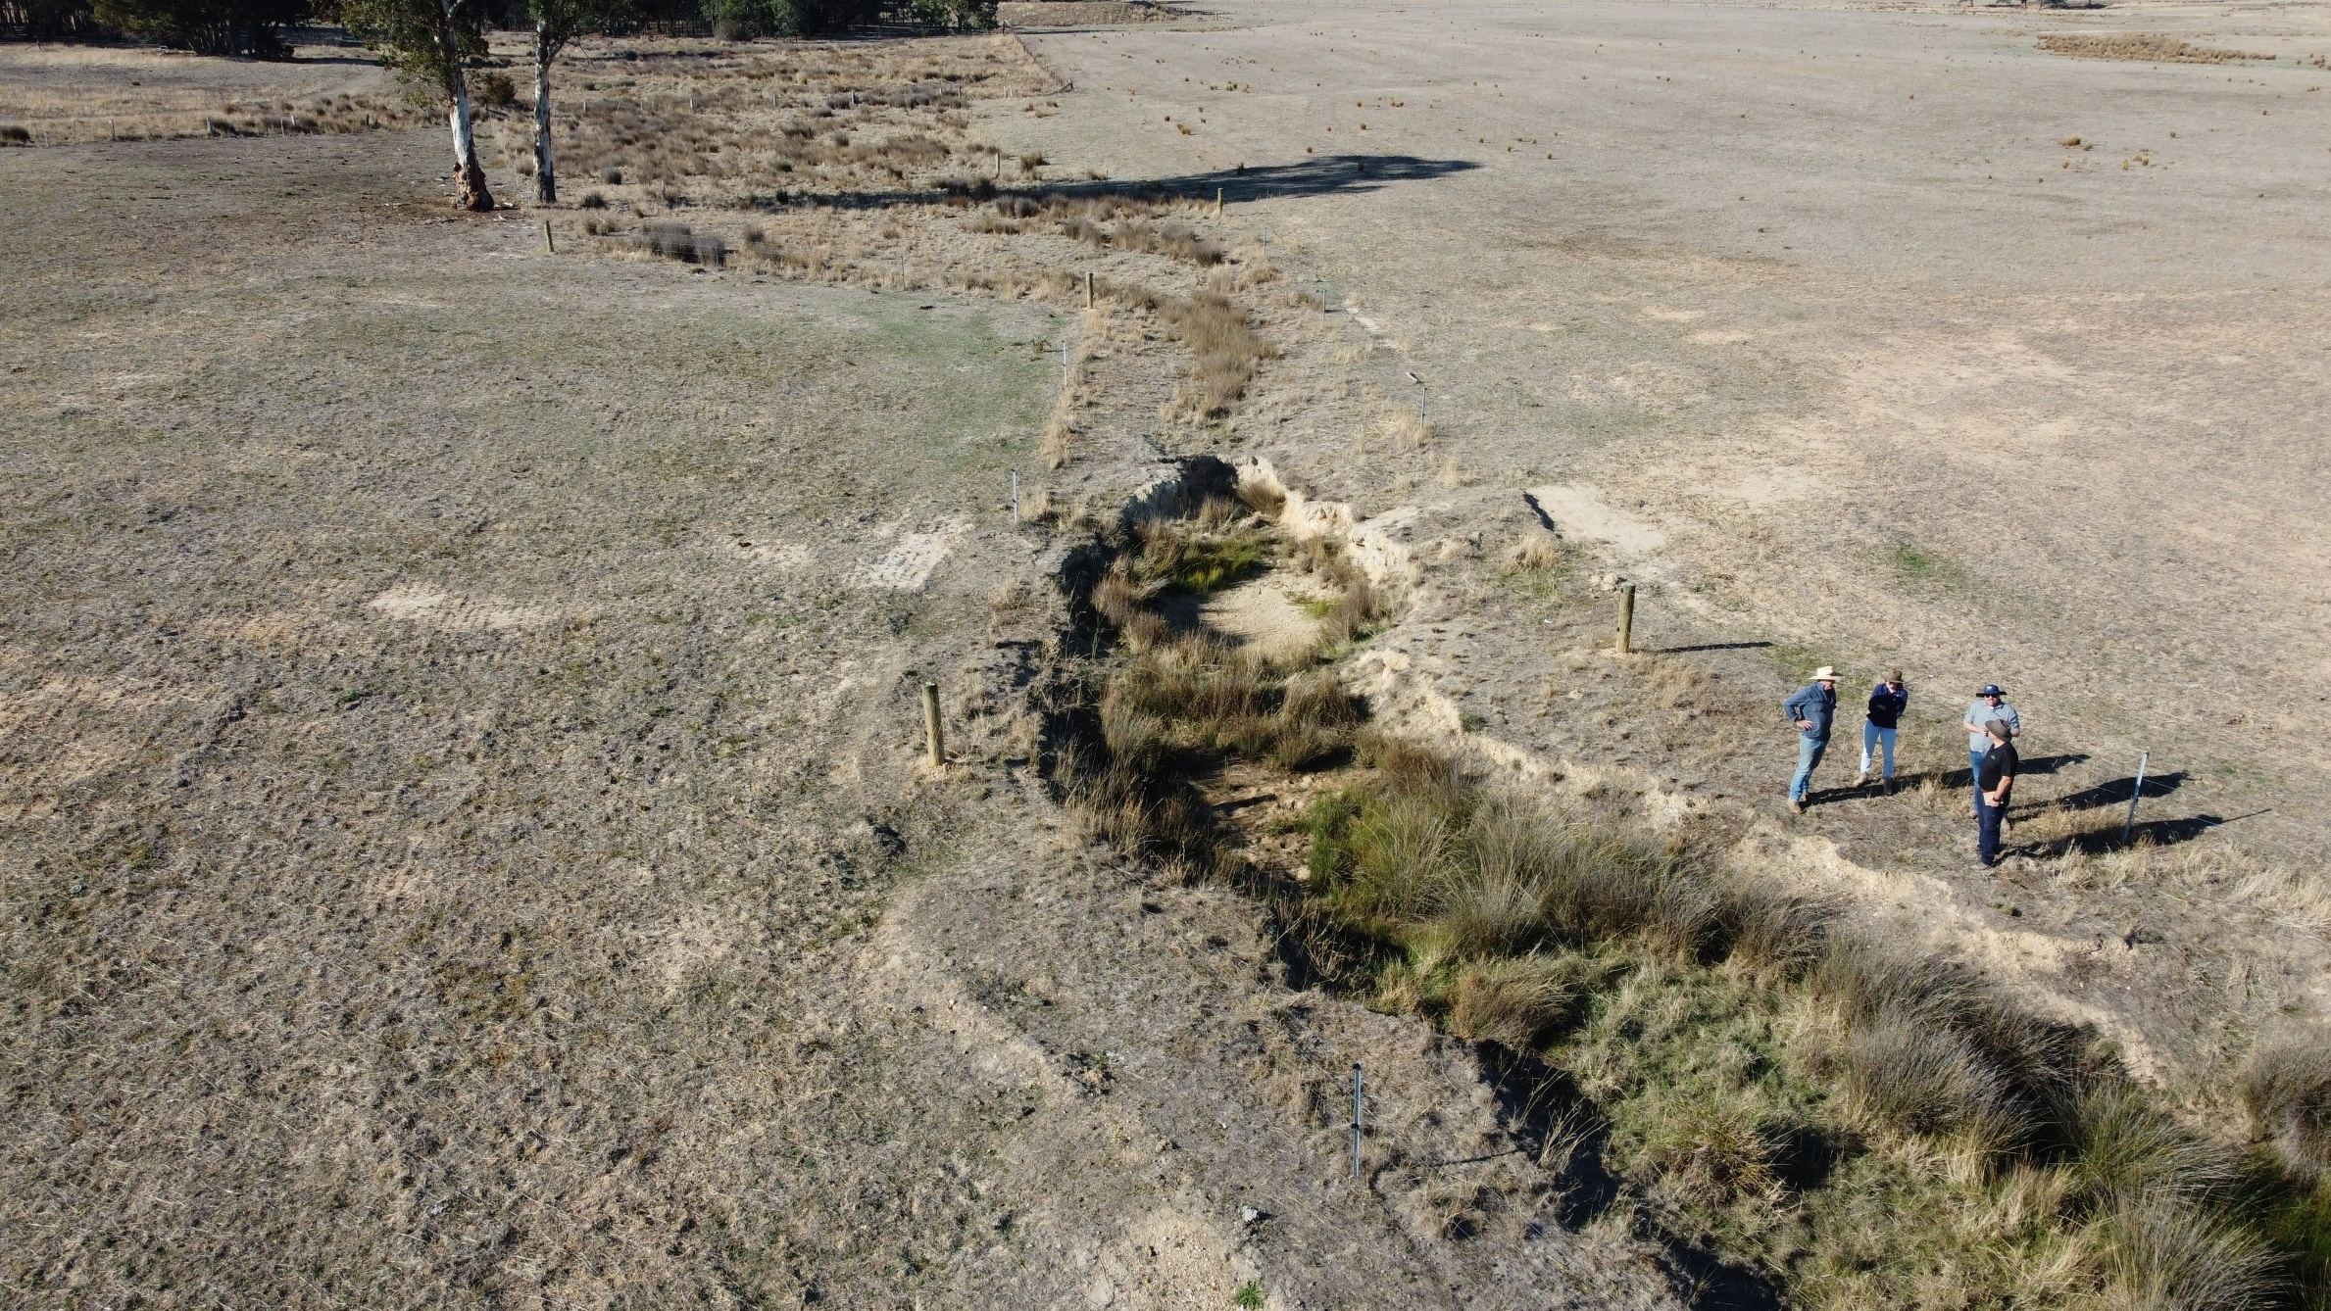
A landowner discussing waterway health works with Wimmera CMA staff.

Funding and cost-sharing
Decisions about what activities to invest in and roles and responsibilities will be made in line with the cost-sharing principles in the draft Victorian Waterway Management Strategy (in development).

Victorian Government Funding
The draft Victorian Waterway Management Strategy (in development) describes the government investment and cost-sharing arrangements for waterway management, summarised below.
The Victorian Government provides funding for waterway management from the environmental contributions. This is a legally required contribution from water corporations to fund initiatives that promote the sustainable management of water or address adverse environmental impacts of water consumption and extraction.
Environmental contributions funding is provided to the Department of Energy, Environment and Climate Action (DEECA), Catchment Management Authorities (CMAs) and Traditional Owners for waterway management activities. It is also provided to the Victorian Environmental Water Holder to enable it to undertake its required functions for managing water for the environment. DEECA supports CMAs to run programs using environmental contribution funds for priority projects. This may involve cost-sharing with other organisations, community groups and individuals in line with the cost-sharing principles in this Plan.
In addition to the state funds provided directly for waterway management, there are other funds provided by the Victorian Government that can benefit the environmental condition of waterways. For example, funds are provided:
- To public land managers, such as Parks Victoria and DEECA to manage the land assigned to them in accordance with statutory requirements, which may include waterway management activities.
- To regional organisations such as rural water corporations to undertake activities outside their statutory functions (and not covered by customers).
- Through the ‘Our Catchments, Our Communities Program,’ supporting integrated catchment management programs.
- For natural disaster relief assistance.

Australian Government funding
The Australian Government provides funds for waterway management through national programs, such as the Natural Heritage Trust Program, which includes the Urban Rivers and Catchments Program and the Restoring our Rivers Program in the Murray Darling Basin.
Australian Government funding generally applies to matters of national significance, such as threatened species and communities and Ramsar sites listed under the Commonwealth Environment Protection and Biodiversity Conservation Act 1999.

Regional funding
Regional and local contributions for implementing activities that contribute to waterway outcomes include:
- Funding and in-kind contributions from landholders, community groups and individuals.
- Local government management of land under its responsibility, such as public open space beside waterways in townships.
- Funding from philanthropists towards regional or local plans and initiatives.

Cost-sharing principles
Victoria’s waterway management approach continues to ensure that resources are directed to the areas of highest priority. Priority waterways for investing in management actions are identified in the Wimmera Waterway Strategy, informed by state priorities, regional planning processes, and where applicable, place-based plans such as local government and Parks Victoria’s plans.
Progressing strategic outcomes is a significant task requiring considerable resources and long-term commitment. Cost-sharing with organisations, groups and individuals that benefit from a management activity is an effective way to achieve outcomes with limited resources.
This Implementation Plan seeks to implement the Victorian Government’s cost-sharing principles for all waterway management projects. These principles are:
- Duty of care – All natural resource users and managers have a duty of care to ensure that they do not damage the natural resource base, as outlined in the Catchment and Land Protection Act 1994 and Victorian Environment Protection Framework. They are responsible for making good any damage incurred because of their actions.
- Government contributions to private beneficiaries – The government contributes primarily to activities that produce public benefits. The government may agree to contribute to land and water management activities that provide significant public benefit and where government support is required to facilitate this uptake.
- Net public benefit – Net public benefits to the Victorian environment, economy and community values must be demonstrated.
- Beneficiary pays – Users, both existing and future, are expected to pay for activities that provide private benefits. Contributions from indirect beneficiaries will, where appropriate, be negotiated with the primary beneficiaries. Managing risks from waterway processes to public and private infrastructure is primarily the responsibility of the infrastructure owner.
- Private cost-share contributions – Management activities will be prioritised based on the greatest public benefit for the least public cost. Where the public cost of a management activity is reduced by financial or in-kind contributions by private or corporate stakeholders, this will influence the support for this activity.
- Upfront and maintenance costs – Waterway managers may collaborate with private landholders and with other government agencies, to upgrade a built asset to a declared standard. After that, the beneficiary will generally be responsible for its maintenance. Government or waterway managers may also collaborate with private landholders and with other government agencies, to build new assets, on the proviso that the maintenance of the built asset will be the responsibility of the beneficiary.
- Extreme events – Funding for the repair and recovery of essential public assets following natural disasters will be in accordance with State and national disaster recovery funding arrangements.
- Statewide policy and monitoring – The government will contribute to the cost of statewide planning, resource monitoring and assessment, research and investigations where they are crucial to evaluating the success of statewide and regional waterway management approaches.
Government may invest where public good benefits outweigh costs and all duty of care and beneficiary pays avenues have been exhausted.
Examples of beneficiaries of waterway management activities include recreation groups, private landholders, water corporations, local government representing regional economic benefits, the broader Victorian community, and owners and managers of public infrastructure.

Traditional Owner knowledge and priorities
Traditional Owner priorities in Water is Life – Traditional Owner Access to Water Roadmap include actions for increasing the resourcing for and role of Traditional Owners in the care and management of waterways and catchments. Regional waterway strategies play a significant role in progressing these actions.
Wimmera CMA and Traditional Owner groups, Barengi Gadjin Land Council and Eastern Maar Aboriginal Corporation, collaborated to develop the Wimmera Waterway Strategy in ways self-determined by each group. We aim to continue these partnerships during delivery of the Strategy.
The Wimmera Waterway Strategy and this Implementation Plan acknowledge and respect Traditional Owners’ obligations and rights to care for water and Country. Together, the two documents seek to increase the role of traditional ecological knowledge, where Traditional Owner consent is provided, to inform waterway management activities on Country.

Desired outcomes
The draft Wimmera Waterway Strategy describes the region’s desired 20-year long-term and 10-year medium-term outcomes for waterways. These outcomes align with the Wimmera Regional Catchment Strategy, with the Wimmera Waterway Strategy together with this Implementation Plan providing a 10-year plan for achieving the catchment strategy’s waterway-related outcomes.
Long-term outcomes are aspirational and expected to take 20 years or more to achieve, with some likely requiring additional time. Medium‑term outcomes are designed to be “SMART” and act as steppingstones toward the region’s long‑term outcomes and vision:
- Specific about what stakeholders and the community aim to achieve for waterways.
- Measurable, with indicators to track progress and determine when it has been achieved.
- Achievable, given available resources, community capacity and climate change.
- Relevant, contributing to the regional vision and based on best available information about waterway condition, threats, priorities, feasibility and stakeholder aspirations.
- Time‑bound, to be achieved over 10‑ and 20‑year timeframes.

Long-term outcomes (>20 years)
- Knowledge and experience of First Nations People is informing waterway planning, management and delivery in the Wimmera, advancing self-determination.
- Values and condition of waterways with formally recognised significance are maintained or improved.
- Waterway condition, connectivity and resilience is improved, providing habitat that supports native species and communities.
- Water is of sufficient quality to support waterway values and uses at important areas for water supply, cultural, environmental and social values.
- Waterways with high environmental, social, cultural and economic values are maintained.
- Wimmera people are active stewards taking action to care for waterways.

Medium-term outcomes (<10 years)
- Ongoing collaboration and two-way learning in waterway planning and management, supporting self-determination and strengthening partnerships with First Nations People.
- More waterways have improved management to enhance habitat, landscape connectivity, and resilience.
- Wetland modification, loss and deterioration of condition occurs at a declining rate.
- Drought refuges support species’ survival and resilience during dry periods.
- Risks to water quality in Wimmera waterways are managed where possible to reduce impacts on values.
- More waterways provide improved recreational opportunities and amenity while minimising impacts on environmental values.
- Healthier waterways enable more On Country activities for First Nations People.
- Key water-dependent species are supported in waterways that provide suitable habitat, including during dry conditions.
- Net rates of streamflow interception from water extraction and storages are stabilising in the Wimmera River catchment.
- Stewardship increases, with more people taking action to care for waterways.

Local areas

Introduction
The region’s five local areas focus on distinct parts of the region and are based around local government and catchment boundaries.
The local areas recognise the importance of community-driven outcomes, participation and management. They seek to:
- Highlight the knowledge and priorities of local communities in a way that is meaningful and relevant in each area.
- Recognise that the characteristics of waterways and the land, biodiversity and community that waterways are a part of vary across the region.
- Identify opportunities for organisations and communities to partner and collaborate to achieve local outcomes.
The Wimmera region overlaps with large and small portions of eight local government areas. This strategy groups local government areas where part of their area is in the Wimmera and they have similar integrated catchment management characteristics. Local areas include (see Figure 2)
- Hindmarsh
- Horsham
- West Wimmera
- Yarriambiack and Buloke
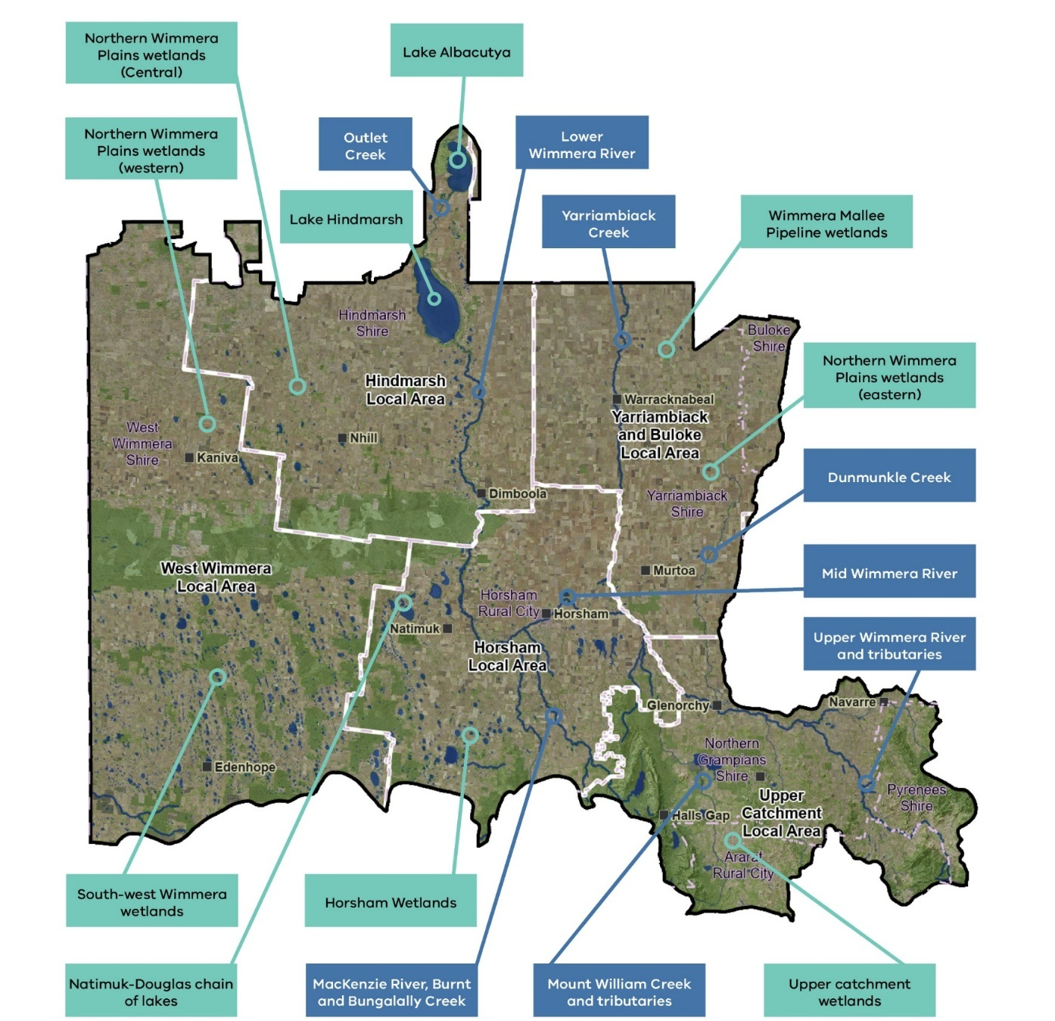
- Upper Catchment (including parts of Ararat, Northern Grampians and Pyrenees local government areas).
Figure 2. Local areas in the Wimmera

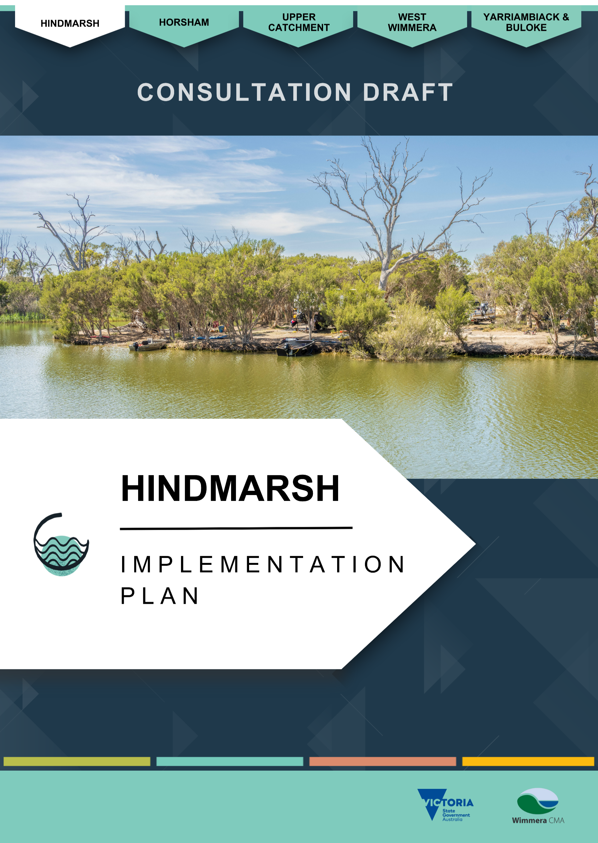

Hindmarsh Implementation plan

About the Hindmarsh Region
The Hindmarsh Local Area covers the southern part of Hindmarsh Shire, extending from the Little Desert National Park in the south to Wyperfeld National Park in the north. The main towns of Nhill, Dimboola, Jeparit and Rainbow have a combined population of about 5,700 people. ⁽²⁾ Dimboola and Jeparit are beside the Wimmera River, while Nhill lies beside Nhill Swamp and Lake, highlighting the importance of waterways for local liveability (see Figure 3).
The area spans almost 485,000 hectares and is predominately agricultural, with 68% dryland broadacre cropping, 11% modified-pasture grazing and over 15% native vegetation and waterways. ⁽³⁾ Key natural features include the Little Desert National Park, the Wimmera Heritage River and a terminal lakes system including Lake Hindmarsh, Outlet Creek, Lake Albacutya, Ross Lake and other wetlands, extending north to the Wirrengren Plain in the Mallee.
Together, these waterways form a natural corridor between the Little Desert and Wyperfeld National Parks through productive cropping farmland.
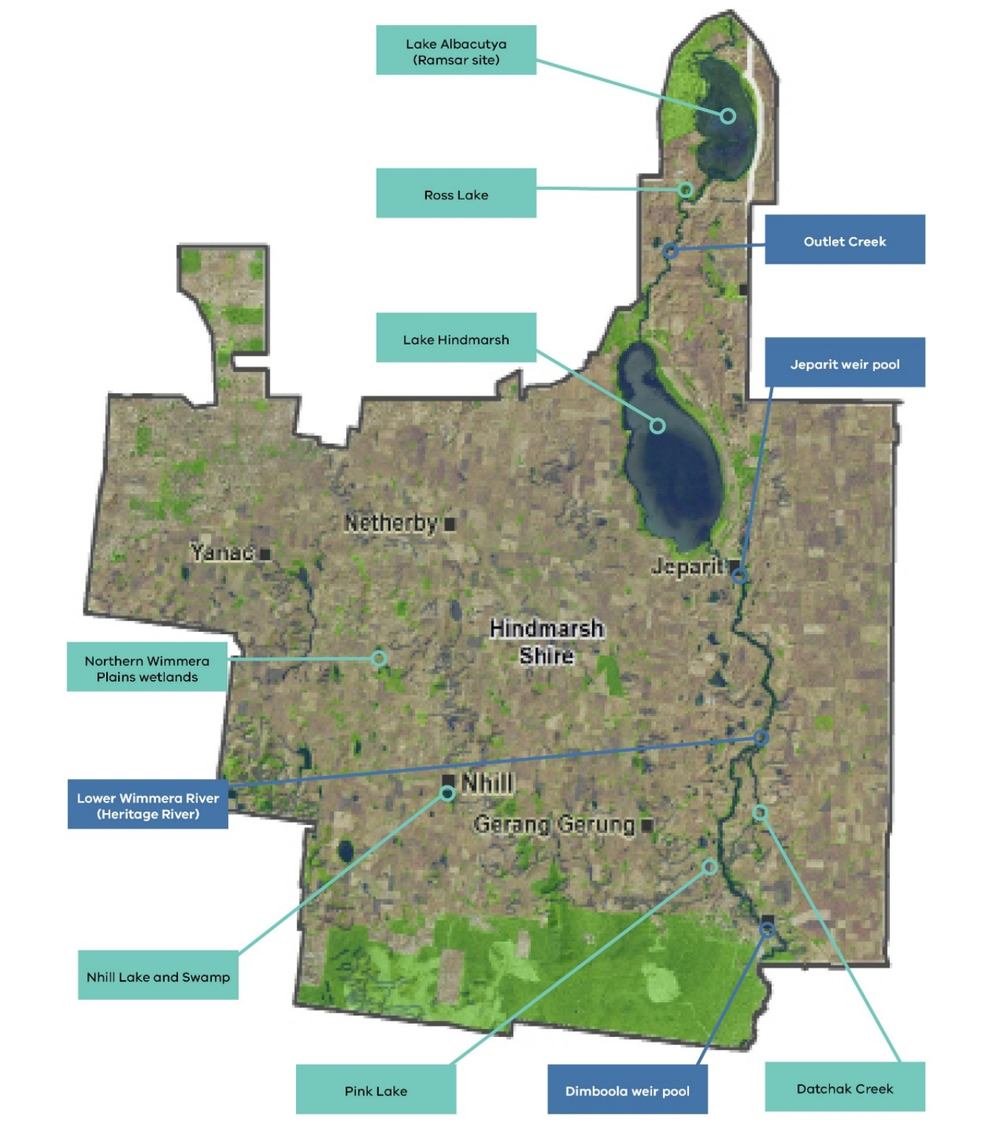
The area also contains many culturally significant sites along the Wimmera River and its wetlands, including Lake Hindmarsh, Lake Albacutya and Ross Lake. This stretch of the river sits within the Wotjobaluk Nations Native Title area, reflecting its deep and continuing cultural importance.
.

Figure 3. The Hindmarsh local area and key waterway assets

Rivers and streams
The Wimmera River runs the length of the Hindmarsh Local Area, flowing into Lake Hindmarsh. While it generally holds water, it only fills Lake Hindmarsh - Victoria’s largest freshwater lake - during extended wet periods or major floods. In very wet years, Lake Hindmarsh spills into Outlet Creek, which flows to Lake Albacutya and then north to smaller wetlands and the Wirrengren Plain in the Mallee.
Lake Albacutya last filled in the 1970s and held water until 1983, with occasional minor inflows from local runoff since then. ⁽⁴⁾
Lake Hindmarsh holds water following Wimmera River flows, but it only fills completely when there are either prolonged high flows or widespread flooding across the Wimmera River system. Between 2016 and 2026, these conditions did occur at times, allowing water to enter the lake and attracting thousands of waterbirds of many species, along with recreational visitors. The vast and shallow lake, subject to considerable evaporation during no-flow periods, fell short of filling and dried out periodically.
When holding water, Lakes Hindmarsh and Albacutya support thousands of waterbirds. Lake Albacutya provides habitat for nationally threatened species such as the regent parrot (Polytelis anthopeplus) and a unique salt-tolerant form of river red gum. Lake Albacutya is internationally recognised as a Ramsar wetland, and both lakes are nationally important wetlands. When they hold water, they become major recreation hubs for water skiing, fishing, yabbying, birdwatching and camping. Outlet Creek, connecting the lakes, supports significant biodiversity and cultural heritage values.
Datchak Creek is a 28-kilometre anabranch of the lower Wimmera River. It leaves the river downstream of Dimboola, flows through Arkona and rejoins the river near Antwerp. The creek is an important place for Wotjobaluk Nations People and contains extensive cultural heritage, including scarred and culturally modified trees.

Wetlands
Hindmarsh contains 281 wetlands, ranging from large systems like Lake Hindmarsh to small seasonal wetlands. Notable examples include Ramsar-listed Lake Albacutya, nationally important wetlands including Lake Hindmarsh and Pink Lake; and key local wetlands including Ross Lake, Nhill Lake, Nhill Swamp, Mount Elgin Swamp, and Yanac Swamp.

Lower Wimmera River and Terminal Lakes

River and stream values
The Wimmera River downstream of Polkemmet, along with Lake Hindmarsh, Lake Albacutya and Outlet Creek, is listed as the Wimmera Heritage River under the Heritage Rivers Act 1992. This 165-kilometre system is recognised for its conservation, scenic, recreational and cultural significance. ⁽⁵⁾

Environmental values
The Wimmera Heritage River forms an important native vegetation corridor through agricultural country. Riparian vegetation is highly intact, with 92% of the Wimmera River and Outlet Creek protected from stock access. ⁽⁶⁾ Key vegetation communities include depleted Riverine Chenopod Woodlands; vulnerable Intermittent Swampy Woodlands, Lignum Swampy Woodlands and Semi-arid Woodlands; and scattered endangered Low Rise Woodlands. ⁽⁷⁾
Local waterways support significant species such as the critically endangered pink cockatoo (Lophochroa leadbeateri) and Australasian bittern (Botaurus poiciloptilus). ⁽⁸⁾ Native Fish include Australian smelt (Retropinna semoni), common galaxias (Galaxias maculatus), carp gudgeon (Hypseleotris spp.) and flatheaded gudgeon (Philypnodon grandiceps); native species thought to be introduced to the Wimmera - endangered freshwater catfish (Tandanus tandanus), golden perch (Macquaria ambigua)and silver perch (Bidyanus bidyanus); and exotic species including carp (Cyprinus carpio), eastern gambusia (Gambusia holbrooki), goldfish, redfin (Perca fluviatilis) and roach (Rutilus rutilus).

Social and recreational values.
The river’s connectivity to the Little Desert National Park and regional reserves enhances local tourism, particularly during the spring wildflower season.
Jeparit and Dimboola townships are connected via the Wimmera River Discovery Trail which officially opened in late 2025. ⁽⁹⁾ It spans 56 kilometers and attracts visitors for walking, cycling and camping. ⁽¹⁰⁾
Weir pools at Dimboola and Jeparit are central to community recreation and tourism, offering walking tracks, picnic areas, campgrounds and water sports. Water‑skiing occurs when levels permit at the Dimboola weir pool and downstream of Jeparit near Lake Hindmarsh.
Fishing is a major activity, supported by Fisheries Victoria stocking golden and silver perch. Freshwater catfish are also highly valued and self-sustaining in the Wimmera. Fishing competitions attract visitors from across western Victoria and interstate.
Dimboola hosts the annual rowing regatta and major barefoot skiing events, including Australia’s largest night‑jump competition, known to attract more than 2,000 visitors. Local clubs have invested heavily in riverfront improvements.
Jeparit’s Easter fishing competition is its major community event, attracting hundreds of competitors and spectators.

Economic values
In 2022–23, an estimated 21,500 river users in Dimboola and 6,400 in Jeparit generated about $737,000 in economic activity. ⁽¹¹⁾
The 2022 Dimboola barefoot skiing event contributed $67,000, and the Jeparit Easter fishing competition generated $48,000 from day and overnight visitors. ⁽¹¹⁾

Cultural values
The Barringgi Gadyin/Wimmera River is central to the Wotjobaluk Nations Peoples as a source of water, food and cultural identity, with hundreds of significant sites along its banks. Traditional foods include mussels, fish and water ribbons, and seasonal movement for ceremony and resource gathering reflected deep ecological knowledge.
Important cultural places include Ranch Billabong, The Common, and a property at Antwerp, which continue to provide cultural, recreational and gathering spaces for Traditional Owners. ⁽¹²⁾
Barengi Gadjin Land Council holds the Ranch Billabong beside the Barringgi Gadyin (Wimmera River) near Dimboola as freehold and manages it on behalf of the Wotjobaluk Nations Peoples. Families once lived here - children were born and raised on site, and people fished in the billabong. It is registered with Aboriginal Victoria as an Aboriginal Place and is a rare surviving example of a former ‘fringe camp.’
The Common, also located along the Barringgi Gadyin at Dimboola, is another important cultural place that holds strong memories for the local Aboriginal community. Many families lived here after the closure of Ebenezer Mission. The area contains scarred trees and other cultural heritage.
The Antwerp property has long provided cultural and recreational opportunities for Traditional Owners, who have camped, swum and fished along Datchak Creek and the Barringgi Gadyin for thousands of years. After the mission closed, many families moved to Antwerp, with Elders living there until recent times. Traditional Owners still visit and hope to see it restored as a gathering place.
Gurru (Lake Hindmarsh) and Ngalpakatia/Ngelpagutya (Lake Albacutya) hold profound cultural meaning. Gurru was part of a large traditional trading route. Ngalpakatia/Ngelpagutya is associated with shell middens, oven mounds, scarred trees and artefacts.
The significance of the Barringgi Gadyin/Wimmera River system to the Wotjobaluk Nations Peoples is substantial. There are many creation stories passed down from ancestors.
In 2005, the Federal Court recognised non-exclusive Native Title rights for the Wotjobaluk, Jaadwa, Jadawadjali, Wergaia and Japagulk Peoples along much of the lower Wimmera River, including rights to hunt, fish, gather and camp for personal and cultural purposes under traditional rights and customs.
Abundant scar trees, shell middens, burial sites and artefact scatters along these waterways, especially the Barringgi Gadyin, bear testimony to the profound connection between the Wotjobaluk Nations Peoples and the Wimmera River system. While some cultural sites have been catalogued on the Victorian Aboriginal Heritage Register, many more exist along the length of the waterway.

River and stream condition
River condition in the Hindmarsh area is strongly influenced by rainfall, runoff and streamflow. The Wimmera River between Antwerp and Lake Hindmarsh was rated poor in the 2010 Index of Stream Condition, while the reach south of Antwerp was rated moderate. These assessments were completed at the end of the Millennium Drought and have not been repeated, but conditions have improved significantly up to at least 2026.
Outlet Creek has not flowed since Index of Stream Condition monitoring began in 1999, yet it remains protected as part of the Wimmera Heritage River. Its riparian zone is still in good condition, achieving moderate Streamside Zone scores. ⁽¹³⁾
Water quality often falls short of water quality targets in Victoria’s Environment Reference Standards, but it has generally been adequate since the end of the Millenium Drought to support native fish, recreation, visitor enjoyment and community events, including fishing competitions and rowing regattas.
The condition of culturally significant trees varies from good to poor due to water quality and availability. Further work is needed to better understand and protect these important cultural values.

Threats and drivers of change

Hydrology – Climate Change and dry conditions
Climate change is having a major impact on natural assets in the Hindmarsh Local Area. More hot days coupled with reduced rain in the Wimmera River’s headwaters have led to reduced flows to the lower Wimmera River. Additional flow reductions come from harvesting of water upstream for towns, farms and stock and domestic dams. These lower flows reduce habitat and connectivity and lead to declining water quality, with salinity increasing when saline groundwater enters the river and there is not enough freshwater to dilute or flush it into the terminal lakes.

Saline groundwater intrusion
Saline groundwater entering the lower Wimmera River is a major threat to water quality and the health of fish, aquatic communities and riparian vegetation. This risk increases when river flows are low. During the Millennium Drought, streamflow declined severely and salinity in some pools approached concentrations higher than seawater, contributing to very poor river health.
Since the end of the Millennium Drought and the major floods of 2010 and 2011, targeted environmental flow management has helped improve water quality by flushing the system with freshwater, connecting pools, maintaining drought refuges, and supporting instream vegetation. River health has generally improved over time, except during drought periods (2014–15, 2018 and 2020–2021), when dry conditions again reduced flows and water quality.

Weeds and pest animals
Weeds like boneseed (Chrysanthemoides monilifera subsp. Monilifera), African boxthorn (Lycium ferocissimum), bridal creeper (Asparagus asparagoides), horehound (Marrubium vulgare), prickly pear (Opuntia spp.), wheel cactus (Opuntia robusta) and olives (Olea eurpaea) can impact on the integrity of riparian and wetland vegetation and require ongoing monitoring and management to prevent their spread. Floods and wildlife can further spread weeds along the river system.
Rabbits are an ongoing issue threatening the condition of riparian vegetation along the Wimmera Heritage River.
Annual fish monitoring shows native fish populations are improving, although carp and other introduced species remain a major threat. These species compete for habitat and food, disturb sediment, and increase turbidity and nutrient levels through their feeding behaviour. Carp can breed rapidly when conditions are suitable.
Monitoring results up to 2025 indicate that carp impacts are not increasing, despite their continued presence. ⁽¹⁴⁾

Grazing by livestock
Livestock grazing poses a low threat along the lower Wimmera River, where 92% of the river frontage is protected from livestock access. ⁽¹⁵⁾ Much of the surrounding land is also used for broadacre cropping, and many farmers no longer run livestock, further reducing grazing pressure.

Impacts of recreation
Impacts from motorised boats and water-skiing on the Wimmera River, such as bank erosion from boat wake, sometimes contribute to riverbank tree instability and a risk of trees falling into the river, creating instream safety hazards.
Wimmera CMA has worked with Hindmarsh Shire Council, Barengi Gadjin Land Council and local groups to reduce erosion impacts and protect cultural heritage along the riverbank.
Illegal activities—such as creating informal vehicle tracks, dumping rubbish and collecting firewood—continue to cause erosion and damage along the river corridor.

Northern Wimmera Plains Wetlands
The Hindmarsh area’s 281 wetlands include the Wimmera River’s terminal lakes system - Lake Hindmarsh, Lake Albacutya, Ross Lake and others – and scattered wetlands in the landscape. Other notable wetlands include Pink Lake, Nhill Lake, Nhill Swamp, Mount Elgin Swamp and Yanac Swamp.

Wetland Values

Environmental values
The environmental values for which Lake Hindmarsh gained recognition as a nationally significant wetland are that it:
- Is a good example of a wetland type occurring within this biogeographic region in Australia.
- Plays an important ecological or hydrological role in the natural functioning of a major wetland complex.
- Is important as the habitat for animal taxa at a vulnerable stage in their life cycles, or provides a refuge when adverse conditions such as drought prevail; and
- Is of outstanding historical or cultural significance.
Lake Hindmarsh and Lake Albacutya are nationally important wetlands because they are outstanding examples of wetland ecosystems in the Wimmera and play a crucial role in the broader terminal lakes system. Both lakes:
- Represent important wetland types within their biogeographic region.
- Play key ecological and hydrological roles in the functioning of the Wimmera River terminal wetland complex.
- Provide critical habitat and drought refuge for wildlife, supporting species during vulnerable life stages.
- Hold outstanding historical and cultural significance.
Beyond meeting the national criteria above, Lake Albacutya is recognised as internationally significant and is Ramsar‑listed because it:
- Regularly supports large populations of waterbirds, including more than 20,000 individuals during wet phases.
- Supports 1% or more of the national population of native waterbirds, meeting key international conservation thresholds.
- Provides habitat for vulnerable, endangered or critically endangered species and contributes to the biodiversity of the region.
- Contains rare or representative wetland types in near‑natural condition.
- Supports migratory bird species protected under international agreements. ⁽⁴⁾
Bird surveys at Lake Hindmarsh between 2023 and 2025 following partial filling demonstrate the lake’s importance as habitat for threatened and migratory bird species, with more than 40 waterbird species recorded and large numbers of birds recorded. Notable observations included Australasian bittern, great egret, Australasian shoveler, musk duck and gull‑billed tern - all listed as Threatened under Victoria’s Flora and Fauna Guarantee Act 1988.
Two migratory shorebird species, the red‑necked stint and sharp‑tailed sandpiper, were also recorded; both are protected under international migratory bird agreements with Japan, China and Republic of Korea. ⁽¹⁶⁾
Across the Hindmarsh Local Area, endangered and vulnerable vegetation communities - such as Plains Grassland, Low Rises Woodland, Red Gum Swamp, Lignum Swampy Woodland, and Salt Paperbark Woodland/Samphire Shrubland Mosaic - commonly occur around smaller wetlands and along the Wimmera River. ⁽⁷⁾

Social and recreational values
The Hindmarsh Local Area is known for its open landscapes and strong connection between waterways and community life. Lakes Hindmarsh and Albacutya hold major social value, especially when they fill after floods. They attract water‑skiers, anglers, campers and visitors seeking wildlife experiences. Even during dry periods, they remain popular tourist destinations. ⁽⁴⁾ For example, Lake Hindmarsh attracted an estimated 6,700 participants in 2022–23. ⁽¹¹⁾
Nhill Lake is a key local recreation space, particularly for fishing, skiing, swimming, community events and birdwatching. Neighbouring Nhill Swamp’s boardwalk provides a natural attraction for locals and visitors.
Pink Lake near Dimboola is a major tourism drawcard for Western Highway travellers, known for its striking pink hue produced by pigment‑secreting algae.
Rainbow Lake, a newer community waterbody supplied with piped recreational water, attracted around 855 visitors in 2022–23. ⁽¹¹⁾

Economic values
A study into the social and economic value of water in the Wimmera and southern Mallee estimated that Lake Hindmarsh contributed $80,100, Rainbow Lake $9,400, and Nhill Lake $6,500, to their respective communities during 2022-23. This is the contribution of locals and visitors to the town economies. ⁽¹¹⁾

Cultural values
Most of the Wimmera’s wetlands have significant cultural value, providing resources, places of gathering and ongoing spiritual significance for First Nations People.
Gurru (Lake Hindmarsh) and Ngalpakatia/Ngelpagutya (Lake Albacutya) hold deep cultural significance for the Wotjobaluk Nations Peoples. Gurru formed part of a major traditional trading route, while the shores of Ngalpakatia/Ngelpagutya contain abundant cultural sites - including shell middens, oven mounds, scarred trees, artefacts and stories - reflecting a long and continuous connection to Country.
A 2017 study at Ross Lake near Ngalpakatia/Ngelpagutya confirmed this enduring connection, identifying previously recorded middens and scar trees as well as discovering dozens of new scarred trees, a rare carved tree, clay balls and additional middens. The study concluded that Ross Lake was a significant meeting place, with cultural sites showing evidence of long-standing use.

Wetland condition
Index of Wetland Condition assessments were carried out at a few Hindmarsh wetlands in 2009–10. These included Lakes Hindmarsh and Albacutya, and several smaller terminal lakes beyond Albacutya. Their condition ratings were lowered due to upstream regulating structures that affected hydrology scores.
All lakes except Lake Hindmarsh were dry at the time, but there was no evidence of rising salinity or nutrient levels, resulting in good water properties sub‑index scores. In contrast, Lake Hindmarsh recorded comparatively poor water quality, which reduced its overall condition rating. ⁽¹⁷⁾

Threats and drivers of change

Hydrology - Climate change and dry conditions
The Hindmarsh Local Area’s wetlands are increasingly threatened by climate change, with reduced filling events affecting vegetation, wildlife and waterbirds that depend on periodic inundation. The very wet years and major floods needed to supply the terminal lakes are expected to occur less often under drier climate scenarios, placing further pressure on the lower Wimmera lakes.

Weeds and pest animals
Invasive weeds—such as boneseed, African boxthorn, bridal creeper, horehound, prickly pear, wheel cactus and wild olives—threaten the health of riparian vegetation along rivers and streams. These same species also spread into nearby wetlands, where they further degrade habitat, outcompete native plants and reduce ecological integrity.
Rabbits continue to threaten native vegetation around lakes and wetlands, especially in the sandy dune areas common on the north‑eastern edges of wetlands such as Lakes Hindmarsh and Albacutya.

Bed and bank modifications

Across the Hindmarsh Local Area, most of the 281 recorded wetlands are modified. A 2017 Wimmera CMA study found that half were wholly or partly cropped, 67 contained a dam, and 71 had a drain or levee. Only 95 wetlands remained unmodified, and most of these typically only fill during very wet years.

Impacts of recreation
Access to rivers, streams and wetlands can lead to impacts such as erosion, vegetation loss, rubbish dumping, and firewood removal.

Previous waterway strategy achievements
The Wimmera Waterway Strategy 2014–2022 focused on reducing threats to Hindmarsh’s high‑value areas. For the lower Wimmera River and Outlet Creek, this included protecting and improving riparian vegetation by supporting farmers to manage stock grazing and by controlling rabbits and invasive weeds such as boneseed and bridal creeper.
Environmental flows helped improve water quality, support native fish populations, maintain instream vegetation and enhance natural flows, contributing to environmental, recreational, social, economic and cultural benefits. During wetter years, inflows to Lake Hindmarsh created valuable habitat for a wide range of waterbirds. Wimmera CMA monitored fish, bird and vegetation communities to assess the outcomes of these actions and guide future management.
At Lake Albacutya, Parks Victoria and Barengi Gadjin Land Council undertook extensive rabbit‑control works, significantly reducing impacts on native vegetation, including nationally endangered Pine-Buloke woodlands.
Wimmera CMA commissioned studies into salinity management in the lower Wimmera River and the movement and behaviour of carp.
Barengi Gadjin Land Council, supported by Wimmera CMA, restored the culturally significant Ranch Billabong at Dimboola, including installing a pipeline to reconnect the billabong to the river for controlled watering.
Additional works included installing floating vegetated pontoons to reduce riverbank erosion upstream of Dimboola.
To strengthen drought resilience, Wimmera CMA and partner organisations began work to connect lower Wimmera River drought refuge pools to the Wimmera Mallee Pipeline. This will allow environmental water to be delivered directly to drought‑refuge pools to maintain water quality and prevent fish deaths during very dry periods when natural flows and environmental water allocations are insufficient to reach this section of the river. Pipeline construction, led by GWMWater, is planned for 2026–27.

Stakeholder and community feedback
During development of the Strategy and Implementation Plan, Wimmera CMA invited input from stakeholders and the community. Participants from the Hindmarsh Local Area identified the following waterways as particularly important:

- Wimmera River
- Wimmera River Discovery Trail
- Jeparit and Dimboola weir pools
- Lake Hindmarsh
- Lake Albacutya
- Terminal lakes system
- Rainbow Lake
- Nhill Lake and Swamp
- Ranch Billabong
- Antwerp Property
- Datchak Creek
- Wetlands across the region.

Key points included:
- Support for recreation and community events: Some stakeholders said they would like to see better water quality, more reliable water availability, and vegetation managed in a way that maintains safe access to waterways. They noted that these factors are essential for successful local events and recreational use.
- Protecting environmental and cultural values: Some participants emphasised the need to maintain environmental health and important species, including those of cultural significance. Some supported exploring reintroductions of culturally important species.
- Clear management plans: Local government stakeholders expressed support for dedicated management plans for the Dimboola and Jeparit weir pools and their surrounding riparian areas. Jeparit weir is aging and needs refurbishing and to maintain the social and economic values provided by the weir to the Jeparit community.
- Addressing invasive species: Stakeholders raised concerns about woody weeds, particularly boneseed, carp, deer and feral cats, noting that they continue to cause significant environmental impacts across the system.
- Ramsar extension support: There was support for extending the Ramsar listing of Lake Albacutya to include Lake Hindmarsh, recognising its ability to hold water more frequently, high numbers and diversity of waterbirds, and high environmental, social, economic and cultural values.

Priority locations for management
The Strategy identified Hindmarsh’s priority waterways for management:

- Lower Wimmera River
- Jeparit and Dimboola weir pools
- Lake Hindmarsh
- Lake Albacutya
- Outlet Creek
- Datchak Creek
- Wetlands with high environmental value
- Crow Swamp - pipeline watered wetland
- Pink Lake
- Nhill Lake and Swamp.
Together, these areas hold the highest ecological, cultural and recreational value and have the greatest management needs. Details of the prioritisation process are described in a supporting document to the Strategy.

Management Activities – Hindmarsh Local Area
The following tables include management actions for the Lower Wimmera River (Heritage River) and Northern Wimmera Plains Wetlands. These actions are intended to be implemented over 10-years from 2026 to achieve the region’s desired outcomes in the Hindmarsh Local Area.
Tables 2 to 9 contain similar management actions according to the following groups:
Rivers and Streams
- Table 2: Enhancing riparian habitat and landscape connectivity.
    - Table 3: Supporting water-dependent species
    - Table 4: Managing instream habitat, water quality and .
    - Table 5: Improving recreational opportunities.

    - Wetlands
    - Table 6: Protecting and managing wetlands on private land.
    - Table 7: Managing pest species.
    - Table 8: Managing pipeline wetlands.
    - Table 9: Protecting significant wetlands.
Some actions contribute to multiple outcomes.
Management actions are shaded green for high priority and orange for medium priority. Actions with no shading are low priority.
Unless otherwise stated, activities are funded under the Environmental Contribution Levy until 2028. Funding is assumed to be maintained at current levels until 2036.

Lower Wimmera River (Heritage River)

Enhancing riparian habitat and landscape connectivity
The actions in Table 2 contribute to the following regional waterway outcomes:
- More waterways have improved management to enhance habitat, landscape connectivity, and resilience.
- Stewardship increases, with more people taking action to care for waterways.
- Healthier waterways enable more On Country activities for First Nations People.
Local Area specific outcomes that contribute to this outcome include:
- More habitat enhancement and revegetation occur in and connecting the Little Desert National Park, large blocks of vegetation and along waterways and roadsides.
- No new pest plants and animals are established beyond small, localised populations.
Associated values of the priority locations include:
- Heritage River.
- Ramsar site.
- Riparian vegetation and connectivity.
- Riparian and water bird species.
- Cultural connections and heritage.
- Amenity and recreation including the Wimmera River Discovery Trail walking and cycling trail, recreational fishing.
- Tourism and economy.
Table 2: Enhancing riparian habitat and landscape connectivity.
Waterway location | Management action | Amount by 2036 | Responsible parties | Connection with other plans or strategies | Status
Lower Wimmera River and Outlet Creek – unfenced sections. | Support private landholders to permanently protect and manage riparian areas on their properties. | 2 km of fence | Wimmera CMA,  Private landholders | Flagship Waterway.  Wimmera Proportion of Waterways Protected (2023).  Trust for Nature Statewide Conservation Plan 2021-2030.  Heritage River Waterway Action Plan (2005).  Wimmera Invasive Plant and Animal Management Strategy (2019). | Continuation of work under the previous regional waterway strategy.
Lower Wimmera River and Outlet Creek – unfenced sections. | Control problem invasive fauna in priority riparian areas. | 2,760 ha of pest animal control  48 partnerships | Wimmera CMA,  Public Land managers,  Landcare Groups |  | Continuation of work under the previous regional waterway strategy.
Lower Wimmera River and Outlet Creek – unfenced sections. | Control problem weeds in priority riparian areas. | 4,560 ha of non woody weed control  4,560 ha of woody weed control  48 partnerships | Wimmera CMA,  Public Land managers,  Landcare Groups
Lower Wimmera River and Outlet Creek – unfenced sections. | Monitor for incursions of new pest plants and animals. Treat incursions to prevent establishment. | 1 partnership per year in collaboration with land managers | Wimmera CMA,  Public land managers,  Agriculture Victoria,  Landholders |  | Continuation of work under the previous regional waterway strategy.
Lake Albacutya, Lake Hindmarsh and adjoining waterways including Outlet Creek. | Control priority weeds including boxthorn, boneseed, bridal creeper, melons and other new and emerging weeds. | 500 ha (annually) | Parks Victoria,  Wimmera CMA,  Barengi Gadjin Land Council | Lake Albacutya Ramsar Site Annual Action Plan.  Lake Albacutya Ramsar site Ecological Character Description.  Wimmera Regional Land Partnerships Program Action Plan.  Wimmera Invasive Plant and Animal Management Strategy (2019). | Continuation of work under the previous regional waterway strategy.  Funded under the Victorian Waterway Health Ramsar Program.
 | Control rabbits. | 250 ha (annually) | Parks Victoria,  Wimmera CMA,  Barengi Gadjin Land Council
 | Monitor rabbit populations via spotlight transect and rapid rabbit assessment monitoring techniques. | 1 assessment (annually)  1 information management system maintained (annually) | Parks Victoria  Wimmera CMA,  Barengi Gadjin Land Council

Supporting water-dependent species
The actions in Table 3 contribute to the following regional waterway outcomes:
- Key water-dependent species are supported in waterways that provide suitable habitat, including during dry conditions.
Local Area specific outcomes that contribute to this outcome include:
- No new pest plants and animals are established beyond small, localised populations.
- Carp numbers and impacts do not get worse.

Associated values include:
- Heritage River.
- Riparian vegetation and connectivity.
- Riparian and water bird species.
- Tourism and economy.
- Cultural connections.
- Amenity and recreation including the Wimmera River Discovery Trail walking and cycling trail, recreational fishing.
Table 3: Supporting water-dependent species
Waterway location | Management action | Amount by 2036 | Responsible parties | Connection with other plans or strategies | Status
All rivers and streams, including the Lower Wimmera River. | Manage European carp according to whole of catchment Management Actions in Table 37. | Refer to whole of catchment implementation section | Wimmera CMA | Wimmera Carp Management Plan.  Wimmera Native Fish Management Plan. | Continuation of work under the previous regional waterway strategy.

Managing instream habitat, water quality and drought refuges
The actions in Table 4 contribute to the following regional waterway outcomes:
- Risks to water quality in Wimmera waterways are managed where possible to reduce impacts on values.
- Drought refuges support species’ survival and resilience during dry periods.
- Healthier waterways enable more On Country activities for First Nations People.
Local Area specific outcomes that contribute to this outcome include:
- Opportunities for delivering water to drought refuge pools, weir pools, scarred trees and wetlands to maintain species and provide community benefits are explored and implemented.
- Water quality in the Wimmera River supports fish populations, recreation and important community events.
Associated values include:
- Heritage River.
- Riparian vegetation and connectivity.
- Riparian and water bird species.
- Cultural connections.
- Amenity and recreation.
- Native fish including Freshwater Catfish, Golden Perch, Silver Perch, Flat-headed Gudgeon, Carp Gudgeon, Australian Smelt.
- Drought mitigation.
Table 4: Managing instream habitat, water quality and drought refuges.
Waterway location | Management action | Amount by 2036 | Responsible parties | Connection with other plans or strategies | Status
Lower Wimmera River | Develop annual Seasonal Watering Proposals for the Wimmera River. | 10 proposals  (comprised of 1 proposal annually) | Wimmera CMA, GWMWater,  VEWH,  CEWH,  Local Government. | Environmental Water Management Plan - Wimmera River, Yarriambiack Creek and their terminal lakes.  Annual Seasonal Watering Plans. | Continuation of work under the previous regional waterway strategy.
Lower Wimmera River | Develop annual Seasonal Watering Plans for the Wimmera River. | 10 plans  (comprised of 1 plan annually) | VEWH  Wimmera CMA,  GWMWater,  VEWH,  CEWH,  Local Government.
Lower Wimmera River | Deliver environmental water to the lower Wimmera River in line with the Victorian Environmental Water Holder’s annual Seasonal Watering Plans. | The volume (ML) of water delivered and extent of river watered depends on annual watering entitlements | Wimmera CMA, GWMWater,  VEWH,  CEWH,  Local Government.
Lower Wimmera River | Deliver environmental water to drought refuge pools during dry periods, in line with the Victorian Environmental Water Holder’s annual Seasonal Watering Plans. | 4 drought refuges sites in the lower Wimmera River connected to the Wimmera Mallee Pipeline. The volume (ML) of water delivered and number of pools receiving water depends on river conditions and annual watering entitlements | Wimmera CMA,  VEWH,  GWMWater,  BGLC | Environmental Water Management Plan - Wimmera River, Yarriambiack Creek and their terminal lakes.  Annual Seasonal Watering Plans.  Wimmera CMA’s Dry Conditions Action Plan. | New action.
Lower Wimmera River | Prepare site management plans for drought refuge pools, identifying “complementary measures” to enhance habitat and reduce threats to environmental values. | 4 drought refuges sites in the lower Wimmera River connected to the Wimmera Mallee Pipeline | Wimmera CMA,  VEWH,  GWMWater,  BGLC | Environmental Water Management Plan - Wimmera River, Yarriambiack Creek and their terminal lakes. | New action.
Lower Wimmera River | If water quality poses a risk of blue green algae and/or fish deaths, manage water quality with environmental flows in consultation with the Victorian Environmental Water Holder if sufficient water is available. | As needed | Wimmera CMA,  VEWH | Environmental Water Management Plan - Wimmera River, Yarriambiack Creek and their terminal lakes.  Annual Seasonal Watering Plans. | Continuation of work under the previous regional waterway strategy.
Lower Wimmera River | Monitor native fish populations via:  - The Native Fish Report Card.  - As required to inform management activities. | 1 Native Fish Report Card (Annually)  As needed | Wimmera CMA,  VEWH,  DEECA | Environmental Water Management Plan - Wimmera River, Yarriambiack Creek and their terminal lakes.  Annual Seasonal Watering Plans. | Continuation of existing arrangements.
Lower Wimmera River | Undertake vegetation monitoring via the Victorian Environmental Flows Monitoring and Assessment Program. | 1 assessment, planned for 2033 | Wimmera CMA,  VEWH,  DEECA | Environmental Water Management Plan - Wimmera River, Yarriambiack Creek and their terminal lakes.  Annual Seasonal Watering Plans. | Continuation of existing arrangements.
Lower Wimmera River | Monitor water quality in high priority areas. | 5 sites monitored | Wimmera CMA | Wimmera CMA’s Water Quality Monitoring Review. | Continuation of existing arrangements.
Lower Wimmera River | Plant native vegetation in areas where saline groundwater is close to the surface, to reduce the impact of saline groundwater on the Wimmera River and floodplain areas. | 1 investigation | Wimmera CMA,  BGLC | Wimmera Saline Pools Investigation. | New action.

Improving recreational opportunities
The actions in Table 5 contribute to the following regional waterway outcomes:
- More waterways provide improved recreational opportunities and amenity while minimising impacts on environmental values.
- Stewardship increases, with more people taking action to care for waterways.
Local Area specific outcomes that contribute to this outcome include:
- More natural areas have improved access and are managed to prevent potential impacts associated with access.
- Visitor numbers to high value natural places are maintained or improved, including the Wimmera River at Dimboola and Jeparit and the Little Desert National Park.
Associated values include:
- Amenity and recreation.
- Tourism and economy.
- Community engagement and events.
Table 5: Improving recreational opportunities.
Waterway location | Management action | Amount by 2036 | Responsible parties | Connection with other plans or strategies | Status
Lower Wimmera River and public riparian land, Jeparit and Dimboola Weir pools, Wimmera River Discovery Trail | Collaborate to implement the Wimmera River Waterway Management Plan Dimboola 2021. | 1 plan implemented | Hindmarsh Shire Council,  Wimmera CMA,  BGLC,  DEECA,  Parks Victoria, GWMWater,  Recreational user groups | Wimmera River Waterway Management Plan Dimboola 2021. | Continuation of existing arrangements.
Jeparit weir pool | Develop a management plan for Jeparit weir pool. | 1 management plan | Hindmarsh Shire Council,  Wimmera CMA,  BGLC,  DEECA,  Parks Victoria, GWMWater,  Recreational user groups |  | New action.
Jeparit weir pool | Investigate options for replacing or refurbishing the weir at Jeparit. | 1 investigation | Hindmarsh Shire Council,  Wimmera CMA,  BGLC,  DEECA,  Parks Victoria, GWMWater,  Recreational user groups |  | Building on investigations by Hindmarsh Shire Council.

Northern Wimmera Plains Wetlands

Protecting and managing wetlands on private land
The actions in Table 6 contribute to the following regional waterway outcomes:
- More waterways have improved management to enhance habitat, landscape connectivity, and resilience.
- Stewardship increases, with more people taking action to care for waterways.
Associated values include:
- Amenity and recreation.
- Cultural connections.
- Native wildlife and flora.
- Agricultural productivity.
Table 6: Protecting and managing wetlands on private land.
Waterway location |  | Management action | Amount by 2036 | Responsible parties  (Lead/Partners) | Connection with other plans or strategies | Status
Wetlands with high environmental value |  | Implement community education activities to increase awareness of cropping, grazing and drainage impacts on wetlands, the values of wetlands and appropriate conservation management techniques. | TBC | Wimmera CMA,  Landcare,  Trust for Nature | Wimmera Wetland Asset Strategy. | Continuation of work under the previous regional waterway strategy.
Wetlands with high environmental value |  | Support private landholders to protect and manage wetlands on their properties. | TBC | Wimmera CMA,  Trust for Nature  Private landholders | Trust for Nature’s Statewide Conservation Plan 2021-2030. | Continuation of work under the previous regional waterway strategy.

Managing pest species
The actions in Table 7 contribute to the following regional waterway outcomes:
- More waterways have improved management to enhance habitat, landscape connectivity, and resilience.
- Healthier waterways enable more On Country activities for First Nations People.
Local Area specific outcomes that contribute to this outcome include:
- No new pest plants and animals are established beyond small, localised populations.
- Carp numbers and impacts do not get worse.
Associated values include:
- Amenity and recreation.
- Cultural connections.
- Native wildlife and flora.
- Agricultural productivity.
Table 7: Managing pest species.
Waterway location | Management action | Amount by 2036 | Responsible parties  (Lead/Partners) | Connection with other plans or strategies | Status
Public wetlands including Lake Hindmarsh | Control invasive fauna in priority wetland areas. | 50 ha (annually) | Parks Victoria, Wimmera CMA,  BGLC | Wimmera Invasive Plant and Animal Management Strategy 2019. | Continuation of work under the previous regional waterway strategy.
Public wetlands including Lake Hindmarsh | Monitor for incursions of new pest plants and animals. Treat incursions to prevent establishment. | 1 partnership per year in collaboration with land managers. | Wimmera CMA, Parks Victoria, Local Government, Landcare, Landholders, BGLC | Wimmera Invasive Plant and Animal Management Strategy 2019.
Public wetlands including Lake Hindmarsh | Control invasive weeds in priority wetland areas. | 100 ha (annually) | Parks Victoria | Wimmera Invasive Plant and Animal Management Strategy 2019.

Managing pipeline wetlands
The actions in Table 8 contribute to the following regional waterway outcomes:
- More waterways have improved management to enhance habitat, landscape connectivity, and resilience.
- Healthier waterways enable more On Country activities for First Nations People.
- Drought refuges support species’ survival and resilience during dry periods.
Local Area specific outcomes that contribute to this outcome include:
- Opportunities for delivering water to wetlands to maintain species and provide community benefits are explored and implemented.
Associated values include:
- Supporting isolated wildlife and flora.
- Cultural connections.
- Drought mitigation.
- Amenity and recreation.
Table 8: Managing pipeline wetlands.
Waterway location | Management action | Amount by 2036 | Responsible parties  (Lead/Partners) | Connection with other plans or strategies | Status
Wimmera Mallee pipeline wetlands including:  Crow Swamp  (Pipeline wetlands also present in Upper Catchment and Yarriambiack and Buloke Local Areas) | Develop annual Seasonal Watering Proposals for Wimmera Mallee pipeline wetlands. | 10 proposals  (comprised of 1 proposal annually) | Wimmera CMA, GWMWater,  VEWH, CEWH,  Local Government. | Environmental Water Management Plan – Wimmera Mallee Pipeline Wetlands – Wimmera CMA Region.  Annual Seasonal Watering Plans. | Continuation of existing arrangements.
 | Develop annual Seasonal Watering Plans for Wimmera Mallee pipeline wetlands. | 10 plans  (comprised of 1 plan annually) | VEWH,  Wimmera CMA,  GWMWater,  VEWH, CEWH,  Local Government. |  | Continuation of existing arrangements.
 | Deliver environmental water releases to Wimmera Mallee pipeline wetland, Crow Swamp, in line with the Victorian Environmental Water Holder’s annual Seasonal Watering Plans. | The volume (ML) of water delivered and timing depends on annual watering entitlements | Wimmera CMA,  GWMWater,  VEWH,  CEWH |  | Continuation of existing arrangements.
 | Explore traditional methods of vegetation management such as cultural burning to enhance wetland habitat in wetlands connected to the Wimmera Mallee Pipeline. | To be confirmed | Wimmera CMA,  BGLC,  Parks Victoria | Environmental Water Management Plan – Wimmera Mallee Pipeline Wetlands – Wimmera CMA Region.  BGLC’s Country Plan. | New action.
Crow Swamp | Monitor vegetation condition and wildlife in Crow Swamp to assess progress towards achieving objectives stated in the Environmental Water Management Plan for the Wimmera Mallee Pipeline Wetlands. | 1 wetland | Wimmera CMA,  Parks Victoria, VEWH | Environmental Water Management Plan – Wimmera Mallee Pipeline Wetlands – Wimmera CMA region. | Continuation of work under the previous regional waterway strategy.

Protecting significant wetlands
The actions in Table 9 contribute to the following regional waterway outcomes:
- More waterways have improved management to enhance habitat, landscape connectivity, and resilience.
Local Area specific outcomes that contribute to this outcome include:
- Wetlands are monitored to ensure the condition and values of Ramsar and nationally significant wetlands are maintained and potential new listings are identified.
Associated values include:
- Ramsar site.
- Internationally significant migratory birds.
- Cultural connections.
- Amenity and recreation.
- Habitat health, birds, frog, fish, mammals and marsupials.
- Tourism.
Table 9: Protecting significant wetlands.
Waterway location | Management action | Amount by 2036 | Responsible parties  (Lead/Partners) | Connection with other plans or strategies | Status
Lake Albacutya and Lake Hindmarsh | Assess and monitor Lake Hindmarsh to determine whether Lake Albacutya’s Ramsar boundary should be expanded. | 1 investigation | Wimmera CMA,  Public Land Managers,  BGLC | Wimmera Regional Catchment Strategy 2021. | Continuation of previous work.
Lake Albacutya and Lake Hindmarsh | Actions to protect lake values from invasive species are included in Table 2.

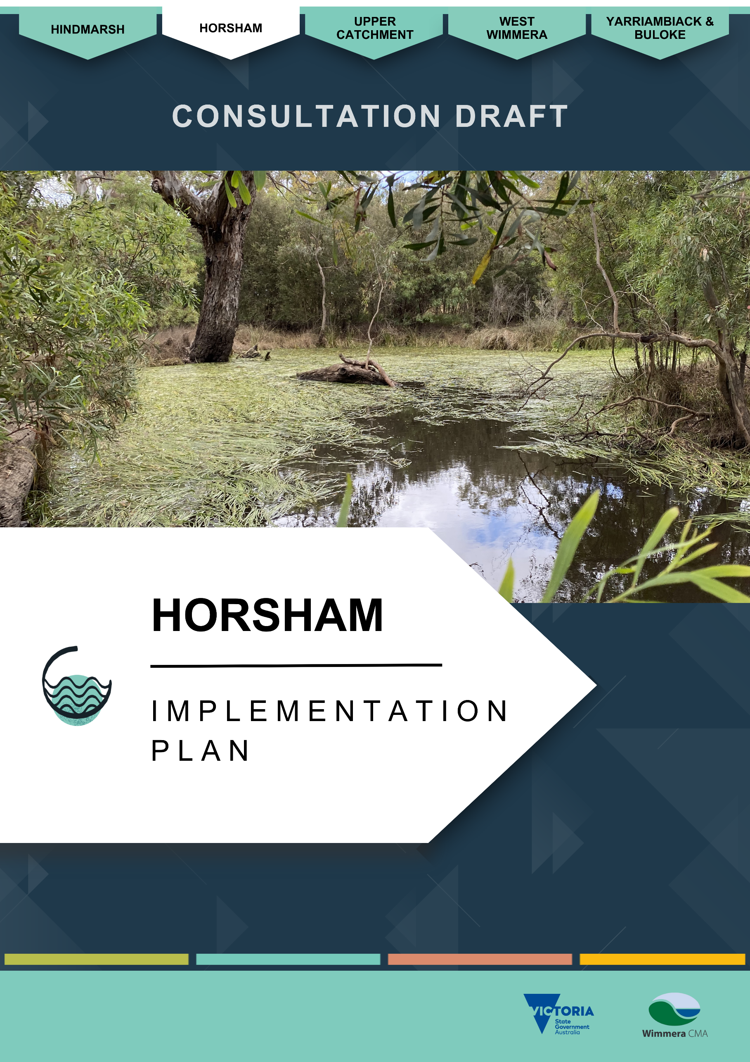

Horsham Implementation plan

About the Horsham Local Area
The Horsham Local Area is a central hub for the Wimmera region and includes its largest centre, Horsham (see Figure 4). Yarriambiack Creek forms the north-eastern boundary, while the Grampians National Park lies to the south.
The area covers 426,600 hectares and is home to around 20,000 residents. ⁽¹⁸⁾ Land use is dominated by dryland cropping (66.5%), with 9% set aside for nature conservation.
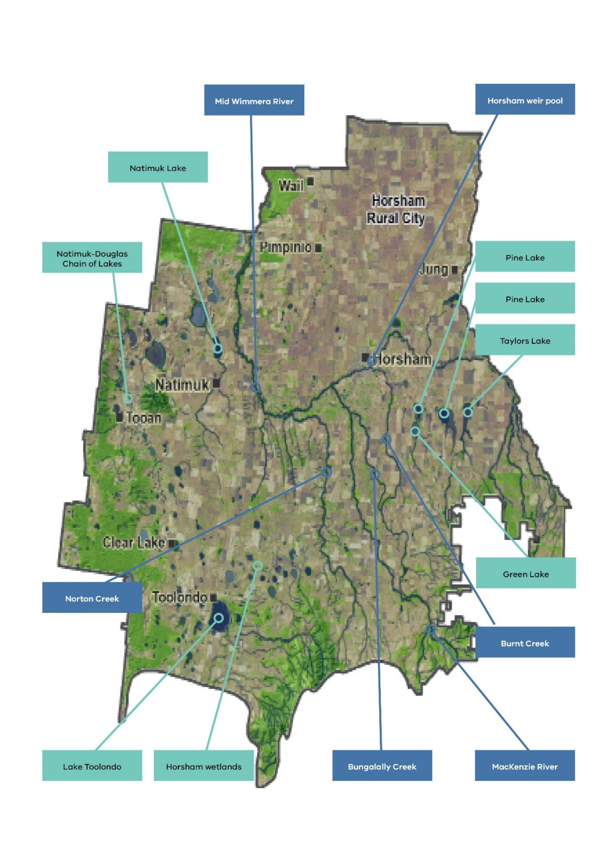
Figure 4. Horsham Local Area and key waterway assets

Rivers and streams
The Horsham Local Area has numerous important waterways. It includes the mid or central stretch of the Wimmera River, fringed by riparian vegetation which meanders through an agricultural landscape and provides a significant social, economic, cultural and environmental asset to the region.
Tributary streams, Golton and Mount William Creeks, join the river north of the Grampians National Park and the river winds between large lakes south-east of Horsham. Before reaching Horsham, distributary streams Dunmunkle and Yarriambiack Creeks branch north off the Wimmera River flowing through the Yarriambiack and Buloke Local Area.
The Wimmera River receives inflows from Burnt Creek at Horsham, and MacKenzie River and Norton Creek join the river downstream of Horsham. The waterway then heads northward towards Lake Hindmarsh in the Hindmarsh Local Area.
The MacKenzie River, arising in the Grampians National Park, supports the last remaining Wimmera population of platypus (Ornithorhynchus anatinus) as well as native fish and crayfish, while Burnt Creek supports the threatened western swamp crayfish (Gramastacus insolitus) and the most southern known population of the Peron’s Tree Frog (Litoria peronii).
Small streams also feature in the landscape. These include Station and Mount Talbot Creeks that flow into Lake Toolondo. Natimuk Creek flows into Natimuk Lake and onto Lake Wyn Wyn, both nationally significant wetlands listed on the Directory of Important Wetlands in Australia.

Wetlands
The Horsham Local Area has approximately 540 wetlands including saline lakes, shallow seasonal wetlands and deep, more permanent freshwater lakes. In the south and west these are diverse with a high density of wetlands – most are on private land. Many provide significant habitat and recreational opportunities.
The Natimuk-Douglas Chain of Lakes is a unique series of lakes hosting nationally significant wetlands, many of which are saline and provide habitat for wetland birds including endangered migratory species.
Taylors Lake is a key water storage which has important roles in stock and domestic water supply via the Wimmera Mallee Pipeline and in providing the Wimmera River with environmental water. Other large lakes, such as Green Lake, are significant for managing water quality within the water supply headworks system, and provide environmental, recreational, social and cultural values. Lake Toolondo is a significant recreational fishery when holding water.
Most wetlands in the area are isolated among extensive agricultural land with varying levels of ecological function due to compounding threats.

Mid-Wimmera River, MacKenzie River and Burnt and Bungalally Creeks

River and stream values

Environmental values
MacKenzie River, Boggy Creek, and Golton Creek were in excellent natural condition in the decade leading up to the Strategy.
Platypus (Ornithorhynchus anatinus) were widespread in parts of the Wimmera catchment before the Millenium Drought, but researchers now believe they are restricted to the MacKenzie River. There are occasional anecdotal reports of sightings elsewhere, but none up to 2025 had been confirmed.
River blackfish (Gadopsis marmorata) have also been a conservation focus in the MacKenzie River and Burnt Creek system. Blackfish were also widespread prior to the Millenium Drought and are now severely restricted.
Further waterway species, present as of 2024 surveys in the Horsham Local Area, included southern pygmy perch, flatheaded gudgeon (Philypnodon grandiceps), and freshwater catfish (Tandanus tandanus). Annual surveys and Horsham Fishing Competition results have indicated that European carp (Cyprinus carpio) numbers in the Wimmera River reduced and then stabilised. This is likely to be because of healthy native fish populations due to fish stocking, environmental water delivery, carp removal programs and water quality efforts.
Terrestrial species of the region’s waterways listed under the Flora and Fauna Guarantee Act 1988 include the vulnerable growling grass frog (Litoria raniformis), endangered southern toadlet (Psuedophryne seminarmorata) and vulnerable Australasian shoveler (Spatula rhynochotis). Some critically endangered species include the Australian bustard (Ardeotis australis), barking owl (Ninox connivens connivens), bush stone-curlew (Burhinus grallarius), curlew sandpiper (Caldris ferruginea), and black falcon (Falco subniger). (19) Threatened and non-threatened species present are not limited to this list.
Waterways in the Horsham Local Area mainly consist of threatened Ecological Vegetation Classes. The Wimmera River supports extensive Riverine Grassy Woodlands (vulnerable), Riparian Woodlands (vulnerable), and Riverine Chenopod Woodlands (endangered). Norton, MacKenzie and Burnt creeks support Plains Woodlands (endangered), Creekline Sedgy Woodlands (endangered), and Sand Ridge Woodlands (endangered). Natimuk Creek also has endangered Drainage-line Woodlands. ⁽⁷⁾

Social and recreational values
The Wimmera River, running through the heart of the rural city of Horsham and downstream to Dimboola, has a profound influence on the general appeal and liveability of these centres. It has long been the subject of enhancement and development. It qualifies as a significant natural asset for promoting tourism, which attracts visitors for major annual events such as an annual Labour Day weekend fishing competition. The river has for many years also provided the backdrop for other major festivals, celebrations and sporting events. Many people regularly gravitate to the river, which borders extensive parkland reserves and residential areas, for passive recreation such as walking, running, cycling and picnicking. Camping facilities are also available.
Horsham Rural City Council has been implementing its Wimmera Riverfront Activation Project as a part of the first stage of its 20-year City to River Masterplan. This is designed to enhance the attraction of the river to residents and visitors with recreation spaces and opportunities.
Socio-economic research has shown that participation at the Horsham weir for recreation has increased from 78,300 participants in 2016-17 to over 84,000 in 2018-19 and 2019-20. This is likely to be attributed to the additional walking tracks and boating facilities that have been installed and the emergence of new activities such as the Horsham Park Run which uses the new walking tracks.
Recreational fishing is popular on the Wimmera River. Target species include exotic redfin (Perca fluviatilis), brown and rainbow trout (Salmo trutta and Oncorhynchus mykiss), and introduced Murray-Darling System natives golden perch (Macquaria ambigua), Murray cod (Maccullochella peelii peelii), freshwater catfish (Tandanus tandanus) and silver perch (Bidyanus bidyanus). Yabbies (Cherax destructor) are also a target species. ⁽²⁰⁾
Seasonal duck hunting is permitted along specific sections of Wimmera River and on public land in accordance with Game Management Authority guidelines.

Economic values
The Wimmera River attracts visitors to Horsham’s annual fishing competition and other fishing events downstream in Hindmarsh Local Area. The competition regularly attracts over 1,000 people from across the state and beyond. ⁽²¹⁾
Wimmera River, with its close proximity to Horsham’s Central Business District, major reserves and gardens and residential areas, is integral to health, liveability and promotional activities of the regional city and downstream towns.

Cultural values
First Nations communities maintain deep, enduring connections to land and water across the Horsham Local Area. The creation story of the Barringgi Gadyin/Wimmera River continues to be celebrated by Barengi Gadjin Land Council and there are significant sites and Special Places associated with the river in Horsham.

River and stream condition
The 2010 Index of Stream Condition assessment rated rivers and streams in the Horsham Local Area as being in moderate to good condition. MacKenzie River, Boggy Creek, and Golton Creek, were rated as being in excellent condition. ⁽¹³⁾

Water quality
There has been a concerted effort to improve runoff water quality of the Wimmera River in Horsham over the past 10 to 15 years, with more to do. Most of the Wimmera River’s water quality issues stem from erosion in the upper catchment.
The river at Horsham regularly fails to meet water quality targets in Victoria’s Environment Reference Standards for phosphorus, nitrogen, turbidity and pH. Despite this, the water quality in Horsham’s weir pool has been good enough to prevent algal blooms and allow for recreation. This has been assisted by water flows for the environment.

Threats and drivers of change

Hydrology - Climate change and dry conditions
Climate change is impacting on water availability and flows in Horsham Local Area waterways.
Horsham residents and businesses as well as threatened wildlife rely on Lake Wartook and the MacKenzie River system for water supply. Domestic supply is essential for Horsham, but species such as platypus and river blackfish and their aquatic communities also need water to survive. Wimmera CMA and GWMWater work together to balance supply needs.
Completion of the Wimmera Mallee Pipeline by 2010 created more efficient means of water transport than previous open channels in a drying climate, however drying conditions are magnified by higher demands on Wartook Reservoir for water supply for Horsham and the environment. This means that during dry times, the authorities’ ability to supply water can be compromised, leading to a potential trade-off in social, economic and environmental outcomes.

Weeds and pest animals
Horsham’s rivers provide essential corridors for wildlife but can also be vectors for invasive plants and animals. These areas require ongoing management by land managers to ensure they continue to maintain their values.
A Wimmera Invasive Plant and Animal Strategy outlines the highest priority areas for the Horsham Local Area being the MacKenzie River. It is a priority for protecting and improving riparian vegetation, controlling bridal creeper (Asparagus asparagoides) and other weeds, and increased rabbit control to prevent stream-bank erosion and impacts on native vegetation. ⁽²²⁾
Carp (Cyprinus carpio) and mosquitofish (Gambusia holbrooki) impact on water quality as well as native fish populations. This will require ongoing maintenance.

Impacts of recreation
In Horsham Local Area, recreational impacts on rivers and streams include inappropriate off-road vehicle use, which can promote bank and creek-bed erosion and be a significant threat to Wimmera and MacKenzie Rivers.
Access for recreational angling can impact bankside vegetation and access tracks. Significant work has occurred in the region in partnership with angling groups to improve access and prevent and minimise impacts in high use areas.

Horsham wetlands including Natimuk-Douglas Chain of Lakes

Wetland values

Environmental values
Many lakes support high numbers and diversity of waterbird species when holding water, including Natimuk Lake, Dock Lake and saline lakes in the Natimuk-Douglas Chain of Lakes.
Survey observations from 2024 included more than 16,700 waterbirds from 26 species at Lake Natimuk and 2,700 waterbirds from 16 species at Dock Lake. ⁽²³⁾
Monthly surveys of Dock Lake during 2024-25 identified three palearctic migratory species including the Red-necked Stint, Sharp-tailed Sandpiper and Bar-tailed Godwit – all which are listed in international migratory bird agreements. A further two species identified include the Freckled Duck and Australasian Shoveler which are listed as threatened by the Flora and Fauna Guarantee Act. Over the period, 40 different species of wetland birds were recorded at Dock Lake.
Surveys of the Natimuk Douglas Chain of Lakes identified the marsh sandpiper (Tringa stagnatilis), red-necked stint (Calidris ruficollis), and common greenshank (Tringa nebularia). These are all listed under the Commonwealth Environment Protection and Biodiversity Conservation Act, Japan-Australia Migratory Bird Agreement, China- Australia Migratory Bird Agreement, and Republic of Korea-Australia Migratory Bird Agreement. ^{(24; 25; 26)}
EPBC-listed species at Green Lake recorded since 2000 include the curlew sandpiper and growling grass frog. ⁽²⁷⁾
Threatened Ecological Vegetation Classes are also supported by local wetlands. This includes Plains Savannah (endangered), Ridged Plains Mallee (endangered), Plains Woodland (endangered), and Low Rises Woodland (endangered) around lakes in the northern reaches of the Natimuk-Douglas Chain of Lakes. Many endangered Brackish Wetlands make up these lakes. Significant Shallow Sands Woodlands surrounds Mitre Lake (vulnerable).
Southern wetlands of the Natimuk-Douglas Chain of Lakes and other areas of the local area further support Red Gum Swamp (endangered), Aquatic Herbland (endangered), and Cane Grass Wetland (vulnerable). Significant Damp Sand Herb-rich Woodland is also significant around Lake Toolondo. ⁽⁷⁾

Social and recreational values
Lakes including Toolondo, Green, Taylors and Natimuk are important assets for water-based recreation in the region.
Periods of limited inflow mean Natimuk, Toolondo and Green Lake fill intermittently and can have insufficient water levels for some recreational activities. When holding enough water, these lakes are important areas for fishing, boating, and swimming in addition to passive activities including picnicking, camping, bird watching, and walking. As an important water supply storage, Taylors Lake regularly holds enough water to support water-based recreation.
Smaller seasonal wetlands have restricted or limited water-based recreational opportunities but are still valued for their nature-based recreation experiences such as bird-watching.

Economic values
Some wetlands in the Horsham Local Area add high economic value to the region via tourism, recreation and acting as a water storage.
Wetlands with the greatest economic contribution, via visitor participation, include Green Lake, Taylors Lake and Lake Toolondo. Total economic contributions were estimated to be $335,000 in 2022-23. Taylors Lake alone had the greatest contribution, estimated at $247,000. ⁽¹¹⁾

Cultural values
First Nations communities retain a strong connection between the land and water. There are many scar trees and artefact scatters associated with waterways and woodlands. Water was a valued aspect of for survival and culture for First Nations People, evident by the array of artefacts beside waterways across the region. Complex fish traps at Lake Toolondo are an example. ⁽²⁸⁾

Wetland condition

Native vegetation
Local wetlands support threatened Ecological Vegetation Communities. This includes Plains Savannah (endangered), Ridged Plains Mallee (endangered), Plains Woodland (endangered), and Low Rises Woodland (endangered) around lakes in the northern reaches of the Natimuk-Douglas Chain of Lakes. Many endangered Brackish Wetlands are part of this system.
Significant Shallow Sands Woodlands surround Mitre Lake (vulnerable), and a community of Salt Paperbark (Melaleuca halmaturorum), listed under the Flora and Fauna Guarantee Act 1988, exists at Lake Wyn Wyn. ⁽²⁹⁾
Southern wetlands of the Natimuk-Douglas Chain of Lakes, and across the remaining local area, further support Red Gum Swamp (endangered), Aquatic Herb land (endangered), and Cane Grass Wetland (vulnerable). Significant Damp Sand Herb-rich Woodland is also significant around Lake Toolondo. ⁽⁷⁾

Water quality
The recreational use of some of the Local Area’s significant water bodies is influenced by several factors. Green Lake is frequently impacted by blue-green algae. When it is clear of algal blooms its value increases. For example, in 2016-17 over 10,000 participants used Green Lake compared to 2018-19 and 2019-20 when the participation was 2,000 and 1,700 due to algae outbreaks.

Recreation
Taylors Lake continues to maintain a healthy participation rate as it retails a reliable volume of water for recreation and its water quality is relatively good. Toolondo Reservoir’s participation rates are dependent on water levels. Since 2017-18 participation rates dropped from 3,340 to 358 in 2019-20 due to declines in water levels and quality.

Threats and drivers of change

Hydrology - Climate change and dry conditions
A drying climate threatens water availability and quality in wetlands used for social, cultural, economic and environmental values.
Excess nutrients from agricultural runoff promotes algal blooms which particularly affect recreational use of larger lakes.

Weeds and pest animals.
Invasive species, including carp, are a major problem for native threatened aquatic species. Carp are linked to reduced water quality and are particularly problematic when they enter recreational lakes, competing with native fish and popular recreational angling species. In the past, this has particularly affected Lake Toolondo, with authorities collaborating to reduce carp impacts.

Modifications
Of the local area’s 538 wetlands, 170 (32%) are free from modifications such as dams, drains, cropping or levees. In 2017, 140 wetlands were cropped compared to 75 in 2004 indicating there is a continued impact on wetlands. Natural water flow was modified as a result, re-directing water into human-made dams, often excavated into the wetland bed.
Many wetlands do not contain water for as long as they once did. For example, Lake Natimuk has been shown to be at risk of a changed hydrologic regime due to man-made modifications, climate change and improved agricultural practices to retain soil moisture, thereby reducing runoff to the lake’s catchment.⁽¹⁵⁾

Impacts of recreation
Due to the high use of wetlands for recreation, it is important to manage access for safety reasons, and to ensure it does not impact on biodiversity, water quality and amenity of natural areas. For example, power boating can result in shoreline-erosion and affect the quality and depth of lakes. Improving access and sustainable visitation to waterways has been a focus for Wimmera CMA, councils and community groups.

Future opportunities
Increasing the resilience of waterways in a drying climate has been a priority for recent management.
With the Wimmera-Mallee Pipeline being an invaluable asset, Wimmera CMA is investigating opportunities for piping water to drought refuges in waterways to help use water efficiently to maintain environmental values during extreme dry periods when there are low natural flows and environmental water allocations. Investigations include the viability of introducing piped water to selected drought refuge pools along Burnt Creek and MacKenzie River.
Regular trapping surveys and eDNA sampling of MacKenzie River has assisted in monitoring platypus presence and informed environmental-water management.
A Wimmera CMA River Blackfish Recovery Project, which has included the release of hatchery-bred and translocated fish in MacKenzie River and Burnt Creek, has relied heavily on environmental-water allocations and management, which would be further benefited by the piped drought refuges project. The blackfish project included a world first with aquarists breeding Wimmera-sourced blackfish under controlled hormone-induced conditions.
Target control measures of invasive carp (Cyprinus carpio) with netting and electrofishing has also occurred in Horsham Local Area. In 2025, electrofishing and netting of the noxious species occurred in streams across the catchment including MacKenzie River and Burnt Creek.

Stakeholder and Community Feedback
During development of the Strategy and Implementation Plan, Wimmera CMA invited input from stakeholders and the community. Participants from the Hindmarsh Local Area identified the following waterways as particularly important:

- Wimmera River
- Horsham weir pool
- MacKenzie River
- Burnt Creek
- Bungalally Creek
- Norton Creek
- Natimuk Lake and Natimuk Creek
- Green Lake
- Taylors Lake
- Lake Toolondo
- Dock Lake
- Boundary Swamp
- Mitre Lake

Key points included:

- Many stakeholders expressed concern about drought, dry climate and water supply security, including having enough water for towns and farms, increased demand for water from new industry including mining, and being able to keep waterways healthy to support water-dependent species like platypus.
- Interest was expressed in exploring integrated water management opportunities to reduce competition for the general supply. There is a shared concern for maintaining water availability.
- Maintaining and enhancing access and infrastructure at priority recreational sites including the Horsham weir pool was a common priority, along with reducing recreational impacts on waterways.
- Monitoring the health of instream and riparian species, continuing pest and weed management, and expanding community education about waterway systems, biodiversity, threats and climate change were also key themes.

Priority locations for management
The Strategy identified Horsham’s priority waterways for management:

- Mid-Wimmera River
- Horsham weir pool
- MacKenzie River
- Burnt Creek
- Wetlands with high environmental value
- Natimuk-Douglas Chain of Lakes
- Wetlands with high social and economic value, including:
  - Taylors Lake
  - Natimuk Lake and Creek
  - Green Lake

Together, these areas hold the highest ecological, cultural and recreational value and face the greatest management needs. Details of the prioritisation process are described in a supporting document to the Strategy.

Management Activities – Horsham
The following tables include management actions for the Mid Wimmera River, MacKenzie River, Burnt and Bungalally Creeks and Horsham wetlands including the Natimuk-Douglas Chain of Lakes.
These actions are intended to be implemented over 10-years from 2026 to achieve the region’s desired outcomes in the Horsham Local Area.
Tables 10 to 16 contain similar management actions according to the following groups:
Rivers and Streams
- Table 10. Management Activities for the Mid Wimmera River, MacKenzie River, and Burnt and Bungalally Creeks
- Table 11: Supporting key water-dependent species
- Table 12: Managing water quality and availability
- Table 13: Improving recreational opportunities
Wetlands
- Table 14: Improving recreational opportunities
- Table 15: Managing pest species
- Table 16: Protecting wetlands on private land
Some actions contribute to multiple outcomes.
Management actions are shaded green for high priority and orange for medium priority. Actions with no shading are low priority.
Unless otherwise stated, activities are funded under the Environmental Contribution Levy until 2028. Funding is assumed to be maintained at current levels until 2036.

Mid Wimmera River, MacKenzie River, Burnt and Bungalally Creeks

Managing priority waterways
The actions in Table 10 contribute to the following regional waterway outcomes:
- More waterways have improved management to enhance habitat, landscape connectivity, and resilience.
- Stewardship increases, with more people taking action to care for waterways.
Local Area specific outcomes that contribute to this outcome include:
- Increased weed, herbivore and pest predator control in priority locations.
- More revegetation in priority locations.
Associated values of the priority locations include:
- Riparian vegetation and connectivity.
- Cultural connections.
- Water quality and supply.
- Amenity and recreation.
- Tourism and economy.
- Agricultural productivity.
- Water bird species.
- Instream species platypus, river blackfish, western swamp crayfish, Glenelg spiny crayfish, small-bodied fish and Wimmera callistemon habitat.
Table 10. Management Activities for the Mid Wimmera River, MacKenzie River, and Burnt and Bungalally Creeks.
Waterway location |  | Management action | Amount by 2036 | Responsible parties | Connection with other plans or strategies | Status
Mid Wimmera River, MacKenzie River and Burnt Creek and other tributaries  - unfenced sections.  Green Lake’s tributaries | Support private landholders to permanently protect and manage riparian areas on their properties. |  | TBC | Wimmera CMA,  Private landholders | Wimmera Proportion of Waterways Protected – Stage 2 (2023).  Trust for Nature Statewide Conservation Plan 2021-2030.  Green Lake Waterway Action Plan 2024. | Continuation of work under the previous regional waterway strategy.
 | Control problem invasive fauna in priority riparian areas. |  | TBC | Wimmera CMA,  Public Land Managers,  Agriculture Victoria,  Landholders | Wimmera Invasive Plant and Animal Management Strategy 2019. | Continuation of work under the previous regional waterway strategy.
 | Control problem weeds in priority riparian areas, such as blackberry, gorse, broom, boneseed and bridal creeper. |  | TBC |  | Wimmera Invasive Plant and Animal Management Strategy 2019. | Continuation of work under the previous regional waterway strategy.

Supporting key water-dependent species
The actions in Table 11 contribute to the following regional waterway outcomes:
- Key water-dependent species are supported in waterways that provide suitable habitat, including during dry conditions.
- Healthier waterways enable more On Country activities for First Nations People.
Local Area specific outcomes that contribute to this outcome include:
- No new pest plants and animals are established beyond small, localised populations.
Associated values of the priority locations include:
- Riparian vegetation and connectivity.
- Riparian and water bird species.
- Amenity and recreation.
- Cultural connections.
- Trail walking and cycling trail, recreational fishing.
- Tourism and economy.
Table 11: Supporting key water-dependent species.
Waterway location |  | Management action | Amount by 2036 | Responsible parties | Connection with other plans or strategies | Status
Mid-Wimmera River, Mackenzie River and Burnt Creek |  | Monitor for new pest species and manage emerging species. | 1 partnership per year in collaboration with land managers. | Wimmera CMA,  Parks Victoria,  Local Government,  Landcare,  Landholders | Wimmera Invasive Plant and Animal Management Strategy 2019. | Continuation of work under the previous regional waterway strategy.
Mid-Wimmera River, Mackenzie River and Burnt Creek |  | Manage European carp according to whole of catchment implementation actions in Table 37. | Refer to whole of catchment management section. | Wimmera CMA | Wimmera Carp Management Plan.  Wimmera Native Fish Management Plan. | Continuation of work under the previous regional waterway strategy.
Mid-Wimmera River, Mackenzie River and Burnt Creek |  | Implement actions for River Blackfish from the whole of catchment implementation actions in Table 37. | Refer to whole of catchment management section. | Wimmera CMA,  BGLC | Wimmera Native Fish Management Plan. | New action.

Managing water quality and availability
The actions in Table 12 contribute to the following regional waterway outcomes:
- Risks to water quality in Wimmera waterways are managed where possible to reduce impacts on values.
- Drought refuges support species’ survival and resilience during dry periods.
- More waterways have improved management to enhance habitat, landscape connectivity, and resilience.
- Healthier waterways enable more On Country activities for First Nations People.
Local Area specific outcomes that contribute to this outcome include:
- More water security by developing and implementing a business case for a supplementary water supply for Horsham and MacKenzie River, Burnt and Bungalally Creeks.
Associated values of the priority locations include:
- Amenity and recreation.
- Tourism and economy.
- Water quality.
- Native fish and instream biodiversity.
- Drought resilience.
- Biodiversity connectivity.
- Birdlife, frogs, and native fish habitat.
- Aquatic species including freshwater catfish, golden and silver perch, river blackfish, platypus, western swamp crayfish, Glenelg spiny crayfish, southern pygmy perch, obscure galaxias.
Table 12: Managing water quality and availability.
Waterway location | Management action | Amount by 2036 | Responsible parties  (Lead/Partner) | Connection with other plans or strategies | Status
Mid-Wimmera River and Horsham Weir Pool | Monitor water quality. | 8 sites monitored | Wimmera CMA | Wimmera CMA’s Water Quality Monitoring Review. | Continuation of work under the previous regional waterway strategy.
Mid-Wimmera River and Horsham Weir Pool | Develop annual Seasonal Watering Proposals for the Wimmera River. | 10 proposals  (comprised of 1 proposal annually) | Wimmera CMA, GWMWater,  VEWH, CEWH,  Local Government. | Environmental Water Management Plan – Wimmera River, Yarriambiack Creek and their terminal lakes. | Continuation of existing arrangements.
Mid-Wimmera River and Horsham Weir Pool | Develop annual Seasonal Watering Plans for the Wimmera River. | 10 plans  (comprised of 1 plan annually) | VEWH,  Wimmera CMA,  GWMWater,  VEWH, CEWH,  Local Government. |  | Continuation of existing arrangements.
Mid-Wimmera River and Horsham Weir Pool | Deliver environmental water to the Wimmera River in line with the Victorian Environmental Water Holder’s annual Seasonal Watering Plans. | The volume (ML) of water delivered and extent of river watered depends on annual watering entitlements | Wimmera CMA, GWMWater,  VEWH,  CEWH,  Local Government. |  | Continuation of existing arrangements.
Mid-Wimmera River and Horsham Weir Pool | If water quality poses a risk of blue green algae and/or fish deaths, manage water quality with environmental flows in consultation with the Victorian Environmental Water Holder if sufficient water is available. | As needed | Wimmera CMA,  VEWH | Environmental Water Management Plan - Wimmera River, Yarriambiack Creek and their terminal lakes.  Annual Seasonal Watering Plans. | Continuation of work under the previous regional waterway strategy.
MacKenzie River, Burnt Creek, Bungalally Creek. | Develop annual Seasonal Watering Proposals for the MacKenzie River, Burnt Creek and Bungalally Creek. | 10 proposals  (comprised of 1 proposal annually) | Wimmera CMA, GWMWater,  VEWH,  CEWH,  Local Government. | Environmental Water Management Plan - MacKenzie River and Burnt and Bungalally Creeks 2025. | Continuation of existing arrangements.
MacKenzie River, Burnt Creek, Bungalally Creek. | Develop annual Seasonal Watering Plans for the MacKenzie River, Burnt Creek and Bungalally Creek. | 10 plans  (comprised of 1 plan annually) | VEWH,  Wimmera CMA,  GWMWater,  VEWH,  CEWH,  Local Government. |  | Continuation of existing arrangements.
MacKenzie River, Burnt Creek, Bungalally Creek. | Deliver environmental water to the MacKenzie River, Burnt Creek and Bungalally Creek in line with the Victorian Environmental Water Holder’s annual Seasonal Watering Plans. | The volume (ML) of water delivered and extent of river and creek watered depends on annual watering entitlements | Wimmera CMA, GWMWater,  VEWH,  CEWH,  Local Government. |  | Continuation of existing arrangements.
Mid-Wimmera River, Mackenzie River, Burnt Creek, Bungalally Creek. | Maintain monitoring sites to assess effectiveness of environmental water releases and flood mitigation. | 195 sites maintained on Victoria's Water Measurement Information System and Wimmera CMA gauge locations | Wimmera CMA, GWMWater,  VEWH,  CEWH,  Local Government. | Environmental Water Management Plan - Wimmera River, Yarriambiack Creek and their terminal lakes. | Continuation of work under the previous regional waterway strategy.
 | Monitor native fish populations via:  - The Native Fish Report Card.  - As required to inform management activities. | 1 Native Fish Report Card (Annually)  As needed | Wimmera CMA,  VEWH,  DEECA | Environmental Water Management Plan - Wimmera River, Yarriambiack Creek and their terminal lakes.  Environmental Water Management Plan - MacKenzie River and Burnt and Bungalally Creeks 2025.  Annual Seasonal Watering Plans. | Continuation of existing arrangements.
 | Undertake vegetation monitoring in the lower MacKenzie River via the Victorian Environmental Flows Monitoring and Assessment Program. | 1 assessment, planned for 2033 | Wimmera CMA,  VEWH,  DEECA | Environmental Water Management Plan - Wimmera River, Yarriambiack Creek and their terminal lakes.  Environmental Water Management Plan - MacKenzie River and Burnt and Bungalally Creeks 2025.  Annual Seasonal Watering Plans. | Continuation of existing arrangements.
MacKenzie River | Reconsider a pipeline project from Rocklands Reservoir to Taylors Lake and Mount Zero Treatment Plant. | 1 proposal submitted | GWMWater,  Wimmera CMA,  Horsham Rural City Council |  | Continuation of work under the previous regional waterway strategy.
MacKenzie River | Investigate the feasibility of altering infrastructure where the Rocklands Channel crosses the MacKenzie River to enable flows from Rocklands Reservoir to enter MacKenzie River, providing another avenue for environmental flow delivery to the MacKenzie River. | 1 assessment | GWMWater,  Wimmera CMA |  | New action.
Burnt Creek | Investigate options to reduce losses at the confluence of Burnt Creek with Rocklands Channel to enable more efficient delivery of environmental water to Burnt Creek. Explore options that don't interfere with the operation of the channel. | 1 investigation | Wimmera CMA,  GWMWater |  | New action.
Burnt Creek | Remove vegetation where vegetation is hampering water flows and supply transfers, such as Boggy Corner along Burnt Creek which has a build-up of cumbungi. | High density instream vegetation identified and managed – case-by case basis | Wimmera CMA,  GWMWater |  | New action.
MacKenzie River, Burnt Creek and Bungalally Creek | Investigate options and explore the long-term feasibility, costs and benefits of establishing pipeline watered drought refuge sites in the MacKenzie River and Burnt Creek.  Feasibility considerations may include:  - Cost–benefit analysis.  - Capacity to continue to support waterway values under climate change scenarios.  - Whether environmental watering at drought refuge sites is likely to sustain target species and ecological values given modelling of future streamflow projections. | 1 feasibility assessment and cost-benefit analysis completed | Wimmera CMA,  GWMWater,  VEWH,  DEECA,  Public Land Managers,  BGLC | Lower MacKenzie River and upper Burnt Creek flow optimisation project 2019.  Wimmera CMA’s Dry Conditions Action Plan. | New action.
Mount Zero Channel | Investigate the environmental values of Mount Zero channel and develop a proposal for managing these values. | 1 investigation completed  1 proposal developed | Wimmera CMA, GWMWater |  | New action.
Mid-Wimmera River  (Also includes Mount William Creek of the Upper Catchment Local Area) | Ensure environmental, waterway and landscape values are maintained in the evolution of Horsham recycled water management. | 1 plan | GWMWater,  Wimmera CMA,  Horsham Rural City Council |  | New action.
 | Modify the outlet from Taylors Lake into the Wimmera River, enabling a wider range of environmental water volumes to be delivered. | 1 outlet modified | Wimmera CMA,  GWMWater |  | New action.
 | Modify the outlet from Mount William Creek inlet channel into the Wimmera River, enabling a wider range of environmental water volumes to be delivered. | 1 outlet modified | Wimmera CMA,  GWMWater |  | New action.
 | Investigate flow thresholds for Mount William Creek to maximise efficiency of environmental water delivery to the Wimmera River. | 1 investigation | Wimmera CMA,  GWMWater |  | New action.

Improving recreational opportunities
The actions in Table 13 contribute to the following regional waterway outcomes:
- More waterways provide improved recreational opportunities and amenity while minimising impacts on environmental values.
- Healthier waterways enable more On Country activities for First Nations People.
- Stewardship increases, with more people taking action to care for waterways.
Local Area specific outcomes that contribute to this outcome include:
- Waterway user participation numbers are maintained or improved on average in the Wimmera River.
- More areas have improved recreational access and management.
Associated values of the priority locations include:
- Amenity and recreation.
- Tourism and economy.
- Community engagement and events.
- Vegetation and bird communities.
Table 13: Improving recreational opportunities.
Waterway location |  | Management action | Amount by 2036 | Responsible parties  (Lead/Partner) | Connection with other plans or strategies | Status
Horsham weir pool |  | Develop a management plan for Horsham weir pool. | 1 management plan | Horsham Rural City Council,  Wimmera CMA,  BGLC,  DEECA,  Parks Victoria, GWMWater,  Recreational user groups |  | New action.

Horsham wetlands including the Natimuk-Douglas Chain of Lakes

Improving recreational opportunities
The actions in Table 14 contribute to the following regional waterway outcomes:
- More waterways have improved management to enhance habitat, landscape connectivity, and resilience.
- More waterways provide improved recreational opportunities and amenity while minimising impacts on environmental values.
- Healthier waterways enable more On Country activities for First Nations People.
- Stewardship increases, with more people taking action to care for waterways.
Local Area specific outcomes that contribute to this outcome include:
- More areas have improved recreational access and management.
- More areas are permanently protected for biodiversity with a priority given to shallow seasonal wetlands, grasslands and woodlands.
Associated values of the priority locations include:
- Habitat connectivity and enhancement.
- Cultural connections.
- Herb-rich communities.
- Amenity and recreation.
- Community engagement and education.
Table 14: Improving recreational opportunities.
Waterway location | Management action | Amount by 2036 | Responsible parties  (Lead/Partners) | Connection with other plans or strategies | Status
Taylors Lake | Investigate the feasibility of altering infrastructure at Taylors Lake to enable efficient environmental flow delivery. | 1 assessment | GWMWater,  Wimmera CMA,  Parks Victoria,  CEWH,  VEWH |  | New action.
Pine Lake | Investigate future management of Pine Lake. | 1 investigation completed | GWMWater,  BGLC, Wimmera CMA |  | New action.
Green Lake | Support management plans to benefit social, cultural, economic and environmental values. | N/A | GWMWater,  Horsham Rural City Council,  Wimmera CMA,  Recreational user groups | Green Lake Waterway Action Plan | Continuation of existing work.

Managing pest species
The actions in Table 15 contribute to the following regional waterway outcomes:
- More waterways have improved management to enhance habitat, landscape connectivity, and resilience.
- Healthier waterways enable more On Country activities for First Nations People.
Local Area specific outcomes that contribute to this outcome include:
- Increased weed, herbivore and pest predator control in priority locations.
Associated values of the priority locations include:
- Amenity and recreation.
- Cultural connections.
- Native wildlife and flora.
- Agricultural productivity.
Table 15: Managing pest species.
Waterway location | Management action | Amount by 2036 | Responsible parties  (Lead/Partners) | Connection with other plans or strategies | Status
Public wetlands | Control invasive fauna for wetlands. | 50 ha (annually) | Parks Victoria,  Wimmera CMA | Wimmera Invasive Plant and Animal Management Strategy. | Ongoing
Public wetlands | Control weeds in priority wetland areas. | 100 ha (annually) | Parks Victoria,  Wimmera CMA,  Landcare | Wimmera Invasive Plant and Animal Management Strategy. | Ongoing
Public wetlands | Manage European carp according to whole of catchment Management Actions in Table 37. | Refer to whole-of-catchment management section | Wimmera CMA | Wimmera Carp Management Plan.  Wimmera Native Fish Management Plan. | Ongoing

Protecting wetlands on private land
The actions in Table 16 contribute to the following regional waterway outcomes:
- More waterways have improved management to enhance habitat, landscape connectivity, and resilience.
- Wetland modification, loss and deterioration of condition occurs at a declining rate.
- Stewardship increases, with more people taking action to care for waterways.
Local Area specific outcomes that contribute to this outcome include:
- More areas are permanently protected for biodiversity with a priority given to shallow seasonal wetlands, grasslands and woodlands.
Associated values of the priority locations include:
- Amenity and recreation.
- Cultural connections.
- Native wildlife and flora.
- Agricultural productivity.
Table 16: Protecting wetlands on private land.
Waterway location | Management action | Amount by 2036 | Responsible parties  (Lead/Partners) | Connection with other plans or strategies | Status
Wetlands on private land with high environmental value. | Support private landholders to protect and manage wetlands on their properties. | TBC | Wimmera CMA,  Trust for Nature,  Private landholders | Trust for Nature’s Statewide Conservation Plan 2021-2030.  Wimmera Wetland Asset Strategy. | Continuation of work under the previous regional waterway strategy.
Wetlands on private land with high environmental value. | Increase community and landholder awareness of the value of wetlands and appropriate conservation management techniques. | TBC | Wimmera CMA,  Landcare,  Trust for Nature

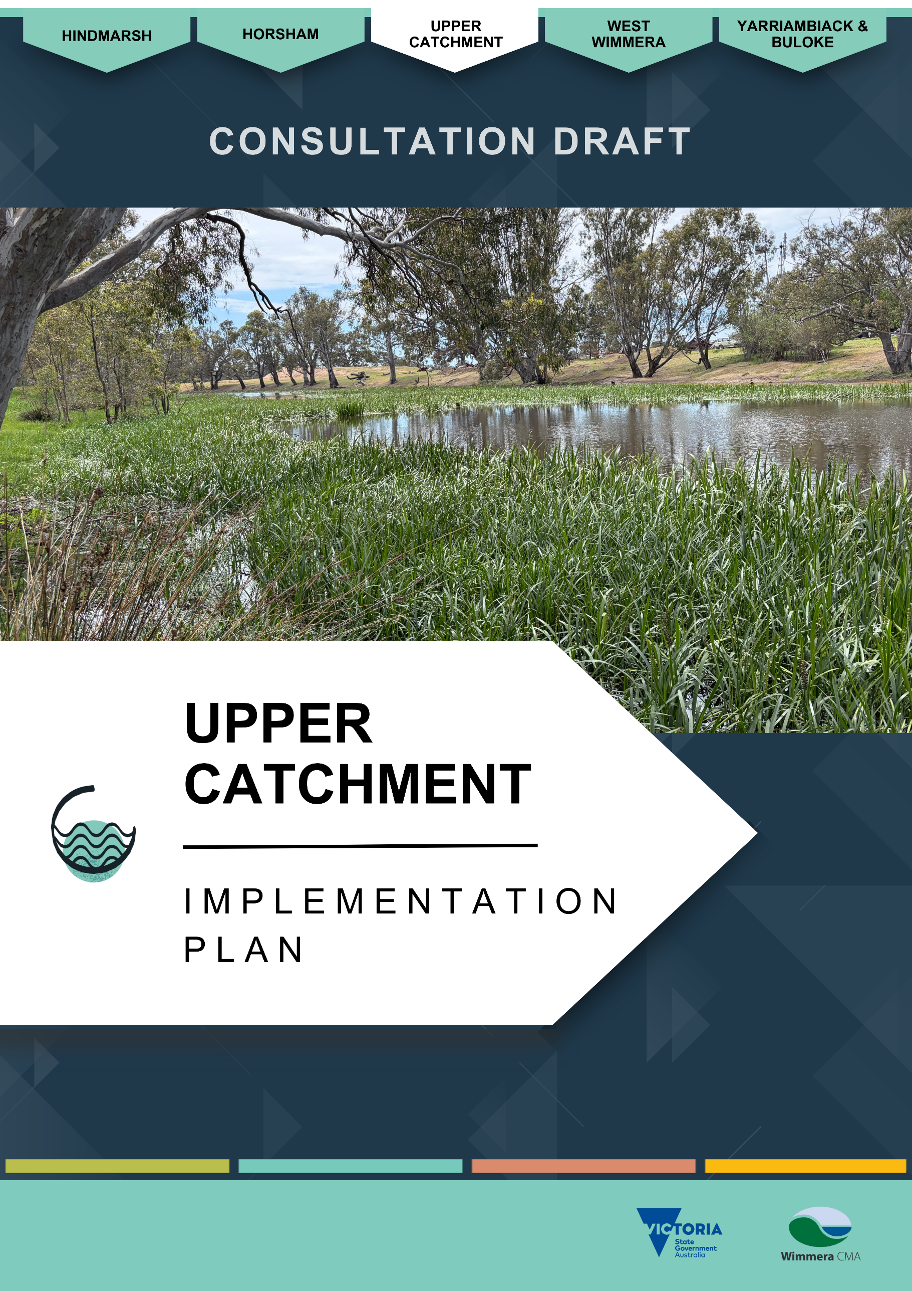

Upper Catchment Implementation Plan

About the Upper Catchment
The Upper Catchment Local Area comprises the upper catchment of the Wimmera River, the northern section of the Grampians National Park (Gariwerd) in its west, and the Pyrenees ranges in its east. The population of the region is over 9,000 people across more than 368,000 hectares.
Nature conservation makes up 20% of the region with extensive areas of public land in the Grampians National Park, other parks and reserves, and beside waterways. Agriculture makes up the majority of the region’s land use with the greatest use being the grazing of modified pastures (42%) and dryland cropping (18%). ^{(7; 30)}
Legislation to create new national parks was introduced into Victoria’s parliament on 10 September 2025, including Mount Buangor National Park, which includes a portion of the current Mount Cole State Park and Mount Buangor State Park; and the Pyrenees National Park, made up of Landsborough and Landsborough Hill nature conservation reserves and the Pyrenees State Forest.
The Upper Catchment Local Area is a living cultural landscape with deep and continuing connections for Wotjobaluk Nations Peoples and Eastern Maar Peoples. The Victorian Aboriginal Heritage Act 2006 recognises two Registered Aboriginal Parties, Barengi Gadjin Land Council Aboriginal Corporation and Eastern Maar Aboriginal Corporation, as the primary guardians, keepers and knowledge holders of Aboriginal Cultural Heritage for sections of the Upper Catchment Local Area.
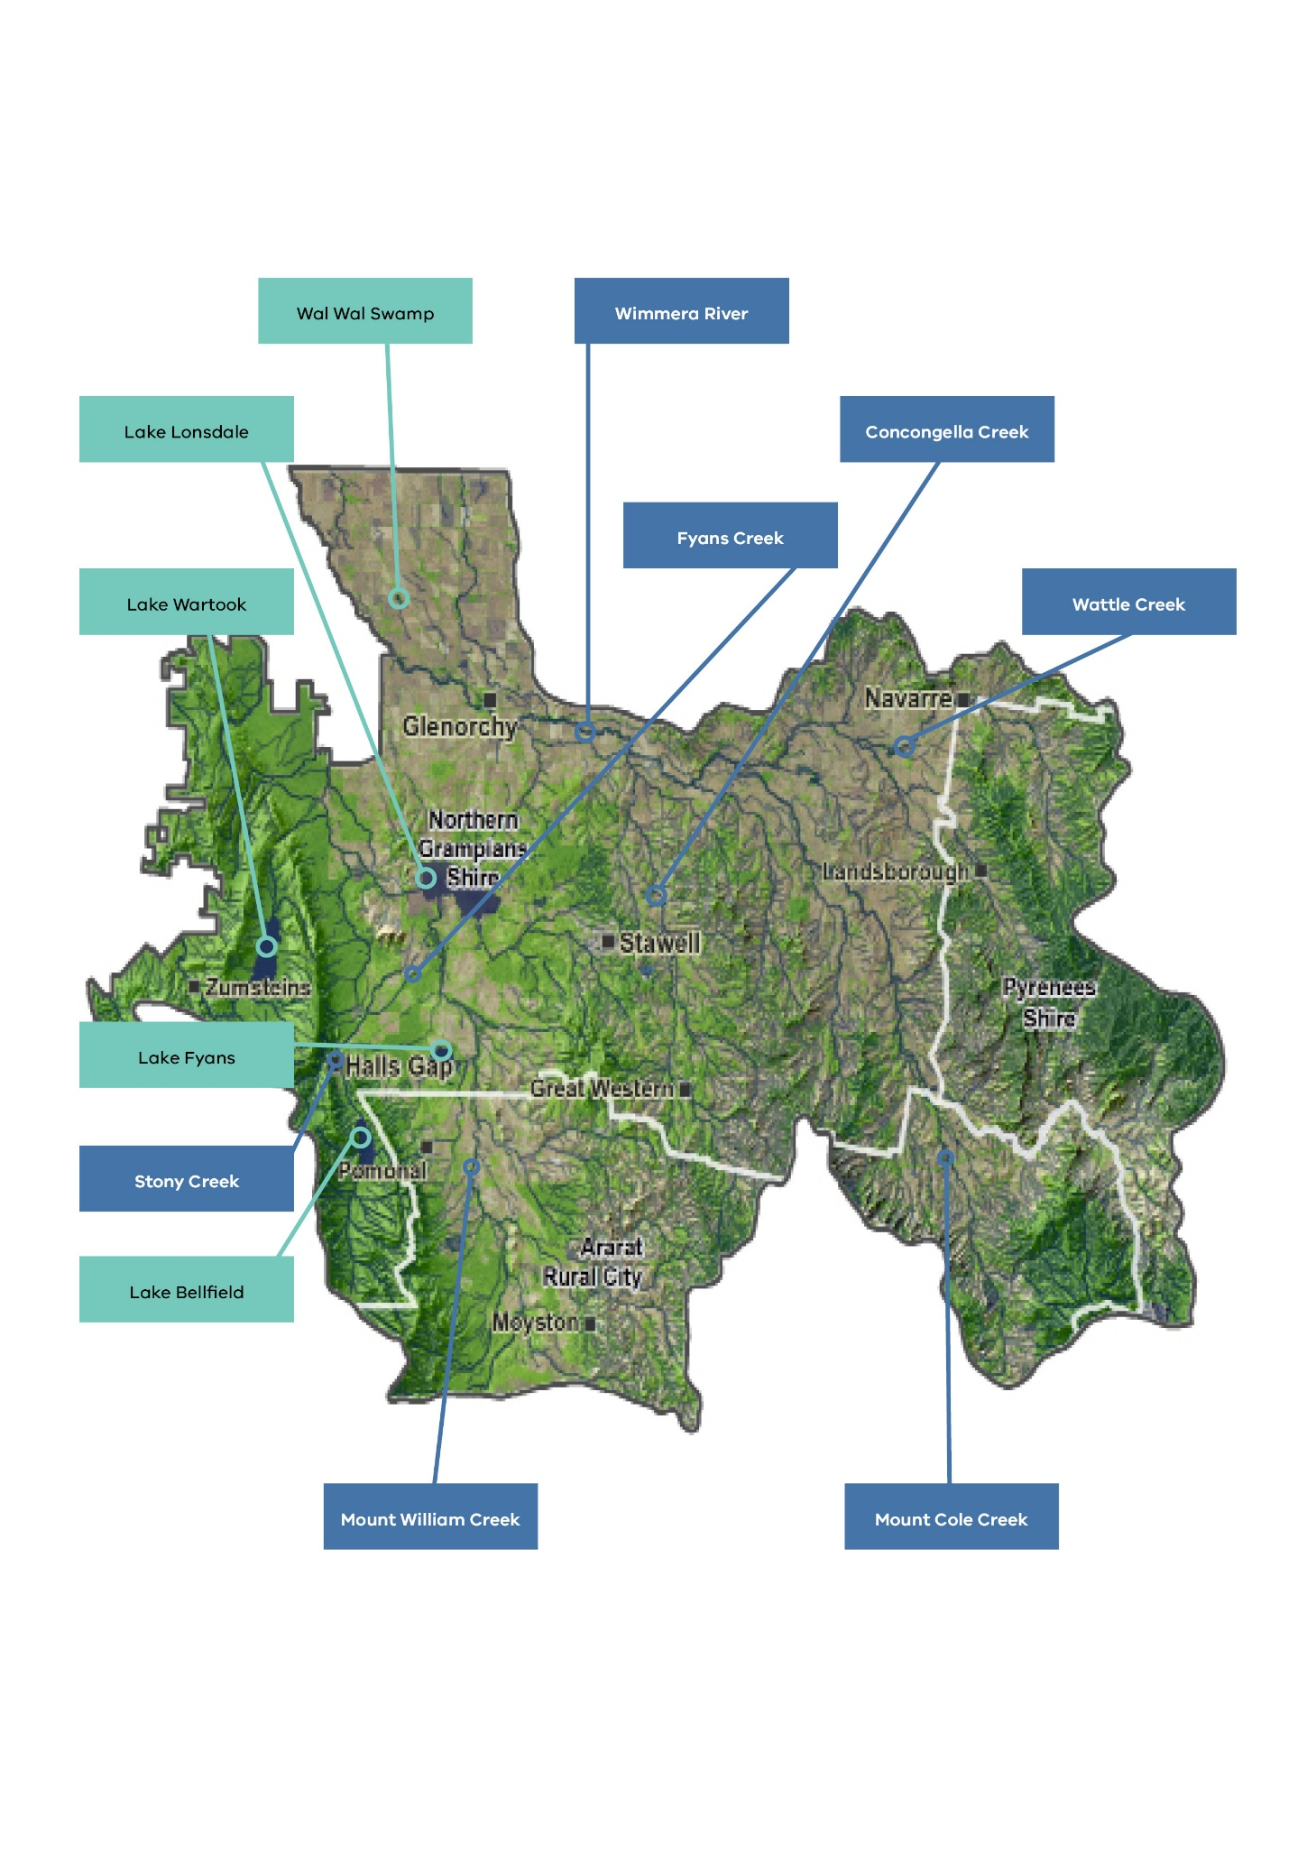
The area includes the southern portion of Northern Grampians shire, north-western section of Pyrenees Shire, and northern sections of Ararat Rural City Council to the east and west of Ararat, see Figure 5.
Figure 5. The Upper Catchment Local Area including municipal boundaries.

Rivers and streams
The Upper Catchment includes the headwaters of the Wimmera River - the heart of the Wimmera catchment. The river begins at Mount Cole in the Pyrenees Ranges and is fed by many tributary streams arising in the steep hill country around Navarre, the Black Range Scenic Reserve, northern sections of the Grampians National Park and the western Pyrenees ranges.
Many Upper Catchment streams flow into large water storages vital for the catchment’s water supply. For example, Fyans Creek feeds Lake Bellfield, providing a regionally important source of water for a vast network of towns and farms distributed via the Wimmera Mallee Pipeline. Several streams also provide water for townships like Elmhurst, Buangor and Moyston.

Wetlands
The Upper Catchment Local Area includes approximately 220 wetlands. Deep or large lakes including Lakes Wartook, Bellfield, Lonsdale, and Fyans, are important water-supply storages with high social, economic, environmental and cultural values.
About two-thirds of the area’s wetlands are shallow and seasonal. Many are associated with rivers, either in a floodplain or connected to a stream channel where they fill from stream flow and overflow to a downstream channel. There are also several non-riverine shallow freshwater wetlands, particularly on the fringes of the Grampians National Park.
Wetlands range in size from less than one hectare to large water storages that are generally more than 200 hectares in area. Relatively shallow Lake Lonsdale is the largest, covering an area of 1,700 hectares. ⁽³¹⁾

Upper Wimmera River, Mount Cole Creek and Tributaries

River and stream values

Environmental values
Creeks with their headwaters in the Grampians National Park and the Pyrenees ranges support considerable environmental values. These creeks stretch over large public land reserves and are sources of water for stock and domestic purposes, and for irrigating vines or perennial pastures. In combination with adjacent agricultural land use, the creeks’ environmental values can diminish.
Glenlofty Creek, an upper Wimmera River tributary arising in the Pyrenees range, continues to hold environmental value within its geomorphologically rare ‘chain of ponds’, and fish, bird and macroinvertebrate communities.
Most streams and creeks throughout the Upper Catchment support threatened Ecological Vegetation Classes. This includes Endangered Plains Grassy Woodlands, Alluvial Terraces Herb-rich Woodlands (Nine Mile Creek), Creek Line Grassy Woodlands and Vulnerable Red Gum Swamp. The Wimmera River supports extensive endangered and rare Riparian Woodlands. Heifer Station Creek additionally has endangered and geographically rare Swampy Riparian and Creekline Sedgy Woodlands.
Threatened fish species in the Upper Catchment, from surveys commissioned by Wimmera CMA since 2014, include: western swamp crayfish (Gramastacus insolitus), in Mount William, Mount Cole, and Burnt creeks; River Blackfish (Gadopsis marmorata), in Fyans and Mount William creeks; and southern pygmy perch (Nannoperca australis), in Burnt, Mount Cole, and Mount William Creeks, and the Wimmera River.
Other threatened or endangered waterway-dependent species across the upper catchment include rakali (Hydromys chrysogaster) and growling grass frogs (Litoria raniformis).
Platypus (Ornithorhynchus anatinus) were widespread before the Millenium Drought but are now believed to be restricted to the Mackenzie River of the Horsham Local Area. There are occasional anecdotal reports of sightings elsewhere in the region, but up to 2025 none had been confirmed.

Social and recreational values
Streams across the Upper Catchment, particularly in and near the Grampians National Park and Pyrenees ranges, help form the atmosphere that attracts many sightseers.
Camping, picnicking, and hiking facilities available across the park where these streams often feature, such as Fyans Creek, enhance the environmental experience that attract many people. Streams beyond the Grampians National Park also carry high value for their amenity and streamside uses when flowing.
Angling is popular in the Wimmera River, and Mount William and Fyans Creeks. Some fish species here include introduced natives golden perch (Macquaria ambigua), Murray cod (Maccullochella peelii peelii), freshwater catfish (Tandanus tandanus) and silver perch (Bidyanus bidyanus), and native Wimmera yabbies (Cherax destructor). Exotic species include redfin (Perca fluviatilis), brown and rainbow trout (Salmo trutta and Oncorhynchus mykiss). ⁽²⁰⁾
Seasonal duck hunting is permitted along specific sections of the Wimmera River on public land in accordance with Game Management Authority guidelines.

Economic values
Streams within the Grampians National Park are important for directing water into water storages and large recreational lakes. These supply water for towns across the catchment for domestic and stock use in addition to environmental water.
Tourism along Upper Catchment local area streams is also valuable for the region’s economy. The natural environment of the Grampians National Park, supported by waterway attractions such as the Venus Baths near Halls Gap and numerous waterfalls, attracts over 800,000 visitors per year.

Cultural values
Barengi Gadjin Land Council Aboriginal Corporation and Eastern Maar Aboriginal Corporation are recognised as the primary keepers and knowledge holders of the Local Area’s Aboriginal Cultural Heritage. Connections between First Nations People and Country are reflected in many ways including artefacts, rock art, culturally significant trees and creation stories featured around Gariwerd/Grampians National Park and surrounds, the Pyrenees range, Lake Lonsdale, Lake Fyans and other waterways.

River and stream condition
A 2010 Index of Stream Condition assessment recorded most streams as being in ‘moderate’ condition.
The majority of ‘good’ condition waterways were those with their headwaters in public reserves. This includes Golton Creek in the Grampians National Park, and small tributaries in the Pyrenees ranges.
Stream condition declines as neighboring land use becomes agricultural or degraded. The Index of Stream Condition assessment classed 77.5 km of Mount William Creek as being in poor condition. It also classed Fyans Creek, as it passes through the tourist town of Halls Gap, and Miller’s Creek, going through agricultural land, as poor. Both waterways terminate at Lake Lonsdale. Smaller tributaries on the northern side of the Wimmera River in the eastern part of the Local Area, where erosion risk is greatest, were also classed as being in poor condition.

Threats and drivers of change

Erosion
The steep gradients and soil types in the Upper Catchment’s hill country are prone to water erosion, particularly when water runs at speed down the steep slopes over exposed soil. This erosion incises and widens creeks, often creating deep gullies with downstream impacts. Eroded sediment can settle in deep pools in the Wimmera River, reducing habitat, and increasing water turbidity and nutrient levels. Wimmera CMA erosion-control works during the two decades before 2025 improved many highly eroded streams and their riparian zones. Works are targeted at sites with the greatest potential to reduce sediment loads into streams.⁽³²⁾ The extent of waterways protected from livestock in the upper catchment currently is 41.5%, compared with 92% in the Wimmera River’s lower catchment, indicating a need for further works.
Reducing livestock access to waterways has been a priority for upper-catchment erosion control, where over 700 km of waterway frontage remains unprotected.⁽¹⁵⁾ Landcare groups, the Perennial Pasture Systems group, and landholders have provided complementary work to buffer waterways from livestock access, protect riparian vegetation, and retain ground cover on neighboring paddocks.
Stream-bed vegetation, such as cumbungi (Typha domingensis), is threatened by a community perception that it prevents water from escaping during floods. There is debate about whether it is best to maintain cumbungi to slow the travel of water in such circumstances. With predicted high-intensity rain and reduced regularity with climate change, degraded land will be at a heightened risk of erosion from such events - slowing water down during a flood and stablising soils with vegetation is likely to be important.
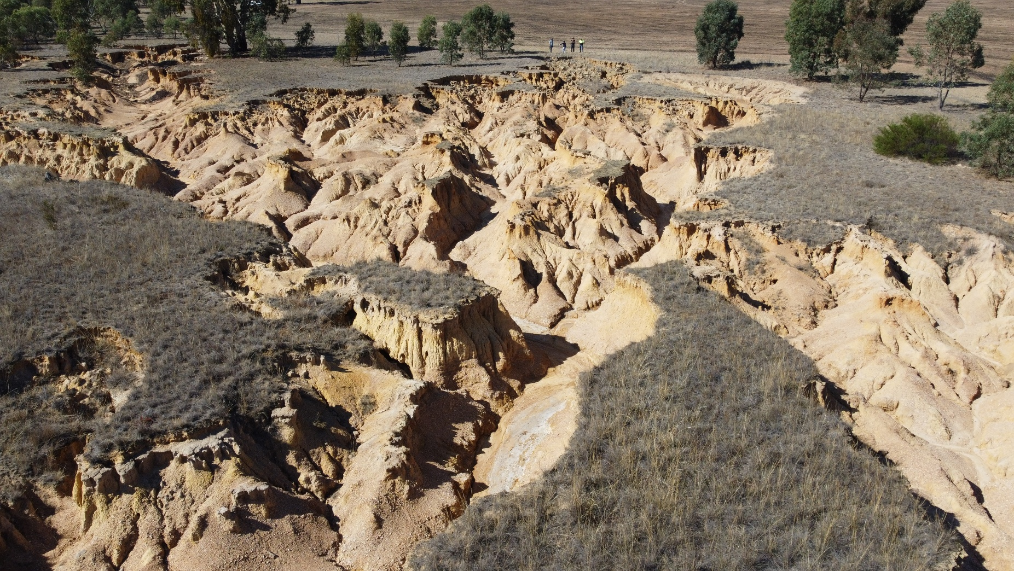
Erosion in a tributary of Salt Creek in the Upper Catchment local area

Water Quality
There are domestic and large irrigation dams that capture water high upstream in the catchment. These dams, mainly used for viticulture and stock watering, can reduce waterway flows and compound water-quality problems in parts of the catchment.
Saline groundwater trickling into creeks during dry conditions also contributes to poor water quality in some streams, although this impact is much reduced in recent times with groundwater levels dropping following successive dry years. Pest fish species including carp (Cyprinus carpio) and mosquito fish (Gambusia holbrooki) also impact water quality.

Hydrology - Climate change and dry conditions
The Wimmera’s future climate is set for reduced rainfall, storm events, variability and increases in average daily temperatures. This is likely to contribute to reduced flows in waterways.
Landscape modifications have altered natural water flow into creeks and streams. Farm dams exacerbate the removal of water from the system. Many landholders value them for their amenity and there is some Landcare interest in enhancing them as wildlife refuges in the highly modified and drying landscape.

Weeds and pest animals
The Wimmera Invasive Plant and Animal Management Strategy identify the ‘Grampians-Pyrenees Arc’ as a high-priority area for invasive plant and animal control. Priorities include:
- Improvement of water quality in tributary streams for the Wimmera River through the reduction in rabbit numbers on steep hill sides and in stream banks, and through the removal of weeds that harbour rabbits such as gorse (Ulex europaeus), blackberry, (Rubus) broom (Cytisus scoparius) and boneseed (Chrysanthemoides monilifera subsp. monilifera).
- Associated improvement in the quality of remnant native vegetation through the removal of these weeds.
- Improvement of quality of riparian vegetation through the removal of blackberry from streams.
Gorse, blackberry, bridal creeper, (Asparagus asparagoides), broom and boneseed are target plant species for removal in the Upper Catchment. Priority areas for weed control are on public land and along high-value streams. Similarly, controlling rabbit and deer (Cervidae) populations in these regions is important for protecting fragile stream banks from erosion.⁽²²⁾
Carp are present in some waterways, requiring ongoing management to protect water quality and native species.

Upper Catchment Wetlands

Wetland values

Environmental values
Waterway-dependent threatened and endangered birds recorded in the area include the Australasian shoveler (Spatula rhynchotis), hardhead duck (Aythya australis), musk duck (Biziura lobata), glossy ibis (Plegadis falcinellus), brolga (Antigone rubicunda), great egret (Ardea alba), freckled duck (Stictonetta naevosa) and royal spoonbill (Platalea regia).
Wal Wal Swamp south of Murtoa receives environmental water via the Wimmera Mallee Pipeline network. Locally, it provides a biodiversity refuge in a highly agricultural landscape for rare, endangered, or poorly known species. Some plant species present include: winged water-starwort (Callirtriche umbonate); ferny small-flower buttercup (Ranunculus pumilio var. politus), annual bitter-cress (Cardamine paucijuga s.s.) and river swamp wallaby-grass (Amphibromus Fluitans).⁽³³⁾ Threatened birds include the eastern great egret (Ardea modesta), spotted harrier (Circus assimilis) and square-tailed kite (Lophoictinia isura).

Social and recreational values
Lakes Lonsdale, Wartook, Bellfield and Fyans closely associated with the Grampians National Park and major tourist destinations, are recreational assets, particularly for fishing, camping, boating and wilderness experiences. Organisers of major events in the catchment often integrate the terrain and vistas as well as facilities associated with the area’s lakes into planning. Access to the lakes’ natural areas improves regional liveability and wellbeing by providing opportunities for people to participate in various forms of outdoor recreation.
All the lakes differ in their appeal. Lake Lonsdale, near Stawell, is renowned for its fish and yabbies when holding water. Neighbouring Lake Fyans also has angling appeal and is a highly attractive camping and water-skiing holiday destination. Lake Fyans’ 9.6 km walking track around its perimeter is also a recreational feature in addition to its many nature tracks.
Lake Bellfield at Halls Gap, and Lake Wartook in the heart of the Grampians National Park, are also renowned angling destinations, and are major features of the Grampians National Park wilderness-holiday experience.

Economic values
Many wetlands have high economic value based on their water-storing role. The Upper Catchment is home to most of the region’s main water storages which supply domestic, stock and environmental water. The largest water storage is Lake Bellfield which can hold 78,500 megalitres. Supported by Taylors Lake near Horsham, it is the main storage for the Wimmera Mallee Pipeline system, and supplies water for towns including Halls Gap and Pomonal, farms, recreational lakes and environmental water for wetlands across the Wimmera-Mallee.
Lake Fyans supplies water to Stawell, Ararat, and Great Western. Lake Wartook is an important water resource for the city of Horsham and township of Natimuk. At maximum capacity it holds 29,300 megalitres, and also provides environmental flows for the MacKenzie River, Burnt Creek and Bungalally Creek.
Recreational lakes support the local economy. Lake Fyans attracted about 20,500 recreational users in 2022-23, providing an estimated economic contribution of $2.9 million. ⁽¹¹⁾ Lake Fyans is one of the most important recreational lakes in the region, hosting several recreational activities including sailing, jet skiing, hunting as well as walking and caravanning opportunities.
Lake Lonsdale also has high recreational value.

Cultural values
Connections between Eastern Maar and Wotjobaluk Nations Peoples and Country are reflected in many ways including artefacts, rock art, scar trees and creation stories featured around Lake Lonsdale, Lake Fyans, Wal Wal Swamp, and other wetlands within Grampians National Park and the Pyrenees range. ⁽³⁴⁾
Protection and respectful management of cultural values associated with Upper Catchment wetlands is a focus of ongoing collaboration, and the Upper Catchment continues to be a place of cultural learning, renewal and responsibility for Wotjobaluk Nations Peoples and Eastern Maar Peoples.

Wetland condition

Pipeline wetlands
Wal Wal Swamp was ranked as ‘Good’ in a 2012 Index of Wetland Condition (IWC) Survey and ‘Moderate’ for the IWC Biota Rating. ⁽³³⁾

Native vegetation
Wetlands within the Grampians National Park are least affected by modification and damage to their neighboring vegetation. Some small reaches of their perimeters support threatened Ecological Vegetation Classes including Wet Heathlands around Lake Wartook; and Valley Grassy Forest/Heathy Woodland Complex, Grassy Dry Forest, and Herb-rich Foothill Forest Complex around Lake Bellfield.
Exiting the confines of public land in the Grampians National Park, Lake Fyans, surrounded by agricultural land, has endangered vegetation communities including Deep Freshwater Marsh, and Plains Grassy Woodland. In addition, it has vulnerable Shallow Sands Herb-rich Woodland and Lateritic Woodland.
Endangered Plains Grassy Woodlands also surround most of Lake Lonsdale, with some portions including Deep Freshwater Marsh. Vulnerable vegetation communities include Heathy Woodland Mosaic, Damp Sand Herb-rich Woodland, and Shallow Sand Woodland.

Threats and drivers of change

Hydrology - Climate change and dry conditions
A drying climate with increasing water extraction and reduced water availability minimises available habitat for native species and waterways’ ability to support economic, cultural, and social values. There are challenges to providing water for some wetlands.
Dry vegetation and hot weather conditions increase the threat of bushfires which remove ground cover, increasing the risk of erosion if major rain events occur before vegetation re-establishes. Rain events can wash ash and sediment into waterways, heightening the risk of ‘black water’ events and fish deaths.
Excess nutrients also promote toxic algal blooms which particularly affect the recreational use of larger lakes. An example is at Lake Lonsdale where high evaporation losses, increases in salinity, and blue-green algal outbreaks impact on recreational activities and environmental flows.

Weeds and pest animals.
Weedy grass species such as Wimmera rye-grass (Lolium rigidum) and Toowoomba canary grass (Phalaris aquatica L) are often prevalent in wetland areas.
Rabbits and foxes (Vulpes vulpes) are attracted to wetlands given they provide a ready source of food and drinking water.⁽³³⁾
Carp, goldfish (Carassius auratus), tench (Tinca tinca) and mosquito fish (Gambusia affinis) threaten native species and overall wetland health across the catchment.

Modifications
Lower regions of the Upper Catchment were highly channelised for water delivery. Natural water flow was modified as a result, directing water away from natural wetlands to man-made dams, or wetlands have been excavated for increased water storage.

Impacts of recreation
Due to the high use of lakes for recreation, it is important to manage access so it is safe and does not impact on biodiversity, water quality and amenity of natural areas. This has been a focus area for Wimmera CMA, councils and recreational user groups.

Stakeholder and community feedback
During development of the Strategy and Implementation Plan, Wimmera CMA invited input from stakeholders and the community. Participants from the Upper Catchment Local Area identified the following waterways as particularly important:

- Wimmera River
- Mount William Creek
- Mount Cole Creek
- Fyans Creek
- Concongella Creek
- Wattle Creek
- Stony Creek
- Pleasant Creek
- Three Mile Creek
- Lake Lonsdale
- Lake Fyans
- Lake Bellfield
- Lake Wartook
- Seasonal wetlands
Stakeholders provided a wide range of suggestions to guide future waterway management across the Local Area. Key themes included:
- Habitat improvement and erosion control: Support for enhancing instream and riparian habitat through fencing, off-stream watering points and measures to reduce bed and bank erosion. Landcare interest in enhancing farms dams to provide habitat for water-dependent native species.
- Biodiversity and species protection: Interest in identifying locations of threatened species, understanding potential habitat benefits, and strengthening weed and pest-management efforts targeting carp, serrated tussock, rabbits, cats, foxes and kangaroos.
- Mount Cole Creek: Strong community and Landcare support for waterway improvements, including providing environmental flows to enhance ecological values and protect drought refuge pools. Stakeholders highlighted the water quality and values supported, with declines observed due to water stored upstream in Mount Cole Reservoir.
- Seasonal freshwater wetlands: Support significant biodiversity. There may be opportunities to remove barriers and enhance flows to these areas as well as improving their protection on private land.
- Sustainable land and water management: Calls to engage farmers in nutrient-retention practices and improve stormwater-fed creek water quality from the Stawell township.
- Connectivity and resilience: Support for linking remnant vegetation and increasing natural disaster-resilience, including identifying high-risk areas and exploring the use of virtual fencing for managing stock in areas tricky to fence or prone to flood and fire.
- Recreation and amenity: The area has terrific recreational lake assets. There is a need to continue to manage them for these values, while managing risks and impacts.
- Community participation: Strong interest in growing Landcare membership and increasing community education on waterways including wetlands, biodiversity, threats and climate change.

Priority locations for management
The Strategy identified the Upper Catchment’s priority waterways for management:

- Upper Wimmera River and tributaries
- Mount Cole Creek and tributaries
- Mount William Creek and tributaries
- Wal Wal Swamp (pipeline watered wetland)
- Wetlands with high environmental value
- Wetlands with high social and economic value, including:
  - Lake Fyans
  - Lake Lonsdale
  - Lake Bellfield
  - Lake Wartook
  - Mount Cole Reservoir
Together, these areas hold the highest ecological, cultural and recreational value and face the greatest management needs. Details of the prioritisation process are described in a supporting document to the Strategy.

Management Activities – Upper Catchment
The following tables include management actions for the Upper Wimmera River and tributaries, Mount William Creek and tributaries and Upper Catchment wetlands.
These actions are intended to be implemented over 10-years from 2026 to achieve the region’s desired outcomes in the Upper Catchment Local Area.
Tables 17 to 22 contain similar management actions according to the following groups:
Rivers and Streams
- Table 17: Enhancing riparian habitat, landscape connectivity, and resilience.
- Table 18: Water-dependent species.
- Table 19: Managing water quality and availability.
Wetlands
- Table 20. Managing water availability for the environment and recreation
- Table 21: Managing pest species
- Table 22: Protecting unmodified wetlands
Some actions contribute to multiple outcomes.
Management actions are shaded green for high priority and orange for medium priority. Actions with no shading are low priority.
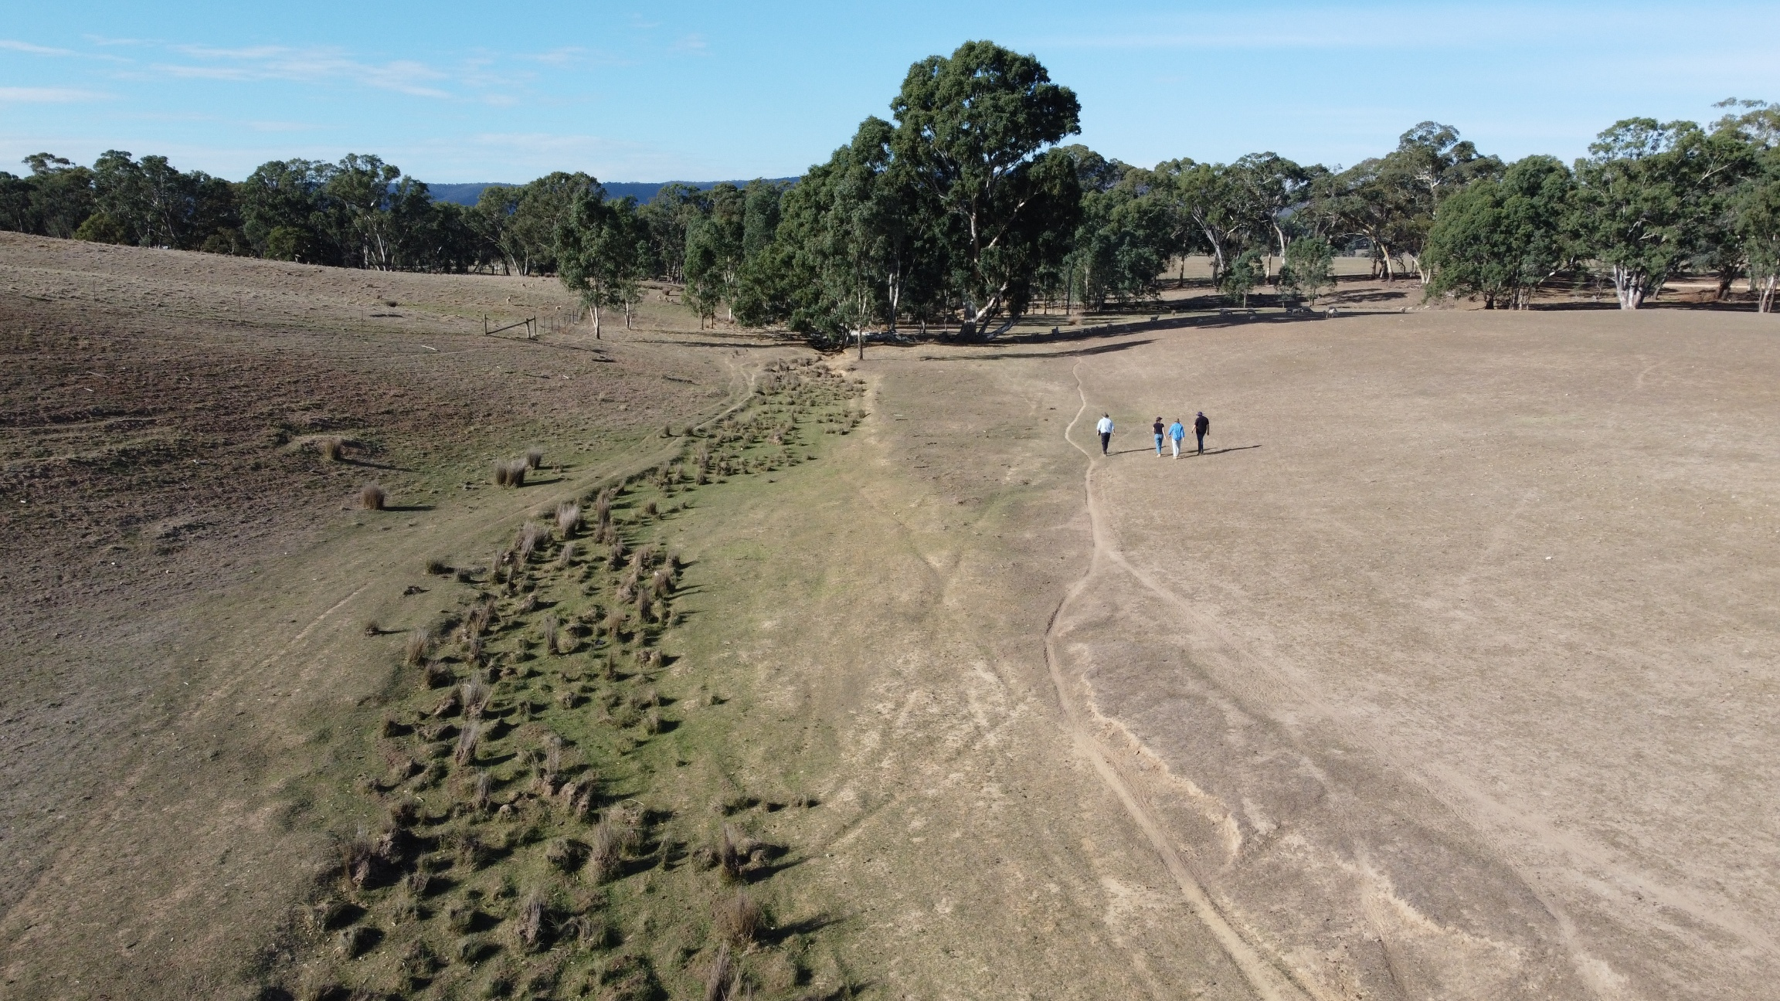
Unless otherwise stated, activities are funded under the Environmental Contribution Levy until 2028. Funding is assumed to be maintained at current levels until 2036.
An upper catchment waterway affected by stock access

Upper Wimmera River and tributaries and Mount William Creek and tributaries

Enhancing riparian habitat, landscape connectivity, and resilience
The actions in Table 17 contribute to the following regional waterway outcomes:
- More waterways have improved management to enhance habitat, landscape connectivity, and resilience.
- Stewardship increases, with more people taking action to care for waterways.
Local Area specific outcomes that contribute to this outcome include:
- Extent of native streamside vegetation is increased.
- More habitat enhancement and revegetation occurs in and around Grampians National Park, large blocks of vegetation and along waterways.
- More eroding waterways are stabilised.
Associated values of the priority locations include:
- Riparian vegetation width and connectivity.
- Water quality and supply.
- Instream species including River Blackfish, Western Swamp Crayfish, Glenelg Spiny Crayfish, Small bodied fish.
- Amenity and recreation.
- Tourism and economy.
- Agricultural productivity.
- Water bird species.
- Cultural connections.
Table 17: Enhancing riparian habitat, landscape connectivity, and resilience.
Waterway location | Management action |  | Amount by 2036 | Responsible parties  (Lead/Partners) | Connection with other plans or strategies | Status
Upper Wimmera River and tributaries  Mount William Creek and tributaries |  | Support private landholders to permanently protect and manage riparian areas on their properties. | TBC | Trust for Nature,  Wimmera CMA,  Landholders | Wimmera Proportion of Waterways Protected – Stage 2 (2024).  Trust for Nature Statewide Conservation Plan 2021-2030. | Continuation of work under the previous regional waterway strategy.  Flagship waterway.
 | Support private landholders to protect, enhance and manage riparian areas. |  | 75 km  760 ha of grazing management | Wimmera CMA,  Landholders | Wimmera Proportion of Waterways Protected – Stage 2 (2024).  Flagship waterway | Continuation of work under the previous regional waterway strategy.  Flagship waterway.
 |  | Control problem invasive fauna in priority riparian areas. | 50 ha (annually) | Wimmera CMA,  Public land managers,  Agriculture Victoria,  Landholders | Waterway Action Plans for creeks including: Concongella,  Glendhu,  Glenlofty,  Glenpatrick,  Millers Creek,  Mount Cole,  Seven Mile,  Shays,  Six Mile,  Spring Creek,  Tuckers Creek,  Wattle Creek,  Wimmera River (reaches 2, 3, 4, 5, 6.1, 6.2)  Wimmera Invasive Plant and Animal Management Strategy | Continuation of work under the previous regional waterway strategy.  Flagship waterway.
 |  | Control problem weeds in priority riparian areas. | 50 ha (annually) | Wimmera CMA,  Public land managers,  Agriculture Victoria,  Landholders |  | Continuation of work under the previous regional waterway strategy.  Flagship waterway.
 |  | Monitor for incursions of new pest plants and animals. Treat incursions to prevent establishment. | 1 partnership per year in collaboration with land managers. | Wimmera CMA,  Public land managers,  Agriculture Victoria,  Landholders |  | Continuation of work under the previous regional waterway strategy.  Flagship waterway.
Mount William Creek |  | Increase community understanding of management of the Lake Lonsdale and Mount William Creek system. | TBC | Wimmera CMA,  GWMWater,  Private Landholders,  VEWH |  | Continuation of previous work.

Supporting key water-dependent species
The actions in Table 18 contribute to the following regional waterway outcomes:
- Key water-dependent species are supported in waterways that provide suitable habitat, including during dry conditions.
- More waterways have improved management to enhance habitat, landscape connectivity, and resilience.
Local Area specific outcomes that contribute to this outcome include:
- No new pest plants and animals are established beyond small, localised populations.
Associated values of the priority locations include:
- Riparian vegetation and connectivity.
- Riparian and water bird species.
- Amenity and recreation.
- Cultural connections.
- Trail walking and cycling trail, recreational fishing.
- Tourism and economy.
Table 18: Supporting key water-dependent species.
Waterway location |  | Management action | Amount by 2036 | Responsible parties  (Lead/Partners) | Connection with other plans or strategies | Status
Upper Wimmera River, Mount William Creek and their tributaries |  | Manage European carp according to whole of catchment Management Actions in Table 37. | Refer to whole-of-catchment management section | Wimmera CMA | Wimmera Carp Management Plan.  Wimmera Native Fish Management Plan. | Continuation of existing work.

Managing water quality and availability
The actions in Table 19 contribute to the following regional waterway outcomes:
- Risks to water quality in Wimmera waterways are managed where possible to reduce impacts on values.
- Drought refuges support species’ survival and resilience during dry periods.
Local Area specific outcomes that contribute to this outcome include:
- Water for the environment maintains or improves habitat values in Mount Cole Creek.
Associated values of the priority locations include:
- Drought resilience.
- Biodiversity connectivity.
- Birdlife, frogs, and native fish habitat.
- Cultural connections.
- Amenity and recreation
- Aquatic species including freshwater catfish, golden and silver perch, river blackfish, platypus, western swamp crayfish, Glenelg spiny crayfish, southern pygmy perch, obscure galaxias.
Table 19: Managing water quality and availability.
Waterway location | Management action | Amount by 2036 | Responsible parties  (Lead/Partners) | Connection with other plans or strategies | Status
Upper Wimmera River, Mount William Creek and tributaries  (This instance also includes MacKenzie River, Burnt Creek, Bungalally Creek, Horsham Weir Pool and Mid-Wimmera River of the Horsham Local Area) | Develop annual Seasonal Watering Proposals for the Wimmera River system. | 10 proposals | Wimmera CMA, GWMWater,  VEWH,  CEWH,  Local Government. | Environmental Water Management Plan - Wimmera River, Yarriambiack Creek and their terminal lakes. | Continuation of existing arrangements.
 | Deliver environmental water in line with the annual Seasonal Watering Plan for the Wimmera River system. | Volume and number of waterways depends on annual watering entitlement | Wimmera CMA  DEECA,  GWMWater,  VEWH .  CEWH |  | Continuation of existing arrangements.
Mount Cole Creek | Develop annual Seasonal Watering Proposals for Mount Cole Creek drought refuge pools. | 10 proposals | Wimmera CMA, GWMWater,  VEWH,  CEWH,  Local Government. | Environmental Water Management Plan.  Victorian Environmental Water Holder's annual Seasonal Watering Plans. | Watering connection completed in 2026, enabling environmental watering of drought refuges when needed during dry periods.
Mount Cole Creek | Deliver environmental water to drought refuges during drought scenarios as guided by the Victorian Environmental Water Holder's annual Seasonal Watering Plans. Monitor the outcomes of providing this water. | As needed during dry periods and in line with the VEWH’s annual Seasonal Watering Plans. | Wimmera CMA,  VEWH,  GWMWater
Mount William Creek and Wimmera River | Modify Mount William Creek/Wimmera River Inlet Channel to improve the ability to direct flows into the Wimmera River. | 1 inlet channel improved | Wimmera CMA,  GWMWater |  | New action.
Upper Wimmera River and its tributaries | Monitor water quality. | 10 sites monitored | Wimmera CMA | Wimmera CMA’s Water Quality Monitoring Review. | Continuation of existing arrangements.
Upper Wimmera River and its tributaries | If water quality poses a risk of blue green algae and/or fish deaths, manage water quality with environmental flows in consultation with the Victorian Environmental Water Holder if sufficient water is available. | As needed. | Wimmera CMA |  | Continuation of existing arrangements.

Upper Catchment Wetlands

Managing water availability for the environment and recreation
The actions in Table 20 contribute to the following regional waterway outcomes:
- More waterways have improved management to enhance habitat, landscape connectivity, and resilience.
- More waterways provide improved recreational opportunities and amenity while minimising impacts on environmental values.
- Stewardship increases, with more people taking action to care for waterways.
Associated values of the priority locations include:
- Habitat connectivity and enhancement.
- Cultural connections.
- Amenity and recreation.
- Community engagement and education.
Table 20. Managing water availability for the environment and recreation.
Waterway location | Management action |  | Amount by 2036 | Responsible parties  (Lead/Partners) | Connection with other plans or strategies | Status
Fyans, Lonsdale, Bellfield, and Wartook Lakes | Upgrade boating facilities in Wimmera catchment storages, for example by lengthening boat ramps. |  | n/a | GWMWater,  Victorian Fisheries Authority |  | Continuation of existing arrangements.
Lake Lonsdale | Develop an agreed management tool for Lake Lonsdale. |  | TBC | Wimmera CMA,  VEWH,  GWMWater,  Northern Grampians Shire Council,  Friends of Lonsdale | Environmental Water Management Plan. | New action.
Lake Lonsdale | Increase community understanding of management of Lake Lonsdale and Mount William Creek.  Increase understanding of how it's operated. |  | As needed | Wimmera CMA,  VEWH,  GWMWater,  Private Landholders |  | New action.
Lake Lonsdale | Establish a more functional dam wall and outlet at Lake Lonsdale that maximises social, environmental and economic values. |  | One dam wall and outlet improved | GWMWater,  Wimmera CMA |  | Planning underway.
Wal Wal Swamp (One of 13 Wimmera Mallee pipeline wetlands) | Develop annual Seasonal Watering Proposals for Wimmera Mallee pipeline wetlands. |  | 10 proposals  (comprised of 1 proposal annually) | Wimmera CMA, GWMWater,  VEWH,  CEWH,  Local Government. | Environmental Water Management Plan – Wimmera Mallee Pipeline Wetlands – Wimmera CMA Region. | Continuation of existing arrangements.
Wal Wal Swamp (One of 13 Wimmera Mallee pipeline wetlands) | Develop annual Seasonal Watering Plans for Wimmera Mallee pipeline wetlands. |  | 10 plans  (comprised of 1 plan annually) | VEWH,  Wimmera CMA,  GWMWater,  VEWH,  CEWH,  Local Government. |  | Continuation of existing arrangements.
Wal Wal Swamp (One of 13 Wimmera Mallee pipeline wetlands) | Deliver environmental releases to Wimmera Mallee pipeline wetlands in line with annual Seasonal Watering Plans. |  | The volume (ML) of water delivered and number of waterways depends on annual watering entitlements | Wimmera CMA,  GWMWater,  VEWH,  CEWH, |  | Continuation of existing arrangements.
Wal Wal Swamp (One of 13 Wimmera Mallee pipeline wetlands) |  | Improve pipeline outlets into Wal Wal Swamp to allow more efficient and effective supply of water. | 1 outlet improved | Wimmera CMA,  Parks Vic VEWH,  GWMWater |  | New action.

Managing pest species
The actions in Table 21 contribute to the following regional waterway outcomes:
- More waterways have improved management to enhance habitat, landscape connectivity, and resilience.
Associated values of the priority locations include:
- Amenity and recreation.
- Cultural connections.
- Native wildlife and flora.
- Agricultural productivity.
Table 21: Managing pest species.
Waterway location | Management action |  | Amount by 2036 | Responsible parties  (Lead/Partners) | Connection with other plans or strategies | Status
All wetlands | Control invasive fauna in wetlands. |  | 100 ha | Parks Victoria, Wimmera CMA | Wimmera Invasive Plant and Animal Management Strategy. | Continuation of work under the previous regional waterway strategy.
All wetlands |  | Monitor for incursions of new pest plants and animals. Treat incursions to prevent establishment. | 1 partnership per year in collaboration with land managers. | Wimmera CMA, Parks Victoria,  Local Government,  Landcare,  Landholders | Wimmera Invasive Plant and Animal Management Strategy.
All wetlands |  | Control weeds in priority wetland areas. | 100 ha | Parks Victoria,  Wimmera CMA | Wimmera Invasive Plant and Animal Management Strategy.

Protecting unmodified wetlands
The actions in Table 22 contribute to the following regional waterway outcomes:
- Wetland modification, loss and deterioration of condition occurs at a declining rate.
- More waterways have improved management to enhance habitat, landscape connectivity, and resilience.
- Stewardship increases, with more people taking action to care for waterways.
Associated values of the priority locations include:
- Herb rich communities.
- Amenity and recreation.
- Cultural connections.
- Native wildlife and flora.
- Agricultural productivity.
Table 22: Protecting unmodified wetlands.
Waterway location | Management action | Amount by 2036 | Responsible parties  (Lead/Partners) | Connection with other plans or strategies | Status
All wetlands | Implement community education activities to increase awareness of cropping, grazing and drainage impacts on wetlands, the values of wetlands and appropriate conservation management techniques. | TBC | Wimmera CMA,  Landcare | Wimmera Wetland Asset Strategy. | New action.
Private wetlands | Support private landholders to protect and manage wetlands on their properties. | TBC | Wimmera CMA,  Trust for Nature  Private landholders | Trust for Nature’s Statewide Conservation Plan 2021-2030. | Continuation of work under the previous regional waterway strategy.
Private wetlands | Increase community and landholder awareness of the value of wetlands and appropriate conservation management techniques. | TBC | Wimmera CMA,  Landcare,  Trust for Nature | Wimmera Wetland Asset Strategy. | Continuation of work under the previous regional waterway strategy.

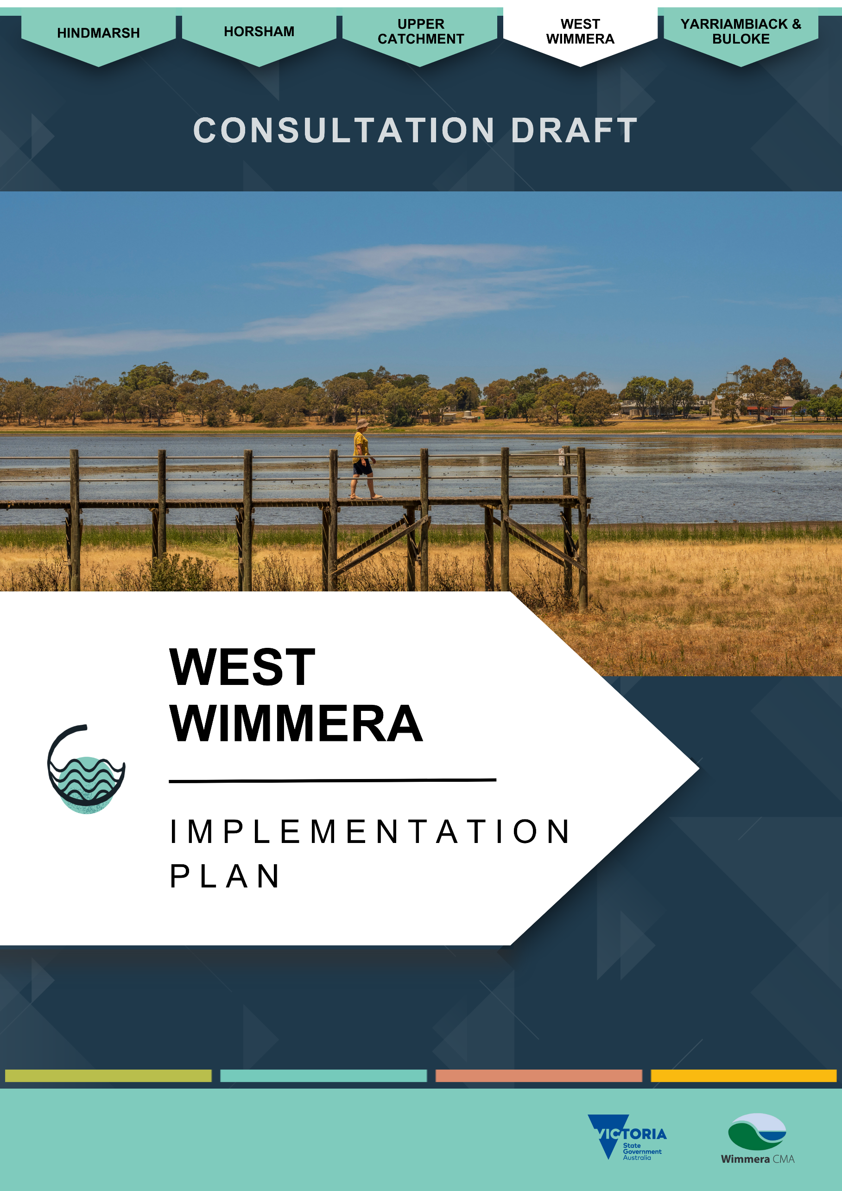

West Wimmera Implementation Plan

About the West Wimmera Local Area
The West Wimmera Local Area, located roughly halfway between Melbourne and Adelaide along the Victoria–South Australia border, is the largest region within the Wimmera catchment. It contains the majority of the catchment’s wetlands, which are highly diverse in type, vegetation, wildlife, and waterbird species.
The region is geographically divided by the Little Desert, creating distinct northern and southern landscapes. South of the Little Desert National Park receives higher rainfall - around 615 mm per year - while the north is considerably drier, averaging around 475 mm per year and supporting fewer seasonal wetlands.
Edenhope is the largest town in the West Wimmera municipality, followed by Kaniva (see Figure 6). West Wimmera has approximately 4,000 residents.⁽³⁵⁾
Agriculture is the primary land use and economic activity. Farming enterprises use 44% of West Wimmera for cropping and 25% for grazing of modified pastures. South of the Little Desert, broadacre cropping and sheep farming are most common. Irrigated crops and pasture cover about 5.5% of land. Nature conservation makes up 15.5% of land use.⁽³⁶⁾
The West Wimmera region has the greatest use of groundwater for irrigation compared to other regions of the Wimmera catchment. This allows for the addition of water-dependent agriculture, such as vegetable production, in addition to cereals grown throughout the catchment. However, this can impact waterways and wetlands relying on this groundwater.
Given the abundance of wetlands, remnant vegetation, and associated wildlife across West Wimmera, the area holds strong cultural connections for First Nations Peoples.

Rivers and streams
The Wimmera Waterway Strategy recognises many small streams in West Wimmera. These streams are small and only flow following high-volume runoff. These include Thompson, Yalla, Koijak, Mosquito, Morambro, and Naracoorte creeks which transport water into South Australia. In the northern part of West Wimmera, waterways are less common; however, chains of wetlands occur, such as those near Lawloit Ridge. Small creeks connect these wetland systems, and larger waterways such as Tatiara and Nalang creeks may also flow west into South Australia, though typically only during very wet years.
In the area’s south-west, Mosquito Creek feeds into the Ramsar-listed Bool and Hacks Lagoons in South Australia, making it a priority for the district. This stream has supported growling grass frogs (Litoria raniformis) and native fish, including the carp gudgeon (Hypseleotris spp) and flathead gudgeon (Philypnodon grandiceps). Historically, it had a reliable base flow from groundwater available, however this is now rare, which threatens the creek’s ability to support water-dependent species in the future.

Wetlands
The West Wimmera is unique due to the myriads of seasonal wetlands in its landscape. While many wetlands are protected in parks and reserves, thousands of smaller, more seasonal wetlands exist on private land.
The West Wimmera Local Area is home to about 66% of the Wimmera’s wetlands - more than 2,100. Many are shallow seasonal wetlands that fill following winter and spring rainfall and dry out during summer and early autumn. There are more than 50 saline wetlands and numerous deep, more permanent open freshwater bodies.
There is a large amount of native vegetation remaining in and south of the Little Desert. This provides good habitat connectivity on a north–south axis, with an alternating dune-swale system supporting hydrologically connected chains of wetlands in the swales, and many of the larger patches of native vegetation connected via the dunes.
Many of region’s wetlands are important for providing unique habitat for diverse bird species. Many species are threatened, including the brolga (Antigone rubicunda) and freckled duck (Stictonetta naevosa). However, most wetlands are isolated and within extensive agricultural land. This has led to compounding threats and varying levels of capability to support ecological function.

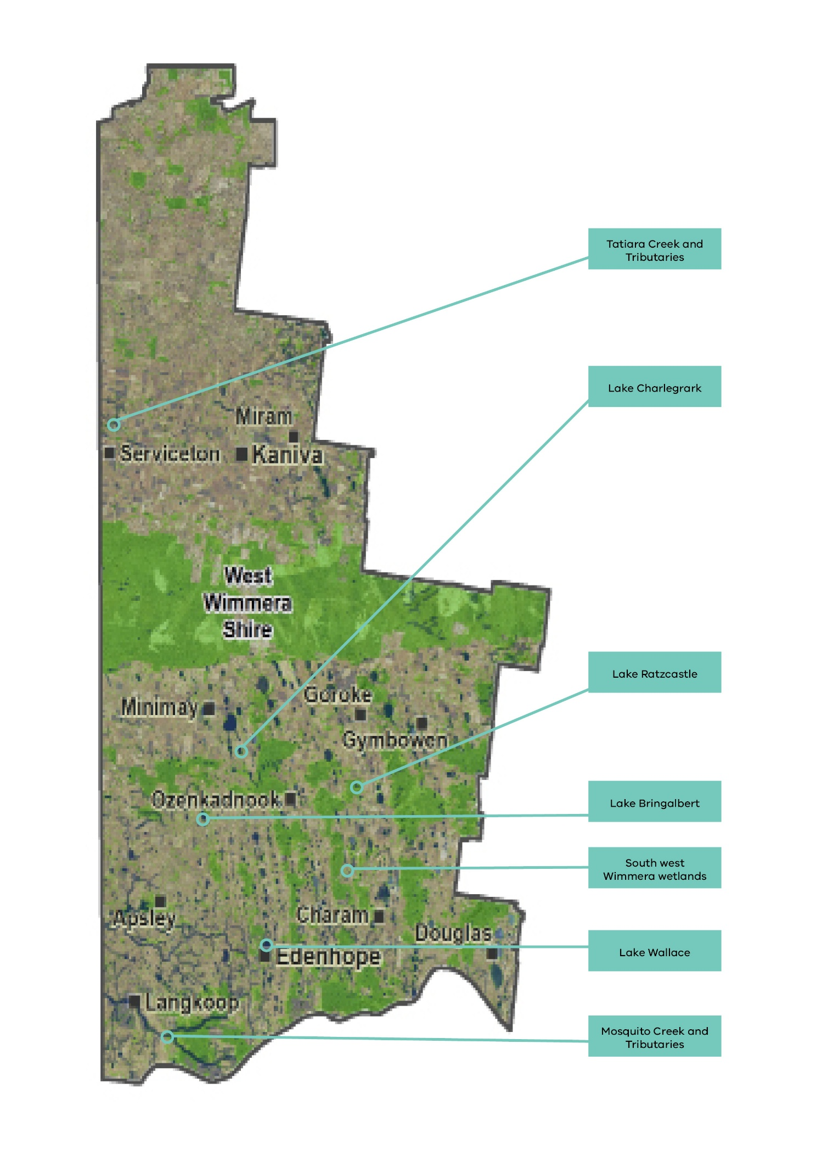
Figure 6. West Wimmera local area.

Mosquito Creek and Tributaries and other west-flowing streams

Stream Values

Environmental values
Mosquito Creek and its tributaries are of high environmental value because they historically provide inflows into the Bool and Hacks Lagoon Ramsar Site in South Australia. Threatened species including Yarra pygmy perch (Nannoperca obscura), southern bell frogs (Rainoidea raniformis) and dwarf galaxias (Galaxiella pusilla) have been recorded in Mosquito Creek. The vulnerable yellow-bellied glider (Petaurus australis) has also been recorded in the creek’s riparian vegetation, in Meereek State Forest and farmland. However, Mosquito Creek no longer, or rarely, receives its historic base flow which reduces its ability to support these environmental values.
Upper Mosquito Creek’s riparian vegetation consists of Endangered Creekline Sedgy Woodland and Plains Woodland. Into the lower stretches, it transitions to Vulnerable Riparian Woodland with fragments of Plains Woodland and Endangered Creekline Grassy Woodland along its tributaries. Endangered Drainage-line Woodland and Escarpment Shrubland also exists along streams in the north towards the Little Desert National Park.

Social and recreational values
Seasonal duck hunting is permitted along specific sections of waterbodies and on public land in accordance with Game Management Authority guidelines.
Given the ephemeral nature of the West Wimmera’s streams, social and economic values are limited. Local residents value the streams in their local areas.

Economic values
West Wimmera’s streams struggle to receive sufficient water because of a combination of land modification, climate change and reduced groundwater. This limits their economic value due to their reduced ability to support water supply for stock and domestic purposes and provide an outlet for tourism and recreation.
However, it is still important to highlight the significance of Tatiara Creek, important for the water supply to Bordertown in South Australia.

Cultural values
Connections between First Nations People and Country are reflected in many ways including artefacts, scar trees and creation stories featured around wetlands, remnant vegetation and associated wildlife of the West Wimmera Local Area. Protection and respectful management of cultural values associated with West Wimmera Local Area sites is a focus of ongoing collaboration.

Stream condition
The 2010 Index of Stream Condition regarded West Wimmera Local Area rivers and streams as having insufficient data to gather accurate condition scores. Only one stream received a score, with the longest reach of the Mosquito Creek being in ‘moderate’ condition.

Threats and drivers of change

Hydrology - Climate change and dry conditions
Reports indicate Mosquito Creek previously had a consistent base flow supported by groundwater. However, due to the increased demand for groundwater for irrigation, stock and domestic purposes and forestry in the region, along with reduced recharge, the water table has lowered beyond the creek’s reach. This means Mosquito Creek flows intermittently, following sufficient rainfall generating runoff.

Weeds and pest animals
The Wimmera Invasive Plant and Animal Strategy identifies that the control of bridal creeper (Asparagus asparagoides), other weeds and rabbits will improve the quality of remnant-threatened vegetation communities.⁽²²⁾

South-west Wimmera and Northern Wimmera Plains (western section) Wetlands

Wetland Values

Environmental values
The substantial number of wetlands in the West Wimmera are of very high value. Long chains of wetlands provide connectivity for frogs, birds and native vegetation.
Many waterbirds, including threatened species such as brolgas (Antigone rubicunda) and freckled ducks (Stictonetta naevosa), rely on these wetlands for habitat and breeding locations.
Saline lakes of the ‘Natimuk-Douglas Chain of Lakes’ provide unique habitat to support internationally significant numbers of bird species including banded stilts (Cladorhynchus leucocephalus), red-capped plovers (Charadrius ruficapillus) and red-kneed doteralls (Erythrogonys cinctus). ⁽³⁷⁾ These lakes also provide habitat for many migratory species including the ‘endangered’ common greenshank (Tringa nebularia), ‘near-threatened’ red-necked stint (Calidris ruficollis), ‘vulnerable’ sharp-tailed sandpiper (Calidris acuminata), and ‘critically endangered’ curlew sandpiper (Calidris ferruginea).⁽³⁸⁾ These species are listed in international migratory bird agreements including Japan-Australia Migratory Bird Agreement, China-Australia Migratory Bird Agreement, and the Republic of Korea-Australia Migratory Bird Agreement.
The region contains threatened Seasonal Herbaceous Wetlands (Freshwater) of the Temperate Lowland Plains, listed as critically endangered under the Commonwealth Environment Protection and Biodiversity Conservation Act 1999.
Extensive endangered Plains Woodland Ecological Vegetation Class interacts with most West Wimmera wetlands. There are also scattered depleted Brackish Lake Aggregates and Heathy Herb-rich Woodlands. ⁽⁷⁾

Social and recreational values
The West Wimmera is renowned for its wetlands, and the filling of lakes after a season of heavy rain provides a spark for regional confidence, activity and tourism. Larger wetlands, including lakes Wallace, Charlegrark, Ratzcastle and Bringalbert, have significant regional recreational and social value.
Lake Wallace, at Edenhope, has annual events including the Edenhope Fishing Competition and the ‘Henley on Lake Wallace’ festival. Being a central focus of Edenhope, with 70 houses and many other facilities with lakeside views, it directly affects the amenity, tourism and liveability of the area. In 2022-23 total recreational water facility users totalled 16,100. ⁽¹¹⁾
Lake Charlegrark has only dried twice in recorded history - 1870-1877 and 2005-2009. It therefore provides a reliable outlet for recreation, particularly boating and angling. There are camping and water-activity facilities including powered camping and self-contained cottages. ⁽¹¹⁾ The lake also hosts annual events including the Lake Charlegrark Country Music Marathon.
Lakes Bringalbert and Ratzcastle have less water reliability with fewer camping facilities compared to the other large lakes and receive lower numbers of recreational participants. But they too generate a district community ‘buzz’ for people keen to soak up social as well as environmental benefits that water provides.

Economic values
Lake Wallace makes the greatest economic contribution of West Wimmera lakes with a total contribution of $293,700 to the local economy. Lake Charlegrark follows with $174,600, then lakes Ratzcastle and Bringalbert with $30,600 and $49,000 respectively.
These lakes are a drawcard for tourism with over 70% of recreational users not living in the West Wimmera Local Area. ⁽¹¹⁾

Cultural values
Given the abundance of wetlands, remnant native vegetation and associated wildlife that remains across the West Wimmera there continues to be a strong connection between Country and First Nations People. Lakes including Lake Ratzcastle are associated with significant Aboriginal cultural heritage values.

Wetland condition

Native vegetation
Native vegetation in the region’s many shallow seasonal wetlands is highly diverse, with water-dependent species booming during wet years. Most West Wimmera wetlands are located on agricultural land and where riparian native vegetation is highly fragmented.
Wetland monitoring shows that wetland vegetation conditions vary considerably, depending on the history of land use and management. Wetland vegetation on public land is typically in good to excellent condition, but varies more broadly on private land, with many grazed wetlands exhibiting good condition and diversity when wet, while cropped wetlands are in poor condition.
The presence of hollows in large trees including river red gums surrounding many lakes and wetlands provide nesting opportunities for arboreal mammals and hollow-nesting bird species such as the Critically Endangered South-eastern Red-tailed Black Cockatoo (Calyptorhynchus banksii graptogyne) and some waterbirds.
Habitat in the west of the region is known to support the vulnerable growling grass frog (Litoria ranifornmis), with sightings increasing during wet years. ⁽³⁹⁾
Extensive endangered Plains Woodland Ecological Vegetation Class interacts with most West Wimmera wetlands. There are also scattered rare depleted Brackish Lake Aggregates and Heathy Herb-rich Woodlands. ⁽⁷⁾

Threats and drivers of change

Climate change and dry conditions
In a drying and unpredictable climate with increasing water extraction, reduced water availability threatens water quality and its ability to support priority values.
The recreational opportunities provided by wetlands in the West Wimmera are strongly influenced by climate and land use. Many local wetlands, particularly those with small catchments, do not contain water for as long as they once did. For example, Lake Wallace at Edenhope has shown to be at risk of a changed hydrologic regime due to climate change and improved agricultural practices to retain soil moisture.⁽¹⁵⁾
Increased rainfall is also expected which risks excess nutrients from agricultural runoff entering wetlands promoting algal blooms. This can affect the recreational use of larger lakes. Lakes Wallace, Ratzcastle, Charlegrark and Bringalbert are the most popular lakes for recreation which have all been impacted by blue-green algae. The economic benefits from the lakes are affected by water levels and water quality.

Weeds and pest animals.
The Wimmera Invasive Plant and Animal Strategy identifies that control of bridal creeper, other weeds and rabbits will improve the quality of remnant threatened vegetation communities. ⁽²²⁾ Landcare group members have observed deer populations growing and expanding into new areas, potentially impacting on waterways.
Ribbon weed affected the usability of Lake Wallace for recreation, impacting boat access.

Modifications
There are 2,174 wetlands in the West Wimmera, and 610 of these have no modification. In 2017, 514 wetlands were cropped compared to 235 in 2004. Dams in wetlands increased from 786 to 963 between 2004 and 2017. The Victoria Land Cover Time Series indicates that between 1985 and 2019 seasonal wetlands reduced in area from 22,000 to 18,000 hectares.⁽²⁵⁾ This indicates there was a continued impact on wetlands natural processes during this period.
The cropping or modification of wetlands reduces their ability to provide environmental benefits. This is most evident in the West Wimmera’s shallow seasonal wetlands. ⁽⁴⁰⁾

Impacts of recreation
Managing community access to waterways so that it is safe and does not impact on biodiversity, water quality and amenity of natural areas has been a focus for Wimmera CMA, councils and community groups.
The community has a strong desire to access public areas for recreation, particularly waterways. This access contributes to liveability and opportunities to improve the economy through tourism and recreation. For example, West Wimmera Shire Council and partner organisations developed a management plan for Lake Wallace to ensure the lake is developed and used in a way that sustains its values. ⁽⁴⁰⁾

Stakeholder and community feedback
Wimmera CMA invited stakeholders and community members to contribute to Strategy development. Stakeholders in the West Wimmera Local Area highlighted the following waterways as important:
- Mosquito Creek
- Tatiara Creek
- Lake Wallace
- Lake Charlegrark
- Lake Bringalbert
- Lake Ratzcastle
- Miga Lake
Key points included:
- Explore the use of ground water or pipeline for wetland water supply, and/or use of integrated water management strategies.
- Reduce the threat of blue-green algae.
- Explore improvements in forestry licensing management.
- Update Index of Wetland Condition data.
- Identify and protect priority wetlands. Protect shallow wetlands on private land.
- Provide incentives and improve landholder engagement to prevent stock access and modification to streams and wetlands.
- Manage invasive species and prevent their spread.
- Identify locations of threatened species and work to protect them.
- Implement or support plans of management for priority recreational lakes.
- Implement strategies to promote more appropriate use of wetlands and reserves for recreation.
- Improve current, or help with the development of new, recreational facilities at priority wetlands.

Priority locations for management
The Strategy identified the West Wimmera’s priority waterways for management:

- Wetlands with high environmental value
- Seasonal Herbaceous Wetlands (Freshwater) of the Temperate Lowland Plains
- Mosquito Creek and tributaries
- Tatiara Creek and tributaries
- Wetlands with high social and economic value, including:
  - Lake Wallace
  - Lake Charlegrark
  - Lake Ratzcastle
  - Lake Bringalbert

Together, these areas hold the highest ecological, cultural and recreational value and face the greatest management needs. Details of the prioritisation process are described in a supporting document to the Strategy.

Management Activities – West Wimmera
The following tables include management actions for the Mosquito Creek and Tributaries and other west-flowing streams and South-west Wimmera and Northern Wimmera Plains (western section) Wetlands.
These actions are intended to be implemented over 10-years from 2026 to achieve the region’s desired outcomes in the West Wimmera Local Area.
Tables 23 to 26 contain similar management actions according to the following groups:
Rivers and Streams
- Table 23: Enhancing riparian habitat, landscape connectivity, and resilience.
Wetlands
- Table 24. Managing large public wetlands
- Table 25: Managing pest species
- Table 26: Enhancing wetland habitat, connectivity, and resilience.
Some actions contribute to multiple outcomes.
Management actions are shaded green for high priority and orange for medium priority. Actions with no shading are low priority.
Unless otherwise stated, activities are funded under the Environmental Contribution Levy until 2028. Funding is assumed to be maintained at current levels until 2036.
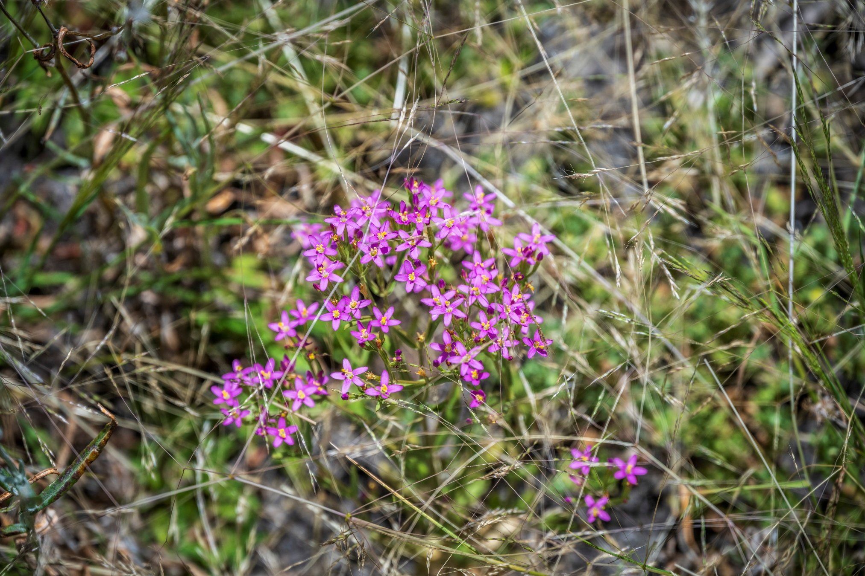
Native herb, spike centaury (Schenkia Australia), at Lake Wartook

Mosquito Creek and Tributaries and other west-flowing streams

Enhancing riparian habitat, landscape connectivity, and resilience
The actions in Table 23 contribute to the following regional waterway outcomes:
- More waterways have improved management to enhance habitat, landscape connectivity, and resilience.
- Healthier waterways enable more On Country activities for First Nations People.
- Stewardship increases, with more people taking action to care for waterways.
Local Area specific outcomes that contribute to this outcome include:
- Revegetation contributes to connectivity, carbon storage and land productivity.
- No new pest plants and animals are established beyond small, localised populations.
- Impacts of weeds, herbivores and pest predators on habitat and wildlife are reduced.
Associated values of the priority locations include:
- Water quality
- Amenity and recreation
- Cultural connections
- Habitat connectivity
- Native species habitat
- Agricultural productivity
Table 23: Enhancing riparian habitat, landscape connectivity, and resilience.
Waterway location | Management action | Amount by 2036 | Responsible parties  Lead/Partners | Connection with other plans, strategies and investigations | Status
Mosquito and Tatiara Creeks and tributaries – unprotected sections on private land. | Support private landholders to permanently protect and manage riparian areas on their properties. | TBC | Trust for Nature,  Wimmera CMA,  Private landholders | Trust for Nature’s Statewide Conservation Plan 2021-2030. | Continuation of work under the previous regional waterway strategy.
 | Support land managers to protect, enhance and manage riparian areas. | 10 km  50 ha | Wimmera CMA,  Private landholders,  Public Land managers | Wimmera Proportion of Waterways Protected – Stage 2. | Continuation of work under the previous regional waterway strategy.
Mosquito Creek and tributaries and public riparian reserves | Control problem weeds in priority riparian areas. | 50 ha (annually) | Wimmera CMA,  Public Land Managers,  Agriculture Victoria,  Landholders | Wimmera Invasive Plant and Animal Management Strategy. | Continuation of work under the previous regional waterway strategy.
Mosquito Creek and tributaries and public riparian reserves | Control problem invasive fauna in priority riparian areas. | 50 ha annually |  | Wimmera Invasive Plant and Animal Management Strategy.

South-west Wimmera and Northern Wimmera Plains (western section) Wetlands

Managing large public wetlands
The actions in Table 24 contribute to the following regional waterway outcomes:
- More waterways provide improved recreational opportunities and amenity while minimising impacts on environmental values.
- Stewardship increases, with more people taking action to care for waterways.
Local Area specific outcomes that contribute to this outcome include:
- Waterway user participation numbers are maintained or improved at Lakes Wallace, Charlegrark, Ratzcastle and Bringalbert when water levels are adequate.
Associated values of the priority locations include:
- Community recreation and amenity.
- Tourism.
- Cultural connections.
- Yabbying and fishing.
- Water quality.
- Wetland habitat connectivity.
- Wetland biodiversity and habitat for birds, fish and frogs.
Table 24. Managing large public wetlands.
Waterway location | Management action | Amount by 2036 | Responsible parties  (Lead/Partners) | Connection with other plans, strategies and investigations | Status
Public wetlands including Lakes Wallace, Charlegrark, Ratzcastle, Bringalbert. | Improve infrastructure and sustainable management of recreational lakes. | TBC | West Wimmera Shire Council,  Committees of Management,  Wimmera CMA,  Public land managers | Conservation Action Plan for parks and reserves managed by Parks Victoria – Wimmera.  Lake Wallace Strategic Plan 2022-2032. | New action.
 | Increase recreational user awareness of low impact recreation at wetlands. | TBC | Wimmera CMA,  DEECA,  Parks Victoria  Landcare |  | New action.
Lake Wallace | Manage ribbon weed to enable boating access for recreational fishing. | As required  1 partnership | West Wimmera Shire Council,  Wimmera CMA | Lake Wallace Strategic Plan 2022-2032. | Continuation of existing work.
Lake Charlegrark | Develop a management plan for Lake Charlegrark to support sustainable social, economic, cultural and environmental outcomes. | 1 management plan | Lake Charlegrark Foreshore Committee,  Parks Victoria,  West Wimmera Shire Council, Wimmera CMA |  | New action.
Lake Bringalbert | Develop a management plan for Lake Bringalbert to support sustainable social, economic, cultural and environmental outcomes. | 1 management plan | Wimmera CMA,  Bringalbert Foreshore Committee,  Friends of Lake Bringalbert,  Parks Victoria,  West Wimmera Shire Council, Wimmera CMA |  | New action.

Managing pest species
The actions in Table 25 contribute to the following regional waterway outcomes:
- More waterways have improved management to enhance habitat, landscape connectivity, and resilience.
Local Area specific outcomes that contribute to this outcome include:
- Impacts of weeds, herbivores and pest predators on habitat and wildlife are reduced.
- No new pest plants and animals are established beyond small, localised populations.
Associated values of the priority locations include:
- Recreation and amenity.
- Agricultural productivity.
- Native species protection.
- Cultural connections.
Table 25: Managing pest species.
Waterway location | Management action | Amount by 2036 | Responsible parties  (Lead/Partners) | Connection with other plans, strategies and investigations | Status
All wetlands | Control problem invasive fauna at priority wetlands. | 50 ha (annually) | Wimmera CMA,  DEECA,  Parks Victoria  Landcare | Wimmera Invasive Plant and Animal Management Strategy. | Continuation of work under the previous regional waterway strategy.
All wetlands | Control problem weeds in priority wetland areas. | 50 ha (annually) | Wimmera CMA,  DEECA,  Parks Victoria  Landcare | Wimmera Invasive Plant and Animal Management Strategy.

Enhancing wetland habitat, connectivity, and resilience
The actions in Table 26 contribute to the following regional waterway outcomes:
- More waterways have improved management to enhance habitat, landscape connectivity, and resilience.
- Wetland modification, loss and deterioration of condition occurs at a declining rate.
- Stewardship increases, with more people taking action to care for waterways.
Local Area specific outcomes that contribute to this outcome include:
- Revegetation contributes to connectivity, carbon storage and land productivity.
- More areas are permanently protected for biodiversity with a priority given to endangered habitat like shallow seasonal wetlands, grasslands and woodlands.
Associated values of the priority locations include:
- Habitat connectivity.
- Supporting native species.
- Recreation and amenity.
- Agricultural productivity.
- Cultural connections.
Table 26: Enhancing wetland habitat, connectivity, and resilience.
Waterway location | Management action | Amount by 2036 | Responsible parties  (Lead/Partners) | Connection with other plans, strategies and investigations | Status
All wetlands | Revegetate areas that enhance wetland connectivity. | TBC | Wimmera CMA,  Landcare,  Greening Australia | Investigating Priorities for Wetland Connectivity in the Wimmera CMA region. | Continuation of work under the previous regional waterway strategy.
Seasonal Herbaceous Wetlands (Freshwater) of the Temperate Lowland Plains.  South-west Wimmera wetlands.  Northern Wimmera Plains wetlands. | Support private landholders to protect and manage wetlands on their properties. | 80 ha (annually)  10 covenants | Wimmera CMA,  Trust for Nature  Private landholders | Trust for Nature’s Statewide Conservation Plan 2021-2030. | Continuation of work under the previous regional waterway strategy.
 | Increase community and landholder awareness of the value of wetlands and appropriate conservation management techniques. | TBC | Wimmera CMA,  Landcare,  Trust for Nature | Wimmera Wetland Asset Strategy. | Continuation of work under the previous regional waterway strategy.

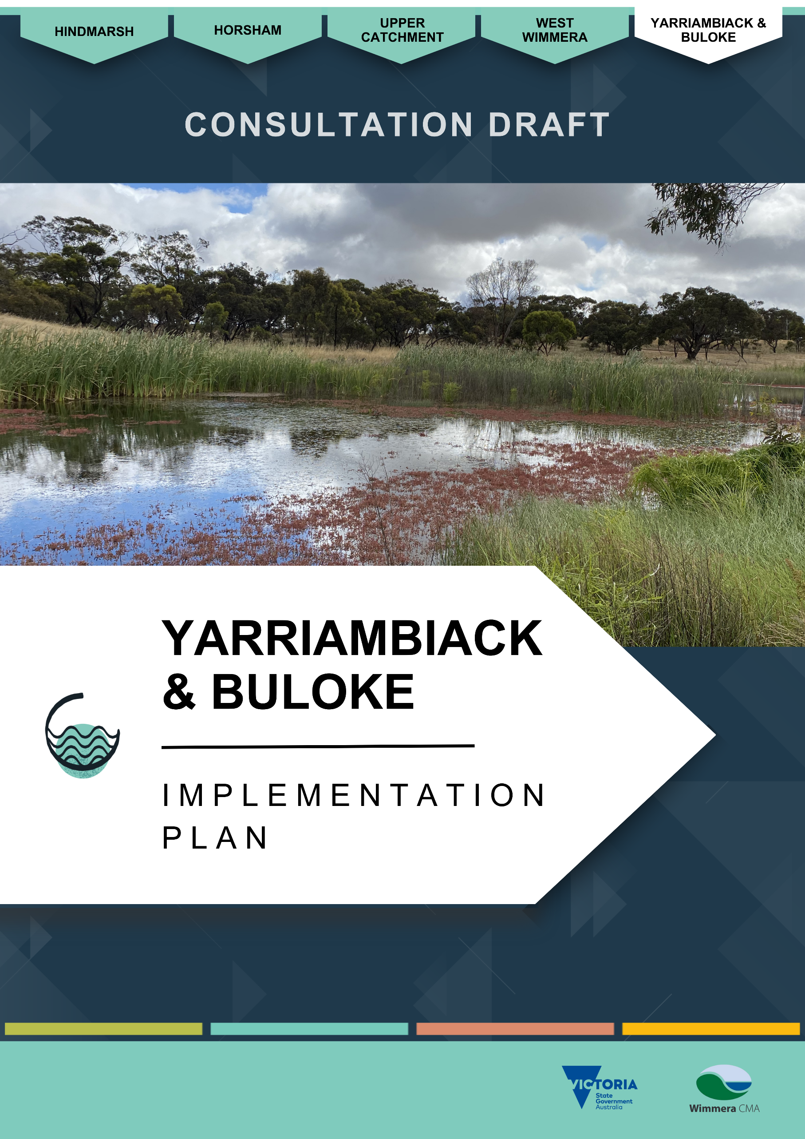

Yarriambiack and Buloke Implementation Plan

About the Local Area
The Yarriambiack and Buloke Local Area extends north from the Wimmera River near the Grampians National Park (Gariwerd) to north of the Brim township. It covers the southern part of Yarriambiack Shire and a western portion of Buloke Shire with the main towns being Warracknabeal, Murtoa, Minyip, Rupanyup and Brim. Approximately 5,100 residents live in the local area which extends across more than 374,000 hectares, encompassing a large portion of the northern Wimmera plains. ⁽⁴¹⁾
The main land use is dryland broadacre cropping (89%), with just over 10% of the area covered by native vegetation and waterways including Yarriambiack and Dunmunkle Creeks and scattered wetlands, see Figure 7. ⁽³⁰⁾
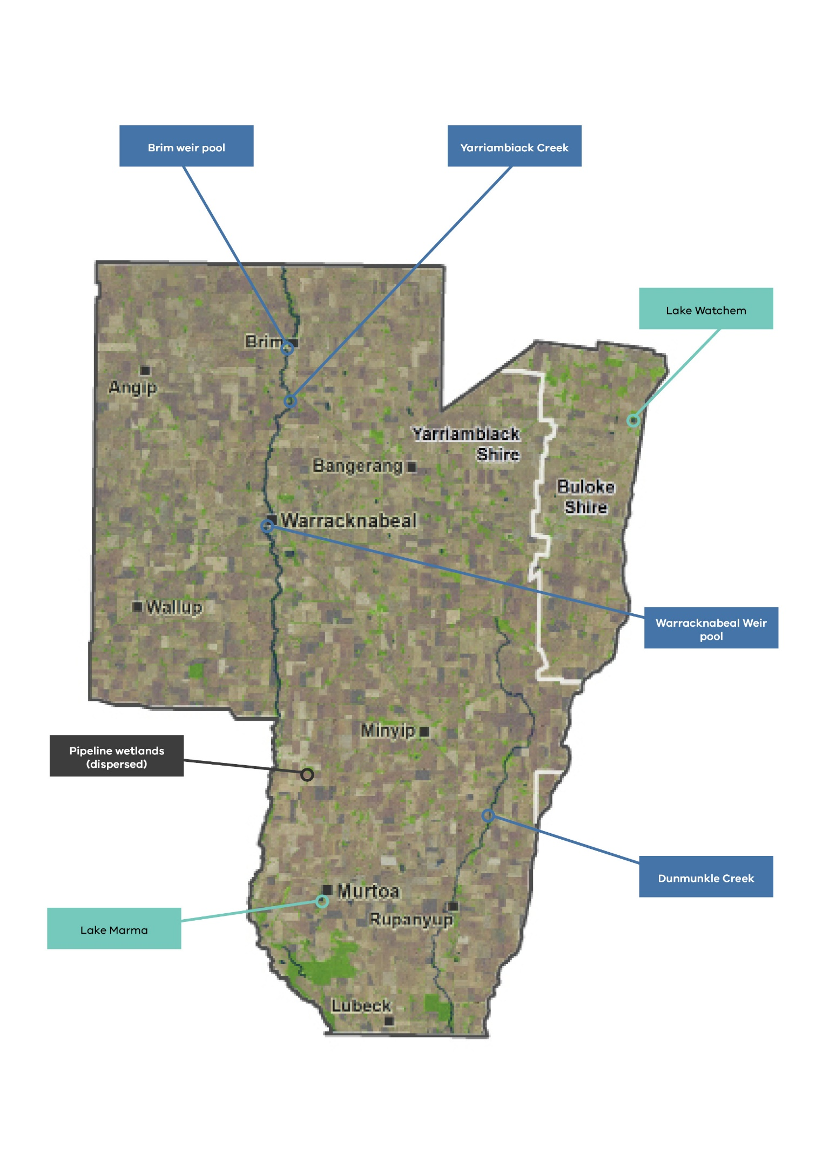
Figure 7. Yarriambiack and Buloke local area and some of its waterway assets.
.

Streams
Yarriambiack Creek is the local area’s main waterway, branching off the Wimmera River near Longerenong to flow 120 km north through Jung, Warracknabeal and Brim, before terminating outside of the Wimmera CMA boundary at Lake Corrong, east of Hopetoun.
Dunmunkle Creek departs from the Wimmera River east of Glenorchy and flows parallel to the Yarriambiack Creek through Rupanyup, extending north past Boolite.
Dunmunkle and Yarriambiack Creeks are distributaries of the Wimmera River. They flow episodically with their main source of water coming from the Wimmera River during high flows and floods. They also drain narrow, localised catchments.

Wetlands
Wetlands scattered throughout the Yarriambiack and Buloke Local Area comprise of the eastern section of the Northern Wimmera Plains Wetlands grouping. This grouping includes wetlands dispersed through the predominantly dryland broadacre cropping landscape extending across the northern Wimmera to the South Australian border.
There are 76 wetlands recorded in the Yarriambiack and Buloke Local Area, with 13 (17%) located on public land. These are predominantly shallow seasonal freshwater wetlands with a small number of deeper more-permanent lakes including Lake Marma at Murtoa.
Eleven wetlands receive environmental water from the Wimmera Mallee Pipeline to retain biodiversity values in their agricultural landscape. Water managers established arrangements for piping water to these wetlands following strong community advocacy when the Wimmera Mallee Domestic and Stock Channel System was replaced with the Wimmera Mallee Pipeline.
Recreational lakes and weir pools that receive piped water from a recreational water entitlement held by GWMWater include Lake Marma at Murtoa, Watchem Lake at Watchem, and Yarriambiack Creek weir pools at Warracknabeal and Brim.

Yarriambiack and Dunmunkle Creeks

Stream values

Environmental values
Yarriambiack and Dunmunkle Creeks are rare systems within south-east Australia from a hydrological perspective. Both creeks are distributaries, flowing away from the Wimmera River during high flows. ⁽⁴²⁾
Yarriambiack and Dunmunkle Creeks provide relatively connected native vegetation corridors between the Wimmera River in the south and the northern parts of the catchment into the Mallee. During floods, Yarriambiack Creek links Darlot Swamp, Barrabool Flora and Fauna Reserve, and Lakes Coorong and Lascelles.
About 10% of remnant and restored native vegetation remains in the Local Area, highlighting the importance these vegetation corridors provide through the agricultural landscape. ⁽³⁰⁾ It is likely that the creek lines will become increasingly important refuge areas under predicted climate change scenarios of reduced rainfall and runoff into waterways, and increased bushfires and droughts.
The most prevalent native vegetation communities along both creeks are considered threatened in Victoria. Victorian Ecological Vegetation Classes in Yarriambiack Creek’s riparian areas include Low Rises Woodlands and Plains Savannah, endangered in the Wimmera Bioregion; and Riverine Chenopod Woodlands, depleted in the Murray Mallee Bioregion. ⁽⁴²⁾ Along Dunmunkle Creek, the Endangered Drainage Line Woodlands Ecological Vegetation Class is dominant south of Rupanyup and Endangered Riverine Chenopod Woodlands are dominant further north.
Studies have recorded threatened species in the riparian zone and catchment of both creeks, including species listed under the Commonwealth Environment Protection and Biodiversity Conservation Act 1999 (EPBC Act) and Victorian Flora and Fauna Guarantee Act 1988. Examples along the Dunmunkle Creek include the growling grass frog (Litoria raniformis), bush stone-curlew (Burhinus grallarius), turnip copperburr (Sclerolaena napiformis), and buloke tree (Allocasuarina luehmannii). ⁽⁴³⁾
Endangered EPBC Act-listed species recorded in the Yarriambiack Creek catchment include slender darling-pea (Swainsona murrayana), winged pepper-cress (Lepidium monoplocoides), floodplain rustyhood (Pterostylis cheraphila), growling grass frog and Australasian bittern (Botaurus poiciloptilus). ⁽⁴²⁾ Victorian endangered species include freshwater catfish (Tandanus tandanus) artificially stocked into Brim and Warracknabeal weir pools, silver perch (Bidyanus bidyanus) stocked at Brim weir pool and freckled duck (Stictonetta naevosa).

Social and recreational values
Sections of Yarriambiack Creek and lakes in the region that regularly hold surface water are a focus for local communities. There is passionate interest in their condition and management.
GWMWater use recreational water allocations from the Wimmera Mallee Pipeline to maintain Yarriambiack Creek weir pools at Warracknabeal and Brim in the Wimmera CMA region, and Beulah in the Mallee CMA region to the north. This water provides recreational opportunities for local communities, attracts visitors, improves amenity and provides environmental benefits.
Water-skiing, camping and fishing are popular at Warracknabeal and Brim weir pools.
Warracknabeal is the largest centre in Yarriambiack Shire, and the weir pool is in the heart of the town and integral to its liveability. As part of Yarriambiack Creek, it connects residential, business and recreational areas and opportunities. It enhances passive recreational opportunities such as walking, sightseeing and angling, more vigorous activities such as water-skiing and is a foundation for visitor attractions and events.
Brim weir pool, north of Warracknabeal, plays a similar but slightly different role. This weir pool represents the primary tourist attraction for this tiny settlement as well as a fundamental recreation asset for the district’s rural community. It is part of a Wimmera bush-camping, water-skiing and angling circuit, and visitors from within Yarriambiack Shire, the Wimmera catchment and beyond, generate critical vibrancy for the local community. Brim community bases its major community events at the weir pool.
Dunmunkle Creek is like Yarriambiack Creek in that it only flows during times of high Wimmera River flows or flood. Works on the town’s stormwater infrastructure helps maintain water in the billabong and regularly attracts caravanners, campers and picnickers. At Rupanyup, stormwater-fed Jack Emmett Billabong at Rupanyup Memorial Park on Dunmunkle Creek, is also a significant social amenity.

Economic values
The Brim and Warracknabeal weir pools provided an estimated economic contribution of $514,000 to the local economy in the 2020-21 financial year, according to the most recent socio-economic assessment. The Warracknabeal weir pool accounted for almost 70% of this total benefit. ⁽⁴⁴⁾
Tourism in the region continues to grow, supported in part by the Silo Art Trail, which is attracting more visitors to rural communities and their nearby water-based attractions. Facilities such as walking tracks, bridges, playgrounds, caravan parks, bathroom and laundry amenities, and barbecue areas enhance the usability and appeal of the weir pools for both tourists and the local community.
Warracknabeal also hosts an annual Easter Festival and Y-Fest, major events that center many of their activities along the Yarriambiack Creek.

Cultural values
Connections between First Nations People and Country are reflected in many ways including artefacts, scar trees and creation stories featured around waterways, remnant vegetation and associated wildlife of the Yarriambiack and Buloke Local Area. Protection and respectful management of cultural values associated with Yarriambiack and Buloke Local Area sites is a focus of ongoing collaboration.
The many scarred trees and middens located along the Yarriambiack and Dunmunkle Creeks, for example, demonstrate the significance of these specific riparian areas to First Nations People. A Cultural Heritage Management Plan for a section of Dunmunkle Creek identified 105 cultural heritage sites including 82 scarred trees, 19 isolated artefact sites and 4 artefact scatter sites. ⁽⁴³⁾

Stream condition
An Index of Stream Condition assessment using data from 2004 to 2010 found that Dunmunkle Creek’s southern section was generally in moderate condition.
Yarriambiack Creek, assessed across three reaches, was recorded to have moderate stream condition, then declining to very poor condition as the creek travels north. ⁽¹³⁾

Riparian vegetation
Yarriambiack and Dunmunkle Creeks support high-value riparian vegetation where the majority is fenced from livestock. However, areas still remain where intensive grazing is evident by a lack of regeneration and reduced shrub understorey. This reduces connectivity and diversity, as well as increasing the risk of bank erosion and weed invasion.
A 2018 assessment for the Yarriambiack Creek Waterway Action Plan found that, overall, the health of the flora in the Yarriambiack Creek reserve is excellent despite ongoing dry conditions. The report notes that dominant overstorey black box (Eucalyptus largiflorens) and river red gum trees (Eucalytpus camaldulensis) are very healthy. Assessors observed relatively uniform vegetation conditions throughout the catchment, with localised pockets of higher quality vegetation.

Hydrology
The Yarriambiack and Dunmunkle Creeks rarely flow as their main source of water is from the Wimmera River during high flows and floods. The creeks regularly experience long periods of no flow or low flow, with water only reaching the farthest extent under very high flow conditions which is predicted to occur less frequently under future climate scenarios.

Channel modifications
Construction of drainage channels and levee banks historically occurred along Yarriambiack Creek to fill adjacent dams for stock and domestic use.
There are substantial weirs at Jung, Warracknabeal, and Brim which provide recreational opportunities and improved amenity for the local communities. ⁽⁴²⁾

Threats and drivers of change

Climate change and dry conditions
Climate change is a significant threat to the Yarriambiack and Buloke Local Area’s waterways through increasing frequency and intensity of extreme weather. It is predicted that the region will experience more regular and extreme drought conditions which will threaten Yarriambiack Creek, Dunmunkle Creek and scattered wetland water flow and quality. ⁽⁴⁵⁾ There will likely be greater reliance on piped water to support priority values.

Weeds and pest animals
Weeds are present along both creeks, as expected in a highly modified agricultural environment. Declared weeds on the Victorian noxious weeds list and Wimmera Regionally Controlled Weeds are present such as African boxthorn (Lycium ferocissimum), Bathurst burr (Xanthium spinosum), horehound (Marrubium vulgare), prickly pear (Opuntia stricta), spear thistle (Cirsium vulgare), common heliotrope (Heliotropium europaeum), wheel cactus (Opuntia robusta) and bridal creeper (Asparagus asparagoides). ^{(43; 42)}
Pest species present threats to native remnant vegetation along creeks. This includes weed incursions, while rabbits and kangaroos also place pressure on vegetation regeneration and growth.

Grazing by livestock
Overall, grazing intensity is relatively low as the area is dominated by broadacre cropping. ⁽⁴²⁾
A 2024 analysis of the level of protection of Wimmera rivers and streams from livestock access found that most (85%) of Yarriambiack Creek’s length south of Warracknabeal is protected. Further north, between Warracknabeal and the Wimmera CMA’s border, about half (53%) of the creek’s length is protected.
A larger proportion of Dunmunkle Creek is unprotected. Fencing protects only 43% of the southern section of the creek, assessed as part of the analysis. ⁽⁴⁶⁾

Creek modification
Historically, Dunmunkle and Yarriambiack Creeks were modified via drainage channels and levee banks to distribute water for stock and domestic supply, and isolated cropping activities. This use ceased since the completion of the Wimmera Mallee Pipeline in 2010. ⁽³⁴⁾
Smaller excavated dams and substantial weirs were also on the Yarriambiack Creek at Jung, Warracknabeal, and Brim, and also Beulah within the Mallee. ⁽⁴²⁾
Dunmunkle Creek remains substantially modified with levee banks lining the creek for much of its length and numerous redundant water regulation and impoundment structures present. ⁽⁴³⁾
These modifications have resulted in many locations, such as deep pools, losing their structural diversity. The community, keen to see a more natural water system, has echoed this concern, especially now the Dunmunkle Creek’s role as a water distribution channel has ended.

Northern Wimmera Plains Wetlands (eastern section)

Wetland values

Environmental values
The Yarriambiack and Buloke Local Area’s scattered wetlands provide important havens for native plants and animals in the largely agricultural landscape.
Lake Marma at Murtoa ranks among the highest of 15 piped recreational lakes across the broader Wimmera-Mallee region for environmental value.
Threatened species recorded at wetlands include species listed under the Commonwealth Environment Protection and Biodiversity Conservation Act 1999 and Victorian Flora and Fauna Guarantee Act 1988. Some of these species include the growling grass frog, Australasian bittern, chariot wheels (Maireana cheelii) and brown treecreeper (Climacteris picumnus), brown toadlet (Pseudophryne bibronii), southern toadlet (Pseudophryne semimarmorata), brolga (Antigone rubicunda), musk duck (Biziura lobata), blue-billed duck (Oxyura australis), freckled duck (Stictonetta naevosa), and royal spoonbill (Platalea regia). ⁽³¹⁾

Social and recreational values
There is passionate community interest in areas that regularly hold surface water.
Wimmera wetlands receiving a recreational water supply from the Wimmera Mallee Pipeline include Lake Marma at Murtoa and Watchem Lake. This water is provided by GWMWater to facilitate recreational opportunities for local communities, attract visitors and have environmental benefits.
Lake Marma generates a community heartbeat at Murtoa, and promotes the settlement as a ‘lakeside town’ which reflects its importance. The town’s infamous ‘Stick Shed’ also draws tourists to the tranquil Lake Marma. The lake’s foreshore, has considerable parkland amenities including a playground, jetty and entertainment facilities, and is the base for major annual celebrations and events. These include highly patronised attractions such as New Year’s Eve, Christmas and Murtoa’s Big Weekend gatherings.
Lake Marma is part of everyday life in the Murtoa district, providing a wealth of recreational opportunities ranging from weekend water-skiing, fishing and picnicking, to everyday activities such as walking, birdwatching and family activities. Angling is popular year-round and Victorian Fisheries Authority regularly stock the lake with recreational fishing species - golden perch and exotic rainbow trout. ⁽⁴⁷⁾
Watchem Lake, at Watchem in the Local Area’s north-east, is of similar community and social value. The artificial lake, which also receives recreational water allocations, provides important recreational amenity for district residents and visitors. Also the subject of fish stockings, Watchem Lake is part of a popular circuit for regional recreational water users such as anglers, water-skiers and other boating and picnicking enthusiasts. Community lake managers have stressed a profound need to protect and enhance the lake to maintain community health and liveability.

Economic values
Yarriambiack Shire had an estimated total of 34,000 participants in water-related activities (2020-21) between Lake Marma and Brim and Warracknabeal weir pools, with participants spending an estimated $640,000. ⁽⁴⁸⁾

Cultural values
Connections between First Nations People and wetlands in the Yarriambiack and Buloke local area are evident throughout the landscape. The presence of scarred trees and artefact scatters around wetland margins demonstrate the cultural significance of these environments to First Nations People.
Protecting and respectfully managing the cultural values of wetlands across the Yarriambiack area remains a key focus of ongoing collaboration.

Wetland condition

Pipeline wetlands
Index of Wetland Condition assessments indicate the condition of the eleven wetlands in the Local Area receiving environmental water from the Wimmera Mallee Pipeline. Surveys completed in 2024 recorded Mutton Swamp and Carapugna Swamp as having ‘Excellent’ condition. Harcoans, Schultz-Koschitske, Pinedale, Tarkedia and Fielding’s Dams, and Sawpit and Krong Swamps, were in ‘Good’ condition. Opie’s Dam and Challambra Swamp were ‘Moderate’ in their overall condition. ⁽³³⁾
Across assessments of physical form, hydrology, water properties and soils, the wetlands are rated mostly as ‘excellent’ across each category. Biota condition had the most variation between sites with Challambra Swamp and Opie’s dam classed as being ‘very poor’, with four others assessed as ‘poor.’ Only Carapugna Swamp had an ‘excellent’ biota score, with Mutton Swamp being ‘good.’ The remaining wetlands having ‘moderate’ biota condition.

Hydrology
Climate change, dry years, modifications to the wetland basin and drainage, and changes to paddock management have led to a decline in wetland-filling frequency if they are not part of environmental or recreational watering allocations.

Threats and drivers of change

Climate change and dry conditions
Future climate scenarios predict that the region will experience more regular and extreme drought conditions which threaten water flow to scattered wetlands. This will particularly impact wetlands with no access to environmental water via the Wimmera-Mallee Pipeline network. As of 2025, the pipeline supported 11 wetlands for environmental purposes in the Yarriambiack and Buloke Local Area.

Weeds and pest animals
Further threats to remnant vegetation in scattered wetlands and along creeks are from pest species. This includes weed incursions, while rabbits and kangaroos also place pressure on vegetation regeneration and growth.

Cropping and other modifications
Drainage alterations and cropping activities have altered water paths and drained some wetlands.
Most of the Local Area’s 76 recorded wetlands are modified, with many covered by an agricultural crop, containing a dam, drain or levee. Only 16 wetlands (21%) were unmodified in a 2017 analysis by Wimmera CMA.
The risk of further wetlands being modified is likely to be low given the extent of existing modifications and stable land use in the area that has long been cropped.

Grazing by livestock
Grazing intensity is relatively low in the Local Area, with land use dominated by broadacre cropping.

Previous waterway strategy achievements
Key achievements from implementing the previous Wimmera Waterway Strategy 2014 in the Yarriambiack and Buloke Local Area include:
- Wimmera CMA and public and private land managers collaborated to enhance riparian vegetation along Yarriambiack and Dunmunkle creeks by fencing areas to manage stock grazing and controlling weeds and rabbits.
- Wimmera CMA developed Waterway Action Plans for Yarriambiack Creek (2018) and Dunmunkle Creek (2020). The plans provide detailed waterway condition assessments and a prioritised management action program for protecting and improving river health. The plans are key documents guiding development and implementation of the Regional Waterway Strategy.
- Wimmera CMA, together with the VEWH, Parks Victoria, BGLC and private landholders, improved the environmental condition of 13 wetlands receiving piped environmental water, with 11 being in the Yarriambiack and Buloke Local Area. This included installing and upgrading infrastructure enabling efficient water delivery, delivering environmental water in line with Seasonal Watering Plans, and monitoring waterbirds, frogs, and native vegetation including threatened species to inform future management regimes.
- Wimmera CMA and Yarriambiack Shire Council assessed the viability and then removed a sediment slug from a section of the Yarriambiack Creek to prevent impacts on the Warracknabeal weir pool.

Future Opportunities

Environmental water
The Wimmera Mallee pipeline enables environmental water managers to pipe water directly to 13 wetlands in the north-eastern Wimmera CMA region, 11 being in the Yarriambiack Local Area. This is part of a network of 52 wetlands in the neighbouring Mallee and North Central CMA regions, providing refuge for native biodiversity.
Stakeholders consulted during the development of the Wimmera Waterway Strategy expressed support for exploring the potential to provide environmental water from the Wimmera Mallee Pipeline to drought refuge pools in Yarriambiack Creek. If possible, this would significantly enhance environmental values and the value of the creek as a wildlife corridor and drought refuge.

Dunmunkle Creek restoration
In 2018, Wimmera CMA completed a flood study of Dunmunkle Creek that included an assessment of the impacts of decommissioning the creek as a channel. ⁽⁴⁹⁾ Through this process, the local community sought to decommission the channel’s banks to minimise the impact of intermittent flooding along the creek’s length and return the creek to as natural a state as possible.
GWMWater developed a plan for decommissioning and, where possible, filled in or removed banks and other structures. ⁽⁵⁰⁾ Barriers to decommissioning prevented changes in some areas. For example, native vegetation clearing laws prevented some decommissioning of channel banks in the Brynterion State Forest due to well-established native vegetation occurring there.
There is a continued desire from the community and waterway managers to decommission these areas and restore the creek to a more natural waterway for both environmental and economic benefits.

Enhancing Whitton Swamp
Community members have expressed interest in exploring the potential to enhance Whitton Swamp south of Warracknabeal as a water-based community reserve.
The swamp has historically undergone major modifications when in use as a water-supply storage for Warracknabeal. Completion of the Wimmera Mallee Pipeline in 2010 removed its need as a water storage. Different sections of the swamp are managed by either GWMWater or the Victorian Department of Environment, Energy and Climate Action management.
The site is surrounded by agricultural land and a series of raised levee banks. Landscape modifications have changed overland water-flow paths and altered the frequency of swamp inundation.
Yarriambiack Shire Council has explored development and watering opportunities to transform the swamp into a water-based parkland reserve.
In 2025, being able to access artificial water supply appeared essential for any development.

Stakeholder and community feedback
Wimmera CMA invited stakeholders and community members to contribute to Strategy development. Stakeholders in the Yarriambiack and Buloke Local Area highlighted the following waterways as important:
- Yarriambiack Creek, including weir pools at the Warracknabeal and Brim townships
- Dunmunkle Creek
- Lake Marma
- Whitton Swamp
- Mutton Swamp
- Wetlands receiving environmental water from the Wimmera Mallee Pipeline.
Key points included:
- Strong support for initiatives to protect and improve waterways for environmental, socio-economic and cultural benefits.
- Support to continue to enhance Yarriambiack and Dunmunkle Creeks as north-south biolink corridors and provide environmental water to wetlands from the Wimmera Mallee Pipeline to sustain the region’s biodiversity. There was also strong support for exploring the potential to provide environmental water to drought refuge pools in Yarriambiack Creek.
- Widespread concern that increasingly dry climate, alongside greater water demand, will continue to stretch water availability. Some stakeholders raised apprehension of potential overallocation of pipeline water supply to new users, particularly large water users like new mineral sands mines.
- Some stakeholders raised concerns about impacts on waterways and riparian areas caused by stock grazing, weeds, erosion and vegetation damage caused by four-wheel drives and motorbikes, firearm use, duck hunting, and illegal firewood collection.
- The proximity of developments to waterways, including mines and renewable energy projects, is a concern to some people due to the potential risk of water pollution from sites.
- Some stakeholders felt that some recreational lakes in the region, such as Lake Marma, would benefit from management plans supporting recreational uses as well as mitigating impacts from recreation.
- Flood mitigation is an issue for some, including stakeholders along Dunmunkle and Yarriambiack Creeks. Some are concerned about in-stream vegetation such as native cumbungi preventing movement of flood waters, while others are concerned about fast-moving flood water causing erosion. Floodplain modifications have also altered the natural flow of water into wetlands and creeks, and caused cross-property drainage problems in some areas. There continues to be a desire to open the Dunmunkle Creek channel to restore flow to the Brynterion State Forest, however this is currently unfeasible due to Victoria’s Native Vegetation Management framework

Priority locations for management
The Strategy identified the Yarriambiack and Buloke Local Area’s priority waterways for management:
- Yarriambiack Creek
- Weir pools at Warracknabeal and Brim
- Wetlands with high environmental value
- Wetlands with high social and economic value, including Lake Marma
- Wimmera Mallee pipeline wetlands

Together, these areas hold the highest ecological, cultural and recreational value and face the greatest management needs. Details of the prioritisation process are described in a supporting document to the Strategy.

Management Activities – Yarriambiack and Buloke
The following tables include management actions for the Yarriambiack and Dunmunkle Creeks and Northern Wimmera Plains Wetlands (eastern section). These actions are intended to be implemented over 10-years from 2026 to achieve the region’s desired outcomes in the Yarriambiack and Buloke Local Area.
Tables 27 to 32 contain similar management actions according to the following groups:
Rivers and Streams
- Table 27: Enhancing riparian habitat, landscape connectivity, and resilience.
- Table 28: Managing water availability
- Table 28: Managing water availability
- Table 29: Improving recreational opportunities
Wetlands
- Table 30: Managing pest species
- Table 31: Managing pipeline wetlands
- Table 32: Protecting Wimmera wetlands
Some actions contribute to multiple outcomes. Management actions are shaded green for high priority and orange for medium priority. Actions with no shading are low priority.
Unless otherwise stated, activities are funded under the Environmental Contribution Levy until 2028. Funding is assumed to be maintained at current levels until 2036.

Yarriambiack and Dunmunkle Creeks

Enhancing riparian habitat, landscape connectivity, and resilience
The actions in Table 27 contribute to the following regional waterway outcomes:
- More waterways have improved management to enhance habitat, landscape connectivity, and resilience.
- Healthier waterways enable more On Country activities for First Nations People.
- Stewardship increases, with more people taking action to care for waterways.
Local Area specific outcomes that contribute to this outcome include:
- No new pest plants and animals are established beyond small, localised populations.
- More farmers use management practices that improve environmental health.
- Geomorphology and habitat of Dunmunkle Creek is restored to a more natural waterway.
Associated values of the priority locations include:
- Riparian vegetation and connectivity.
- Riparian and water bird species.
- Cultural connections.
- Amenity and recreation.
- Tourism and economy.
- Water quality.
Table 27: Enhancing riparian habitat, landscape connectivity, and resilience.
Waterway location | Management action |  | Amount by 2036 | Responsible parties  (Lead/Partners) | Connection with other plans or strategies | Status
Yarriambiack Creek and Dunmunkle Creek  - unfenced sections. |  | Support private landholders to permanently protect and manage riparian areas on their properties. | TBC | Trust for Nature,  Wimmera CMA,  Private landholders | Yarriambiack Creek (2018) and Dunmunkle Creek (2020) Waterway Action Plans.  Wimmera Proportion of Waterways Protected – Stage 2 (2024).  Trust for Nature Statewide Conservation Plan 2021-2030. | Continuation of work under the previous regional waterway strategy.
Yarriambiack Creek and Dunmunkle Creek  - unfenced sections. | Support land managers to protect, enhance and manage riparian areas. |  | 117 km | Wimmera CMA,  Public Land Managers\Private land owners | Yarriambiack Creek (2018) and Dunmunkle Creek (2020) Waterway Action Plans.  Wimmera Proportion of Waterways Protected – Stage 2 (2024). | Continuation of work under the previous regional waterway strategy.
Dunmunkle Creek | Explore methods of restoring Dunmunkle Creek to a more natural state. |  | TBC | Wimmera CMA,  GWMWater,  Public land managers | Dunmunkle Creek Waterway Action Plan (2020).  Dunmunkle Creek Decommissioning Report (2018). | Continuation of previous work.
Yarriambiack and Dunmunkle Creeks on public land | Control problem invasive fauna in priority riparian areas. |  | 200 ha | Wimmera CMA,  Public land managers,  Agriculture Victoria.  Landholders | Yarriambiack Creek (2018) and Dunmunkle Creek (2020).  Waterway Action Plans.  Wimmera Invasive Plant and Animal Management Strategy. | Continuation of work under the previous regional waterway strategy.
Yarriambiack and Dunmunkle Creeks on public land | Control problem weeds in priority riparian areas. |  | 200 ha
 | Monitor for incursions of new pest plants and animals. Treat incursions to prevent establishment. |  | 1 partnership per year in collaboration with land managers. | Wimmera CMA,  Public land managers,  Agriculture Victoria,  Landholders

Managing water availability
The actions in Table 28 contributing to the following regional waterway outcomes:
- Drought refuges support species’ survival and resilience during dry periods.
- More waterways have improved management to enhance habitat, landscape connectivity, and resilience.
Local Area specific outcomes that contribute to this outcome include:
- Water delivered to wetlands, drought refuges and pools in Yarriambiack Creek and Dunmunkle Creek maintain environmental, cultural, social and economic values.
Associated values of the priority locations include:
- Drought resilience.
- Biodiversity connectivity.
- Birdlife, frogs, and native fish habitat.
- Cultural connections.
- Amenity and recreation.
- Native fish.
Table 28: Managing water availability.
Waterway location | Management action | Amount by 2036 | Responsible parties  (Lead/Partners) | Connection with other plans or strategies | Status
Yarriambiack Creek (medium priority)  Dunmunkle Creek (low priority) | Investigate opportunities to provide environmental water to drought refuge pools from the Wimmera Mallee Pipeline. | 1 investigation | Wimmera CMA,  VEWH,  GWMWater,  BGLC,  Yarrilinks Landcare Network | Yarriambiack Creek Waterway Action Plan (2018). | Concept – new action.

Improving recreational opportunities
The actions in Table 29 contribute to the following regional waterway outcomes:
- More waterways provide improved recreational opportunities and amenity while minimising impacts on environmental values.
- More waterways have improved management to enhance habitat, landscape connectivity, and resilience.
- Healthier waterways enable more On Country activities for First Nations People.
- Stewardship increases, with more people taking action to care for waterways.
Local Area specific outcomes that contribute to this outcome include:
- Improve habitat quality and manage the impacts of recreation and access to waterways and public reserves, including Yarriambiack Creek, Dunmunkle Creek and Barrabool Flora and Fauna Reserve
Associated values of the priority locations include:
- Amenity and recreation.
- Tourism and economy.
- Community engagement and events.
- Barrabool Flora and Fauna reserve.
Table 29: Improving recreational opportunities.
Waterway location | Management action | Amount by 2036 | Responsible parties  (Lead/Partners) | Connection with other plans or strategies | Status
Yarriambiack and Dunmunkle Creeks | Explore opportunities to improve management of the impacts of recreation | Explore opportunities | Wimmera CMA,  Councils,  Public Land Managers,  BGLC,  GWMWater | Yarriambiack Creek (2018) and Dunmunkle Creek (2020) Waterway Action Plans. | Continuation of work under the previous regional waterway strategy.
Yarriambiack and Dunmunkle Creeks | Explore opportunities to improve recreational access. | Explore opportunities | Wimmera CMA,  Councils,  Public Land Managers,  BGLC,  GWMWater |  | Continuation of work under the previous regional waterway strategy.

Northern Wimmera Plains Wetlands (eastern section)

Managing pest species
The actions in Table 30 contribute to the following regional waterway outcomes:
- More waterways have improved management to enhance habitat, landscape connectivity, and resilience.
- Healthier waterways enable more On Country activities for First Nations People.
Local Area specific outcomes that contribute to this outcome include:
- No new pest plants and animals are established beyond small, localised populations.
Associated values of the priority locations include:
- Amenity and recreation.
- Cultural connections.
- Native wildlife and flora.
- Agricultural productivity.
Table 30: Managing pest species.
Waterway location | Management action |  | Amount by 2036 | Responsible parties  (Lead/Partners) | Connection with other plans or strategies | Status
Public wetlands | Control invasive fauna for wetlands. |  | 100 ha | Parks Victoria,  Wimmera CMA | Wimmera Invasive Plant and Animal Management Strategy 2019. | Continuation of work under the previous regional waterway strategy.
Public wetlands |  | Monitor for incursions of new pest plants and animals. Treat incursions to prevent establishment. | 1 partnership per year in collaboration with land managers. | Wimmera CMA,  Parks Victoria,  Local Government,  Landcare,  Landholders | Wimmera Invasive Plant and Animal Management Strategy 2019. | Continuation of work under the previous regional waterway strategy.
Public wetlands |  | Control weeds in priority wetland areas. | 100 ha | Parks Victoria,  Wimmera CMA | Wimmera Invasive Plant and Animal Management Strategy 2019. | Continuation of work under the previous regional waterway strategy.

Managing pipeline wetlands
The actions in Table 31 contribute to the following regional waterway outcomes:
- More waterways have improved management to enhance habitat, landscape connectivity, and resilience.
- Stewardship increases, with more people taking action to care for waterways.
Local Area specific outcomes that contribute to this outcome include:
- Water delivered to wetlands, drought refuges and pools in Yarriambiack Creek and Dunmunkle Creek maintain environmental, cultural, social and economic values
Associated values of the priority locations include:
- Supporting isolated wildlife and flora.
- Cultural connections.
- Drought mitigation.
- Amenity and recreation.
Table 31: Managing pipeline wetlands.
Waterway location | Management action | Amount by 2036 | Responsible parties  (Lead/Partners) | Connection with other plans or strategies | Status
Wimmera Mallee pipeline wetlands including:  Harcoans Swamp  Krong Swamp  Carapugna Swamp  Challambra Swamp  Tarkedia Swamp  Mutton Swamp  Saw Pit Swamp  Pinedale Dam  Fielding’s Dam  Schultz/Koschitske Dam  Opie’s Dam  (Including Wal Wal and Crow Swamps in Upper Catchment and Hindmarsh Local Areas) | Develop annual Seasonal Watering Proposals for Wimmera Mallee pipeline wetlands. | 10 proposals  (comprised of 1 proposal annually) | Wimmera CMA, GWMWater,  VEWH,  CEWH,  Local Government. | Environmental Water Management Plan. – Wimmera Mallee Pipeline Wetlands. – Wimmera CMA Region. | Continuation of existing arrangements.
 | Develop annual Seasonal Watering Plans for Wimmera Mallee pipeline wetlands. | 10 plans  (comprised of 1 plan annually) | VEWH,  Wimmera CMA,  GWMWater,  VEWH,  CEWH,  Local Government. |  | Continuation of existing arrangements.
 | Deliver environmental releases to Wimmera Mallee pipeline wetlands in line with annual Seasonal Watering Plans. | The volume of water delivered and number of waterways depends on annual watering entitlements. | Wimmera CMA,  GWMWater,  VEWH,  CEWH |  | Continuation of existing arrangements.
 | Implement infrastructure improvements to maximise outcomes from environmental water delivery from the Wimmera Mallee Pipeline. | n/a | Wimmera CMA,  VEWH,  GWMWater,  Local Government.,  Public land managers,  BGLC | Environmental Water Management Plan. – Wimmera Mallee Pipeline Wetlands. – Wimmera CMA Region. | New action.
 | Explore traditional methods of vegetation management such as cultural burning to enhance wetland habitat connected to the Wimmera Mallee Pipeline. | 2 sites | Wimmera CMA,  BGL,  Parks Victoria,  DEECA | Environmental Water Management Plan. – Wimmera Mallee Pipeline Wetlands. | New action. Planning underway.
 | Monitor wetlands to assess progress towards achieving objectives stated in the Environmental Water Management Plan – Wimmera Mallee Pipeline Wetlands, including monitoring vegetation condition and wildlife. | 11 wetlands | Wimmera CMA,  Parks Vic VEWH | Environmental Water Management Plan – Wimmera Mallee Pipeline Wetlands – Wimmera CMA region. | Continuation of previous work.

Protecting Wimmera Wetlands
The actions in Table 32 contribute to the following regional waterway outcomes:
- More waterways have improved management to enhance habitat, landscape connectivity, and resilience.
- Stewardship increases, with more people taking action to care for waterways.
- Wetland modification, loss and deterioration of condition occurs at a declining rate.
Associated values of the priority locations include:
- Amenity and recreation.
- Cultural connections.
- Native wildlife and flora.
- Agricultural productivity.
Table 32: Protecting Wimmera wetlands.
Waterway location | Management action | Amount by 2036 | Responsible parties  (Lead/Partners) | Connection with other plans or strategies | Status
All wetlands | Increase community and landholder awareness of the value of wetlands and appropriate conservation management techniques. | TBC | Wimmera CMA,  Landcare,  Trust for Nature | Wimmera Wetland Asset Strategy | Continuation of work under the previous regional waterway strategy.
Lake Marma | Develop a management plan for Lake Marma to support sustainable social, economic, cultural and environmental outcomes. | 1 management plan | Committee of management,  DEECA,  Yarriambiack Shire Council,  Wimmera CMA |  | New action.

Whole of catchment - implementation
This section addresses key issues that affect waterways across the entire Wimmera catchment, rather than specific local areas. These topics represent broad-scale challenges and opportunities that require coordinated management to protect environmental, cultural, social, and economic values.
The section covers themes such as supporting First Nations Peoples’ self-determination, waterway-based recreation, water quality, fire preparedness and recovery, blue-green algae management, native fish conservation, platypus recovery, and birdlife protection.
For each topic, this section outlines the current context, major threats, and desired medium-term outcomes, supported by evidence and examples of ongoing initiatives.

Collaborating with First Nations People and supporting self-determination - management actions
Long-term desired outcome (>20-year): Knowledge and experience of First Nations People is informing waterway planning, management and delivery in the Wimmera, advancing self-determination.

Values targeted:
- Partnerships supporting self-determination.
- River, wetland and aquatic ecosystems – all plants and animals are important.
- In-stream biota including platypus, native fish, western swamp crayfish, Glenelg spiny crayfish, yabbies, native vegetation and freshwater mussels.
- Riparian vegetation health and connectivity and water quality.
- Community connections.
- Cultural connections to Country.
- Cultural heritage.
NOTE: Additional specific opportunities for collaborating on planned waterway activities are identified in Local Area sections of this Implementation Plan.

Table 33: Implementation actions for collaborating with First Nations People and supporting self-determination regarding waterway management.
10-year desired outcome | Target values | Waterway location | Management action | Amount by 2036 | Responsible parties  (Lead/Partners) | Connection with other plans or strategies | Status
Ongoing collaboration and two-way learning in waterway planning and management, supporting self-determination and strengthening partnerships with First Nations People.  Healthier waterways enable more On Country activities for First Nations People. | Partnership  Relationships  Self-determination  Two-way capacity-building  Waterway values  Cultural connections and values. | Whole of-catchment | Meet regularly to discuss waterway plans, strategies, projects and initiatives. | As agreed by the parties. | Wimmera CMA,  BGLC | Water is Life: Traditional Owner Access to Water Roadmap  Country Plan. | Continuation of existing arrangements.
 |  |  |  |  | Wimmera CMA,  EMAC |  | Building a relationship.
 |  | Whole of-catchment | Collaborate on opportunities to build two-way knowledge and capacity to implement waterway-related actions on Country including, for example, disaster preparedness, response and recovery, riverbank and tree management, cultural burning, aquatic species. | As opportunities arise. | Wimmera CMA,  BGLC  EMAC | Water is Life  Country Plan. | Continuation of existing arrangements.
 |  | Whole of-catchment | Support employment and training opportunities for First Nations People. | When funding is available. | Wimmera CMA,  BGLC  EMAC | Water is Life  Country Plan. | Continuation of existing arrangements.
 |  | Whole of-catchment | Support BGLC and EMAC to operate as the lead organisations for advice related to cultural heritage and other cultural considerations. | As relevant. | Wimmera CMA,  BGLC  EMAC | Water is Life  Country Plan. | Continuation of existing arrangements.
 |  | Whole of-catchment | Collaborate on activities that advance Barengi Gadjin Land Council’s self-determination, including strategic management of property along the Datchak Creek at Antwerp, as well as other culturally significant sites. | Ongoing collaboration | BGLC,  Wimmera CMA | Growing What is Good Country Plan: Voices of the Wotjobaluk Nations. | Continuation of existing arrangements.

Water quality - management actions
Long-term desired outcome (>20-year):
Water is of sufficient quality to support waterway values and uses at important areas for water supply, cultural, environmental and social values.
Values targeted:
- Water quality.
- In-stream biota including platypus, native fish, western swamp crayfish, Glenelg spiny crayfish.
- Riparian vegetation health and connectivity.
- Community connections.
- Cultural connections.
Table 34: Implementation actions for water quality
10-year desired outcome | Waterway location | Management action | Amount by 2036 | Responsible parties  (Lead/Partners) | Connection with other plans or strategies | Status
Risks to water quality in waterways are managed where possible to reduce impacts on values. | Whole of-catchment | Monitor water quality at high priority locations. | 10 annual water quality monitoring programs | Wimmera CMA | Wimmera water quality information needs summary report. | Continuation of work under the previous regional waterway strategy.
 | Whole of-catchment | Support Waterwatch volunteers to collect water quality data. | Active Waterwatch volunteers are supported with resources annually | Wimmera CMA,  Waterwatch volunteers | www.vic.waterwatch.org.au | Continuation of work under the previous regional waterway strategy.
 | Whole of-catchment | Establish interim water quality targets at priority locations identified in the Regional Waterway Strategy. | Water quality targets at 3 priority locations by 2030 | Wimmera CMA, GWMWater  DEECA  EPA | Victoria’s Environment Reference Standards.  Former State Environment Protection Policy (Waters) 2018. | New action.
Net rates of streamflow interception from water extraction and storages are stabilising in the Wimmera River catchment. | Whole of-catchment | Support water efficiency programs such as piped water supply. | As opportunities arise | Wimmera CMA |  | New action.
 | Whole of-catchment | Trial incentive programs to decommission and use farm dams for environmental purposes in areas where water supply pipelines are being built and/or release water from them. | TBC | Wimmera CMA, GWMWater  Landholders |  | New action.

Fire preparedness, response and recovery - management actions
Long-term desired outcome (>20-year):
Water is of sufficient quality to support waterway values and uses at important areas for water supply, cultural, environmental and social values.
Values targeted:
- Water quality.
- In-stream biota including platypus, native fish, western swamp crayfish, Glenelg spiny crayfish.
- Riparian vegetation.
Table 35.Implementation actions for fire preparedness, response and recovery.
10-year desired outcome | Waterway location |  | Management action | Amount by 2036 | Responsible parties  (Lead/Partners) | Connection with other plans or strategies | Status
Risks to water quality in Wimmera waterways are managed where possible to reduce impacts on values. | Forested catchments:  - Wimmera River  - Lake Bellfield  - Wartook Reservoir  - Mount William Creek. |  | DEECA working with relevant authorities and community to develop preparedness, response and recovery action plans to minimise the risk of bushfire to water quality and waterway values. | 1 Plan | DEECA,  Wimmera CMA,  Parks Victoria,  GWMWater,  Local community members,  Barengi Gadjin Land Council | Wimmera Emergency Preparedness and Response Plan for Biodiversity and Agricultural Natural Assets. | New action.

Blue-green algae - Implementation plan – management actions
Long-term desired outcome (>20-year):
- Water quality is improved at important areas for water supply, environmental and recreational values.
- Rivers and streams with high environmental, social, cultural and economic values are improving their value despite climate change.
Values targeted:
- Water quality.
- In-stream biota.
- Riparian vegetation.
- Recreation including swimming, angling, boating and sightseeing.
- Water for stock and domestic supply.
- Native wildlife, people or companion animals.
Table 36: Implementation actions for Blue-green algae
10-year desired outcome | Waterway location | Management action | Amount by 2036 | Responsible parties  (Lead/Partners) | Connection with other plans or strategies | Status
Risks to water quality in Wimmera waterways are managed where possible to reduce impacts on values. | Wimmera River weir pools, recreation lakes and water storages including Lake Wallace, Green Lake, Dock Lake, Lake Toolondo, Lake Marma, Lake Charlegrark, Nhill Lake; and Yarriambiack Creek weir pools at Warracknabeal and Brim. | Monitor for new developments and innovation for preventing and treating blue-green algal blooms and act if process or product is available and appropriate. | Biannual Australia and New Zealand Cyanobacteria Workshops | DEECA,  GWMWater,  Wimmera CMA,  Municipal councils,  Parks Victoria,  International and national water-research agencies | Environmental Watering Delivery Plan – Wimmera-Mallee Wetlands – Wimmera CMA Region.  Seasonal Watering Proposal.  Regional Blue-Green Algae Coordination Plan. | Continuation of existing arrangements.
 |  | Monitor water quality, especially when conditions pose a higher risk of blue-green algae such as after storm runoff and the potential of increased nutrient loads (higher risk with climate change). | Monitoring based on observational reports. | GWMWater,  Wimmera CMA, municipal councils and other Local Water Managers. | Regional Blue-Green Algae Coordination Plan. | Continuation of existing arrangements.
 |  | Manage environmental flows where possible to maintain water conditions that minimise the risk of a blue-green-algal blooms occurring. | Three environmental watering plans. | Wimmera CMA, GWMWater,  Victorian Environmental Water Holder, Commonwealth Environmental Water Holder,  GWMWater. | Environmental Watering Management Plan for Wimmera River, Yarriambiack Creek and the Terminal Lakes.  Environmental Watering Management Plan for the MacKenzie River and Burnt and Bungalally Creeks.  Environmental Watering Management Plan for Wimmera Mallee Pipeline Wetlands.  Wimmera Regional Catchment Strategy. | Continuation of existing arrangements.
 |  | Implement landowner education programs to minimise nutrient run-off from properties. | Annual information workshops. | Wimmera CMA,  Agriculture Victoria, DEECA,  GWMWater. | Wimmera Regional Catchment Strategy. | Continuation of existing arrangements.

Native fish - Implementation plan – management actions
Long-term desired outcomes (>20-year):
- Waterways with high environmental, social, cultural and economic values are maintained.
- Waterway condition, connectivity and resilience is improved, providing habitat that supports native species and communities.
Values targeted:
- Water quality.
- In-stream biota including native fish, western swamp crayfish, Glenelg spiny crayfish.
- Riparian vegetation health and connectivity.
- Community connections.
- Cultural connections.
Table 37: Implementation actions for the Wimmera’s native fish.
10-year desired outcome | Target values | Waterway location | Management action | Amount by 2036 | Responsible parties  (Lead/Partners) | Connection with other plans or strategies | Status
Key water-dependent species are supported in waterways that provide suitable habitat, including during dry conditions. | Small-bodied native fish including river blackfish and southern pygmy-perch. | MacKenzie River  Burnt Creek  Mount William Creek  Mount Cole Creek  Glenlofty Creek  Wimmera River  Wetlands. | Increase understanding of how to successfully breed river blackfish in captivity. | Complete a breeding-research project with Snobs Creek Conservation Hatchery by 2028 | Wimmera CMA, BGLC,  Victorian Fisheries Authority,  Native Fish Australia Wimmera Branch,  Arthur Rylah Institute. | Wimmera Native Fish Management Plan 2022. | A funded project from 2025 to 2028.
 |  |  | Investigate potential release sites for hatchery-bred river blackfish and other small-bodied native fish. | One investigation completed. |  | Wimmera Native Fish Management Plan 2022. | Underway.
 |  |  | Investigate habitat enhancement that supports small-bodied native fish. | One investigation. |  | Wimmera Native Fish Management Plan 2022. | New action.
 |  |  | Monitor river blackfish survival and recruitment at translocation sites. | Annual monitoring of two waterways and two dams. |  | Wimmera Native Fish Management Plan 2022. | Underway.
 |  |  | During dry periods, translocate small-bodied native fish from stressed and drying pools to more secure waterway sites. | Dependent on seasonal climate conditions. | TBC | Annual Wimmera Seasonal Watering Plans.  Dry Contingency Inflow Plan. | Standard procedure.
Key water-dependent species are supported in waterways that provide suitable habitat, including during dry conditions. | Native fish including river blackfish and southern pygmy perch and other aquatic life including western swamp and Glenelg spiny crayfish, freshwater mussels and rakali. | Wimmera River, Mount William Creek, MacKenzie River, Burnt Creek, Yarriambiack Creek weir pools at Jung, Warracknabeal and Brim and Wimmera Recreation and storage lakes. | Explore carp-control measures such as trapping and removal where and when appropriate in waterways. | Annual assessment of carp proliferation. | Wimmera CMA,  BGLC,  Victorian Fisheries Authority, GWMWater, DEECA | Wimmera Native Fish Management Plan 2022. | New action, building on previous work.
 |  |  | Explore the potential of creating waterway-flow regimes that promote natural spawning of native fish. | One investigation completed. | Wimmera CMA, Victorian Fisheries Authority, Victorian Environmental Water Holder. | Wimmera Native Fish Management Plan 2022. | Underway.
 |  |  | Act if and as directed as part of national or state biological carp control involving the use of cyprinid herpes virus 3 (carp virus). | Follow National Carp Control Plan roll-out | Australian Government Department of Agriculture Fisheries and Forestry, DEECA, Wimmera CMA, other CMAs, | National Carp Control Plan. | Further investigation and research occurring.
 |  |  | Increase understanding of freshwater mussel populations in the Wimmera. Investigate the feasibility of management actions to improve their population and identify priority locations for management. | 1 investigation | BGLC,  Wimmera CMA | Wimmera Native Fish Management Plan 2022. | New action.
 |  |  | Increase understanding of freshwater crayfish populations in the Wimmera. Investigate the feasibility of management actions to improve their population and identify priority locations for management. | 1 investigation | BGLC,  Wimmera CMA | Wimmera Native Fish Management Plan 2022. | New action.

Platypus - Implementation plan – management actions
Long-term desired outcome (>20-year):
- Waterways with high environmental, social, cultural and economic values are maintained.
- Waterway condition, connectivity and resilience is improved, providing habitat that supports native species and communities.
Values targeted:
- Platypus.
- Water quality.
- In-stream biota including native fish, western swamp crayfish, Glenelg spiny crayfish, vegetation.
- Riparian vegetation health and connectivity.
- Community connections.
- Cultural connections.
Table 38. Implementation actions for the Wimmera’s platypus population.
10-year desired outcome | Waterway location |  | Management action | Amount by 2036 | Responsible parties  (Lead/Partners) | Connection with other plans or strategies | Status
Key water-dependent species are supported in waterways that provide suitable habitat, including during dry conditions. | MacKenzie River  Wimmera River |  | Develop and implement a platypus management plan for the Wimmera region. | 1 plan developed | Wimmera CMA,  BGLC,  Cesar Australia,  Parks Victoria,  DEECA,  Victorian Environmental Water Holder | Wimmera Platypus Management Plan (under development).  Greater Gariwerd Landscape Management Plan (Parks Victoria, 2021).  Action statement. Flora and Fauna Guarantee Act 1988. Platypus (Ornithorhynchus anatinus). | Underway.
 | MacKenzie River  Wimmera River |  | Monitor the distribution, abundance and health of the platypus population in accordance with the platypus management plan. | TBC (based on the platypus management plan under development) | Wimmera CMA,  BGLC,  Cesar Australia,  Parks Victoria,  DEECA,  Victorian Environmental Water Holder |  | Not funded.  Continuation of previous monitoring by Wimmera CMA.

Resources and budget
The implementation of the Wimmera Waterway Strategy will be largely contingent on adequate funding being available for Wimmera CMA and its partners.
As has been past practice, opportunities will be sought to attract funding from different sources.

Risk management
Potential risks that may affect the success of the implementation plan’s delivery include:
Climate Variability and Drying Conditions
Risk: Reduced rainfall and runoff may impact waterway health and restoration success.
Mitigation:
- Incorporate climate adaptation measures (e.g., drought-tolerant vegetation).
- Explore the use of alternative water sources to reduce demand on the potable supply water.
- Align with the Western Region Sustainable Water Strategy for long-term water security.
Insufficient Funding or Resource Constraints
Risk: Limited financial resources could delay priority actions.
Mitigation:
- Develop co-investment models with government, councils, and private sector.
- Apply for state and federal grants and leverage community volunteer programs.
- Prioritise actions based on cost-benefit analysis and ecological significance.
Stakeholder Engagement Challenges
Risk: Lack of community or landholder support may hinder on-ground works.
Mitigation:
- Maintain transparent communication and regular updates.
- Offer incentives for landholders (e.g., fencing subsidies).
- Strengthen partnerships with Traditional Owners and community groups.
Cultural Heritage Mismanagement
Risk: Failure to respect cultural values could damage relationships and heritage sites.
Mitigation:
- Ensure co-design with Traditional Owners for all projects.
- Align with Water is Life roadmap and Country Plans.
- Support cultural awareness training for delivery partners.
Regulatory and Policy Changes
Risk: Changes in legislation or water policy may affect implementation timelines.
Mitigation:
- Monitor policy developments and maintain flexibility in planning.
- Engage with DEECA and other agencies early to align priorities.
Environmental Risks During Works
Risk: Construction or restoration activities may cause temporary habitat disturbance.
Mitigation:
- Implement best-practice environmental management plans.
- Schedule works outside sensitive breeding seasons.
- Monitor impacts and adapt methods as needed.

Monitoring and evaluation
Monitoring, Evaluation, Reporting and Improvement (MERI) is a structured approach for tracking progress, assessing effectiveness, and guiding continuous improvement in delivering strategic outcomes and actions. It ensures accountability and transparency by monitoring activities, evaluating results, reporting findings, and applying lessons learned to improve future planning and implementation.
MERI is critical to:
- Demonstrate implementation of actions to progress toward achieving regional waterway outcomes.
- Support adaptive management by identifying improvements.
- Provide accountability for public investment and government obligations.
- Share lessons and best practices to strengthen waterway management across Victoria and the Wimmera.
MERI processes for this Implementation Plan will be described in a separate MERI Plan for the Wimmera Waterway Strategy.

Review and update
The Implementation Plan will be reviewed and updated regularly to ensure it remains current and responsive to changing conditions:
- Annual light review – to account for changes occurring during the year.
- Every four years – aligned with Environmental Contribution tranche funding cycles.
- When new funding becomes available – to incorporate opportunities from additional funding sources.
- In line with Wimmera Waterway Strategy formal reviews – at mid-life (after 5 years) and end-of-life (after 10 years).
The Wimmera Waterway Strategy will be implemented using the best available science and knowledge. Waterway managers will update and adapt the Implementation Plan as new information emerges, subject to available funding.
Regular reviews are essential to ensure effective implementation and identify opportunities for improvement. Reviews will focus on adaptive management, ensuring the Plan remains relevant and effective. They will be undertaken in collaboration with Traditional Owners and other partners.

Conclusion
The Implementation Plan for the Wimmera Waterway Strategy provides a clear roadmap for delivering priority actions that protect and enhance the region’s rivers, streams, and wetlands over the next decade. Through collaboration with Traditional Owners, local communities, government agencies, and delivery partners, this plan ensures that environmental, cultural, social, and economic values of Wimmera waterways are sustained for future generations.
By outlining practical actions, roles and responsibilities, risk management measures, and a robust monitoring and evaluation framework, the plan supports adaptive management in response to changing conditions such as climate variability and resource constraints. Success will depend on strong partnerships, transparent communication, and ongoing community engagement.
Together, these efforts will contribute to healthier waterways, resilient ecosystems, and strengthened cultural connections across the Wimmera region—delivering on the vision of the Wimmera Waterway Strategy.

References
1. Victorian Aboriginal Heritage Council. Waters are our spirit. Victorian Aboriginal Heritage Council. [Online] Victorian Aboriginal Heritage Council, 2025. [Cited: 20 October 2025.] https://www.aboriginalheritagecouncil.vic.gov.au/taking-care-culture-discussion-paper/waters-are-our-spirit.
2. Australian Bureau of Statistics. Hindmarsh 2021 Census. Australian Bureau of Statistics . [Online] 2021. [Cited: 25 March 2025.] https://www.abs.gov.au/census/find-census-data/quickstats/2021/LGA22980.
3. Department of Agriculture, Fisheries and Forestry. Catchment scale land use profile dashboard – Local government areas. [Online] Department of Agriculture, Fisheries and Forestry, 2022. [Cited: 20 October 2025.] https://www.agriculture.gov.au/abares/aclump/land-use/catchment-scale-land-use-profile-lga.
4. Cibilic, A., & White, L. Ecological Character Description for Lake Albacutya. Ballina : WetlandCare Australia, 2010.
5. EarthTech. Heritage River Waterway Action Plan. Melbourne : EarthTech Natural Resource Group for Wimmera Catchment Management Authority, 2005.
6. RMCG. Wimmera Proportion of Waterways Protected. Horsham : Wimmera CMA, 2023.
7. Department of Energy, Environment and Climate Action. NatureKit. [Online] DEECA, 2023. [Cited: 31 July 2025.] https://maps2.biodiversity.vic.gov.au/Html5viewer/index.html?viewer=NatureKit.
8. Atlas of Living Australia . Search the Atlas of Living Australia. [Online] NA. [Cited: 31 July 2025.] https://bie.ala.org.au/.
9. Council, Hindmarsh Shire. Official Opening of the Wimmera River Discovery Trail. Hindmarsh Shire Council. [Online] 2025. [Cited: 3 March 2026.] https://www.hindmarsh.vic.gov.au/Council/News-and-Media/Latest-News/Official-Opening-of-the-Wimmera-River-Discovery-Trail.
10. —. Wimmera River Discovery Trail. Hindmarsh Shire Council. [Online] 1016. [Cited: 3 March 2026.] https://www.hindmarsh.vic.gov.au/Visit-Hindmarsh/Explore-our-Great-Outdoors/Wimmera-River-Discovery-Trail/Wimmera-River-Discovery-Trail-Horse-and-Dog-Information.
11. Street Ryan. Wimmera Southern Mallee: Socio-economic value of recreational and environmental water. Horsham : Wimmera Southern Mallee Development, 2023.
12. Barengi Gadjin Land Council Aboriginal Corporation. Growing What is Good Country Plan: Voices of the Wotjobaluk Nations. Horsham : Barengi Gadjin Land Council Aboriginal Corporation, 2017.
13. Department of Environment and Primary Industries. Index of Stream Condition - The Third Benchmark of Victorian River Condition. Melbourne : Department of Environment and Primary Industries, 2010.
14. Wimmera CMA. Wimmera Regional Catchment Strategy. Horsham : Wimmera Catchment Management Authority, 2021.
15. RMCG. Wimmera Proportion of Waterways Protected. Bendigo : Wimmera Catchment Management Authority, 2023.
16. Starks, Jonathan. Lake Hindmarsh Bird Surveys 2023/24. Horsham : Wimmera CMA, 2024.
17. Wimmera CMA. Environmental Water Management Plan – Wimmera River System. Horsham : Wimmera CMA, Wimmera Catchment Management Authority, 2015.
18. Australian Bureau of Statistics. Horsham - 2021 Cencus All persons QuickStats. [Online] Australian Bureau of Statistics, 2021. [Cited: 30 5 2025.] https://www.abs.gov.au/census/find-census-data/quickstats/2021/LGA23190.
19. Wimmera Catchment Management Authority. Environmental Water Management Plan - Wimmera River, Yarriambiack Creek and their Terminal Lakes. Horsham : RM Consulting Group, 2024.
20. Department of Primary Industries . Wimmera Fishery Management Plan. [Online] Victorian Fisheries Authority , 2009. [Cited: 17 April 2025.] https://vfa.vic.gov.au/operational-policy/fisheries-management-plans/wimmera-fishery-management-plan/wimmera-fishery-management-plan-Nov-2009#:~:text=The%20Wimmera%20and%20Mackenzie%20Rivers%20and%20the%20Mount,freshwater%20catfish%2C%20silver%20perch%2C%.
21. Henry, Lauren. Weekend Showcase for Horsham. The Weekly Advertiser. 5 March 2025.
22. Wimmera Catchment Managament Strategy. Wimmera Invasive Plant and Animal Management Strategy. Horsham : WCMA, 2019.
23. ARI. Waterbird surveys at select Wimmera lakes. Heidelberg : Arthur Rylah Institute for Environmental Research, 2024.
24. Atlas of Living Australa. Marsh Sandpiper. [Online] Atlas of Living Australia, NA. [Cited: 30 July 2025.] https://bie.ala.org.au/species/https://biodiversity.org.au/afd/taxa/8fa8d059-9ce9-41f4-b604-63408d1de0b4.
25. Atlas of Living Australia. Red-necked Stint. [Online] Atlas of Living Australia , NA. [Cited: 30 July 2025.] https://bie.ala.org.au/species/https://biodiversity.org.au/afd/taxa/3d2396a0-b532-410a-87e7-d1fe3ab497f6.
26. Atlas of Living Australia . Comon Greenshank. [Online] Atlas of Living Australia, NA. [Cited: 30 July 2025.] https://bie.ala.org.au/species/https://biodiversity.org.au/afd/taxa/d792ddc0-bdc2-4764-ab9c-ea9e43cd586e.
27. Water Technology. Green Lake Waterway Action Plan. Horsham : Wimmera Catchment Management Authority , 2024.
28. Grieve Gillett. Horsham Heritage Study (Stage 1). Horsham : Rural City of Horsham, 2012.
29. Department of Energy, Environment and Climate Action. Directory of Important Wetlands in Australia - Natimuk Lake, Natimuk Creek, & Lake Wyn Wyn. [Online] Department of Energy, Environment and Climate Action, 14 June 2019. [Cited: 30 July 2025.] https://www.environment.gov.au/cgi-bin/wetlands/report.pl.
30. Department of Energy, Environment, and Climate Action. Victoria's Land Cover Time Series. Victoria State Government . [Online] Victoria State Government, 2025 March 20. [Cited: 21 March 2025.] https://www.environment.vic.gov.au/biodiversity/Victorias-Land-Cover-Time-Series.
31. Wimmera CMA. Wimmera Wetland Asset Strategy. Horsham : Wimmera Catchment Management Authority, 2011.
32. ID&A Pty Ltd. Wimmera River Geomorphic Investigaton,Sediment Sources, Transport and Fate. Horsham : ID&A, 2004.
33. Wimmera CMa. Environmental Water Management Plan, Wimmera Mallee Pipeline Wetlands, Wimmera CMA Region. Horsham : Wimmera CMA, 2015.
34. Wimmera Catchment Management Authority. 2014-2022 Wimmera Waterway Strategy. Horsham : Wimmera Catchement Management Authority, 2014.
35. Australian Bureau of Statistics. West Wimmera - 2021 Census All persons QuickStats. [Online] Australian Bureau of Statistics , 2021. [Cited: 6 June 2025.] https://www.abs.gov.au/census/find-census-data/quickstats/2021/LGA26890.
36. Department of Agriculture, Fisheries and Forestry . Landuse and Management. [Online] Australian Government, 2022. [Cited: 6 June 2025.] https://www.agriculture.gov.au/abares/aclump/land-use/catchment-scale-land-use-profile-lga.
37. Department of Climate Change, energy, the Environment and Water. Directory of Important Wetlands. [Online] 2019. [Cited: 23 June 2025.] https://www.environment.gov.au/cgi-bin/wetlands/list.pl.
38. Department of Climate Change, Energy, the Environment and Water. Protected Matters Search Tool. [Online] [Cited: 23 June 2025.] https://pmst.environment.gov.au/#/map?lng=141.78646087646487&lat=-36.947696792507315&zoom=12&baseLayers=Imagery,ImageryLabels&l=2,3.
39. Water Technology . Wimmera Wetland Hydrology Investigation. Horsham : Wimmera Catchment Management Authority , 2019.
40. Wimmera Catchment Management Authority. 2014-2022 Wimmera Regional Catchment Strategy. Horsham : Wimmera Catchement Management Authority, 2022.
41. Australian Bureau of Statistics . Yarriambiack. Australian Bureau of Statistics . [Online] Australian Bureau of Statistics , 2021. [Cited: 21 March 2025.] https://abs.gov.au/census/find-census-data/quickstats/2021/IQSLGA27630.
42. Alluvium. Yarriambiack Creek Waterway Action Plan. Horsham : Wimmera Catchment Management Authority , 2018.
43. Water Technology. Dunmunkle Creek Waterway Action Plan. Horsham : Wimmera Catchment Management Authority , 2020.
44. Wimmera Development Association . Wimmera Southern Mallee: Socio-Economic Value of Recreational and Environmental Water. Horsham : Wimmera Development Association , 2021.
45. Victorian Government. Wimmera Southern Mallee Climate Projections 2024. Victoria's Changing Climate. [Online] CSIRO and Department of Energy environjment and Climate Action (DEECA) (2024), 2024. [Cited: 15 October 2025.] https://www.climatechange.vic.gov.au/__data/assets/pdf_file/0025/732391/Victorian-Climate-Science-Report-Collateral-Regional-Reports-Wimmera-Southern-Mallee.pdf.
46. Wimmera Catchment Management Authority. Wimmera proportion of waterways protected - stage 2. Horsham : Wimemra Catchment Management Authority, 2024.
47. Victorian Fisheries Authority. Fish stocking database. Victorian Fisheries Authority. [Online] Victorian Fisheries Authority, 2025. [Cited: 1 October 2025.] https://vfa.vic.gov.au/db/fishstockdatabase.
48. Street Ryan. Wimmera Southern Mallee: Socio-Economic Value of Recreational and Environmental Water. s.l. : Wimmera Development Association, 2021.
49. Water Technology. Dunmunkle Creek Final Report. Horsham : Wimmera Catchment Management Authority, 2018.
50. Dunmunkle Creek Asset Decommissioning Project. GWMWater. [Online] GWMWater, 2025. [Cited: 13 October 2025.] https://www.gwmwater.org.au/our-water-supply/current-projects/dunmunkle-creek-asset-decommissioning-project.

This strategy addresses the waterways component of this desired outcome.

