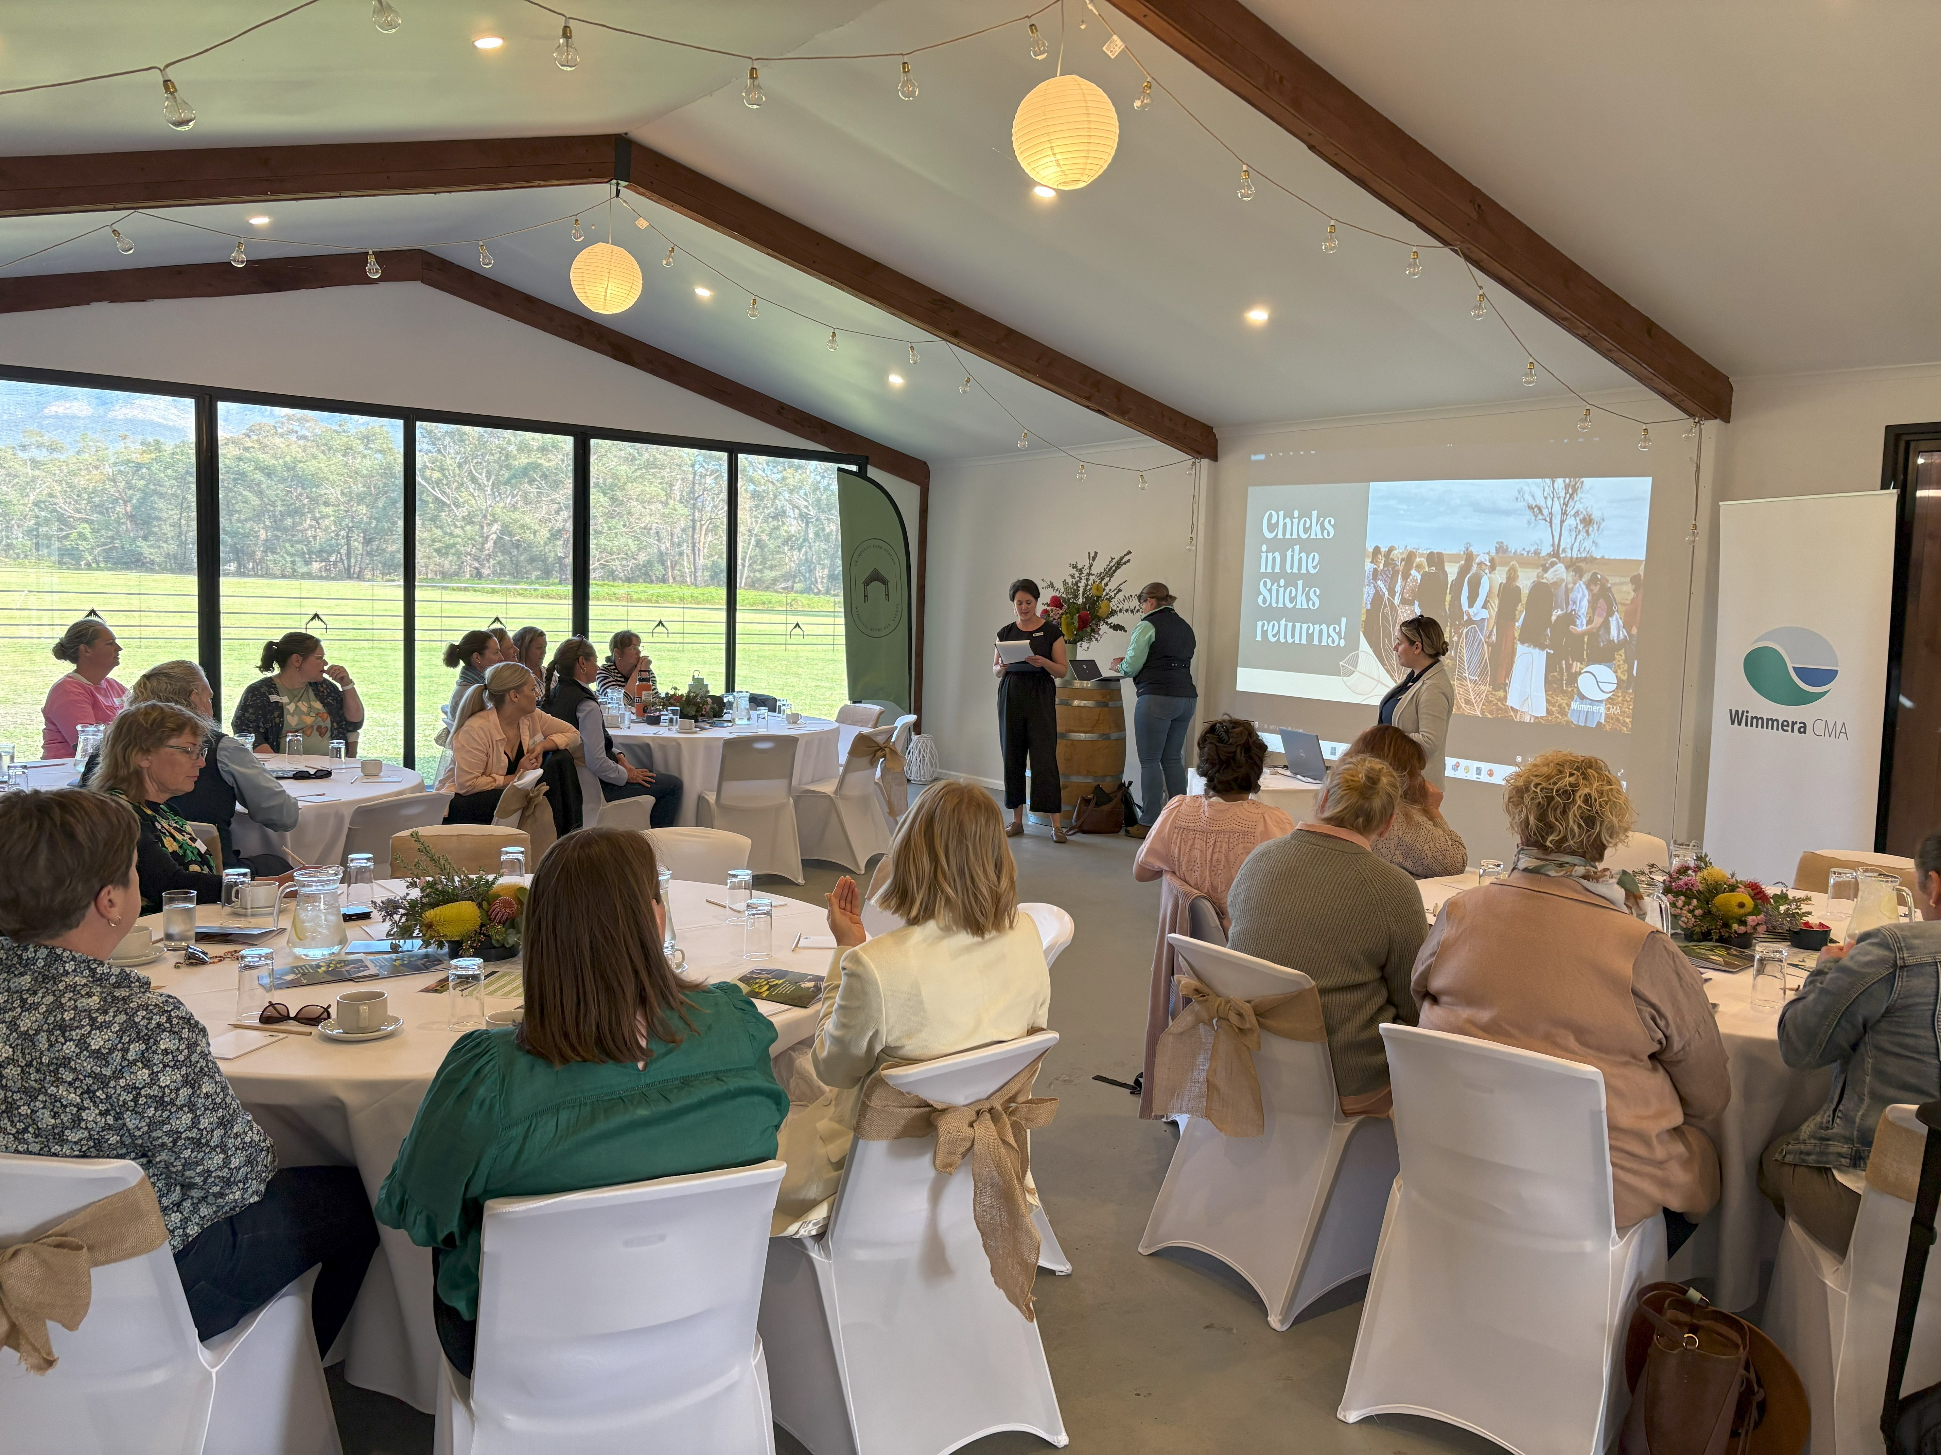

Corporate Plan

2025 - 2030

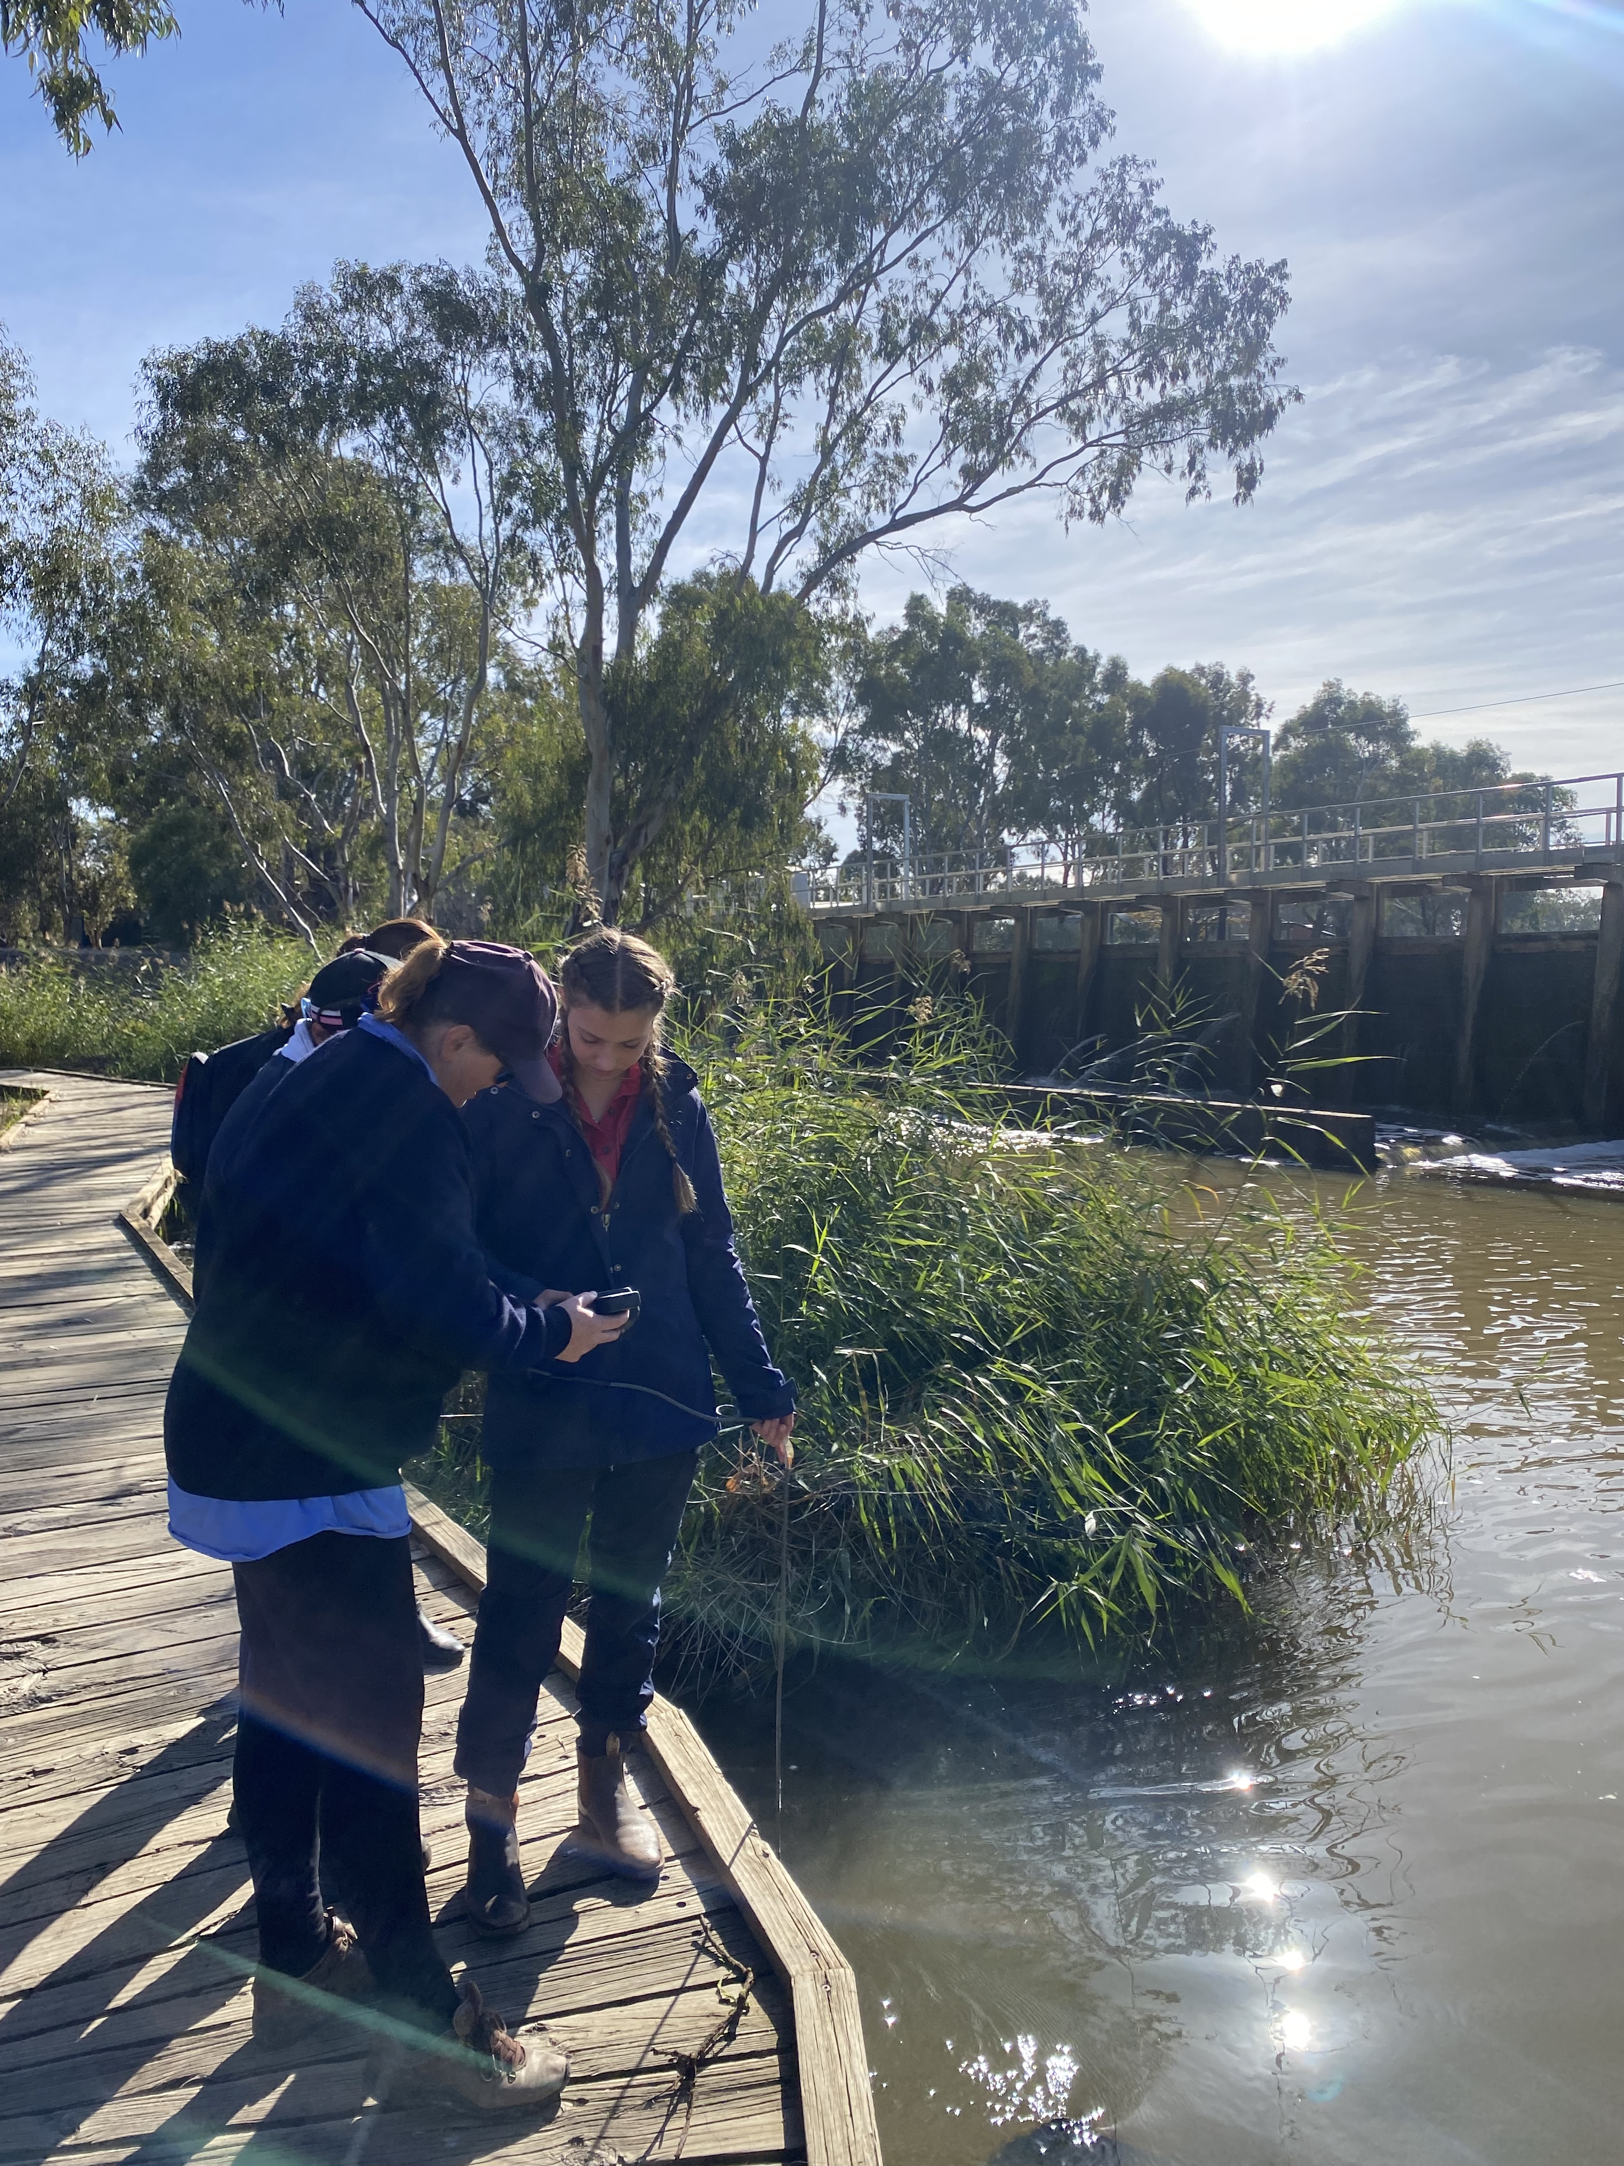
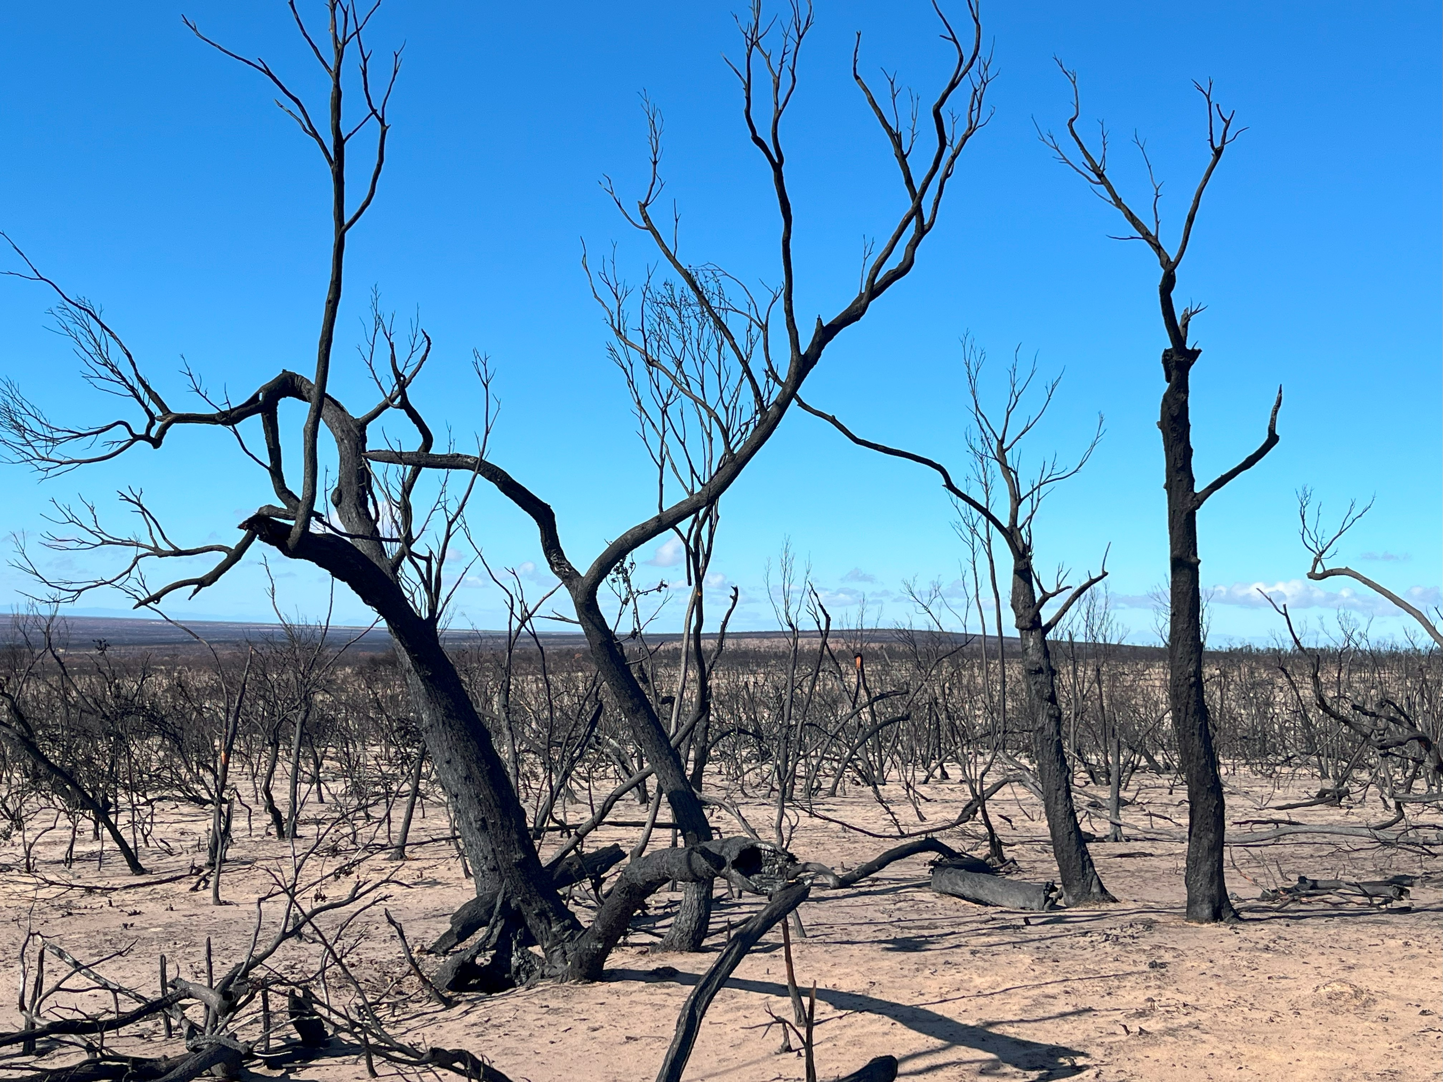

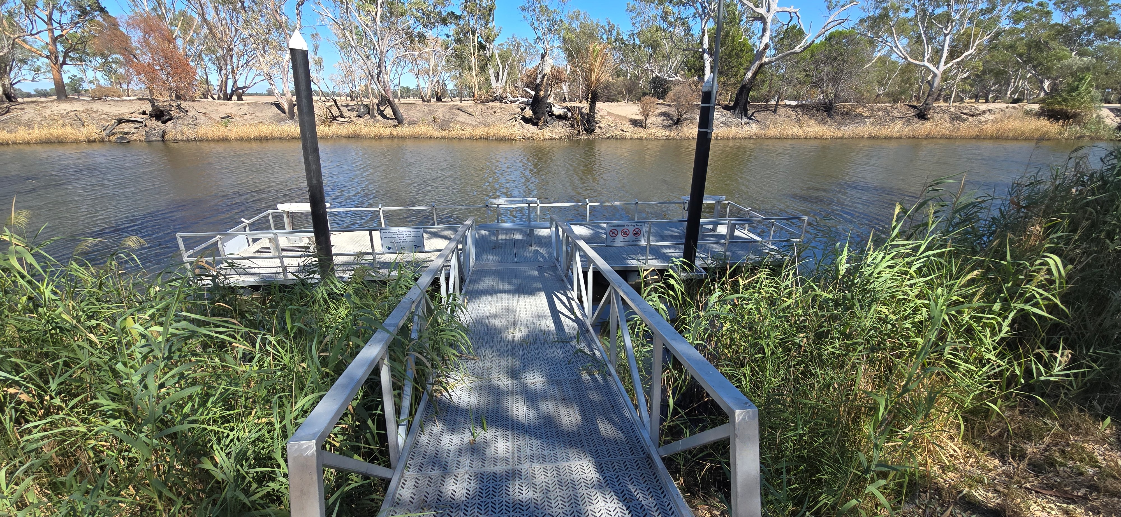

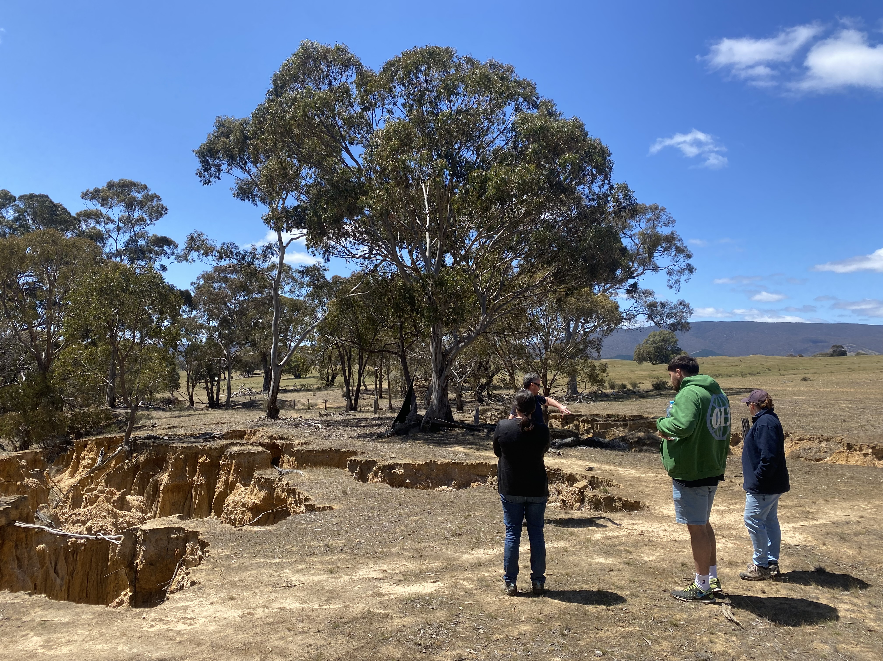



Wimmera Catchment Management Authority
24 Darlot St, Horsham Victoria 3400
PO Box 479 Horsham Victoria 3402

Phone: (03) 5382 1544
Email: wcma@wcma.vic.gov.au
ABN: 83 900 830 261
Website: www.wcma.vic.gov.au

First published – July 2025

Cover photographs:
Wimmera CMA hosting Chicks in the Stick event 2024
Little Desert after 2025 fires
Improved river access with installed fishing pontoon on Wimmera River, Dimboola
Wimmera CMA staff with students on Careers Taster 2024
Wimmera CMA and Eastern Maar Aboriginal Corporation staff inspecting waterways and erosion

Back:
Wimmera River, Horsham

Acknowledgement Of Country
Wimmera CMA acknowledges the Traditional Custodians of the land and waters where we work and pay our respects to the Elders past and present.

We acknowledge and respect Traditional Owners, Aboriginal communities and organisations. We recognise the diversity of their cultures and the deep connections they have with Victoria’s lands and waters.

We value partnerships with Traditional Owners for the health of people and country.

Wimmera CMA Board, management and staff recognise the primacy of Traditional Owners’ obligations, rights and responsibilities to use and care for their traditional lands and waters.

Disclaimer
Statements and information in this document are current only as at July 2025 and the information remains subject to change without notice.
While reasonable care has been taken in preparing this document none of the organisation Board members or employees guarantees the accuracy, forecasts, estimates and conclusions in the document.
Certain statements in this document may constitute forward looking statements and comments about future events that involve known and unknown risks, uncertainties, assumptions and other important factors that are beyond the control of the organisation and may cause actual results, performance or achievements to differ materially from those expressed.
Given these uncertainties, recipients are cautioned not to place undue reliance on any forward-looking statement.

The document has been compiled following the guidelines issued by the Minister for water as required undersection 19C (2) of the Catchment and Land Protection Act 1994 (CaLP Act).

CEO’s Foreword
Our Corporate Plan is the primary business planning document, articulating our strategies and objectives for the next five years to realise our organisation’s vision of a healthy Wimmera catchment where a resilient landscape supports a sustainable and profitable community. The Corporate Plan is based on “all things being equal” and covers a three-year financial outlook. As a Victorian government statutory authority, we look forward to delivering and exceeding the Minister’s priorities and delivering significant community outcomes. As part of our accredited ISO9001:2015 quality management system, before preparing our corporate plan we complete a major review of all business activities and make changes to reflect the external and internal operating environments.
This year a key focus will be working with the community and key stakeholders as drought conditions impact the entire Wimmera catchment. With reduced water storage levels and unfavourable short-term weather forecasts a drought mindset approach will be adopted to all on ground activities until significant rain arrives.
Fortunately, we have two strategically important drought refuge projects that are progressing well and will provide transformational change to sections of the Lower Wimmera River and Mount Cole Creek in the Upper Catchment by delivering piped water in drought conditions. Pleasingly both drought refuge projects have been planned and organised in anticipation of a return to drought conditions. Significant consultation with Traditional Owners and the community has shaped these projects.
From an Integrated Water Management (IWM) perspective, our region is well coordinated with key stakeholders focusing on the efficient and effective use of water resources, including the use of recycled water.
We continue to support recovery efforts from the summer Grampians (Gariwerd) and Little Desert National Park bushfires. This involves monitoring of waterways and habitat for iconic species such as Mallee Fowl and Red-tailed Black Cockatoos.
We are developing a three-year research program to facilitate future stocking of River blackfish across key locations. This innovative project has key partnerships with Barengi Gadjin Land Council (BGLC), Victorian Fisheries Authority and Arthur Rylah Institute.
As large scale, renewable energy projects, transmission lines and critical mineral projects are changing the Wimmera landscape, we will work with industry to meet our statutory requirements and their Environment, Social and Governance (ESG) ambitions/requirements. Equally we will provide strong leadership by; participating in regional forums, shaping policy, advocating for pragmatic outcomes and promoting opportunities for our community. At the same time, we acknowledge the uncertainty and stress these changes are causing to some members of our community.
We will deliver a range of water-related projects that increases recreational, environmental, cultural and socio-economic outcomes. Consultation with a range of local community groups, local government, agencies and non-government organisations for the renewal of the Wimmera Waterway Strategy will continue.
We will support local government to ensure that the most up to date flood information is converted to planning schemes as quickly as possible.
We look forward to working closely with CSIRO and all other CMA’s as we coordinate Victorias participation in the National Soils Monitoring program. This program will provide important baseline data on soil characteristics across Victoria.

For further information on our previous achievements and learnings please read our annual report.

David Brennan
Chief Executive Officer

Table of Contents

Forward | 4
CEO’s Statement | 4
Table of Contents | 5
1. Business Direction | 6
1.1 Purpose (Mission) | 6
1.2 Vision | 6
1.3 Agency Objectives (Outcomes) | 6
2. Planned Programs, Services and Infrastructure Delivery (Outputs) | 7
2.1 Context  2.2 Outcome Indicators | 7  8
3. Future Challenges & Opportunities | 19
3.1 Business Risks and Mitigating Controls | 19
3.2 Underpinning Assumptions for the Next Five Years | 21
3.3 Opportunities | 21
3.4 Challenges | 21
4. Estimates of Revenue and Expenditure | 22
4.1 Investor Income Assumptions 2025-2026 | 22
4.2 Programs Budget for the 2025-2026 year | 22
4.3 Estimated Operating Statement | 23
4.4 Estimated Statement of Cashflows | 24
4.5 Estimated Balance Sheet | 25
4.6 Planned Capital & Business Improvement Activities | 26
4.7 Notes to the Financial Estimates | 26

- Business Direction

  - Purpose

Wimmera CMA’s mission is to bring out the best in our staff, community and environment.

  - Vision

Our vision is for a healthy Wimmera catchment where a resilient landscape supports a sustainable and profitable community.

To realise our vision, Wimmera CMA has four strategic objectives:
1. Improve catchment health through continuous improvement and implementation of the Wimmera Regional Catchment Strategy
2. Build understanding and create effective partnerships by involving our regional communities
3. Influence policy and investment decisions through respected and valued delivery partnerships
4. Foster a healthy organisation based on achievement, knowledge, diversity, flexibility and high governance standards.

  - Agency Objectives

Based on our certified ISO9001:2015 quality Management system and processes we will:
- Deliver innovative services in an efficient and effective manner.
- Promote a culture of continuous learning and diversity.
- Be recognised as a leader in customer service and engagement with the community.
- Continuously align our business model to investor and stakeholders’ expectations
- Apply best practice corporate governance.

To deliver on our business objectives we will undertake the following actions:
- Collaboratively build community awareness & participation
- Establish future priorities, minimising risks and maximising opportunities.
- Deliver on ground works that improve physical change and catchment health outcomes.
- Increase knowledge management and identify gaps.
- Implement the Regional Catchment Strategy (RCS) and supporting strategic documents.
- Work with the community to maintain and improve the condition of our natural environment.
- Minimise the impacts of introduced pest plant and animals.
- Provide tailored information to community and local government to make informed decisions on environmental issues i.e., flood plain management.
- Provide incentives and support for landholders undertaking management change to improve their environment.

- Planned Programs, Services and Infrastructure Delivery
  - Outcomes framework program logic
The below program logic has been applied to all services we deliver, see 2.2.

  - Outcomes Indicators

Planned Programs Services and Infrastructure Delivery (outputs)

Below is a list of Wimmera CMA’s 5-year proposed business objectives and outcomes based on the Ministers letter of expectations 2024, Victorian and Australian Governments investment and Wimmera CMA’s vision. Outcome Indicators will act as a proxy for overall CMA performance.

Outcomes and activities have been developed based on an “all things being equal” basis and a high level of assumption.

CLIMATE CHANGE AND ENERGY (LOE1)

OUTCOME INDICATOR | INDICATOR CODE | ACTIVITY INDICATOR | ACTIVITY MEASURE
Carbon Sequestration | 1.4.1.001 | Explore opportunities and/or deliver initiatives to:  - Sequester carbon and generate carbon offset credits and  - Adapt to climate change and climate variability | - Contribution to CMA-funded climate officer position and Natural Capital project. A key requirement being to investigate carbon sequestration opportunities  - Continue to participate in the implementation of priorities from the Grampians Region Climate Change Adaptation Strategy  - Continue to implement all strategic documents that have reference to climate change adaption and climate variability: Regional Catchment Strategy (RCS), Regional Waterway Strategy, (RWS), Carbon Ready Plan (CRP), Emergency Management Preparedness and Response Plan for Biodiversity and Natural Capital Assets  - Contribute to the delivery of the Carbon Outreach Program.

CUSTOMER, COMMUNITY ENGAGEMENT AND PARTNERSHIPS (LOE2)

OUTCOME INDICATOR | INDICATOR CODE | ACTIVITY INDICATOR | ACTIVITY MEASURE
Engagement and Partnerships | 2.5.1.001 | CMAs to continue to build extensive, effective and consistent approaches to community engagement and partnerships in regional planning and implementation and to further the objectives of the CaLP Act 1994 | - Continue to work with CMAs and relevant government departments to deliver consistent approaches to community engagement and planning.  - Participate in Regional Partnership and advocate for CMA and IWM/ICM outcomes  - Deliver interagency NRM forum  - Support Landcare and community groups in capacity building activities or events  - Maintain or increase the number of community groups participating in NRM projects over the 5-year period
Engagement and Partnerships | 2.5.1.002 | CMAs to work collaboratively with organisations and communities to strengthen engagement approaches and capacity | - Support delivery of impactful and tailored events and activities such as: Wimmera Biodiversity Seminar, Best of the West Landcare facilitator training forum and training activities for group volunteers, nature connection activities and school plant outs  - Engage angling groups that deliver shared benefits including recreational, social, economic, cultural and environmental outcomes  - Working with BGLC, VFA and GWM Water to deliver an annual water engagement event.  - Collaborate with Landcare to deliver sustainable agricultural and environmental outcomes  - Environmental education activities such as River Detectives are delivered to schools through a variety of platforms  - Participate in emergency management forums and incidents  - Partner with Melbourne, Monash, Federation universities and researchers to deliver key projects  - Host Yarriambiack area Landcare facilitator, and Trust for Nature  - Continue relationships with municipal councils through shared development and implementation of plans and strategies  - Participate in seasonal condition forums including the South West Drought Coordination Group.

RECOGNISE ABORIGINAL VALUES (LOE 3)

OUTCOME INDICATOR | INDICATOR CODE | ACTIVITY INDICATOR | ACTIVITY MEASURE
Partnerships with Traditional Owners | 3.1.1.001 | Provide the number of formal partnership agreements with Traditional Owners/ Traditional Owner Groups | - BGLC and Wimmera CMA are engaged in ongoing collaboration and two-way learning to strengthen NRM planning and actions in the region. Our long-standing collaborative and positive partnership is reflected throughout our project-specific plans and joint strategic planning rather than a single formal partnership agreement
Partnerships with Traditional Owners | 3.1.1002 | Describe the nature of the formal partnership agreements entered into with Traditional Owner groups | - Maintain robust working relationships with Barengi Gadjin Land Council (BGLC), Eastern Marr Aboriginal Corporation (EMAC), Dja Dja Wurrung Goolum Clans Aboriginal Corporation’s (DJAARA’s), Goolum Aboriginal Co-operative  - Continue to meet regularly with BGLC.  - Continue to use ranger crews for on ground works where appropriate  - Purchase of plants from Dalki Garringa (BGLC owned nursery) where appropriate  - Support Traditional Owner participation and engagement in project delivery and implementation at a range of levels  - Build long-term capacity in NRM sector through employment and capacity building opportunities with Wimmera CMA  - Joint funding bids
Partnerships with Traditional Owners | 3.1.1.005 | CMAs to demonstrate how Traditional Owners’ aspirations and recommendations have influenced water planning, strategies and management | - Support the BGLC-led Environmental Water Reserve (EWR) watering proposal for the Ranch/Billabong and Aboriginal water officer position  - Promote involvement in the development and design of watering plans and engagement activities  - Joint On Country project delivery for example fish translocations/ introductions, Ranch Billabong rehabilitation  - Endorsement of seasonal watering plan  - Participation in emergency response and recovery  - Work collaboratively on the renewal of the Regional Waterway Strategy

RECOGNISE RECREATIONAL VALUES (LOE4)

OUTCOME INDICATOR | INDICATOR CODE | ACTIVITY INDICATOR | ACTIVITY MEASURE
Engagement processes with community or stakeholders | 4.2.1.001 | Provide evidence of community engagement processes that identified and considered recreational objectives relating to:  - waterway health and environmental land  - water planning and management | - Working closely with councils, user groups and adjoining landholders to design and deliver improved recreational outcomes  - Implement the Green Lake Master Plan  - Partner with Yarriambiack Shire Council to reduce sediment loads in the Warracknabeal Weir Pool  - Partner with fishing competition committees including Horsham, Jeparit, Dimboola, Grampians Lakes, Rainbow Lake  - Assist Stawell, Murtoa, Horsham Angling clubs to deliver mutually beneficial projects.  - Annual water engagement event aimed at recreational fishers and other recreational water users.
Improvements to information sources | 4.3.1.001 | Provide evidence of actions taken to improve information sources to help recreational users plan their activities | - Continually improve our online content for river flow information  - Continue to deliver quarterly media information regarding the water for the environment program  - Deliver SMS environmental water release information and flood alerts when required  - Annual water engagement event to communicate water for the environment annual plan
Collaboration with stakeholder | 4.4.1.001 | Provide evidence of actions taken to collaborate with other organisations and government agencies to explore and progress opportunities to support recreational objectives | - Deliver annual water community forum with Fisheries for recreational user groups to discuss watering requirements balanced against watering needs and objectives  - Influence land development along waterbodies to incorporate walking tracks and access  - Deliver seasonal watering plans that maximise recreational outcomes via activities such as fishing competitions, rowing regattas, water skiing events and community outcomes over summer

RESILIENT AND LIVEABLE CITIES AND TOWNS (LOE 5)

OUTCOME INDICATOR | INDICATOR CODE | ACTIVITY INDICATOR | ACTIVITY MEASURE
Integrated Water Management | 5.1.1.006 | Actively participate and promote stakeholder collaboration with other organisations, through IWM Forums, to help facilitate IWM | Wimmera CMA CEO chairs the Wimmera IWM forum, and actively supports DEECA staff and partners with local organisations in delivering IWM objectives
Integrated Water Management | 5.1.1.007 | CMAs to participate in the preparation and monitoring the implementation of IWM plans, particularly through prioritising to enhance waterway values | Wimmera CMA led the development of IWM Strategic Direction Statements and continues to work closely with DEECA and partners on monitoring and reporting
Integrated Water Management | 5.1.1.008 | CMAs to provide quantitative data to support the narration provided regarding participating in the preparation and monitoring the implementation of IWM plans, particularly through prioritising measures to enhance waterway values | As the organiser of all IWM meetings in the Wimmera we ensure that a holistic approach to water management is implemented, this includes prioritising measures to enhance waterway values, flood plain management, IWM, ICM and shared benefits

LEADERSHIP, DIVERSITY AND CULTURE (LOE6)

OUTCOME INDICATOR | INDICATOR CODE | ACTIVITY INDICATOR | ACTIVITY MEASURE
Diversity and Inclusion | 6.1.1.001 | Is a Diversity Inclusion Plan/s published on entity website (Y/N) | Not required
Diversity and Inclusion | 6.1.1.005 | Percentage of all the staff who complete the VPSC people matter survey | Wimmera CMA has historically participated annually in the “People Matter Survey.” This will continue with the objective of reaching a participation rate of around 80%.  Results are analysed and improvements made if necessary
Diversity and Inclusion | 6.1.1.008 | Summary of progress against Letter of Expectation (LoE) Priority Area Leadership, diversity and culture | All LoE priority areas have been meet. As an organisation we continue to maintain a healthy and diverse workplace as per our Diversity and Inclusion Plan. This includes maintaining the percentage of women in executive roles, percentage of First Nations people and percentage of youth. For further information see annual report

PERFORMANCE AND FINANCIAL MANAGEMENT (LOE7)
.
OUTCOME INDICATOR | INDICATOR CODE | ACTIVITY INDICATOR | ACTIVITY MEASURE
Delivering efficiencies leading to cost savings | 7.2.1001 | CMAs to provide commentary on strategies undertaken to achieve efficiencies and cost savings | - Continue to use internal Quality Assurance system to identify business improvements and efficiencies  - Participate in CEOs, Corporate Services Managers and Vic Catchment forums to explore and implement efficiencies including shared services.  - Implement CMA collective Base and Efficiency Review findings  - Continue to develop the organisations Information, Technology Communications (ITC) systems and capability including SharePoint in the cloud for greater efficiencies and cost savings  - Explore opportunities to reduce administration burden such as exemptions and adoption of model policies  - Analysis of procurement expectations to identify efficiencies
Improve reporting systems and processes | 7.3.1.001 | CMAs to collaborate with DEECA to improve reporting systems and processes | - Continue to participate and contribute to Vic Catchments. Including hosting and supervision of executive officer position  - Actively participate and collaborate with DEECA in system and process improvement.  - Participate in CMA Waterway and RCS managers forums and investment coordinators forum to explore improvements in monitoring, reporting and evaluation processes

WATERWAY AND CATCHMENT HEALTH (LOE9)

OUTCOME INDICATOR | INDICATOR CODE | ACTIVITY INDICATOR | ACTIVITY MEASURE
Implementation and reporting of the regional catchment management strategy and the regional waterway strategy | 9.1.1.001 | CMAs to coordinate and monitor the implementation of your regional catchment strategy and regional waterway strategy (Healthy Waterways Strategy for Melbourne Water) | - Continue to implement and continually review Monitoring, Evaluation, Reporting and Improvement (MERI) plans for RCS and Wimmera Waterway Strategy  - Commence the renewal of the of regional waterway strategy and its MERI plan
Waterway and Integrated Catchment Management | 9.2.1.001 | CMAs to deliver waterway and integrated catchment management in line with government policies and frameworks | - Improved stewardship in priority areas as per strategic documents and funding agreements  - Deliver objectives of Water for Victoria, Water is Life, Victorian Waterway Management Strategy and Our Catchment Our Community.  - Begin the review of the Regional Waterway Strategy to ensure alignment with policies
Catchment Partnership | 9.3.1.001 | Report on arrangements in your region in accordance with the Catchment Partnership Framework 2024. | - Wimmera CMA’s Partnership Agreement have lapsed with no compelling need to re-establish as relationships are robust and strong. Participation in Regional Partnership, Integrated Water Management (IWM) forum, Natural Resource Management (NRM) interagency forum suffice

WATER FOR AGRICULTURE (LOE10)

OUTCOME INDICATOR | INDICATOR CODE | ACTIVITY INDICATOR | ACTIVITY MEASURE
Sustainable Irrigation Management Practices | 10.1.1.001 | CMAs to provide commentary on actions taken to promote sustainable irrigation management practices to support the growth and viability of regional communities | - Continue to participate in the GWM Water groundwater reference group  - Work in partnership with GWM Water to implement the Irrigation Development Guidelines
Manage Salinity Waterlogging and Water quality in Agricultural Areas | 10.2.1.001 | CMAs to provide commentary on actions taken to plan and coordinate activities to manage salinity, waterlogging and water quality in agricultural areas | - Contribute to annual Basin Salinity Management reporting as required
Flexibility for Agriculture to continue adapting to change | 10.3.1.001 | CMAs to provide commentary actions taken to improve flexibility for agriculture to continue to adapt to change and help the sector to increase water use efficiency | - In partnership with Ag Vic support Sustainable Cropping Rotations in Mediterranean Environments (SCRIME) working group strategic directions.  - Maintain and expand soil moisture probe and weather station network (72 devices)  - Land transect surveys (northern and southern) indicate groundcover is maintained to better than 1995 levels in the northern Wimmera, and maintained to better than 2014 benchmark  - CMA participate in the joint AgVic Carbon Out Reach program to landowners

Additional Focus Areas
CUSTOMER DATA PROTECTION

OUTCOME INDICATOR | INDICATOR CODE | ACTIVITY INDICATOR | ACTIVITY MEASURE
Implementation of robust customer data protection measures to minimise risk and consequence to customers, staff and contractors |  | Adherence to the Victorian Protective Data Security Standards (PDSP) | - Implementation of new system to manage PDSP  - Review and submit PDSP to Office of Victorian Information Commissioner (OVIC) by 31 August  - Review and update internal policy in the event of a data breach
 |  | Implementation of recommendations from Privacy and Management of Personal Information Audit | - Adoption of privacy declarations  - Update the privacy policy and relevant PD to nominate the role of Privacy Officer  - Delivery of “privacy training for the public sector” to all staff  - Upgrade of record management systems for contractor agreements

CYBER SECURITY

OUTCOME INDICATOR | INDICATOR CODE | ACTIVITY INDICATOR | ACTIVITY MEASURE
Implementation of fit for purpose cyber security systems and processes |  | Adoption of Essential 8 security maturity model | - Develop maturity level targets  - Identify priority areas for investment  - Report against targets quarterly  - Implement training and awareness  - Policy review  - Monthly ICT provider meetings  - Incident reporting  - Review and consideration of quarterly Cyber Hygiene Improvement Program (CHIPS) report

- Future Challenges and Opportunities
  - Business Risks and Mitigating Controls
Wimmera CMA has a comprehensive Risk Management process overseen by; our Board, Audit Risk & Finance committee, OH&S committee and underpinned by Quality Management System ISO9001:2015. Below are high risks from the Risk Register and Risk Management Framework assessment.

Major risks rated as high | Treatments of risk | Strategies for risks
Machinery of government change | Input into policy documents at various levels  Membership and input to Vic Catchments forum  Input into government and departmental processes  Maintain positive and productive relationships  Continue to be a high performing CMA | - Ability to identify and respond to risk/opportunities  - Ensure CMA value proposition aligns to investor expectations.  - Work collectively as a CMA and NRM sector to influence policy and decisions  - Maintain Wimmera CMA’s reputation as a valued service provider
Community perception of Wimmera CMA | Ensure CMA is applying best management practice service delivery  Ensure engagement objectives, communication and education are clear  Maintain relationships with media organisations and key stakeholders | - Maintain goodwill and reputation.  - Ensure community support for integrated catchment management.  - Leadership in good governance.
Ineffective in achieving outcomes. | Anticipate planning approval delays  Consider supply chain constraints including labour | - Demonstration of effective and adaptive project management including problem solving and innovation
ITC including cyber security | Ensure ICT systems and equipment has up to date anti-virus capability installed and appropriate hardware is provided  Relevant cyber security training for staff  Work with IT Provider to work toward adopting the Essential 8  Ensure private data is stored safely and only store what is required | - Reduce cyber-attacks by purchasing best practice hardware and software to limit risk.  - Educate staff to minimise cyber attacks  - Minimise impacts of potential cyber threats  - Collect only required information and store for required timelines as per PROV guidelines
Motor Vehicles | Adequate insurance  Defensive driver training for staff  4X4 driver training for staff  Navigation and tracking devices in all office based vehicles | - Use of video meetings  - Minimise vehicle travel  - Purchase of vehicles with up-to-date safety equipment
Major disruption to organisational  systems and modes of work, work  practices, including natural disasters | Drought refuge plans for watering points  Translocation of fish species  Increased community awareness  Diligent planning for water delivery  Diligent planning for on ground NRM delivery | - Emergency preparedness plans  - Drought management plans and actions  - Identify opportunities for works and improvements in drought conditions i.e. advocate for boat ramp extensions.
Damage and destruction of previously funded CMA works | Work with landowners to mitigate potential risks  Promotion of best practice asset construction  Monitoring and assessment of key works | - Support policy change, such as virtual fencing  - Limit investment in locations of high risk of destruction or damage  - Advocate for fire and flood recovery resources
Tendering and contracting | Effective procurement policy and due diligence  Review policies and procedures including purchasing and, tendering and outsourcing policy  Contract panel  Compliance under the Financial Management Act. | - Delivery of outcomes that are efficient, effective and demonstrate value for money
Partners and Clients | Close working relationships for high-risk projects/ activities  Strengthen communication with Partners and clients | - Support regional partners in delivering outcomes

  - Underpinning Assumptions for the next five years:

  - Government policies or revenue do not significantly change.
  - Likelihood of extreme weather events i.e., flooding, fire, natural disasters.
  - Organisation is managed as an ongoing concern.
  - Funding from investors including EC7 and NLP4.
  - Funding reflects service delivery costs.
  - No major machinery of government change for CMA sector.
  - Flexibility and adaptability to deliver government services.
  - Regional economy and agricultural sector is profitable.
  - Customer base continues to engage in our service offerings.
  - Organisational expertise and capacity is maintained and retained.
  - Compliance, legal and regulatory standards remain constant.
  - Stakeholders and partners have the capacity and capabilities to deliver services.
  - Mining and renewable infrastructure expansion.

  - Opportunities:

The Wimmera CMA has identified the following opportunities to enable it to meet its objectives more effectively:
  - Embrace technology; new social media and engagement approaches, business efficiencies, Internet of Things (IoT).
  - New partnerships; the ability to deliver high profile projects that leverages additional funding.
  - Continue to work with other CMAs and organisations to improve business outcomes.
  - Champion Integrated Water Management to deliver greater community outcomes.
  - Climate change mitigation and adaption.

  - Challenges:

To reach its business objectives, the Wimmera CMA will have to address the following challenges:
  - Increase in farm size and equipment; increased paddock tree pressure.
  - Land use change; continued trend of pasture into cropping system, mining – reduced inflows.
  - Carp management.
  - Fire recovery from 2025 fires.
  - Divergence of attitudes towards transmission lines and renewable energy infrastructure.
  - Drought impacts on point locations and water quality.
  - Climate change.

- Estimates of Revenue & Expenditure
  - Investor Income assumptions 2025-2026

  - Programs Budget for the 2025-2026 year
Based on estimated carry forwards and income assumptions with all figures in $ unless otherwise stated. We anticipate an approximate budget expenditure of $10.2 million.

  - Estimated Operating Statement

The budgeted deficit is using committed unspent project funds carried forward from the previous year and grants received in advance for the 2025/2026. financial year. Grants received in advance total $1.172 million.

  - Estimated Statement of Cashflows

  - Estimated Balance Sheet

Assets are diminishing due to project carry forward dollars being spent, less capital asset purchases and depreciation expenses in the outer years.

  - Planned Capital and Business Improvement Activities

Category | Funding Source | Cost  ($000’s) | Description
Program Support | Business Improvement | 40 | SharePoint development
Program Support | Reserves | 50 | Motor vehicle replacement

  - Notes to the Financial Estimates

Accounting Policies
All the Authority’s accounting policies are consistent with the Financial Management Act 1994 and applicable Ministerial directions.

Australian Accounting Standards
Annual accounts are prepared in accordance with Australian Accounting Standards. The annual accounts are audited by the Victorian Auditor General to ensure compliance with accounting standards.

Corporate Costs and Project Costing
The State Government funds the Authority’s governance, corporate and statutory costs via a grant through DEECA. Costs in excess of the grant required to enhance and maintain business systems, infrastructure, resources services and compliance requirements are charged to projects inclusive as a direct labour charge. The costs that exceed the grant are those costs that can be attributed to the cost of staff accommodation, provision and maintenance of resources and services provided to staff to enable them to carry out the organisation’s programs efficiently and effectively. The use of a labour charge to projects ensures that staff costs are equitably spread over projects according to resources used in project delivery.

Funding Estimates and Assumptions
Planned programs for the forthcoming year are based on funding agreements in place and Wimmera CMA’s estimate of funding available through State and Australian Government funding programs. We have received some early funding in the 2024/2025 year which relates to the 2025/2026 financial year. This includes landcare grants, floodplain management, vic catchments, integrated water management and part corporate and governance funding There may be possible additional funds which may flow to the Authority during the period. At the stage of preparation of the Corporate Plan State Government four-year SLAs have been signed up to and including the 2027/2028 year. The Australian Government work orders have also been signed up to and including the 2027/2028 year. The financial statements are based on receiving State funding equal to the funding amounts communicated for the next three years. The Australian Government funding is based on receiving the amounts signed off in the work orders for the next three years.

Assumptions Underpinning Financial Statements
At the level of funding assumed from both Victorian and Australian Governments the Authority’s financial position will be able to meet all financial obligations and targeted strategic goals over the next three years. The Wimmera CMA will be operating as a going concern. See also Underpinning Assumptions for the next five years, section 3.2.

Cost Recovery
Wimmera CMA does not currently charge for services to the public.
