
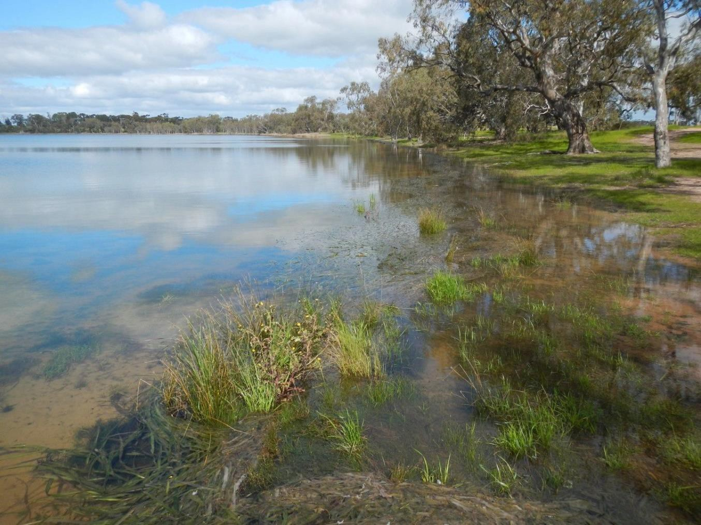
Recreation Lakes Environmental Values Analysis

Recreation Lakes Environmental Values Analysis

Front image © Wimmera CMA; Walkers Lake

Submitted to:
Dean Lawson, NRM Strategic Planning Officer, Wimmera CMA.

Document version | Description | Contributors | Reviewed by | Issued to
Draft_05102022 | Context setting Briefing paper | Peter Cottingham, Rhonda Butcher | Rhonda Butcher, WCMA | Dean Lawson
Draft_13102022 | MCA approach Briefing paper | Peter Cottingham, Rhonda Butcher, Sabine Schreiber | Rhonda Butcher, NCCMA | Dean Lawson, Steering Committee
Draft_30112022 | Working draft report | Peter Cottingham, Rhonda Butcher | Rhonda Butcher, NCCMA | Dean Lawson
Final_21122022 | Final report | Peter Cottingham, Rhonda Butcher | Rhonda Butcher | Dean Lawson

Acknowledgement of Country:
The authors of this report acknowledge Traditional Owners within the region, their rich culture and spiritual connection to Country. We also acknowledge the contribution and interest of Aboriginal and Torres Strait Islander people and organisations in land and natural resource management, and pay respects to Elders past, present and emerging.



CONTENTS

- Introduction 5
  - Context 5
- Approach 7
- Ecosytem classification and typology 8
  - Aquatic ecosystem classification systems 8
    - ....... Terminology 8
    - ....... Australian National Aquatic Ecosystem (ANAE) classification 9
    - ....... Victorian classification systems 9
  - Ecosystem complexes 11
  - Typology 12
- Current environmental values and condition 14
  - Environmental values 14
  - Current condition 21
    - ....... Environmental condition 21
- Lake conceptualisation 24
  - Conceptualisation 24
  - Ecosystem type conceptual models 25
    - ....... Threats to environmental condition 29
  - Lake watering scenarios 34
    - ....... Scenarios 34
- MCA approach 36
  - Criteria 37
    - ....... Scoring 38
  - Ranking of lakes 39
    - ....... MCA results 39
    - ....... Sensitivity analysis 40
- Summary 40
  - Knowledge gaps 41
- References 42
- Appendix 1: Summary of social and economic values 44
  - Social values 44
  - Economic values 46
- Appendix 2: Terminology used in classification 47
- Appendix 3: Species lists for individual lakes 48
  - Wimmera CMA region 48
    - ..... Brim Weir Pool 48
    - ..... Lake Marma 50
    - ..... Warracknabeal Weir Pool 53
    - ..... Watchem Lake 55
  - North Central CMA region 56
    - ..... Donald Caravan Park Lake 56
    - ..... Walkers Lake 58
    - ..... Wooroonook Lake 61
  - Mallee CMA region 63
    - ..... Beulah Weir Pool 63
    - ..... Green Lake 65
    - ..... Hopetoun storage (Willow Lake) 69
    - ..... Lake Lascelles 70
    - ..... Ouyen Lake 72
    - ..... Rainbow Lake 74
    - ..... Tchum Lake (south) 75
    - ..... Yaapeet (Turkey Bottom Lake) 76
- Appendix 4: Index of Wetland Condition 77
- Appendix 5: Weighted MCA scores 81
- Appendix 6: Recreation facilities 87
  - Brim weir pool 87
  - Lake Marma 87
  - Warracknabeal weir pool 88
  - Watchem Lake 88
  - Donald Caravan Park Lake 89
  - Walkers Lake 90
  - Lake Wooroonook 90
  - Beulah weir pool 91
  - Green Lake – near Sea Lake – Supplied by Murray system 92
  - Hopetoun Lake (Willow Lake) 92
  - Lake Lascelles 92
  - Lake Ouyen – Supplied by Murray system 93
  - Rainbow Lake 93
  - Tchum Lake 93
  - Yaapeet Storage (Turkey Bottom Lake) 94

INTRODUCTION
  - CONTEXT

Water savings from the Wimmera Mallee Pipeline Project supported the creation of new water entitlements for consumptive, recreational and environmental use in the Wimmera-Glenelg supply system.
The Wimmera and Glenelg rivers’ environmental entitlement defines the Victorian Environmental Water Holder’s
(VEWH) rights to water across both river systems.
Grampians Wimmera Mallee Water (GWMWater) delivers the water allocated to the recreational entitlement to recreation lakes and weir pools via the Wimmera Mallee Pipeline. These lakes and weir pools include Yarriambiack Creek weir pools at Warracknabeal, Brim and Beulah and lakes including Lascelles at Hopetoun; Tchum near Birchip; Marma, Murtoa; Wooroonook, Charlton; Watchem at Watchem; Donald Caravan Park Lake at Donald; Willow Lake annexed to Lascelles at Hopetoun. Donald Weir Pool at Donald also a receives a piped recreational allocation via the Wimmera Mallee Pipeline but is not part of this report.
Allocations to the recreation entitlement commence later than allocations to the Wimmera Mallee Pipeline Product (WMPP) entitlements for consumptive and environmental use. Therefore, in dry years, a greater proportion of the environmental entitlement is available for use compared to the recreational entitlement. Ouyen Lake and Green Lake (near Sea Lake) are supplied with allocations from GWMWater’s Murray River entitlement.
Periodic low inflows to major water storages have often resulted in low allocation to Wimmera-Glenelg entitlements, including that for the recreation lakes (Figure 1). GWMWater holds surplus water resources in reserve due to unused allocations against unsold growth water and large industrial customers not operating. This has enabled it to make unused water available for recreational use in seasons where allocations to the recreation entitlement are low. For example, since 2011 only 26% of the volume supplied to the recreational lakes has come from allocations to the recreation entitlement, with the remainder being supplied from GWMWater’s surplus holdings. GWMWater’s 2022 Urban and Rural Water Strategy acknowledges that with the projected increases to demand and the uptake of growth water, GWMWater is less likely to hold surplus allocation to support deliveries to recreational lakes in the future.
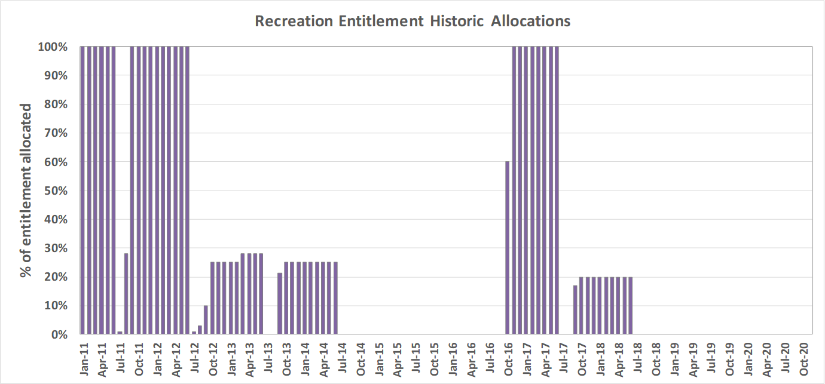
Figure 1. Water allocation to recreation lakes from 2011-2020 (source: GWMWater).
The recreation lakes supported by the pipeline system are valuable to local communities, which have benefited from increased tourism due to the lakes being popular locations for camping and water-based recreational activities. The recreation lakes also contribute socio-economic benefits, including to regional liveability values and general wellbeing. Surface water in a dry landscape can also support regional biodiversity values, with the lakes supporting aquatic species and terrestrial species such as woodland birds, reptiles and other fauna.

While socio-economic and recreation values of Wimmera-Mallee lakes have been well documented in relatively recent studies, an understanding of environmental values of lakes and weir pools supplied with designated recreation water supply is absent from up-to-date information. The previous environmental evaluation of an original list of recreation-supply lakes occurred in 2004 before construction of pipelines. This was during the millennium drought when there was little water in the broader regional landscape.
This 2022 Recreation Lakes Environmental Values Analysis was undertaken at a time when much of the Wimmera-Mallee was experiencing wet conditions and most recreation lakes and weir pools were full, with some having experienced almost a decade of consistent supply. The study was to reconsider the environmental values of these recreation lakes.
Understanding the role of the recreation lakes in contributing to ecosystem function and biodiversity values will be important to inform future management decisions - for example, Regional Waterway Strategies.
This project will contribute to a better understanding of the triple-bottom-line values of these waterbodies and help catchment and water managers meet broad socio-economic demands involving relatively isolated communities especially during a return to times of water scarcity.

It might also guide future decisions relating to water-sharing arrangements. However, changes to bulk and environmental entitlements that impact water-sharing arrangements must be agreed upon by other entitlement holders and can only be amended via statutory processes set out under the Water Act 1989. In addition, further data on environmental values would be required to inform that process.
This project has reviewed existing data and information to assess the environmental values of the recreation lakes. The information collected also provided the conceptual basis for assessing the relative environmental benefits for the lakes under various water-delivery regimes, as well as the main threats to environmental condition of each lake. The recreation lakes included in the assessment are (Figure 2):
- Wimmera CMA region:
  - Brim Weir Pool
  - Lake Marma
  - Warracknabeal Weir Pool
  - Watchem Lake
- North Central CMA region:
  - Donald Caravan Park Lake
  - Walkers Lake
  - Wooroonook Lake
- Mallee CMA region:
  - Beulah Weir Pool
  - Green Lake
  - Hopetoun Storage (Willow Lake)
  - Lake Lascelles
  - Ouyen Lake
  - Rainbow Lake
  - Tchum Lake
  - Yaapeet Storage (Turkey Bottom Lake).

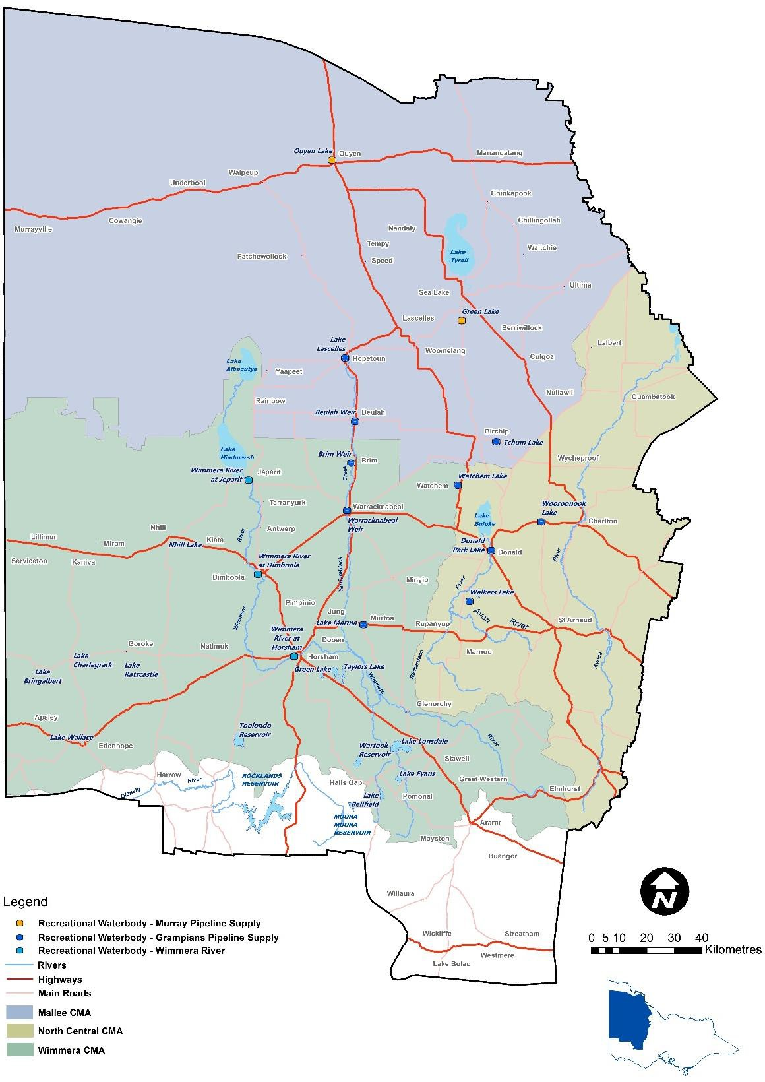

Figure 2. Location of the GWMWater Recreation Lakes (source: GWM Water).

APPROACH
This study is collaborative in nature with Wimmera CMA undertaking community engagement and field assessments of each lake. The initial stage of the project was to collate and synthesise existing data and information on the environmental values of the lakes. In addition, a short summary of the social and economic values is provided in Appendix 1.
The synthesis of the environmental values for the lakes includes review of existing reports, datasets, and hydrological information, outputs from site inspections, and listing of the values identified during the community engagement (WCMA unpublished). Each lake has been classified according to a set of attributes used in

classification and typologies for aquatic ecosystems. Conceptual models relating to threatening processes have been developed for each ecosystem type. Combined, this will detail the current condition and environmental values for each lake.
The second phase of the project was to develop and apply a multicriteria assessment (MCA) as a tool to inform future decisions around the supply of water to recreation lakes for environmental outcomes. The environmental values and MCA are based around elements of the program logic of several key documents used in the planning and management of environmental water in Victoria, including:
  - Basin Plan Environmental Watering Plan, Chapter 8 objective hierarchy (Sections 8.5, 8.6 and 8.7 in Commonwealth of Australia 2012)
  - DELWP Guidelines for Environmental Water Management Plans (DELWP 2022)
  - Victorian environmental water management program, including the Seasonal Watering Plan drafted by the Victorian Environmental Water Holder (e.g., VEWH 2022)
  - Regional Waterway Strategies and Catchment Strategies.
One of the responsibilities of the Victorian Environmental Water Holder (VEWH) is to work with stakeholders¹, the community and First Nations to coordinate and achieve environmental outcomes from the delivery of all water, including environmental water (VEWH 2022).
At the local scale, Regional Waterway Strategies identify priority waterways and outline integrated waterway management actions and are a sub- strategy of regional catchment strategies.
The third phase of this project considered the adaptive management options available to water managers with regards to making trade-off decisions, applying the appropriate spatial and temporal scales at individual recreation lakes to justify watering needs for environmental outcomes, for example the consideration of environmental water allocations, and recommendations for additional work to improve decision-making, which will include improving the evidence base.This will ultimately lead to a system that establishes an environmental-values ranking for each of the Wimmera-Mallee recreation lakes supplied with piped recreational water. Therefore, there will be greater clarity about which lakes receiving recreation allocations have the highest environmental values and will benefit from intervention aimed at improving their environmental values.
3 ECOSYTEM CLASSIFICATION AND TYPOLOGY
  - AQUATIC ECOSYSTEM CLASSIFICATION SYSTEMS
    - Terminology

Terminology for aquatic ecosystems is often inconsistently applied. As mentioned above the recreation lakes are not actually all lakes, however these systems are referred to in this way to avoid confusion. Throughout the rest of the text where reference is made to a system the following terms will be used (modified from AETG 2012):
  - Aquatic ecosystem. Includes any system dependent on flows, or periodic or sustained inundation/waterlogging for their ecological integrity e.g., wetlands, rivers, karst and other groundwater-dependent ecosystems, saltmarshes, estuaries, and areas of marine water the depth of which at low tide does not exceed 6 metres.
  - Recreation lake. Includes the 15 target systems in this analysis.
  - Lake (Lacustrine systems). Described by Cowardin et al. (1979) as those aquatic ecosystems situated in a topographic depression or a dammed river channel², having sparse vegetation coverage (less than 30

1 Includes storage managers, waterway managers and other environmental water holders
2 Excludes weir pools which are considered riverine for this project

percent of their coverage area is made up of vegetation such as trees, shrubs, or persistent emergent vegetation), and the total area exceeds 8 hectares.
  - Wetland (Palustrine systems). Are typically described as swamps, bogs, marshes and meadows, are dominated by trees, shrubs, persistent emergents, emergent mosses, and lichens (greater than 30%). Aquatic ecosystems that lack emergent vegetation might also be palustrine if they are less than 8 hectares, active wave-formed or bedrock shoreline features are lacking, and water depth in the deepest part of the basin is less than 2 metres at low water. As for other inland waters, salinity from ocean-derived salts is less than 0.5‰. Palustrine wetlands may be situated shoreward of lakes, river channels, or estuaries, on river floodplains, in isolated catchments, or on slopes. They may also occur as islands in lakes or rivers (Cowardin et al. 1979).
  - Riverine systems. Systems contained within a channel and its associated streamside vegetation. This definition refers to both single channel and multi-channel systems. The beds of channels are not typically dominated by emergent vegetation, might be naturally or artificially created, periodically or continuously contain moving water, and might form a connecting link between two bodies of standing water. As for other inland waters, salinity from ocean-derived salts is less than 0.5‰ (Cowardin et al. 1979).
    - Australian National Aquatic Ecosystem (ANAE) classification

The National aquatic ecosystem classification and typology adopted for use by the Murray-Darling Basin Authority (MDBA) and the Commonwealth Environmental Water Office (CEWO) is the interim Australian National Aquatic Ecosystem (hereafter ANAE) (AETG 2012, Butcher et al. 2012, Brooks 2021). The AETG (2012) distinguish between classification and typology and is adopted here for consistency:
  - Classification. The process of cataloguing items, in this case aquatic ecosystems, into logical groups based on attributes that have been identified as being relevant to, for example, ecological functioning
  - Typology. An extension to classification whereby those classified aquatic ecosystems are assembled into groups for a specific purpose i.e., a naming convention.
The ANAE classification is considered a broad-scale, semi-hierarchical, attribute-based, biophysical framework (AETG 2012). It presumes that most classifications will be undertaken in areas with poor and patchy biological data, therefore a broad-scale (top-down) approach is argued as the most feasible way to classify aquatic ecosystems. The AETG (2012) distinguish between top-down and bottom-up approaches as follows (Butcher et al. 2012):
  - Bottom-up, point-based classification is possible where there is sufficient biological/ecological data and accompanying environmental information to do a classification based on biodiversity or ecological functioning. This approach is generally the exception rather than the rule.
  - Top-down, broad-scale classification is where data is patchy and/or incomplete. By making careful assumptions, surrogate relationships between the physical characteristics (geomorphology, hydrology, chemistry and habitat form) and biodiversity and ecological functioning can be drawn, although caution should be exercised as these relationships are not uniformly strong.
A top-down approach is considered necessary for this project, consistent with the ANAE, as data are known to be limited. As the emphasis of the current project is on classifying recreation lakes for the purpose of environmental water delivery this review predominantly focuses on attributes at the habitat or lower levels of the classifications – the scale of the ecosystem. The recommended, widely accepted, regionalisations suggested for Level 1 and 2 of the ANAE are considered fit for purpose for this project as is the main typology used in Brooks (2021). These have not been reproduced here.
    - Victorian classification systems

The Victorian wetland classifications including the Corrick type (Corrick and Norman 1980, Corrick 1981, 1982) and the current Victorian classification as per DELWP (2016), along with area (in ha) from MapShare (accessed October

2022) are presented in Table 1. We have included the Corrick type as it provides a historic perspective on ecosystem type. The definitions relating to the hydrological regimes of the Victorian system are presented in Appendix 2.
The ANAE typology (Brooks 2021) was developed at the scale of the Murray-Darling Basin to provide cross-jurisdictional consistency and support for managing aquatic ecosystems with relevance to Commonwealth environmental water management. It is described in more detail below and will be used in this project. One of the most significant differences between the Victorian classification and the ANAE typology is that in Victoria the assignment of wetlands to the Lacustrine or Palustrine category is based solely on the percentage of vegetation cover, regardless of area. In the ANAE, only ecosystems that have less than 30% vegetation cover and are greater than 8 hectares are considered Lacustrine systems.
Table 1. Victorian classification data and area of each recreation lake (from MapShare), ANAE data supplied S Brooks, 13.10.2022.

Recreation lake | Size (ha) | Corrick type | Vic wetland type, regime, and origin | ANAE system and type
Wimmera CMA
Brim Weir Pool | 5.8 | Shallow freshwater marsh | Type: Unknown- listed as Palustrine or Lacustrine? Water regime: Periodically  Inundated - Seasonal Or Episodic  Origin: Dam / Storage <8ha | System: Riverine  Type: Temporary lowland stream
Lake Marma | 18.0 | Permanent open water | Type: Unknown - listed as Palustrine or Lacustrine? Water regime: Intermittent  Origin: Naturally occurring | System: Palustrine  Type: Permanent wetland
Warracknabeal Weir Pool | 15.5 | - | No data | System: Riverine  Type: Temporary lowland stream
Watchem Lake | 13.9 | Shallow freshwater marsh | Type: Unknown - listed as Palustrine or Lacustrine? Water regime: Periodically  Inundated - Seasonal Or Episodic  Origin: Naturally occurring | System: Palustrine  Type: Temporary black box swamp
North Central CMA
Donald Caravan Park Lake | 3.5 | Deep freshwater marsh | Type: Temporary freshwater lake Water regime: Periodically Inundated – Episodic  Origin: Naturally occurring | System: Floodplain3  Type: River red gum woodland riparian floodplain
Walkers Lake | 35.0 | Permanent open water | Type: Unknown - listed as Palustrine or Lacustrine? Water regime: Periodically  Inundated - Seasonal Or Episodic  Origin: Naturally occurring | System: Palustrine  Type: Freshwater meadow
Wooroonook Lake | 36.7 | Permanent open water | Type: Unknown - Palustrine Water regime: Periodically Inundated - Seasonal Or Episodic  Origin: Naturally occurring | System: Palustrine  Type: Freshwater meadow
Mallee CMA
Beulah Weir Pool | 5.0 | Permanent open water | Type: Unknown - listed as Palustrine or Lacustrine? Water regime: Periodically  Inundated - Seasonal Or Episodic  Origin: Dam / Storage =>8ha | Null
Green Lake (Wetland Id 19295) | 29.5 | Permanent open water | Type: Temporary freshwater lake Water regime: Periodically Inundated - Episodic  Origin: Naturally occurring | System: Lacustrine  Type: Temporary lake

3 Considered palustrine, marsh, under current conditions

Recreation lake | Size (ha) | Corrick type | Vic wetland type, regime, and origin | ANAE system and type
Hopetoun Storage (Willow Lake) (Wetland  Id 19295) | 2.2 | - | No data | System: Palustrine  Type: Permanent wetland
Lake Lascelles (Wetland Id 19295) | 21.0 | Permanent open water | Type: Unknown - Palustrine or Lacustrine  Water regime: Periodically Inundated - Seasonal Or Intermittent  Origin: Naturally occurring | System: Palustrine  Type: Permanent wetland
Ouyen Lake | 13.5 | - | No data | System: Lacustrine  Type: Permanent lake
Rainbow Lake | 1.5 | - | No data | Null
Tchum Lake | 34.8 | Freshwater meadow | Type: Temporary freshwater marshes and meadows Water regime: Periodically Inundated - Episodic  Origin: Naturally occurring | System: Palustrine  Type: Temporary black box swamp
Yaapeet Storage (Turkey Bottom Lake) | 1.3 | - | No data | Null
  - ECOSYSTEM COMPLEXES
A recreation lake is considered likely to have higher environmental values when part of an ecosystem complex that allows movement of biota, a range of species habitat and variable water regimes. Ecosystem complex is defined as being hydrologically connected and mapped as adjoining or nearby polygons on MapShare (https://mapshare.vic.gov.au/mapsharevic/).

Table 2. Wimmera recreation lakes ecosystem type by ecosystem complex description.

Recreation lake | Part of a  complex | Ecosystem Description
Wimmera CMA
Brim Weir Pool | No | Part of Yarriambiack Creek, which only flows during rare occasions of extreme flooding from its source, the Wimmera River near Horsham. Weirs at the north and south end of the pool result in a ponded system. An overflow creek area south of the southern weir supports woody vegetation, which has undergone regeneration post the 2011 flood. Downstream of the weir, the creek runs through a redgum forest.  Yarriambiack Creek’s natural termination is Lake Coorong next to Lake Lascelles in  Hopetoun.
Lake Marma | Yes | Part of a chain of three wetlands, in an urbanised area. The system on the northern side is classified as a temporary freshwater lake (Rabl Park Lake), on the southern side a temporary freshwater swamp (inside the racetrack). Corrick type these two systems  is permanent open water, and shallow freshwater marsh respectively.
Warracknabeal Weir Pool | No | A floodplain reserve runs along most of the length of the weir pool which would provide some habitat value, mainly for non-water-dependent species. There are no floodplain or non-floodplain wetlands in close proximity. A part of Yarriambiack Creek, which only flows naturally from its source at the Wimmera River in Horsham  during occasions of flooding.
Watchem Lake | Partial | Not directly mapped as hydrologically connected but there are three freshwater meadows to the east in the proximity of Watchem Lake. Mobile biota would be able  to move between the systems.
North Central CMA
Donald Caravan Park Lake | No | No mapped wetlands in the proximity of the recreation lake. The nearest waterway is Richardson River but there is no hydrological connection. The recreation lake has an artificial island which may provide additional environmental value (i.e. potential  roosting habitat for waterbirds safe from predation).
Walkers Lake | Yes | Adjoining system is Corrick type freshwater meadow.

Recreation lake | Part of a complex | Ecosystem Description
Wimmera CMA
Wooroonook Lake | Yes | The recreation lake is separated by a road into Wooroonook Lake Main and Church,  both same Corrick type – permanent open water.
Mallee CMA
Beulah Weir Pool | No | Part of Yarriambiack Creek, which only flows during occasions of flooding from its source, the Wimmera River near Horsham. Weirs at the north and south end of the pool result in a ponded system. An upstream section of the creek periodically receives  environmental watering.
Green Lake (at Sea  Lake) | Yes | The lake is the prime feature of the Green Lake Regional Park.
Hopetoun Storage (Willow Lake) | Yes | The recreation lake forms part of a complex with Lake Lascelles, Coorong Lake and an unnamed freshwater wetland.
Lake Lascelles | Yes | Hydrologically connected to Hopetoun Storage and Coorong Lake wetland, forming part of the terminal system of Yarriambiack Creek.
Ouyen Lake | No | Created, provided with recreation allocation of water from the Murray River via  Northern Mallee Pipeline
Rainbow Lake | No | An isolated former water storage for the town of Rainbow that relies solely on piped  water.
Tchum Lake | Yes | The recreation lake features two systems, Tchum Lake south, which is the recreation lake and Tchum Lake north, previously watered from a former channel system and  now periodically receiving an environmental water allocation.
Yaapeet Storage  (Turkey Bottom Lake) | No | A former water storage for the town of Yaapeet that relies on piped water for supply.

  - TYPOLOGY
The Victorian classification and typology is quite similar to the ANAE and is currently being updated to align more closely with the ANAE. For this reason, and as it is the preferred system at the Murray-Darling Basin scale we have adopted the ANAE typology as the basis for this project with some modifications.
The attributes used to classify the recreation lakes for the current study are listed below. Under the ANAE some recreation lakes are classified as riverine, floodplain, and some are palustrine systems (AETG 2012, Brooks 2021). Three of the recreation lakes are weir pools on Yarriambiack Creek and two others are created systems. The remaining recreation lakes are natural basins, but were the subject of modification to varying degrees, mainly their water regime. All recreation lakes are assumed to be freshwater and the water source as being a mixture of run-off from the catchment, rainfall and supply via the Wimmera-Mallee Pipeline system.
Attributes in the typology for the recreation lakes include:

Lacustrine
  - Water regime
    - Permanent – includes those systems which are identified in the Corrick system as Permanent Open Water
    - Temporary – includes those systems that were previously classified as meadows, marshes, but are now listed as temporary freshwater systems in the Victorian 2016 classification.

Origin
    - Natural – listed as natural origin on MapShare
    - Modified – created system

Complex
    - No – single basin – assumed unless otherwise stated
    - Yes – either hydrologically connected or in close proximity to another aquatic ecosystem

Palustrine
  - Water regime
    - Permanent

    - Temporary

Origin
    - Natural – listed as natural origin on MapShare
    - Modified – created system

Complex
    - No – single basin – assumed unless otherwise stated
    - Yes – either hydrologically connected or in close proximity to another waterbody

Riverine
  - Water regime
    - Permanent
    - Temporary

Origin
    - Natural – listed as natural origin on MapShare
    - Modified – created system

Table 3. Lacustrine typology for recreation lakes

Type |  | Description/Justification | Recreation lake
Permanent lake | Permanent lake  – natural | Typically, > 2 metres deep when full, with substantial areas of open water – may have fringing vegetation in littoral zone but are defined as having less than 30% emergent vegetation and little submergent vegetation. Often greater than 8 ha in size, but smaller systems are also included if they are greater than 2m deep and support wave action.  May or may not have aquatic lakebed vegetation, but less than 30% emergent vegetation. | Lake Marma
Temporary lake | Temporary lake  - natural | Tend to be shallower, 1-2 m, and periodically dries (temporary). Under current water management these recreation lakes have their water levels artificially maintained as semi-permanent to permanent (i.e., mostly have water all year round but can vary in area of inundation).  May or may not have aquatic lakebed vegetation, but less than 30% emergent vegetation. | Walkers Lake, Wooroonook Lake, Green Lake
Temporary lake | Temporary lake – natural - complex | As for temporary lake – natural, but part of a complex of hydrologically connected wetlands. | Lake Lascelles

Table 4. Palustrine typology for recreation lakes

Type |  | Description/justification | Recreation lake
Permanent palustrine (wetland) | Permanent marsh –  modified - complex | Created and within an urban setting on the downstream end of a wetland complex on the terminal end of Yarriambiack Creek. Area  unknown but should be less than 8 ha (compared with Lascelles which is 21ha), therefore in the Palustrine system, not Lacustrine. | Hopetoun Storage
Temporary palustrine (wetland) | Temporary marsh – natural | May be up to 1-2 m in depth: less frequently inundated than seasonally. May have more than 30% vegetation, but also can be dominated by open water. Vegetation if present is dominated by non-woody marsh species (e.g., sedges, rushes) may have some trees, but not dominant.  Victorian classification has this system labelled as a temporary freshwater lake with episodic inundation. | Donald Caravan Park Lake

Type |  | Description/justification | Recreation lake
 |  | Donald Caravan Park Lake is less than 8ha in size, therefore is not Lacustrine. Is classified as floodplain under the ANAE.
 | Temporary marsh – modified | Created system, depth, duration, and frequency of inundation similar to natural systems. Typically characterised by steeper edges than natural basins and less variation in shoreline shape. | Ouyen Lake, Rainbow Lake, Yaapeet Storage
 | Temporary marsh – natural  - complex | As above, but is hydrologically connected to nearby/adjoining aquatic ecosystems | Watchem Lake, Tchum Lake

Table 5. Riverine typology for recreation lakes

Type |  | Description | Recreation lake
Temporary | Temporary | Temporary flowing river and or creeks with one or more in channel | Brim Weir Pool,
riverine | river/stream - | barriers to connectivity. Systems which rise and fall rapidly, wetting | Warracknabeal
 | modified | and drying for varying lengths of times, lowland system such as | Weir Pool, Beulah
 |  | these are only wet periodically. | Weir Pool

CURRENT ENVIRONMENTAL VALUES AND CONDITION
  - ENVIRONMENTAL VALUES
The area of each ecosystem type represented by the recreation lakes is presented in Table 6. The most prevalent ecosystem types are temporary lakes (122.2 hectares) and temporary marsh (68.5 hectares), which together account for 81% of the total recreation lake area. Temporary marsh is an important aquatic ecosystem in the Wimmera Regional Waterway Strategy (Wimmera CMA 2014) as it is a wetland type that has declined rapidly in number and quality across the Wimmera catchment.
Table 6. Area of ecosystem type across the recreation lakes

Ecosystem type |  | Lakes | Total area (hectares)
Lacustrine | Permanent lake | Lake Marma | 18.0
Lacustrine | Temporary lake – natural | Walkers Lake, Wooroonook Lake, Green Lake | 101.2
Lacustrine | Temporary lake – natural complex | Lake Lascelles | 21.0
Palustrine | Permanent marsh – modified - complex | Hopetoun Lake | 2.2
Palustrine | Temporary marsh - natural | Donald Caravan Park Lake | 3.5
Palustrine | Temporary marsh – natural - complex | Watchem Lake, Tchum Lake | 48.7
Palustrine | Temporary marsh – modified | Ouyen Lake, Rainbow Lake, Yaapeet Storage | 16.3
Riverine | Temporary river/stream - modified | Brim Weir Pool, Warracknabeal Weir Pool, Beulah Weir Pool, | 26.3

The environmental values associated with the recreation lakes are presented in Table 8 to Table 11, while a summary of the number of frog, fish, waterbird and vegetation records is presented in Table 7. Species records from the Victorian Biodiversity Atlas (VBA) and Atlas of Living Australia (ALA) and elsewhere from 1 January 2012 to 15 September 2022 were accessed for individual recreation lakes; see Appendix 3 (Table 21 to Table 35). This provides records for the past decade, which post-dates the Millennium Drought and aligns with the general timing of the Wimmera Waterway Strategy 2014-2022 (WCMA 2014).

The number of species recorded in the VBA and ALA varies considerably, with some recreation lakes having expansive species lists while others have relatively few species listed. Care is needed in interpreting such lists, as some lakes will have received more attention than others when it comes to surveying frequency and effort, and upload of survey results. It is expected that additional survey work at each recreation lake would record additional species, particularly for aquatic and riparian vegetation; the number of aquatic and riparian plant species listed is almost certainly un underestimate of the species present over the last 10 years.
Recreation lakes with the largest number of water dependent species (Table 21 to Table 35) include:
  - Wooroonook Lake
  - Lake Marma
  - Walkers Lake
  - Lake Lascelles
  - Green Lake.
Threatened species (mostly waterbirds and woodland birds) and Ecological Vegetation Classes (EVC) (from Ecology Australia 2004) have been recorded at nearly all the recreation lakes.
Table 7. Summary of water dependent species records (from VBA and ALA).

Taxonomic group | Number of recreation lakes with records | Number of water dependent species or communities
Frogs | 5 | 5
Fish | 13 (including stocked lakes) | 5
Waterbirds | 15 | 60
Vegetation | 14 | 24 (including EVCs)

Table 8. Summary of environmental values at recreation lakes in the Wimmera CMA region

 | Brim Weir Pool | Lake Marma | Warracknabeal Weir Pool | Watchem Lake
Ecosystem type | Temporary riverine - modified | Permanent lake - natural | Temporary riverine - modified | Temporary marsh – natural - complex
Volume at FSL  (ML) | 120 | 170 | 210 | 259
Environmental values | - 17 records of water dependent species:  - 2 fish species  - 12 waterbird species  - 3 plant species  - Threatened species include: endangered Freshwater catfish  - Stocked with approximately 9,000 Golden perch since 1/07/2018  - EVC 653 – Aquatic Herbland (endangered) – 1% of vegetated area when visited in 2022  - Surrounded by box woodlands?  - Wetland area to the south of the weir pool adds to habitat matrix  - EVCs listed by Ecology Australia (2004) include: Riverine Chenopod Woodland and Lignum Swampy Woodland | - 47 records of water dependent species:  - 3 fish species  - 44 waterbird species  - Threatened species include: critically endangered Intermediate egret; endangered Freckled duck; vulnerable Hardhead, Musk duck and Eastern great egret  - Stocked with approximately 13.000 Golden perch since 1/07/2018  - EVC 653 - Aquatic Herbland (endangered) - 50% of vegetated area when visited in 2022  - Anecdotal evidence of the aquatic plant Vallisneria australis | - 18 records of water dependent species:  - 1 fish species  - 2 frog species  - 14 waterbird species (1 alien)  - 1 plant species  - Threatened species include: Australasian shoveler and Musk duck; the critically endangered Black falcon has also been recorded  - Stocked with approximately 9,000 Golden perch since 1/07/2018  - Abundant birdlife  - EVC 653 - Aquatic Herbland (endangered) - 20% of vegetated area when visited in 2022  - EVCs listed by Ecology Australia (2004) include: Riverine Chenopod Woodland, Lignum Swampy Woodland, Aquatic Herbland  - Presence of large river red gums  - Anecdotal evidence of the aquatic plant Vallisneria australis  - White-striped Freetail-bat (ALA) | - 14 records of water dependent species:  - 2 fish species  - 12 waterbird species  - Stocked with approximately 15,000 Golden perch and 40,000 Silver perch since 1/07/2018  - EVC 602 - Cane Grass Wetland/Aquatic Herbland Complex  - 1% of vegetated area when visited in 2022  - EVCs listed by Ecology Australia (2004) include: Lignum Swampy Woodland
Catchment setting | Located on the western edge of Brim township. Receives urban runoff. | Located within Murtoa township. Receives urban runoff. | Located within Warracknabeal township. Receives urban runoff. | Surrounded by agricultural land.

Table 9. Summary of environmental values at recreation lakes in the North Central CMA region

 | Donald Caravan Park | Walkers Lake | Wooroonook Lake
Ecosystem type | Temporary marsh – natural | Temporary lake - natural | Temporary lake - natural
Volume at FSL (ML) | 170 | 120 | 700
Environmental values | - 32 records of water dependent species including  - 2 fish species  - 1 frog species  - 26 waterbirds species  - 3 plant species  - Threatened species include: critically endangered Freckled duck, and vulnerable Hardhead  - Stocked with approximately 11,000 Golden perch and 27,000 Silver perch since 1/07/2018  - EVC 821 - Tall Marsh - 1% of vegetated area when visited in 2022  - EVCs listed by Ecology Australia (2004) include: Riverine Chenopod Woodland | - 47 records of water dependent species including  - 2 fish species  - 3 frog species  - 37 waterbird species  - 5 plant species  - Threatened species include: endangered species include White bellied sea eagle and Brolga; vulnerable Australian shoveler, Blue-billed duck, Hardhead and Musk duck. The critically endangered Black falcon has also been recorded at the location  - Stocked with approximately 15,000 Golden perch and 18,300 Silver perch since 1/07/2018  - EVC 653 - Aquatic Herbland (endangered) - 100% of vegetated area when visited in 2022 | - 51 records of water dependent species, including  - 2 fish species  - 4 frog species  - 40 waterbird species  - 5 plant species  - Threatened species include: critically endangered Plumed egret, endangered Freckled duck and vulnerable Hardhead, Musk duck and Blue-billed duck. Critically endangered Black falcon have also been recorded at the location  - Stocked with approximately 15,000 Golden perch and 40,000 Silver perch since 1/07/2018  - EVC 292 - Red Gum Swamp (vulnerable) - 50% of vegetated area when visited in 2022  - EVC 653 - Aquatic Herbland (endangered) - 50% of vegetated area when visited in 2022  - EVCs listed by Ecology Australia (2004) include: Riverine Chenopod Woodland, Low Rises Woodland, Plains Woodland, Red Gum Wetland,  Wetland Formation and Lake-bed Herbfield
Catchment setting | Located on the north-eastern edge of Donald township, surrounded mainly by recreation reserves. | Located 0.5-1.0 km from two other Avon floodplain lakes; surrounded by agricultural land. | Western lake is part of a wetland complex. Middle and eastern lakes have variable water levels. Complex surrounded by agricultural land.

Table 10. Summary of environmental values at recreation lakes in the Mallee CMA region: Lakes 1-4 of 8 lakes. See Table 11 for environmental values for lakes 4-8.

 | Beulah Weir Pool | Green Lake | Hopetoun Storage (Willow Lake) | Lake Lascelles
Ecosystem type | Temporary riverine - modified | Temporary lake - natural | Permanent marsh – modified - complex | Temporary lake – natural - complex
Volume at FSL (ML) | 140 | 480 | 2 | 440
Environmental values | - 14 records of water dependent species, including:  - 1 fish species  - 1 frog species  - 12 waterbird species  - Stocked with approximately 9,000 Golden perch since 1/07/2018  - Threatened species include the endangered Wood Sandpiper  - EVC 653 - Aquatic Herbland (endangered) - 60% of the vegetated area when visited in 2022  - EVCs listed by Ecology Australia (2004) include: Riverine Chenopod Woodland and Lignum Swampy Woodland | - 41 records of water dependent species, including:  - 1 fish species  - 33 waterbird species  - 7 plant species  - Stocked with approximately 70,000 Golden perch since 1/07/2018  - Threatened species include the endangered Common greenshank; also present are woodland birds such as the vulnerable Regent parrot and Hooded robin; woodland plants such as the critically endangered Silver cassia, Buloke, Buloke mistletoe and Umbrella wattle  EVC 653 - Aquatic Herbland (endangered) - 100% vegetated area when visited in 2022  - EVCs listed by Ecology Australia (2004) include: Ridged Plains Mallee, Semi-arid Woodland, Woorinen Mallee, Lignum Swampy Woodland, Fringing Sedgeland, Tall Marsh, Lake-bed Herbfield | - No species listed in VBA. The location of the species listed in ALA strongly overlap with the connecting Lake Lascelles, so the 22 waterbird species numbers may be inflated:  - 2 fish species  - 1 frog species  - 22 waterbird species  - Stocked with approximately 31,900 Golden perch and 12,500 Silver perch since 1/07/2018  - Threatened species include: vulnerable hardhead  - EVC 653 - Aquatic Herbland (endangered) - 10% of the vegetated area when visited in 2022 | - 44 records of water dependent species, including:  - 3 fish species  - 38 waterbird species  - 1 reptile  - 2 plant species  - Stocked with approximately 8,000 Murray cod, 25,000 Golden perch and 85,000 Silver perch since 1/07/2018  - Threatened species include: endangered Murray River turtle, Little egret, Gull-billed tern and Freckled duck, vulnerable Australasian shoveler, Blue billed duck, Eastern great egret, Hard head and Musk duck; critically endangered Cane grass; also endangered Bush stone curlew  - The vulnerable woodland birds Diamond firetail and Elegant parrot, and critically endangered Umbrella wattle have also been recorded at the site  - EVC 653 - Aquatic Herbland (endangered) - 20% of the vegetated area when visited in 2022  - EVCs listed by Ecology Australia (2004) include: Ridged Plains Mallee, Semi-arid Woodland, Lake-bed Herbfield, Lignum Swampy  Woodland, Riverine Chenopod

 | Beulah Weir Pool | Green Lake | Hopetoun Storage (Willow Lake) | Lake Lascelles
Woodland, Plains Savannah, Plains Woodland, Woorinen Mallee, Fringing Sedgeland, Tall Marsh
- See also large bird species list from local birdwatcher Jenny Stephens (unpublished)
Catchment setting | Located at the south western edge of Beulah township. Receives urban runoff. There is community parkland (bushland) above and below the weir pool, along Yarriambiack Creek. | Set within a regional park. Species list is large, reflecting diversity of plants in the bushland reserve. | Located on the eastern margin of Hopetoun township. Receives urban runoff; adjoins Lake Lascelles and Lake Coorong. | Lake Lascelles is on the eastern margin of Hopetoun township. Receives urban runoff; adjoins Hopetoun Storage and Lake Coorong.

Table 11. Summary of environmental values at recreation lakes in the Mallee CMA region: Lakes 4-4 of 8 lakes.

 | Ouyen Lake | Rainbow Lake | Tchum Lake | Yaapeet Storage
Ecosystem type | Temporary marsh - modified | Temporary marsh - modified | Temporary marsh – natural - complex | Temporary marsh - modified
Volume at FSL (ML) | 450 | 55 | 730 | 40
Environmental values | - 30 records of water dependent species;  - 2 fish species  - 28 waterbird species  - Stocked with approximately 45,000 Golden perch and 108,000 Silver perch since 1/07/2018  - Threatened species include: endangered Australian gull-billed tern and vulnerable Hard head  - Other threatened birds recorded at the site include the critically endangered Major Mitchell cockatoo and vulnerable Little eagle and Regent parrot  - EVC 653 - Aquatic Herbland (endangered) - 100% of the | - No VBA or ALA records; three waterbird species sighted when visited in 2022  - EVC 653 - Aquatic Herbland (endangered) - 1% of the vegetated area when visited in 2022 | - 25 records of water dependent species, including:  - 2 fish species  - 19 waterbird species  - 4 plant species  - Stocked with approximately 17,000 Golden perch and 42,500 Silver perch since 1/07/2018  - Threatened species include: vulnerable Australian shoveler, Musk duck  - Many scrub and woodland birds have also been recorded, including the vulnerable Diamond firetail, Hooded robin, Little eagle, Mallee fowl, Purple-gaped honeyeater,  Inland dotterel, White-throated | - 7 records of water dependent species; all are waterbird species  - The critically endangered Umbrella wattle and endangered Fine-hair spear-grass have also been recorded at the location  - EVC 653 - Aquatic Herbland (endangered) - 10% of the vegetated area when visited in 2022

 | Ouyen Lake | Rainbow Lake | Tchum Lake | Yaapeet Storage
 | vegetated area when visited in 2022 |  | needle tail and Regent parrot. The endangered woodland birds Redthroat and Mallee emu-wren, and critically endangered Major Mitchell cockatoo have also been recorded at the site when visited in 2022  EVC 292 - Red Gum Swamp (vulnerable) - 5% of the vegetated area  - EVCs listed by Ecology Australia (2004) include: Ridge Plains Mallee, Lignum Swampy Woodland, Plains  Savannah and Woorinen Mallee
Catchment setting | Located on the north-western edge of the Ouyen township. Receives urban runoff. Surrounded by bushland reserve and golf course. | Located on the southern edge of Rainbow township. There is nearby bushland reserve. | Divided from Tchum Lake north (wetland) by a road. Southern unit receives recreation water.  Both units surrounded by agricultural  land. | Located on the south-east of Yaapeet township. Receives urban runoff; surrounded by bushland reserve and agricultural land.

  - CURRENT CONDITION

Environmental condition
The current environmental condition at the recreation lakes was assessed by Wimmera CMA staff in September 2022 using the Index of Wetland Condition (IWC) (DELWP 2020). A summary of IWC indices and components is provided in Table 12; further information on the IWC is provided in Appendix 4, with the raw data held by Wimmera CMA (Wimmera CMA, unpublished).
At the time of assessment, each of the lakes was in good to moderate condition (Table 13). This is despite the generally poor hydrological conditions that prevailed. The reasons for the generally poor hydrology scores are presented in Table 14.
Table 12. Sub-indices, components and measures used in the IWC (DELWP 2020).

IWC sub-index | Key ecological component | Measure | Measure type
Wetland catchment | Wetland catchment | Land-use intensity adjacent to the wetland | Threat
Wetland catchment | Wetland buffer | Average width of the buffer | Component
Wetland catchment |  | Percentage of wetland perimeter with a buffer | Component
Physical form | Area of the wetland | Percentage reduction in wetland area | Component
Physical form | Wetland form | Percentage of wetland where activities have resulted in a change in bathymetry | Threat
Hydrology | Water regime | Severity of change to the water regime expected from activities identified as altering the water regime | Threat
Water properties | Nutrients | Severity of nutrient enrichment | Threat
Water properties | Salinity | Severity of change in salinity | Threat
Soils | Soil physical properties | Severity and extent of wetland soil disturbance | Impact
Biota | Wetland plants | Critical life forms | Component
Biota |  | Presence of weeds | Impact
Biota |  | Indicators of altered processes | Impact
Biota |  | Vegetation structure and health | Component

Table 13. Recreation lakes - Index of wetland condition ranking, September 2022.

Lake | Biota category | Hydrology category | Physical form category | Water properties category | Catchment category | Overall assessment category
Wimmera CMA region
Brim Weir Pool | Poor | Poor | Moderate | Good | Good | Moderate
Lake Marma | Good | Poor | Excellent | Good | Moderate | Good
Watchem Lake | Poor | Poor | Good | Excellent | Poor | Moderate
Warracknabeal Weir Pool | Good | Poor | Excellent | Good | Poor | Good

Lake | Biota category | Hydrology category | Physical form category | Water properties category | Catchment category | Overall assessment category
North Central CMA region
Donald Caravan Park Lake | Excellent | Poor | Moderate | Good | Poor | Good
Walkers Lake | Good | Poor | Excellent | Excellent | Good | Good
Wooroonook Lake - Main | Good | Poor | Excellent | Excellent | Good | Good
Mallee CMA region
Beulah Reservoir | Poor | Poor | Excellent | Good | Good | Moderate
Green Lake | Moderate | Poor | Excellent | Excellent | Excellent | Good
Hopetoun Storage (Willow Lake) | Good | Poor | Moderate | Good | Poor | Good
Lake Lascelles | Good | Moderate | Excellent | Good | Moderate | Good
Ouyen Lake | Poor | Poor | Moderate | Good | Good | Moderate
Rainbow Lake | Excellent | Poor | Moderate | Excellent | Poor | Good
Tchum Lake | Poor | Poor | Excellent | Good | Good | Moderate
Yaapeet Storage (Turkey Bottom Lake) | Excellent | Poor | Moderate | Good | Good | Good

Recreation Lakes Environmental Values Analysis

Table 14. Recreation lakes – reasons for poor IWC hydrology scores.

Lake | River regulation | Altered local surface drainage patterns | Artificial drawdown not associated with restoring  reference condition | Altered connection between the wetland and its water source | Obstruction or regulation of natural water outlets | Disposal of drainage water not associated with restoring  reference condition | Permanently raised water level when full | Altered seasonality of filling and drying
Wimmera CMA region
Brim Weir Pool |  |  |  |  | ✓ |  | ✓ | ✓
Lake Marma | ✓ | ✓ | ✓ |  |  | ✓ |  | ✓
Watchem Lake |  |  |  |  | ✓ |  | ✓ | ✓
Warracknabeal Weir Pool |  | ✓ |  |  | ✓ | ✓ |  | ✓
North Central CMA region
Donald Caravan Park Lake |  | ✓ |  |  | ✓ | ✓ | ✓ | ✓
Walkers Lake |  |  |  |  |  |  | ✓ | ✓
Wooroonook Lake - Main |  | ✓ |  |  | ✓ |  |  | ✓
Mallee CMA region
Beulah Reservoir |  | ✓ |  |  | ✓ | ✓ |  | ✓
Green Lake |  |  |  |  |  |  | ✓ | ✓
Hopetoun Storage (Willow Lake) |  | ✓ | ✓ | ✓ | ✓ |  |  | ✓
Lake Lascelles |  | ✓ |  |  |  | ✓ | ✓
Ouyen Lake |  | ✓ | ✓ |  |  |  |  | ✓
Rainbow Lake |  |  |  |  |  |  | ✓ | ✓
Tchum Lake |  | ✓ |  |  | ✓ |  |  | ✓
Yaapeet Storage (Turkey Bottom Lake) |  |  |  |  |  |  | ✓ | ✓

LAKE CONCEPTUALISATION
  - CONCEPTUALISATION
The conceptualisations presented below are to be used to inform the possible role these waterbodies may play in supporting environmental values in a regional context across various climate scenarios (droughts/floods).
Inland Australian aquatic ecosystems are naturally adapted to a highly variable climate, both spatially and temporally, resulting in relatively few natural permanent aquatic ecosystems in the landscape in many areas of Australia, including the Wimmera-Mallee. Since European settlement that has changed somewhat, with an emphasis on creating permanent, or near permanent, systems through the alteration and management of the natural hydrology of systems to meet consumptive uses.
In the footprint of the Wimmera-Mallee pipeline, most natural aquatic ecosystems are non-floodplain palustrine systems, with several major riverine systems and some large lakes. Most of palustrine wetlands, the dominant ecosystem type, are temporary in nature and undergo wetting and drying phases. This promotes heterogeneity in the habitat available to support different species and affects alpha diversity (number of species at a site/ ecosystem) as well as beta diversity (turnover of species within a system; Butcher 2003).
Temporary aquatic ecosystems can range from those that have water for a few days or months, to seasonal systems that fill and dry annually on a seasonal basis, to those that retain water for most years but will occasionally dry out. Wetting and drying cycles alter the physical and chemical resources for biota and the secondary processes which affect others. Some of the responses of aquatic biota to wetting and drying are shown in Table 15.
The change to supporting more permanent aquatic ecosystem in the landscape has several implications, including the potential for biotic homogenisation to occur. Biotic homogenisation is the potential to increase similarity amongst species and communities or to decrease beta diversity over time (McKinney and Lockwood 1999 cited in Olden et al. 2018). Whilst the concept of homogenisation has been around for several decades, evidence for it occurring is limited, and often restricted to single taxon studies (e.g., Rolls et al. 2021, Rolls et al. 2022). Biotic homogenisation is most likely to occur in ecosystems altered by human activity, mostly via the spread of invasive species and local to regional extinction of native species (Olden 2006; McGill et al. 2015; Nielsen et al. 2019 cited in Rolls et al. 2021). Natural disturbances often increase beta diversity, in part due to the patchy, complex nature and variation in severity (i.e., think wildfire). This can result in increased heterogeneity in landscapes and the fostering of biodiversity as well as biodiversity-dependent ecosystem function (Mori et al. 2018).
Recent and historic patterns of wetting and drying cycles affect community patterns observed, with temporal and spatial variability being key drivers of the observed environmental values evident. Studies into the biodiversity patterns in aquatic ecosystems over longer periods of time are rare and also often limited to single groups of taxa (e.g., Atkinson et al. 2021). In a drying climate, changes at the landscape scale will become more evident, however at this point in time there are few datasets available on which to track changes.
Table 15 Responses of wetland biota to wetting and drying (from Boulton and Brock 1999).

Biotic component | On flooding | While damp | On drying
Soil | Pulse of nutrients, siltation |  | Nutrients locked up, deflation
Micro-organisms | Process nutrients and organic matter |  | Change from anaerobic to aerobic bacteria, resistant stages
Cyanobacteria | Photosynthesise, reproduce, bloom | Fix nitrogen | Propagule bank of resistant sexual and asexual spores
Aquatic plants: submerged | Germinate, grow and reproduce in water | Seed bank | Seed bank

Biotic component | On flooding | While damp | On drying
Aquatic plants: amphibious | Aquatic form or seed bank | Tolerate or respond to water fluctuation | Seed bank
Aquatic plants: semi-terrestrial | Seed bank | May tolerate damp | Grow in damp areas
Zooplankton | Feed and breed |  | Propagule bank of resistant eggs
Benthic invertebrates | Many larval stages of aerial adults; others, aquatic larvae and adults |  | Terrestrial adults, resistant eggs
Frogs | Eggs in or near water; tadpoles grow, mature, in water; many adults leave, return to lay | Tolerate or use damp areas to move between wet and dry | Adults lay briefly resistant eggs in edge vegetation; some adults aestivate
Turtles | Lay and hatch out of wetland; grow, feed and mature in water; move between wetlands | Move between dry and wet wetlands | Eggs in terrestrial surrounds; some adults aestivate in cover; others leave to find wet refuges
Waterbirds | Feed, nest when habitat available |  | Disperse to other wetlands

  - ECOSYSTEM TYPE CONCEPTUAL MODELS
There are a range of conceptual models that have been developed to illustrate the key ecological attributes of the different ecosystem types, along with a series of stressor models that show the potential threatening processes associated with each ecosystem type (see Section 5.2.1). The models presented below represent simple schematics of the main ecosystem types found represented by the recreation lakes. They are not comprehensive as the models would need to be developed for each lake as the local conditions will dictate the values supported at each waterbody.
The term “value” is anthropocentric; hence assigning values to different natural processes or ecological components of an ecosystem usually reflects human perceptions and needs rather than intrinsic ecological processes. Aquatic ecosystems are multiple value systems. For example, a temporary freshwater marsh is perhaps better habitat for herbivorous waterbirds and plants than a permanent lake, but a lake is potentially a better fish habitat and piscivorous waterbirds – which is of more value?
Depth and duration of inundation are drivers of aquatic vegetation. Variability in water levels tend to promote diversity in conditions which in turn support a wider range of vegetation than in permanent stable systems in which water levels are artificially maintained (Figure 3 and Figure 4).

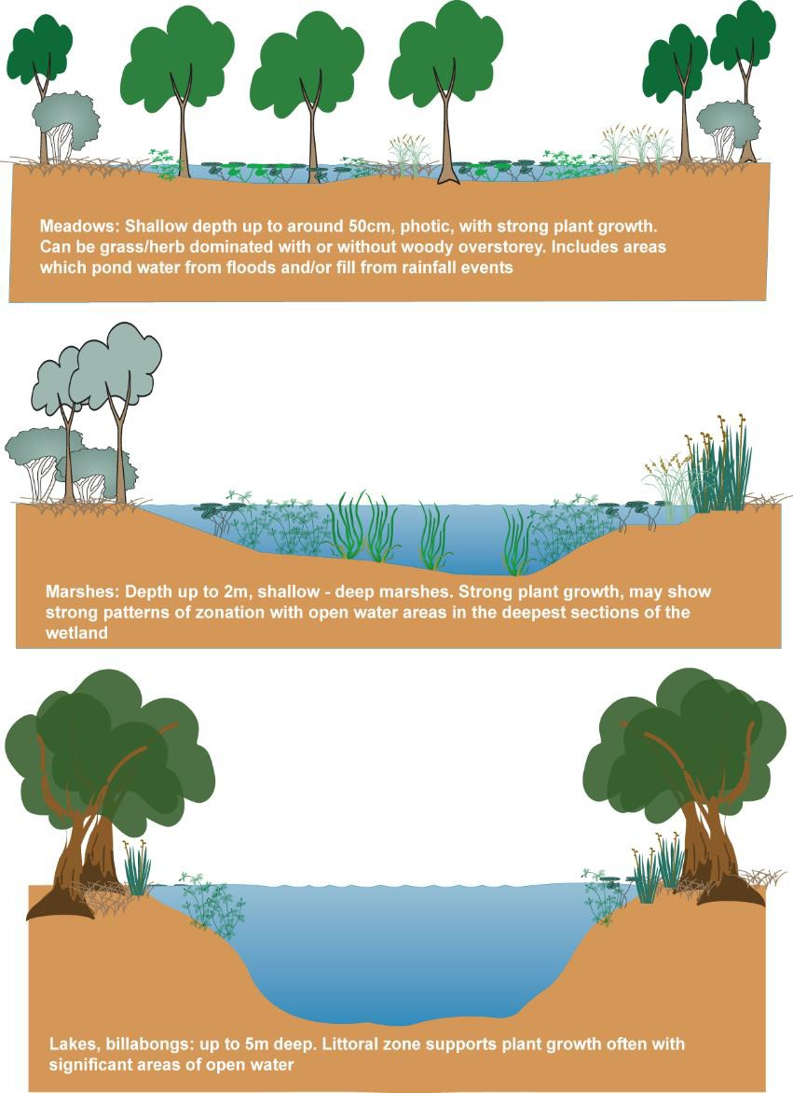

Figure 3. Schematic of key attributes of broad palustrine ecosystem types (meadows and marshes) and lacustrine (lakes) showing how depth affects presence of aquatic plants (modified from Butcher 2008).

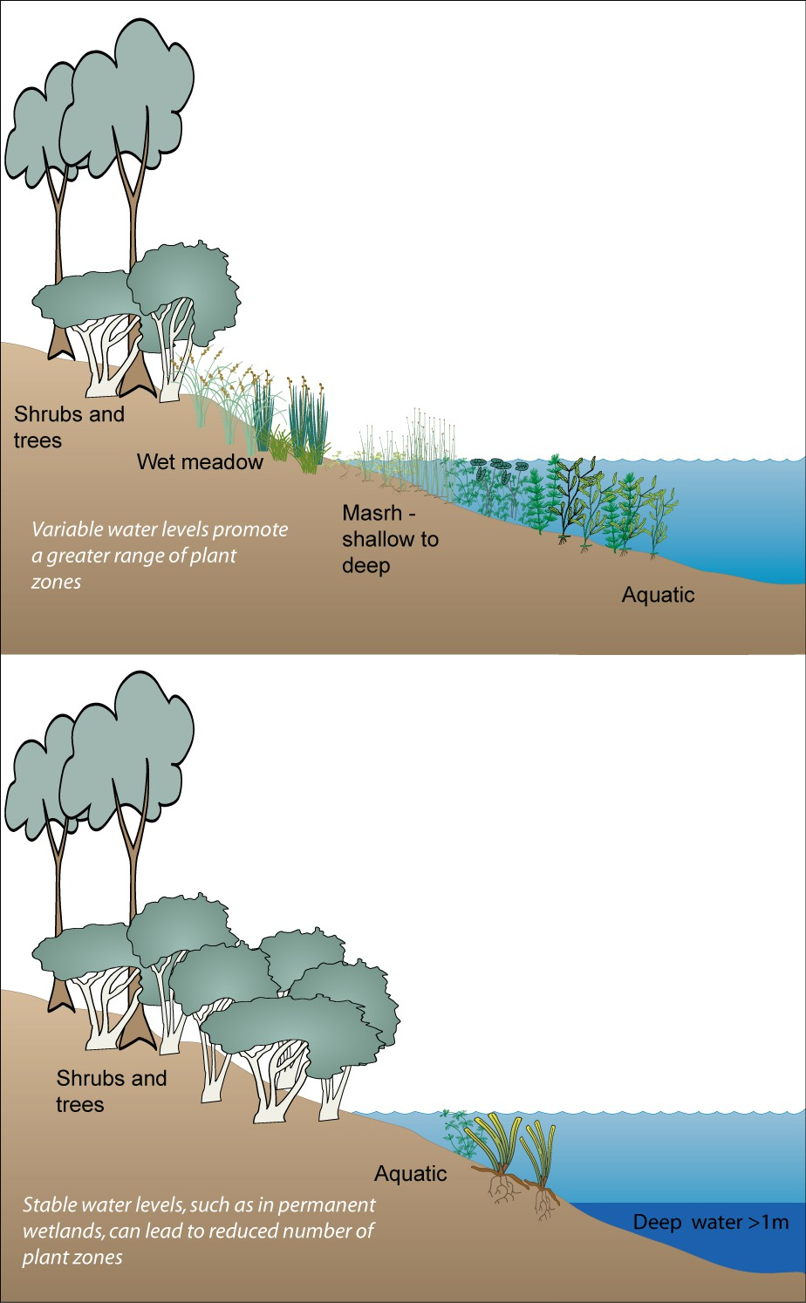

Figure 4. Schematic of how a variable water level promotes aquatic macrophyte diversity and structural habitat for fish, birds and invertebrates (from Butcher 2008).
The riverine ecosystems are atypical in that the weir pools are predominantly lacking in flow except during floods. This influences the chemistry and biota of the sites with values like those seen in the lentic lacustrine, and in some instances palustrine, systems likely to dominate (Figure 5). In general, the deeper riverine and lacustrine systems will support submerged vegetation to the depth which light penetrates (Figure 6 and Figure 7) and in many cases primary productivity will be algal driven as opposed to macrophyte driven, although this will be site specific and is yet to be determined for the recreation lakes. The relative importance of the recreation lakes to waterbirds is a knowledge gap, however a range of species typical of the regional fauna are listed as being present. There are no data on waterbird breeding, although there have been anecdotal reports of breeding (e.g., by black swan and swamp hen at Lake Marma).

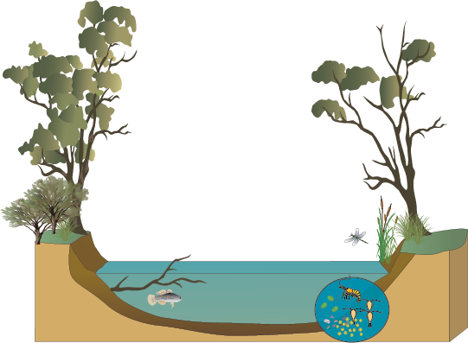

Figure 5. Schematic cross section of a riverine/weir pool channel. Predominantly non-flowing, with organic debris from the riparian zone.

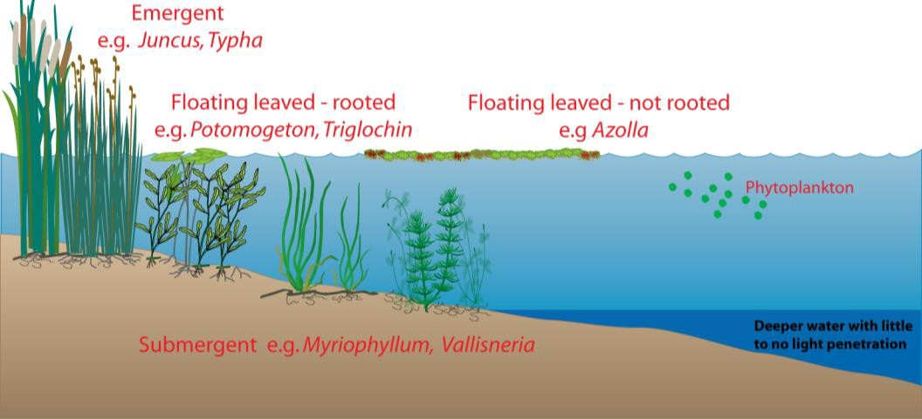
Figure 6 Vegetation zonation seen in palustrine systems and potentially in littoral zone of lacustrine systems – will be site specific regarding species diversity.

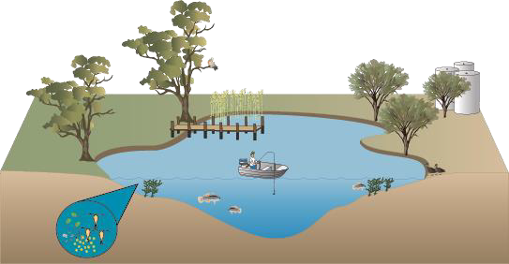
Figure 7 Schematic cross section of a lacustrine ecosystem. Fish and waterbirds will be present, primary productivity is likely to be algal driven with submergent macrophytes present in the photic zone. Emergent vegetation is limited, and littoral zone structural habitat complexity limited.

Threats to environmental condition

Wetlands can be subject to a range of water-related threats to their environmental values and condition. These threats can limit the achievement of environmental objectives targeted by environmental watering (DELWP 2022). Generally, they are direct threats from proximate human activities or processes that have impacted, are impacting, or may impact the wetland or broader environment and can be past (historical, unlikely to return or historical, likely to return), ongoing, and/or likely to occur in the future (IUCN 2012).
In the context of managing environmental values of recreation lakes threats can be related to factors that constrain the achievement of environmental objectives for these lakes, as well as inadvertent outcomes associated with the delivery of environmental water to them.
Victoria’s guidelines for developing environmental water plans recommend the adoption of the threat classification scheme of the IUCN Red List (DELWP 2022) and hence this is the typology followed here (https://www.iucnredlist.org/resources/threat-classification-scheme). It is noted that the IUCN typology is broadly consistent with other threat classifications (Salafsky et al. 2008).
In the context of this project the following types of threats may be of relevance to the wetlands under consideration (note the tiered nature of the IUCN threat classification scheme):

Residential & commercial development
      - Tourism & recreation: these are threats tied to a defined and relatively compact area. In the context of the recreation lakes in this project can include campgrounds associated with the lakes or other tourist accommodation and associated facilities.

Agriculture & aquaculture
      - Freshwater aquaculture: examples in the IUCN classification scheme includes “hatchery fish allowed to roam in the wild”. Given that several the recreation lakes are specifically stocked for recreational purposes, this threat is applicable in the context of this project.

      - Grazing: stocking of domestic animals in the mid catchment of the Yarriambiack Creek, whilst not a direct threat to the three weir pools, the water quality of inflows could be compromised due to the free access to this section of the creek system and its associated floodplain (Alluvium 2018).

Biological resource use
      - Fishing & harvesting aquatic resources: this includes harvesting of aquatic wild animals or plants for commercial, recreation, subsistence, research, or cultural purposes and includes accidental mortality and bycatch. Given that fishing is a key recreational activity of the lakes considered in this project, this threat category is of relevance here.

Human intrusions & disturbance
      - Recreational activities: this includes threats from human activities that can alter, destroy and disturb habitats and species associated with non-consumptive uses of biological resources. In this context this can include motorboats, jet-skis, birdwatchers, pets brought into recreation areas and temporary campsites.

Natural system modifications
The IUCN threat classification includes three levels within this category that are all associated with threats from actions that convert or degrade habitat in service of managing natural or semi-natural systems, such as the recreation lakes, often to improve human welfare:
      - Fire & fire suppression: this category focuses on the human activities that lead to either not enough fire or too much fire in the surroundings of the wetlands under consideration. It can also include damaging natural fires in systems that have lost their natural resilience. Given the nature of the recreation lakes it can include escaped campfires and fire suppression to protect caravan parks and associated tourist facilities surrounding these lakes.
      - Dams & water management/use: this includes changing the frequency, magnitude, duration of water regimes to patterns outside of their natural range of variation. This includes changing the hydrology of wetlands from temporary to permanent systems and the creation of artificial lakes.
      - Other ecosystem modifications: this includes actions that convert or degrade habitat in service of managing natural systems to improve human welfare. Within the context of the recreation lakes examples could include the construction of boat ramps, removal of aquatic vegetation and creation of artificial islands to introduce safe refuges for waterbirds.

Invasive & other problematic species, genes & diseases
The IUCN Classification of direct threats (IUCN 2012) restricts the use of the term “invasive species” non-native species. Other problematic species, genes and diseases can also include native plants, animals, pathogens or microbes or genetic material that have or are predicted to have harmful effects on biodiversity following their introduction, spread and/or increase in abundance. For northern Victoria there are a number of water-dependent vectors (e. g. mosquitoes) for viral diseases that affect humans that can be included in this threat category, as well as diseases of aquatic animals, such as frogs and fish.
Identifications of this threat category should also include the source of the invasive species and/or conditions that exacerbate their effect, for example, transporting boats contaminated by invasive algae or diseased aquatic animals between recreational water bodies.

Pollution
      - Domestic & urban wastewater: given the recreational nature of these lakes both sewage from adjacent caravan park or other recreational facilities (e. g., toilets associated with picnic areas or boating facilities) and run-off from surrounding roads, residential areas and recreational areas can represent a threat to the environmental conditions of these lakes. Furthermore, human contamination from in-water activities can also represent a threat in these systems.

      - Pollutants: spills or leakages from fuel tanks from motorboats or jet skis can also constitute a threat to recreation lakes given the increased intensity of human recreational activities in and around these lakes.
      - Garbage and solid waste: represent a problem as it can entangle wildlife and/or can result in flotsam and jetsam from recreational boats that interferes with aquatic ecological processes and functions.

Climate change & severe weather
Finally, while strictly speaking climatic variability may be part of natural disturbances, it is now well recognised that climate change caused by human activities has resulted in changed rainfall and temperature regimes that are outside of the natural range of variation historically experienced by species or ecological communities. Specific threats in this category include droughts, temperature extremes and changed frequency and intensity of storms and flooding.

Conceptual models
Several conceptual models were developed to illustrate threats specific to the recreation lakes of this project within each IUCN threat category described above, the stressor and its impact on the environmental values in each of four types of systems:

      - Weir pools – these are viewed as modified riverine systems (Figure 8),
      - Lacustrine (lake) systems (Figure 9).
      - Palustrine (marsh) systems (Figure 10), and
      - Aquatic ecosystem complexes (Figure 11).

For each system the conceptual model describes the likely e-values associated with each type, and current/potential threats. This will inform potential 'improvement outcomes' associated with different water management scenarios.

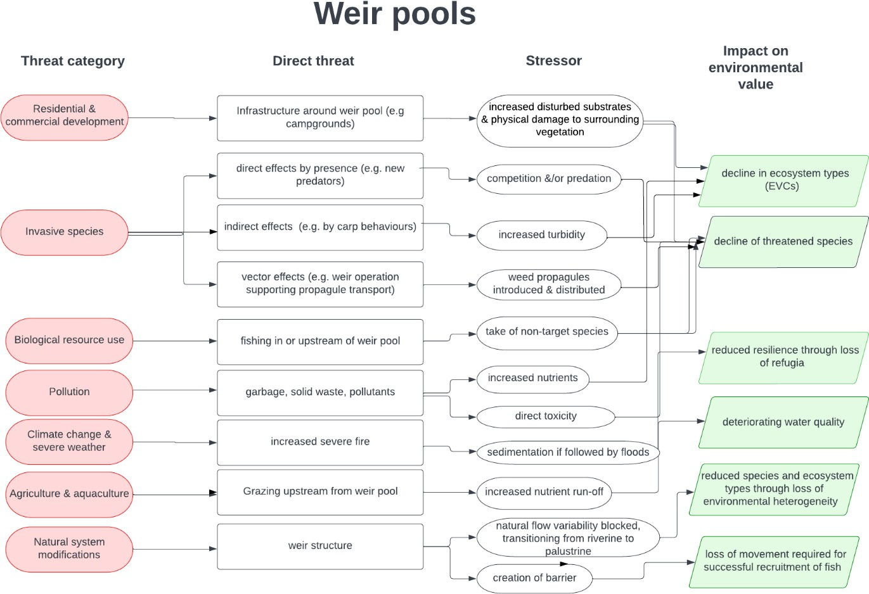

Figure 8. Conceptual model illustrating the impacts of stressors associated with direct threats in each of the IUCN threat category discussed on weir pools.

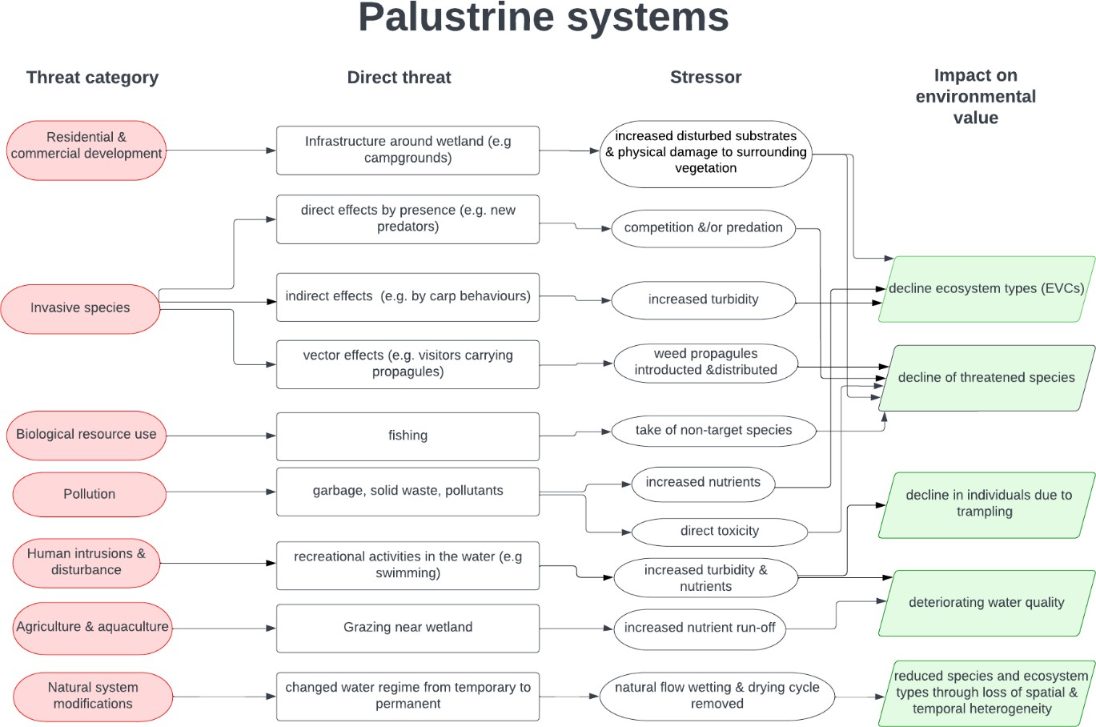
Figure 9. Conceptual model illustrating the impacts of stressors associated with direct threats in each of the IUCN threat category discussed on lacustrine systems.

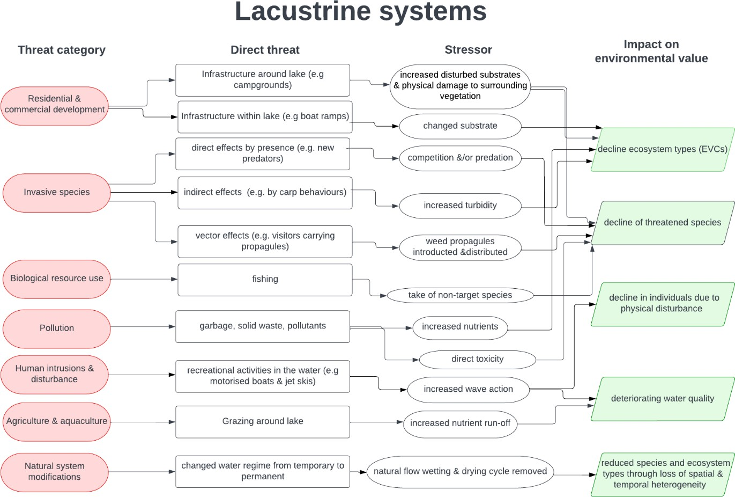
Figure 10. Conceptual model illustrating the impacts of stressors associated with direct threats in each of the IUCN threat category discussed on palustrine systems.

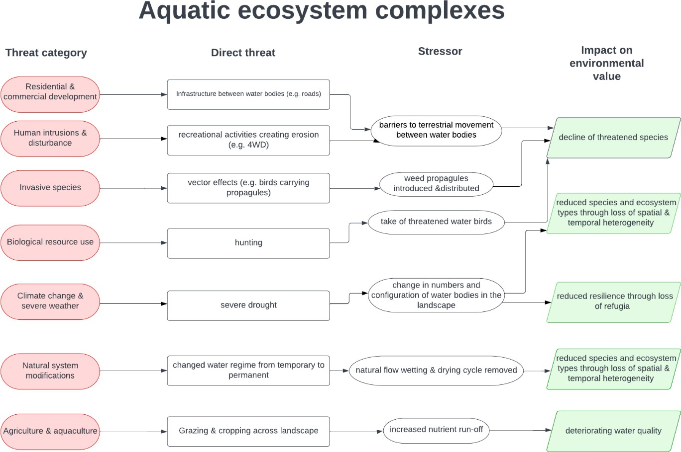
Figure 11. Conceptual model illustrating the impacts of stressors associated with direct threats in each of the IUCN threat category discussed on aquatic ecosystem complexes.

  - LAKE WATERING SCENARIOS

Scenarios
Potential future environmental watering scenarios at the recreation lakes are likely to follow the pattern outlined in the seasonal watering approach used by the VEWH (2022) (Figure 12).
During drought and dry climatic conditions, management objectives will be to protect or maintain the environmental values of the lakes to the extent possible given the potential for water scarcity and the need to prioritise environmental water to the lakes whose environmental values will be most at risk. Thus, the potential for water scarcity will likely necessitate the prioritisation of which lakes receive water (see Chapter 6).
During average and wet climatic conditions, management objectives will be to promote recovery, and where possible increase environmental values at the lakes receiving water.

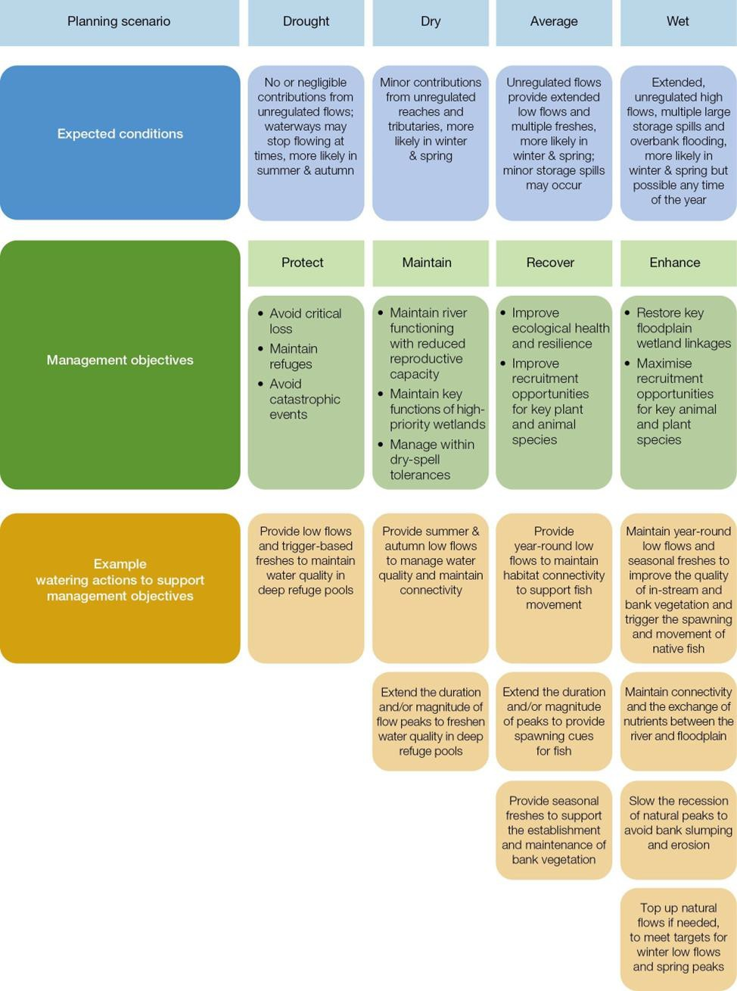
Figure 12. Planning scenarios under a range of climatic conditions (VEWH 2022).

MCA APPROACH
A multi-criterion analysis (MCA) and ranking matrix was developed to rank the recreation lakes by environmental values. The purpose of the MCA is to rank the recreational lakes against each other based on environmental values that would be supported or improved with water delivery. This report does not compare the recreation lakes with other wetland and lake assets in the Wimmera and Glenelg catchments that receive environmental water from the Wimmera and Glenelg Rivers Environmental Entitlement. The use of environmental water for new assets would require confirmation of environmental values and clear environmental watering objectives and targets, which would be included in Environmental Water Management Plans and seasonal watering proposals, as per the established environmental water management framework of the VEWH (e.g., VEWH 2022). As such this report addresses the first two steps of the MCA approach, with further work required to address data gaps.
The VEWH lists the following factors that potentially influence decisions for environmental water management via their Seasonal Water Plan (VEWH 2022):
  - Seasonal conditions, weather forecasts and catchment conditions
  - River and system operations (such as unregulated flows, catchment inflows, storage levels, other water
users’ needs and potential delivery constraints)
  - Ecological or biological factors and triggers (such as plant and animal responses to natural flows or temperature)
  - Water availability
  - Risks or costs associated with an action to deliver water for the environment
  - The opportunity to deliver shared benefits (for example, for Traditional Owners’ and recreational values).
It is important there is the flexibility to respond to these different factors, as they can significantly influence the environmental outcomes and shared benefits that can be achieved. Currently, the VEWH undertakes a prioritisation process in collaboration with stakeholders, which has mainly been undertaken at the asset scale. However, the VEWH is moving to consider outcomes for ecological processes that underpin waterway health at a landscape scale; thus, the environmental water allocation process is evolving to consider the combination of watering actions that are needed across multiple waterways in a region to achieve the best environmental outcomes (VEWH 2022). The current, asset based, prioritisation criteria used by the VEWH are shown in Figure 13. Details on what landscape scale ecological processes are considered to underpin waterway health have not been documented, nor what would be considered as the best environmental outcome.
Ultimately, the ranking of the recreation lakes will be a four-step process:
- Determine the environmental values of each lake and identify key knowledge gaps
- Rank the recreation lakes based on the current understanding of their environmental values
- Rank the recreation lakes based on type/threat/likelihood of measurable improvement achieved with environmental water management (relates to VEWH extent and significance of environmental benefit)
  - Based on likely improvement in key environmental values (i.e., those that would respond to watering and ability to mitigate threats)
- Weight by judgement of if receiving water, which lakes would get the best outcome
  - Feasibility of water level variability
  - Likelihood of benefits – triple bottom line
This current ranking focuses on the first two steps, above, as further investigations of environmental values, threats and ecological responses to watering is required to inform the latter two steps.

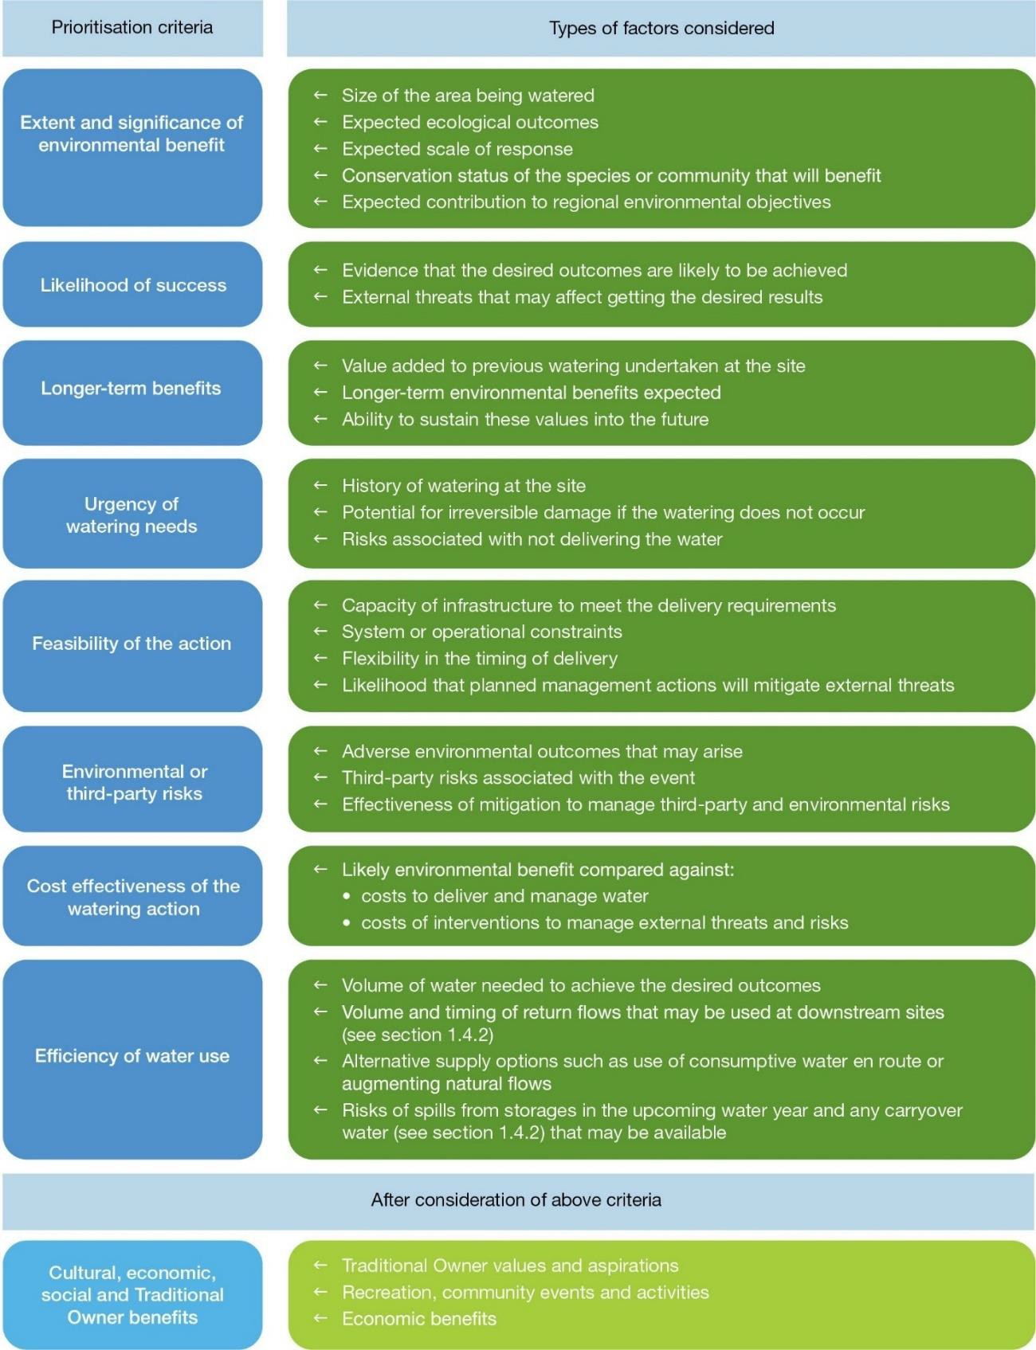

Figure 13. Criteria for prioritising actions to deliver water for the environment used in Seasonal Water Planning by the VEWH (from VEWH 2022).
  - CRITERIA
The selection of MCA criteria has been guided by environmental objectives included in Chapters 5 and 8 of the Basin Plan, as well as factors included in the VEWH Seasonal Water Plan (VEWH 2022, Figure 13). The environmental outcomes expected with achieving Basin Plan objectives are:

- To protect and restore water-dependent ecosystems of the Murray-Darling Basin and the biota that depend on them; and

- To protect and restore the ecosystem functions of water-dependent ecosystems (and the biodiversity that is dependent on them); and
- To ensure that water-dependent ecosystems are resilient to climate change and other risks and threats.

Thus, the criteria based on Basin Plan logic relate the aquatic ecosystem types present, ecosystem processes (e.g., fish breeding, waterbird breeding) and the relative risk posed by threats to environmental values and thus resilience.
Relevant criteria and factors from the VEWH prioritisation approach include:
- Extent and significance of the environmental benefit
  - Size of area being watered
  - Conservation status of the species or community that will benefit
- Urgency of watering needs
  - History of watering at the site
  - Risks associated with not delivering water
- Cost effectiveness of the watering action
  - Costs to deliver and manage water
  - Costs of interventions to manage external threats and risk
- Efficiency of water use
  - Volume of water needed to achieve the desired outcome
Many criteria and factors included in the VEWH prioritisation have been omitted as they apply equally to the recreation lakes (e.g. feasibility of the action - all delivery is via pipeline, third party risks associated with the watering event), there is insufficient information available from which to differentiate between each lake (e.g., longer term benefits), or there is redundancy when considering criteria related to Basin Plan objectives (e.g., the number of water dependent species present generally increases with the size of the lake (Figure 14).
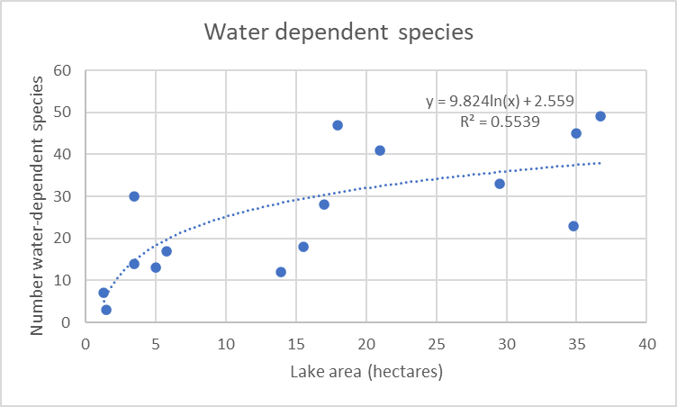
Figure 14. Relationship between lake area and number of water dependent species.

Scoring

A scoring (Table 16) and weighting system has been adopted that helps identify preferred options from less preferred options. It assigns a score of 1-3, where 1 is low and 3 is high, to each criterion and then sums the scores

to identify the relevant importance of each recreation lake (i.e., highest to lowest score; maximum score is 18). The exception is for scoring the criterion for refugia, which has scores of 3 (can be a refugia) or 1 (not likely to be a refugia) based on whether a lake has a permanent typology (see Section 3.3). Weighting of criterion scores (e.g., using numerical multipliers) can be used to better separate the relative importance of each criterion, if required.
Table 16. MCA criteria and scoring system for prioritising recreation lakes based on environmental values

Criterion | Criterion score
Ecosystem type | 3: Lake is a single asset inclusive of multiple ecosystem types, and/or, part of a complex  2: Lake is a single ecosystem type but is part of a wetland complex  1: Lake is a single asset and single ecosystem type and is isolated from other aquatic ecosystems
Supports biodiversity | 3: Lake supports 31 or more water dependent species  2: Lake supports between 16 and 30 water dependent species 1: Lake supports less than 15 water dependent species
Supports threatened water dependent species listed under the EPBC or FFG Acts | 3: Lake supports 5 or more threatened species or communities  2: Lake supports between 3 and 4 threatened species or communities 1: Lake supports less than 2 threatened species or communities
Supports threatened ecological communities at state or regional level (not under legislation – e.g. EVCs) | 3: Lake supports 5 or more threatened species or communities  2: Lake supports between 3 and 4 threatened species or communities 1: Lake supports less than 2 threatened species or communities
Refugia for flora and fauna | 3: Lake can be a refugia for flora and fauna (waterbirds, frogs and plants) at the landscape level in years of sustained drought  1: System is not likely to provide refugial habitat for flora and fauna in years of sustained drought
Surrounding landuse | 3: Lake is within a reserve and/or remnant native vegetation  2: Lake partially abuts landscape that contains remnant native vegetation reserve 1: Lake is in an altered landscape – either urban or agricultural
  - RANKING OF LAKES

MCA results

The MCA criteria described in Section 6.1 were assigned scores based on the environmental values information presented in Section 4.1. To reduce operator bias in assigning a final high, medium, and low ranking, K-mean analysis (Past statistical package, Hammer 2011) was applied to the scores to separate the three groups statistically (Table 17). The break in scores for each group were:
      - >10 received a high ranking
      - 8-10 received a medium ranking
      - 6-7 received a low ranking.
Based on existing information and the criteria applied as at November 2022, Lake Marma, Wooroonook Lake, Green Lake, Lake Lascelles and Tchum Lake ranked highest in terms of priority for receiving water. Brim Weir Pool, Warracknabeal Weir Pool, Donald Caravan Park Lake, Walkers Lake, Beulah Weir Pool, Hopetoun Storage (Willow Lake) and Ouyen Lake had a medium ranking for receiving water, while the remaining lakes ranked as low.

As noted in Section 4.1., the information on environmental values at each recreation lake is patchy, and likely influenced by which lakes have been surveyed and data made available in the VBA, ALA and technical reports. It is possible that further surveys at each of the lakes could change the relative ranking of individual lakes in the future.
Table 17. MCA results for the recreation lakes. Green shading indicates a high ranking for receiving water, orange indicates medium ranking and red indicates a low ranking.

 | Supports ecosystem types | Supports biodiversit y | Supports threatene d species | Supports EVCs | Refugia for flora and fauna | Surrounding landuse | Total score
Brim Weir Pool | 1 | 2 | 1 | 2 | 1 | 1 | 8
Lake Marma | 1 | 3 | 3 | 1 | 3 | 1 | 12
Warracknabeal Weir Pool | 1 | 2 | 1 | 2 | 1 | 1 | 8
Watchem Lake | 2 | 1 | 1 | 1 | 1 | 1 | 7
Donald Caravan Park Lake | 1 | 3 | 1 | 1 | 1 | 1 | 8
Walkers Lake | 1 | 3 | 3 | 1 | 1 | 1 | 10
Wooroonook Lake | 1 | 3 | 2 | 3 | 1 | 2 | 12
Beulah Weir Pool | 1 | 1 | 1 | 2 | 1 | 2 | 8
Green Lake | 1 | 3 | 2 | 2 | 1 | 3 | 12
Hopetoun Storage (Willow  Lake) | 1 | 1 | 2 | 1 | 3 | 1 | 9
Lake Lascelles | 3 | 3 | 3 | 3 | 1 | 2 | 15
Ouyen Lake | 1 | 2 | 1 | 1 | 1 | 2 | 8
Rainbow Lake | 1 | 1 | 1 | 1 | 1 | 1 | 6
Tchum Lake | 2 | 2 | 1 | 3 | 1 | 2 | 11
Yaapeet Storage (Turkey Bottom  Lake) | 1 | 1 | 1 | 1 | 1 | 2 | 7

Sensitivity analysis

A sensitivity analysis was undertaken by doubling the score for each criterion, in turn, whilst maintaining the original scores for the remaining criteria (Appendix 5). This weighting of individual criterions generally had a relatively minor effect on the overall ranking. All the high-ranking lakes retained their high ranking. In addition:
      - Walkers Lake had a high ranking for receiving water when any of the criteria were weighted.
      - Hopetoun Storage (Willow Lake) had a high ranking when the ‘supports threatened species’ and ‘refugia for flora and fauna’ criteria were weighted
      - Donald Caravan Park Lake had a high ranking when the ‘supports biodiversity’ criterion was weighted.

SUMMARY
This project was to investigate the environmental values of 15 recreation lakes in the Wimmera-Mallee which are currently supplied with designated recreation water supply and provide an environmental ranking. The findings are considered preliminary in that there are very limited data available on the environmental values for these sites.

The findings suggest that five of the recreation lakes ranked highly from an environmental perspective. These include Lake Marma, Wooroonook Lake, Green Lake, Lake Lascelles and Tchum Lake. The addition of Walkers Lake to this group could also be considered, given it received a high ranking if any of the assessment criteria were weighted. Lake Tchum is a temporary marsh, Lake Marma a permanent lake and the rest are temporary lakes. This finding matches the judgement of on ground managers, that these lakes would be likely to support environmental values in addition to recreation and social values.
To increase the confidence in the ranking of environmental value of the sites, further environmental data is required across all 15recreation lakes. If these assets were to be managed for environmental outcomes, it is likely that a variation in water levels and or a wetting and drying regime would need to be considered. Potential benefits from managing the six high environmental value recreation lakes (Marma, Wooroonook, Green, Walkers, Lascelles and Tchum), for environmental outcomes could include:
  - Increased alpha diversity in water-dependent plant species and or communities (i.e., EVCs)
  - Improved condition in water-dependent woody and non-woody vegetation
  - Provision of refuge habitat in drought conditions
  - Improved water quality via promotion of macrophyte dominated primary production and increased filtration of run off by enhancing riparian vegetation cover
The other nine lakes could improve their ranking if they had their environmental values improved via the mitigation of threats, for example by:
  - Reintroduction of hydrological regimes typical of historic conditions (i.e., introduce varied lake levels)
  - Control of non-native species, and / or
  - Planting of native riparian plant species to provide habitat for fauna and also to filter overland run-off.

  - KNOWLEDGE GAPS

  - Two lakes, Rainbow Lake and Hopetoun Storage, do not have any species listed in the VBA. Surveys are recommended to put these lakes on the same basis as other lakes.
  - Biotic surveys across all sites at a comparable level to existing sites that receive environmental water within the Wimmera-Mallee pipeline footprint. In particular the following need to be addressed:
    - Vegetation data is extremely limited, both fringing, riparian and in-system
    - Waterbird data is extremely limited and there are only anecdotal data for breeding
  - Confirm salinity status at Green Lake as Ruppia has been identified as being present.

REFERENCES
AETG (Aquatic Ecosystems Task Group) (2012). Aquatic Ecosystems Toolkit. Module 2. Interim Australian National Aquatic Ecosystem Classification Framework. Australian Government Department of Sustainability, Environment, Water, Population and Communities, Canberra.
Brooks S., Cottingham P., Butcher R. and Hale J. (2014). Murray-Darling Basin aquatic ecosystem classification: Stage 2 report. Peter Cottingham & Associates report to the Commonwealth Environmental Water Office and Murray-Darling Basin Authority, Canberra.
Brooks, S. (2021). Australian National Aquatic Ecosystem (ANAE) Classification of the Murray-Darling Basin v3.0: User Guide. Commonwealth Environmental Water Office, Department of Agriculture, Water and the Environment, Australia.
Butcher R., Cottingham P. and Hale J. (2012). Murray-Darling Basin aquatic ecosystem classification: Review of jurisdiction and ANAE classifications. Peter Cottingham & Associates report to the Department of Sustainability, Environment, Water, Population and Communities, Canberra.
Commonwealth of Australia (2012). Basin Plan 2012. Prepared by the Office of Parliamentary Counsel, Canberra.
Cowardin, L. M., Carter, V., Golet, F.C., and LaRoe, E.T. (1979). Classification of wetlands and deep water habitats of the United States. U.S. Department of the Interior, Fish and Wildlife Service, Washing, D.C. Jamestown, ND: Northern Prairie Wildlife Research Center.
DEPI (2013). Victorian Waterway Management Strategy, Victoria Department of Environment and Primary and Industries, Melbourne, Victoria.
DEWLP (2016). The Victorian wetland classification framework 2014. Department of Environment, Land, Water and Planning, East Melbourne.
DELWP (2020). Index of Wetland Condition assessment procedure December 2020. Department of Environment, Land, Water and Planning, East Melbourne, Victoria.
DELWP (2022). Environmental Water Management Plan Guidelines. Department of Environment, Land, Water and Planning, East Melbourne, Victoria.
Hammer, O. (2011). PAST Paleontological Statistics Version 2.10. Natural History Museum University of Oslo,
McGill, B.J., Dornelas, M., Gotelli, N.J., Magurran, A.E. (2015). Fifteen forms of biodiversity trend in the anthropocene. Trends Ecol. Evol. 30, 104–113
MDBA (2020). Basin-wide environmental watering strategy, Murray‒Darling Basin Authority Canberra, ACT.
Second Edition, February 2020.
Mori, A.S., Isbell, F. and Seidl, R., 2018. β-diversity, community assembly, and ecosystem functioning. Trends in ecology & evolution, 33(7), pp.549-564.
Moysey E., McMahon J., Barlow T., Cook S., Conole L., Quin D., Wilson C. and McMahon A. (2004). Assessment of environmental values associated with the recreational water bodies nominated for supply under the Wimmera Mallee Pipeline System. Ecology Australia, Fairfield, Victoria.
Nielsen, T.F., Sand-Jensen, K., Dornelas, M., Bruun, H.H., 2019. More is less: net gain in species richness, but biotic homogenization over 140 years. Ecol. Lett. 22, 1650–1657.
Olden, J.D., 2006. Biotic homogenization: a new research agenda for conservation biogeography. J. Biogeogr. 33, 2027–2039.
Rolls, R.J., Chessman, B.C., Heino, J., Wolfenden, B., Growns, I.O., Cheshire, K.J., Curwen, G., Ryan, D. and Butler, G.L., 2021. Consequences of hydrological alteration for beta diversity of fish assemblages at multiple spatial scales. Science of the Total Environment, 798, p.149170.

Rolls, R.J., Chessman, B.C., Heino, J., Wolfenden, B., Thurtell, L.A., Cheshire, K.J., Ryan, D., Butler, G., Growns, I. and Curwen, G., 2022. Change in beta diversity of riverine fish during and after supra-seasonal drought. Landscape Ecology, 37(6), pp.1633-1651.
Street Ryan (2022). Wimmera southern Mallee Recreational and Environmental Water: Socio-Economic Value Trends and Insights 2016-17 to 2019-20. Street Ryan report to the Wimmera Development Association.
VEWH (2022). Seasonal watering plan: 2022-23. Victorian Environmental Water Holder, Melbourne. Victorian Biodiversity Atlas, viewed October 2022, http://www.dse.vic.gov.au/environment-and-
wildlife/biodiversity/victorian-biodiversity-atlas. Victoria Department of Environment, Land, Water and Planning,
Melbourne, Victoria.
Wimmera CMA (2014). Wimmera waterway strategy. Wimmera Catchment Management Authority, Horsham.

APPENDIX 1: SUMMARY OF SOCIAL AND ECONOMIC VALUES
The social and economic values associated with the recreation lakes are summarised in the following sections. Social values are based on interviews with representatives for each recreation lake, as well as economic analyses based on visitor numbers and associated economic and health benefits (Street Ryan 2022 and 2022a).
  - SOCIAL VALUES
The social values associated with the recreation lakes is summarised in Table 19. Each lake is valued for opportunities for fishing, camping, caravanning, birdwatching, walking and other passive activities. Many are also highly valued for activities such as fishing, boating (power boats as well as canoeing and kayaking) and swimming. All of these values contributed to the social values and lifestyles of nearby regional, town and local communities. This was reflected in visitor number information (Table 18) collected for many of the lakes as part of a wider study on the socio-economic value of recreation lakes in the Wimmera-Southern Mallee (Street Ryan 2022). Community satisfaction, pride, reduced social isolation and volunteering were all reported to be improved by having functional lakes and weirs.

Table 18. Summary of visitor numbers at recreation lakes 2020/21 (from Street Ryan 2022a)

 | Overnight visitors | Visit nights | Active day participants | Passive day participants | Total water participants 2021
Wimmera CMA Region
Brim Weir Pool | 1,178 | 3,937 | 3,643 | NA | 4,822
Lake Marma | 1,007 | 3,596 | 732 | 9,250 | 10,989
Warracknabeal Weir Pool | 1,840 | 8,983 | 2,464 | 13,983 | 18,287
Watchem Lake | 847 | 5,953 | 581 | NA | 1,429
North Central CMA region
Donald Caravan Park Lake | 933 | 3,835 | 1,081 | 2,995 | 5,009
Walkers Lake | 1,067 | 5,134 | 1,342 | NA | 2,409
Wooroonook Lake | 1,004 | 4,345 | 794 | NA | 1798
Mallee CMA region
Beulah Weir Pool | 717 | 2,308 | 955 | NA | 1,672
Green Lake | 493 | 3,939 | 3,120 | NA | 3,613
Hopetoun Storage (Willow Lake) | NA | NA | NA | NA | NA
Lake Lascelles | 1,374 | 7,348 | 6,383 | 4,233 | 11,990
Ouyen Lake | 200 | 544 | 7,500 | 5,000 | 12,700
Rainbow lake | NA | NA | NA | NA | NA
Tchum Lake | 898 | 4,899 | 2,050 | 1,320 | 4,268
Yaapeet storage (Turkey Bottom Lake) | NA | NA | NA | NA | NA

Recreation Lakes Environmental Values Analysis

Table 19. Summary of social values at recreation lakes.

Lake | Fishing | Boating/ Water skiing | Kayaking/ canoeing | Swimming | Camping/ caravanning | Birdwatching | BBQ/  picnicking | Walking/ other passive
Brim Weir Pool | ✓✓✓ | ✓✓✓ | ✓ | ✓✓ | ✓✓✓ | ✓✓ | ✓✓✓ | ✓✓
Lake Marma | ✓✓✓ | ✓✓✓ | ✓✓ | ✓ | ✓✓✓ | ✓ | ✓✓✓ | ✓✓✓
Watchem Lake | ✓✓✓ | ✓✓✓ | ✓✓ | ✓✓ | ✓✓✓ | ✓ | ✓✓✓ | ✓
Warracknabeal Weir Pool | ✓✓✓ | ✓✓✓ | ✓✓ | ✓ | ✓✓✓ | ✓ | ✓✓✓ | ✓✓✓
Donald Caravan Park Lake | ✓✓✓ |  | ✓✓✓ | ✓ | ✓✓✓ | ✓ | ✓✓✓ | ✓✓✓
Walkers Lake | ✓✓✓ | ✓✓ | ✓ | ✓✓ | ✓ | ✓✓✓ | ✓✓✓ | ✓
Wooroonook Lake | ✓✓✓ | ✓✓✓ | ✓✓ | ✓✓✓ | ✓✓✓ | ✓✓ | ✓✓✓ | ✓✓
Beulah Weir Pool | ✓✓✓ | ✓✓✓ | ✓ | ✓✓ | ✓✓✓ | ✓✓ | ✓✓✓ | ✓✓✓
Green Lake | ✓✓✓ | ✓✓✓ | ✓✓ | ✓✓✓ | ✓✓✓ | ✓✓ | ✓✓✓ | ✓✓✓
Hopetoun Storage (Willow Lake) | ✓✓ |  | ✓ | ✓ | ✓✓ | ✓ | ✓✓✓ | ✓
Lake Lascelles | ✓✓✓ | ✓✓✓ | ✓✓ | ✓✓✓ | ✓✓✓ | ✓✓ | ✓✓✓ | ✓✓✓
Ouyen Lake | ✓✓✓ | ✓✓✓ | ✓✓ | ✓✓✓ | ✓ | ✓✓ | ✓✓✓ | ✓✓
Rainbow Lake | ✓✓✓ |  | ✓ | ✓✓✓ |  | ✓ | ✓✓✓ | ✓✓
Tchum Lake | ✓✓✓ | ✓✓✓ | ✓✓ | ✓✓✓ | ✓✓✓ | ✓✓✓ | ✓✓✓ | ✓✓
Yaapeet Storage  (Turkey Bottom Lake) | ✓✓✓ |  | ✓ | ✓✓✓ | ✓✓ | ✓✓✓ | ✓✓✓ | ✓✓✓

  - ECONOMIC VALUES
An investigation of the economic value of activities at 31 lakes and waterways across the Wimmera-Southern Mallee region between 2016/17-2019/20 (Street Ryan 2022) confirmed the lakes in this study as valuable recreational assets. The economic contribution associated with the 31 lakes varies between $33.7 million during 2018-19 to $28.5 million in 2019/2020, the latter period being affected by threats of fire, low or poor quality water at several waterbodies, and restrictions imposed during the COVID-19 pandemic.
Street Ryan (2022) also estimated the value of health benefits to be approximately $1.5 million per annum for Wimmera-South Mallee resident who visited the recreation lakes, and between $2.5 million and $4 million per annum for all regional Victorian residents.
As tourism assets, the recreation lakes were considered underdeveloped in this investigation (Street Ryan 2022). Additional investment in infrastructure, facilities and promotion, particularly around events and festivals at individual lakes (e.g. water skiing, fishing events) were suggested as possibilities to increase the economic return from the lakes.

APPENDIX 2: TERMINOLOGY USED IN CLASSIFICATION
Table 20. Victorian wetland water regime descriptions (from DELWP 2016)

Water regime | Water regime description | Water regime subcategory | Frequency of inundation | Duration of inundation
Permanent | Inundated constantly, rarely drying completely | - | Constant, annual or less frequently but usually before system dries | Never dries or dries rarely (i.e. holds water at least 8 years in 10), but levels may fluctuate within or  between years
Periodically inundated | Inundated annually to infrequently, holding water for at least 1 month to more than 1 year before drying | Seasonal | Annual or near annual inundation (i.e. holds water at least 8 years  in 10) | Holds water 1-8 months, then dries
Periodically inundated |  | Intermittent | Infrequent – holds water on average 3-8  in every 10 | Holds water >1 month to >1 years, then dries
Periodically inundated |  | Episodic | Infrequent – holds water on average less than 3 years in every  10 | Holds water >1 month to >1 years, then dries

APPENDIX 3: SPECIES LISTS FOR INDIVIDUAL LAKES
The following species lists have been compiled from the Victorian Biodiversity Atlas (VBA, accessed 27 September 2022) and Atlas of Living Australia (ALA, accessed 20 October 2022). THE VBA provides speies lists for all records within a user-defined polygon. This allowed access to records for each recreation lake and its immediate surrounds. The ALA provides a species list for all records within a 1 km radius of a centroid. For this project, the centroid was placed in order to isolate as much as possible records at the recreation lakes and their fringe from other features in the landscape, such as other wetlands and parks. Thus, the ALA lists were used to complement the VBA lists for water dependent species only.
The Victorian Flora and Fauna Guarantee (FFG) and EPBC codes for all tables are: VU = vulnerable, EN = endangered, CR = critically endangered.

  - WIMMERA CMA REGION

Brim Weir Pool

Table 21. Species recorded in the VBA and ALA for Brim Weir Pool: January 2012 – September 2022. Water-dependent native species are shaded.

Scientific Name | Common Name | FFG  Status | EPBC  Status
Fish
Bidyanus bidyanus | Silver perch (stocked) | EN | CR
Carassius auratus | Goldfish*
Cyprinus carpio | European Carp*
Macquaria ambigua | Golden Perch (stocked)
Perca fluviatilis | Redfin*
Tandanus tandanus | Freshwater Catfish | EN
Waterbirds
Anas (Nettion) gracilis | Grey Teal
Anas superciliosa | Pacific Black Duck
Anhinga novaehollandiae | Australasian Darter
Chenonetta jubata | Australian Wood Duck
Egretta novaehollandiae | White-faced Heron
Elseyornis melanops | Black-fronted Dotterel
Gallinula tenebrosa | Dusky Moorhen
Microcarbo melanoleucos | Little Pied Cormorant
Phalacrocorax sulcirostris | Little Black Cormorant**
Tachybaptus novaehollandiae | Australian Little Grebe
Tadorna tadornoides | Australian Shelduck
Vanellus miles | Masked Lapwing
Woodland birds
Aegotheles cristatus | Australian Owlet-nightjar
Anthochaera carunculata | Red Wattlebird
Artamus personatus | Masked Woodswallow
Artamus superciliosus | White-browed Woodswallow
Cacatua tenuirostris | Long-billed Corella

Scientific Name | Common Name | FFG  Status | EPBC  Status
Climacteris picumnus | Brown Treecreeper
Columba livia | Domestic Pigeon*
Coracina novaehollandiae | Black-faced Cuckoo-shrike
Corcorax melanorhamphos | White-winged Chough
Corvus coronoides | Australian Raven
Cracticus nigrogularis | Pied Butcherbird
Dacelo novaeguineae | Laughing Kookaburra
Elanus axillaris | Black-shouldered Kite
Eolophus roseicapilla | Galah
Falco berigora | Brown Falcon
Falco cenchroides | Nankeen Kestrel
Falco longipennis | Australian Hobby
Falco peregrinus | Peregrine Falcon
Glossopsitta concinna | Musk Lorikeet
Grallina cyanoleuca | Magpie-lark
Gymnorhina tibicen | Australian Magpie
Haliastur sphenurus | Whistling Kite
Hirundo neoxena | Welcome Swallow
Malurus cyaneus | Superb Fairy-wren
Manorina melanocephala | Noisy Miner
Milvus migrans | Black Kite
Ocyphaps lophotes | Crested Pigeon
Pardalotus punctatus | Spotted Pardalote
Pardalotus striatus | Striated Pardalote
Passer domesticus | House Sparrow*
Petrochelidon ariel | Fairy Martin
Phaps chalcoptera | Common Bronzewing
Platycercus eximius | Eastern Rosella
Psephotus haematonotus | Red-rumped Parrot
Ptilotula penicillata | White-plumed Honeyeater
Rhipidura leucophrys | Willie Wagtail
Sturnus vulgaris | Common Starling*
Sugomel nigrum | Black Honeyeater
Turdus merula | Common Blackbird*
Vegetation
Duma florulenta | Tangled Lignum
Eucalyptus camaldulensis | River Red-gum**
Eucalyptus largiflorens | Black Box**
*Alien species, **seen during IWC 2022 assessment

Lake Marma

Table 22. Species recorded in the VBA and ALA for Lake Marma: January 2012 – September 2022. Water-dependent native species are shaded.

Scientific Name | Common Name | FFG  Status | EPBC  Status
Fish
Bidyanus bidyanus | Silver Perch (stocked) | EN | CR
Carassius auratus | Goldfish*
Cyprinus carpio | European Carp*
Macquaria ambigua | Golden Perch (stocked)
Perca fluviatilis | Redfin*
Philypnodon grandiceps | Flatheaded Gudgeon
Tandanus tandanus | Freshwater Catfish | EN
Tinca tinca | Tench*
Waterbirds
Acrocephalus australis | Reed-Warbler
Anas castanea | Chestnut Teal
Anas gracilis | Grey Teal**
Anas rhynchotis | Australasian Shoveler
Anas superciliosa | Pacific Black Duck**
Anhinga novaehollandiae | Australasian Darter
Ardea alba | Eastern Great Egret
Ardea intermedia | Intermediate Egret | CR
Ardea pacifica | White-necked Heron
Aythya australis | Hardhead | VU
Biziura lobata | Musk Duck | VU
Bubulcus ibis | Cattle Egret
Casmerodius modesta | Eastern Great Egret | VU
Chenonetta jubata | Australian Wood Duck**
Chlidonias hybrida | Whiskered Tern
Chroicocephalus novaehollandiae | Silver Gull**
Cladorhynchus leucocephalus | Banded Stilt
Cygnus atratus | Black Swan
Egretta novaehollandiae | White-faced Heron
Elseyornis melanops | Black-fronted Dotterel
Erythrogonys cinctus | Red-kneed Dotterel
Fulica atra | Eurasian Coot**
Gallinula tenebrosa | Dusky Moorhen
Malacorhynchus membranaceus | Pink-eared Duck
Microcarbo melanoleucos | Little Pied Cormorant**
Nycticorax caledonicus | Nankeen Night Heron
Pelecanus conspicillatus | Australian Pelican
Phalacrocorax carbo | Great Cormorant
Phalacrocorax sulcirostris | Little Black Cormorant**
Phalacrocorax (Phalacrocorax) varius | Pied Cormorant
Podiceps cristatus | Great Crested Grebe
Poliocephalus poliocephalus | Hoary-headed Grebe

Scientific Name | Common Name | FFG  Status | EPBC  Status
Porphyrio melanotus | Australasian Swamphen
Porzana (Porzana) fluminea | Spotted Crake
Porzana pusilla | Baillon's Crake
Recurvirostra novaehollandiae | Australian Red-necked Avocet
Spatula rhynchotis | Australasian Shoveler
Stictonetta naevosa | Freckled Duck | EN
Tachybaptus novaehollandiae | Australasian Grebe
Tadorna (Casarca) tadornoides | Chestnut Sheldrake
Threskiornis moluccus | Black-necked Ibis
Tribonyx ventralis | Black-tailed Native Hen
Vanellus miles | Masked Lapwing
Vanellus (Lobivanellus) tricolor | Banded Lapwing
Woodland birds
Accipiter fasciatus | Brown Goshawk
Anthochaera carunculata | Red Wattlebird
Artamus cyanopterus | Dusky Woodswallow
Artamus superciliosus | White-browed Woodswallow
Cacatua galerita | Sulphur-crested Cockatoo
Cacatua sanguinea | Little Corella
Cacatua tenuirostris | Long-billed Corella
Columba livia | Domestic Pigeon*
Carduelis carduelis | European Goldfinch*
Coracina novaehollandiae | Black-faced Cuckoo-shrike
Corvus mellori | Little Raven
Dacelo novaeguineae | Laughing Kookaburra
Eolophus roseicapilla | Galah
Falco peregrinus | Peregrine Falcon
Geopelia placida | Peaceful Dove
Glossopsitta concinna | Musk Lorikeet
Grallina cyanoleuca | Magpie-lark
Gymnorhina tibicen | Australian Magpie
Haliastur sphenurus | Whistling Kite
Hirundo neoxena | Welcome Swallow
Milvus migrans | Black Kite
Ocyphaps lophotes | Crested Pigeon
Parvipsitta porphyrocephala | Purple-crowned Lorikeet
Passer domesticus | House Sparrow*
Petrochelidon ariel | Fairy Martin
Petrochelidon nigricans | Tree Martin
Phaps chalcoptera | Common Bronzewing
Phylidonyris novaehollandiae | New Holland Honeyeater
Platycercus eximius | Eastern Rosella
Poodytes gramineus | Little Grassbird
Psephotus haematonotus | Red-rumped Parrot
Ptilotula penicillata | White-plumed Honeyeater
Rhipidura leucophrys | Willie Wagtail

Scientific Name | Common Name | FFG  Status | EPBC  Status
Sturnus vulgaris | Common Starling*
Tribonyx ventralis | Black-tailed Native-hen
Trichoglossus molucannus | Rainbow Lorikeet
Turdus merula | Common Blackbird*
*Alien species,**seen during IWC 2022 assessment

Warracknabeal Weir Pool

Table 23. Species recorded in the VBA and ALA for Warracknabeal Weir Pool: January 2012 – September 2022. Water-dependent native species are shaded.

Scientific Name | Common Name | FFG  Status | EPBC  Status
Fish
Bidyanus bidyanus | Silver Perch (stocked) | EN | CR
Carassius auratus | Goldfish*
Cyprinus carpio | European Carp*
Macquaria ambigua | Golden Perch (stocked)
Perca fluviatilis | Redfin*
Frogs
Limnodynastes dumerilii | Eastern Banjo Frog
Litoria peronii | Peron's Tree Frog
Waterbirds
Anas gracilis | Grey Teal
Anas superciliosa | Pacific Black Duck
Anas superciliosa X Anas platyrhynchos | Pacific Black Duck/Mallard Hybrid*
Ardea pacifica | White-necked Heron
Biziura lobata | Musk Duck | VU
Chenonetta jubata | Australian Wood Duck
Egretta novaehollandiae | White-faced Heron
Gallinula tenebrosa | Dusky Moorhen
Microcarbo melanoleucos | Little Pied Cormorant**
Pelecanus conspicillatus | Australian Pelican
Phalacrocorax carbo | Great Cormorant
Spatula rhynchotis | Australasian Shoveler | VU
Tribonyx ventralis | Black-tailed Native-hen
Todiramphus sanctus | Sacred Kingfisher
Vanellus miles | Masked Lapwing
Woodland birds
Acanthiza chrysorrhoa | Yellow-rumped Thornbill
Anthochaera carunculata | Red Wattlebird
Artamus superciliosus | White-browed Woodswallow
Cacatua galerita | Sulphur-crested Cockatoo
Cacatua sanguinea | Little Corella
Cacatua tenuirostris | Long-billed Corella
Caligavis chrysops | Yellow-faced Honeyeater
Climacteris picumnus | Brown Treecreeper
Columba livia | Domestic Pigeon*
Coracina novaehollandiae | Black-faced Cuckoo-shrike
Corcorax melanorhamphos | White-winged Chough
Corvus mellori | Little Raven
Cracticus nigrogularis | Pied Butcherbird
Dacelo novaeguineae | Laughing Kookaburra
Eolophus roseicapilla | Galah

Scientific Name | Common Name | FFG  Status | EPBC  Status
Glossopsitta concinna | Musk Lorikeet
Grallina cyanoleuca | Magpie-lark**
Gymnorhina tibicen | Australian Magpie
Hirundo neoxena | Welcome Swallow
Lalage tricolor | White-winged Triller
Manorina melanocephala | Noisy Miner**
Melithreptus brevirostris | Brown-headed Honeyeater
Merops ornatus | Rainbow Bee-eater
Milvus migrans | Black Kite
Ocyphaps lophotes | Crested Pigeon
Pachycephala rufiventris | Rufous Whistler
Pardalotus striatus | Striated Pardalote
Parvipsitta porphyrocephala | Purple-crowned Lorikeet
Passer domesticus | House Sparrow*
Phaps chalcoptera | Common Bronzewing
Phylidonyris novaehollandiae | New Holland Honeyeater
Platycercus eximius | Eastern Rosella
Psephotus haematonotus | Red-rumped Parrot
Ptilotula penicillata | White-plumed Honeyeater
Rhipidura albiscapa | Grey Fantail
Rhipidura leucophrys | Willie Wagtail
Smicrornis brevirostris | Weebill
Sturnus vulgaris | Common Starling*
Turdus merula | Common Blackbird*
Zosterops lateralis | Silvereye
Vegetation
Eucalyptus camaldulensis | River Red-gum**
*Alien species, **seen during IWC 2022 assessment

Watchem Lake

Table 24. Species recorded in the VBA and ALA for Watchem Lake: January 2012 – September 2022. Water-dependent species are shaded.

Scientific Name | Common Name | FFG  Status | EPBC  Status
Fish
Bidyanus bidyanus | Silver Perch (stocked) | EN | CR
Macquaria ambigua | Golden Perch (stocked)
Waterbirds
Anas gracilis | Grey Teal
Anas superciliosa | Pacific Black Duck**
Chenonetta jubata | Australian Wood Duck
Elseyornis melanops | Black-fronted Dotterel
Fulica atra | Eurasian Coot
Phalacrocorax carbo | Great Cormorant
Phalacrocorax sulcirostris | Little Black Cormorant**
Phalacrocorax varius | Pied Cormorant**
Poliocephalus poliocephalus | Hoary-headed Grebe
Tachybaptus novaehollandiae | Australian Little Grebe
Tribonyx ventralis | Black-tailed Native Hen
Vanellus miles | Masked Lapwing**
Woodland birds
Grallina cyanoleuca | Magpie-lark
Gymnorhina tibicen | Australian Magpie
Hirundo neoxena | Welcome Swallow**
Manorina melanocephala | Noisy Miner
Milvus migrans | Black Kite
Pardalotus striatus | Striated Pardalote
Petrochelidon ariel | Fairy Martin
Psephotus haematonotus | Red-rumped Parrot
Sturnus vulgaris | Common Starling*
*Alien species, **seen during IWC 2022 assessment

  - NORTH CENTRAL CMA REGION

Donald Caravan Park Lake
Table 25. Species recorded in the VBA and ALA for Donald Caravan Park Lake: January 2012 – September 2022. Water-dependent species are shaded.

Scientific Name | Common Name | FFG  Status | EPBC  Status
Fish
Bidyanus bidyanus | Silver Perch (stocked) | EN | CR
Macquaria ambigua | Golden Perch (stocked)
Perca fluviatilis | Redfin
Waterbirds
Acrocephalus australis | Reed-Warbler
Anas (Nettion) gracilis | Grey Teal
Anas superciliosa | Pacific Black Duck**
Anhinga novaehollandiae | Australasian Darter
Aythya (Nyroca) australis | Hardhead | VU
Chenonetta jubata | Australian Wood Duck
Chroicocephalus novaehollandiae | Silver Gull
Egretta novaehollandiae | White Faced heron
Elseyornis melanops | Black-fronted Dotterel
Fulica atra | Eurasian Coot**
Gallinula tenebrosa | Dusky Moorhen**
Himantopus himantopus | Pied Stilt
Microcarbo melanoleucos | Little Cormorant
Nycticorax caledonicus | Nankeen Night Heron
Pelecanus conspicillatus | Australian Pelican
Phalacrocorax carbo | Great Cormorant**
Phalacrocorax (Phalacrocorax) sulcirostris | Little Black Cormorant
Phalacrocorax (Phalacrocorax) varius | Pied Cormorant
Platalea (Platalea) regia | Royal Spoonbill
Platalea (Platibis) flavipes | Yellow-legged Spoonbill
Poliocephalus poliocephalus | Hoary-headed Dabchick
Stictonetta naevosa | Freckled Duck | EN
Tachybaptus novaehollandiae | Australian Little Grebe
Todiramphus (Todiramphus) sanctus | Sacred Kingfisher
Tribonyx ventralis | Black-tailed Native-hen
Vanellus miles | Masked Lapwing
Woodland birds
Anthochaera carunculata | Red Wattlebird
Artamus cyanopterus | Dusky Woodswallow
Artamus superciliosus | White-browed  Woodswallow
Cacatua tenuirostris | Long-billed Corella
Columba livia | Domestic Pigeon*
Corcorax melanorhamphos | White-winged Chough

Scientific Name | Common Name | FFG  Status | EPBC  Status
Corvus mellori | Little Raven
Eolophus roseicapilla | Galah
Glossopsitta concinna | Musk Lorikeet
Grallina cyanoleuca | Magpie-lark**
Gymnorhina tibicen | Australian Magpie
Hirundo neoxena | Welcome Swallow
Manorina melanocephala | Noisy Miner**
Milvus migrans | Black Kite
Ocyphaps lophotes | Crested Pigeon
Petrochelidon nigricans | Tree Martin
Psephotus haematonotus | Red-rumped Parrot
Ptilotula penicillata | White-plumed Honeyeater
Rhipidura leucophrys | Willie Wagtail
Sturnus vulgaris | Common Starling*
Turdus merula | Common Blackbird*
Vegetation
Eucalyptus camaldulensis | River Red Gum**
Eucalyptus largiflorens | Black Box**
Typha domingensis | Narrowleaf Cumbungi**
Vallisneria australis | Eel Grass**
*Alien species, **seen during IWC 2022 assessment

Walkers Lake

Table 26. Species recorded in the VBA and ALA for Walkers Lake: January 2012 – September 2022. Water-dependent native species are shaded.

Scientific Name | Common Name | FFG  Status | EPBC  Status
Fish
Bidyanus bidyanus | Silver Perch (stocked) | EN | CR
Macquaria ambigua | Golden Perch (stocked)
Frogs
Crinia parinsignifera | Eastern Sign-bearing Froglet
Limnodynastes dumerilii | Eastern Banjo Frog
Limnodynastes tasmaniensis | Spotted Marsh Frog (race unknown)
Waterbirds
Anas castanea | Chestnut Teal
Anas gracilis | Grey Teal**
Anas superciliosa | Pacific Black Duck**
Anhinga novaehollandiae | Australasian Darter
Ardea alba | Great Egret
Ardea pacifica | White-necked Heron
Aythya australis | Hardhead | VU
Biziura lobata | Musk Duck | VU
Charadriidae spp. | Plovers, Dotterels and Lapwings
Chenonetta jubata | Australian Wood Duck
Chlidonias hybrida | Whiskered Tern
Chroicocephalus novaehollandiae | Silver Gull
Cygnus atratus | Black Swan
Egretta novaehollandiae | White-faced Heron
Elseyornis melanops | Black-fronted Dotterel
Erythrogonys cinctus | Red-kneed Dotterel
Fulica atra | Eurasian Coot**
Haliaeetus leucogaster | White-bellied Sea-Eagle | EN
Himantopus leucocephalus | Pied Stilt
Malacorhynchus membranaceus | Pink-eared Duck
Microcarbo melanoleucos | Little Pied Cormorant**
Pelecanus conspicillatus | Australian Pelican
Phalacrocorax carbo | Great Cormorant**
Phalacrocorax sulcirostris | Little Black Cormorant
Phalacrocorax varius | Pied Cormorant
Platalea flavipes | Yellow-billed Spoonbill
Podicipedidae spp. | Grebes
Poliocephalus poliocephalus | Hoary-headed Grebe
Porphyrio melanotus | Australasian Swamphen
Recurvirostra novaehollandiae | Red-necked Avocet
Spatula rhynchotis | Australasian Shoveler | VU
Tachybaptus novaehollandiae | Australasian Grebe

Scientific Name | Common Name | FFG  Status | EPBC  Status
Tadorna tadornoides | Australian Shelduck
Threskiornis spinicollis | Straw-necked Ibis
Todiramphus sanctus | Sacred Kingfisher
Tribonyx ventralis | Black-tailed Native-hen
Vanellus miles | Masked Lapwing**
Woodland birds
Aegotheles cristatus | Australian Owlet-nightjar
Anthochaera carunculata | Red Wattlebird
Artamus leucorynchus | White-breasted Woodswallow
Cacatua galerita | Sulphur-crested Cockatoo
Cacatua sanguinea | Little Corella
Cacatua tenuirostris | Long-billed Corella
Chrysococcyx basalis | Horsfield's Bronze-Cuckoo
Circus assimilis | Spotted Harrier
Climacteris picumnus | Brown Treecreeper
Colluricincla harmonica | Grey Shrike-thrush
Coracina novaehollandiae | Black-faced Cuckoo-shrike
Coracina papuensis | White-bellied Cuckoo-shrike
Corvus coronoides | Australian Raven
Corvus spp. | Ravens and Crows
Cracticus nigrogularis | Pied Butcherbird
Dacelo novaeguineae | Laughing Kookaburra
Elanus axillaris | Black-shouldered Kite
Eolophus roseicapilla | Galah
Falco berigora | Brown Falcon
Falco cenchroides | Nankeen Kestrel
Falco subniger | Black Falcon | CR
Glossopsitta concinna | Musk Lorikeet
Grallina cyanoleuca | Magpie-lark
Gymnorhina tibicen | Australian Magpie
Haliastur sphenurus | Whistling Kite
Hirundo neoxena | Welcome Swallow
Malurus cyaneus | Superb Fairy-wren
Manorina melanocephala | Noisy Miner
Melithreptus lunatus | White-naped Honeyeater
Melopsittacus undulatus | Budgerigar
Milvus migrans | Black Kite
Ocyphaps lophotes | Crested Pigeon
Pardalotus striatus | Striated Pardalote
Parvipsitta porphyrocephala | Purple-crowned Lorikeet
Passer domesticus | House Sparrow*
Petrochelidon ariel | Fairy Martin
Petrochelidon nigricans | Tree Martin
Petroica goodenovii | Red-capped Robin
Phaps chalcoptera | Common Bronzewing

Scientific Name | Common Name | FFG  Status | EPBC  Status
Platycercus eximius | Eastern Rosella
Psephotus haematonotus | Red-rumped Parrot
Ptilotula penicillata | White-plumed Honeyeater
Rhipidura leucophrys | Willie Wagtail
Sturnus vulgaris | Common Starling*
Tyto alba | Barn Owl
Vegetation
Eleocharis acuta | Common Spike-sedge**
Eucalyptus camaldulensis | River Red-gum**
Sporobolus mitchellii | Rat-tail Couch**
Typha spp. | Bulrush**
Vallisneria australis | Eel Grass**
*Alien species, **seen during IWC 2022 assessment

Wooroonook Lake

Table 27. Species recorded in the VBA and ALA for Wooroonook Lake: January 2012 – September 2022. Water-dependent native species are shaded.

Scientific Name | Common Name | FFG  Status | EPBC  Status
Fish
Bidyanus bidyanus | Silver Perch (stocked) | EN | CR
Macquaria ambigua | Golden Perch (stocked)
Frogs
Crinia parinsignifera | Eastern Sign-bearing Froglet
Limnodynastes dumerilii | Eastern Banjo Frog**
Limnodynastes tasmaniensis | Spotted Marsh Frog (race unknown)
Litoria peronii | Peron's Tree Frog
Waterbirds
Acrocephalus (Acrocephalus) australis | Australian Reed Warbler
Anas castanea | Chestnut Teal
Anas gracilis | Grey Teal**
Anas rhynchotis | Australasian Shoveler
Anas superciliosa | Pacific Black Duck**
Anhinga novaehollandiae | Australasian Darter
Ardea alba | Great Egret
Ardea pacifica | White-necked Heron
Aythya (Nyroca) australis | Hardhead | VU
Biziura lobata | Musk Duck | VU
Chenonetta jubata | Australian Wood Duck
Chlidonias (Pelodes) hybrida | Whiskered Tern
Chroicocephalus novaehollandiae | Silver Gull
Cygnus atratus | Black Swan**
Egretta novaehollandiae | White-faced Heron
Elseyornis melanops | Black-fronted Dotterel
Erythrogonys cinctus | Red-kneed Dotterel
Fulica atra | Eurasian Coot**
Gallinula (Gallinula) tenebrosa | Dusky Moorhen
Malacorhynchus membranaceus | Pink-eared Duck
Microcarbo melanoleucos | Little Pied Cormorant**
Nycticorax caledonicus | Nankeen Night-Heron
Oxyura australis | Blue-billed Duck | VU
Pelecanus conspicillatus | Australian Pelican
Phalacrocorax carbo | Great Cormorant
Phalacrocorax sulcirostris | Little Black Cormorant
Phalacrocorax varius | Pied Cormorant
Platalea flavipes | Yellow-billed Spoonbill
Platalea regia | Royal Spoonbill
Plegadis falcinellus | Black Curlew
Podiceps cristatus | Great Crested Grebe

Scientific Name | Common Name | FFG  Status | EPBC  Status
Poliocephalus poliocephalus | Hoary-headed Grebe
Spatula rhynchotis | Australasian Shoveler
Tachybaptus novaehollandiae | Australasian Grebe
Tadorna tadornoides | Australian Shelduck
Threskiornis molucca | Australian White Ibis
Threskiornis spinicollis | Straw-necked Ibis
Todiramphus (Todiramphus) sanctus | Sacred Kingfisher
Tribonyx ventralis | Black-tailed Native Hen
Vanellus miles | Masked Lapwing
Woodland birds
Artamus cyanopterus | Dusky Woodswallow
Cacatua tenuirostris | Long-billed Corella
Climacteris picumnus | Brown Treecreeper
Corvus coronoides | Australian Raven
Eolophus roseicapilla | Galah
Glossopsitta concinna | Musk Lorikeet
Grallina cyanoleuca | Magpie-lark
Gymnorhina tibicen | Australian Magpie
Hirundo neoxena | Welcome Swallow
Manorina melanocephala | Noisy Miner
Ocyphaps lophotes | Crested Pigeon
Pardalotus striatus | Striated Pardalote
Platycercus eximius | Eastern Rosella
Psephotus haematonotus | Red-rumped Parrot**
Rhipidura leucophrys | Willie Wagtail
Vegetation
Azolla sp | Azolla**
Cycnogeton procerum s.s. | Common Water-ribbons**
Eleocharis pusilla | Small Spike Rush
Eucalyptus camaldulensis | River Red Gum**
Eucalyptus largiflorens | Black Box
*Alien species, **seen during IWC 2022 assessment

  - MALLEE CMA REGION

Beulah Weir Pool
Table 28. Species recorded in the VBA and ALA for Beulah Weir Pool: January 2012 – September 2022. Water-dependent species are shaded.

Scientific Name | Common Name | FFG Status | EPBC Status
Fish
Macquaria ambigua | Golden Perch (stocked)
Frogs
Limnodynastes dumerilii | Eastern Banjo Frog
Waterbirds
Acrocephalus australis | Reed-Warbler
Anas superciliosa | Pacific Black Duck
Anhinga novaehollandiae | Australasian Darter
Aphelocephala leucopsis | Southern Whiteface
Ardea pacifica | White-necked Heron
Chenonetta jubata | Australian Wood Duck
Egretta novaehollandiae | White-faced Heron
Elseyornis melanops | Black-fronted Dotterel
Fulica atra | Eurasian Coot
Pelecanus conspicillatus | Australian Pelican
Todiramphus sanctus | Sacred Kingfisher
Tringa glareola | Wood Sandpiper | EN
Woodland birds
Artamus personatus | Masked Woodswallow
Anthochaera carunculata | Red Wattlebird
Artamus superciliosus | White-browed Woodswallow
Cincloramphus mathewsi | Rufous Songlark
Climacteris picumnus | Brown Treecreeper
Colluricincla harmonica | Grey Shrike-thrush
Columba livia | Domestic Pigeon*
Coracina novaehollandiae | Black-faced Cuckoo-shrike
Corcorax melanorhamphos | White-winged Chough
Corvus coronoides | Australian Raven
Corvus mellori | Little Raven
Dacelo novaeguineae | Laughing Kookaburra
Daphoenositta chrysoptera | Varied Sittella
Eolophus roseicapilla | Galah
Epthianura albifrons | White-fronted Chat
Falco cenchroides | Nankeen Kestrel
Geopelia placida | Peaceful Dove
Glossopsitta concinna | Musk Lorikeet
Grallina cyanoleuca | Magpie-lark
Gymnorhina tibicen | Australian Magpie
Hirundo neoxena | Welcome Swallow

Scientific Name | Common Name | FFG Status | EPBC Status
Lalage tricolor | White-winged Triller
Malurus lamberti | Variegated Fairy-wren
Manorina melanocephala | Noisy Miner
Merops ornatus | Rainbow Bee-eater
Milvus migrans | Black Kite
Ocyphaps lophotes | Crested Pigeon
Pardalotus striatus | Striated Pardalote
Passer domesticus | House Sparrow*
Petrochelidon ariel | Fairy Martin
Petrochelidon nigricans | Tree Martin
Platycercus eximius | Eastern Rosella
Pomatostomus superciliosus | White-browed Babbler
Psephotus haematonotus | Red-rumped Parrot
Ptilotula penicillata | White-plumed Honeyeater
Rhipidura leucophrys | Willie Wagtail
Sturnus vulgaris | Common Starling*
Turdus merula | Common Blackbird
*Alien species

Green Lake

Table 29. Species recorded in the VBA and ALA for Green Lake: January 2012 – September 2022. Water-dependent native species are shaded.

Scientific Name | Common Name | FFG  Status | EPBC  Status
Fish
Macquaria ambigua | Golden Perch (stocked)
Waterbirds
Anas (Nettion) castanea | Chestnut Teal
Anas gracilis | Grey Teal
Anas superciliosa | Pacific Black Duck
Anhinga novaehollandiae | Australasian Darter
Ardea alba | Great Egret
Ardea pacifica | White-necked Heron
Aythya (Nyroca) australis | Hardhead | VU
Chenonetta jubata | Australian Wood Duck
Chroicocephalus novaehollandiae | Silver Gull
Cygnus atratus | Black Swan
Calidris (Erolia) acuminata | Sharp-tailed Sandpiper
Chlidonias (Pelodes) hybrida | Whiskered Tern
Egretta novaehollandiae | White-faced Heron
Elseyornis melanops | Black-fronted Dotterel
Fulica atra | Eurasian Coot
Himantopus himantopus | Pied Stilt
Malacorhynchus membranaceus | Pink-eared Duck
Microcarbo melanoleucos | Little Pied Cormorant
Nycticorax caledonicus | Nankeen Night Heron
Oxyura australis | Blue-billed Duck
Pelecanus conspicillatus | Australian Pelican
Phalacrocorax carbo | Great Cormorant
Phalacrocorax sulcirostris | Little Black Cormorant**
Poliocephalus poliocephalus | Hoary-headed Grebe
Porzana (Porzana) fluminea | Spotted Crake
Recurvirostra novaehollandiae | Australian Red-necked  Avocet
Spatula rhynchotis | Australasian Shoveler
Tachybaptus novaehollandiae | Australasian Grebe
Todiramphus sanctus | Sacred Kingfisher
Tadorna tadornoides | Australian Shelduck
Tribonyx ventralis | Black-tailed Native-hen
Tringa nebularia | Common Greenshank | EN
Vanellus miles | Masked Lapwing
Woodland birds
Acanthiza nana | Yellow Thornbill
Aegotheles cristatus | Australian Owlet-nightjar
Artamus personatus | Masked Woodswallow
Artamus superciliosus | White-browed Woodswallow

Scientific Name | Common Name | FFG  Status | EPBC  Status
Barnardius zonarius | Australian Ringneck
Barnardius zonarius barnardi | Mallee Ringneck
Barnardius zonarius zonarius | Port Lincoln Parrot
Cacatua galerita | Sulphur-crested Cockatoo
Climacteris picumnus | Brown Treecreeper
Colluricincla harmonica | Grey Shrike-thrush
Coracina novaehollandiae | Black-faced Cuckoo-shrike
Corcorax melanorhamphos | White-winged Chough
Corvus coronoides | Australian Raven
Dacelo novaeguineae | Laughing Kookaburra
Dicaeum hirundinaceum | Mistletoebird
Gerygone fusca | Western Gerygone
Grallina cyanoleuca | Magpie-lark
Gymnorhina tibicen | Australian Magpie
Hirundo neoxena | Welcome Swallow
Malurus cyaneus | Superb Fairy-wren
Manorina melanocephala | Noisy Miner
Merops ornatus | Rainbow Bee-eater
Myiagra inquieta | Restless Flycatcher
Nymphicus hollandicus | Cockatiel
Pachycephala pectoralis | Golden Whistler
Pachycephala rufiventris | Rufous Whistler
Petrochelidon nigricans | Tree Martin
Petroica goodenovii | Red-capped Robin
Phaps chalcoptera | Common Bronzewing
Philemon citreogularis | Little Friarbird
Platycercus eximius | Eastern Rosella
Plectorhyncha lanceolata | Striped Honeyeater
Polytelis anthopeplus monarchoides | Regent Parrot | VU | VU
Psephotellus varius | Mulga Parrot
Psephotus haematonotus | Red-rumped Parrot
Ptilotula ornata | Yellow-plumed  Honeyeater
Ptilotula penicillata | White-plumed  Honeyeater
Rhipidura leucophrys | Willie Wagtail
Vegetation
Carex bichenoviana | Plains Sedge
Duma florulenta | Tangled Lignum
Eleocharis acuta | Common Spike-sedge
Eucalyptus largiflorens | Black Box
Juncus bufonius | Toad Rush
Acacia oswaldii | Umbrella Wattle | CR
Alectryon oleifolius subsp. canescens | Cattle Bush
Arctotheca calendula | Cape Weed
Asphodelus fistulosus | Onion Weed
Austrostipa acrociliata | Graceful Spear-grass
Austrostipa elegantissima | Feather Spear-grass

Scientific Name | Common Name | FFG  Status | EPBC  Status
Austrostipa spp. | Spear Grass
Avena ludoviciana | Winter Wild-oat
Beyeria lechenaultii | Pale Turpentine-bush
Brachyscome dentata | Lobe-seed Daisy
Brachyscome lineariloba | Hard-head Daisy
Brassica tournefortii | Mediterranean Turnip
Bromus diandrus | Great Brome
Bromus rubens | Red Brome
Bulbine semibarbata | Leek Lily
Calandrinia eremaea | Small Purslane
Callitris gracilis | Slender Cypress-pine
Cassytha melantha | Coarse Dodder-laurel
Chenopodium curvispicatum | Cottony Saltbush
Chenopodium desertorum subsp.  microphyllum | Small-leaf Goosefoot
Cirsium vulgare | Spear Thistle*
Convolvulus erubescens s.l. | Pink Bindweed
Crassula colorata | Dense Crassula
Cynodon dactylon | Couch
Ehrharta longiflora | Annual Veldt-grass
Eremophila longifolia | Berrigan
Erodium crinitum | Blue Heron's-bill
Eucalyptus dumosa | Dumosa Mallee
Euchiton involucratus s.l. | Common Cudweed
Euphorbia drummondii s.l. | Flat Spurge
Glycyrrhiza acanthocarpa | Southern Liquorice
Goodenia fascicularis | Silky Goodenia
Goodenia pinnatifida | Cut-leaf Goodenia
Hakea leucoptera subsp. leucoptera | Silver Needlewood
Helichrysum leucopsideum | Satin Everlasting
Heliotropium europaeum | Common Heliotrope
Helminthotheca echioides | Ox-tongue
Hordeum glaucum | Northern Barley-grass
Hordeum leporinum | Barley Grass
Hyalosperma semisterile | Orange Sunray
Hypochaeris glabra | Smooth Cat's-ear
Lactuca serriola | Prickly Lettuce
Lamarckia aurea | Golden-top
Linum marginale | Native Flax
Lolium rigidum | Wimmera Rye-grass
Maireana decalvans s.l. | Black Cotton-bush
Marsilea drummondii | Common Nardoo
Medicago minima | Little Medic
Millotia myosotidifolia | Broad-leaf Millotia
Olearia passerinoides | Slender Daisy-bush
Onopordum acaulon | Stemless Thistle
Oxalis perennans | Grassland Wood-sorrel

Scientific Name | Common Name | FFG  Status | EPBC  Status
Parapholis incurva | Coast Barb-grass
Parietaria debilis s.l. | Shade Pellitory
Pauridia glabella var. glabella | Tiny Star
Pauridia glabella/vaginata spp. agg. | Tiny/Yellow Star species  aggregate
Pittosporum angustifolium | Weeping Pittosporum
Plantago hispida | Hairy Plantain
Poa annua s.l. | Annual Meadow-grass
Ptilotus seminudus | Rabbit Tails
Rhodanthe corymbiflora | Paper Sunray
Rhodanthe pygmaea | Pygmy Sunray
Rytidosperma pilosum | Velvet Wallaby-grass
Rytidosperma setaceum | Bristly Wallaby-grass
Rytidosperma setaceum var. setaceum | Bristly Wallaby-grass
Rytidosperma setaceum var. setaceum | Bristly Wallaby-grass
Santalum acuminatum | Sweet Quandong
Schismus barbatus | Arabian Grass
Scorzonera laciniata | Scorzonera
Scorzonera spp. | Scorzonera
Senecio glossanthus s.l. | Slender Groundsel
Senecio quadridentatus | Cotton Fireweed
Senna artemisioides subsp. filifolia | Fine-leaf Desert Cassia
Silene apetala var. apetala | Mallee Catchfly
Silene nocturna | Mediterranean Catchfly
Sisymbrium erysimoides | Smooth Mustard
Sisymbrium orientale | Indian Hedge-mustard
Sonchus asper s.l. | Rough Sow-thistle
Sonchus oleraceus | Common Sow-thistle
Spergularia spp. | Sand Spurrey
Stellaria media | Chickweed
Stellaria pallida | Lesser Chickweed
Stemodia glabella s.l. | Blue Rod
Stuartina muelleri | Spoon Cudweed
Trifolium arvense var. arvense | Hare's-foot Clover
Triptilodiscus pygmaeus | Common Sunray
Veronica peregrina subsp. xalapensis | Wandering Speedwell
Vittadinia cervicularis | Annual New Holland Daisy
Vittadinia gracilis | Woolly New Holland Daisy
Vulpia muralis | Wall Fescue*
Vulpia myuros f. myuros | Rat's-tail Fescue
Vulpia myuros f. myuros | Rat's-tail Fescue
Vulpia spp. | Fescue
Wahlenbergia capillaris s.l. | Tufted Bluebell
Wahlenbergia spp. | Bluebell
Wurmbea dioica | Common Early Nancy
*Alien species, **seen during IWC 2022 assessment

Hopetoun storage (Willow Lake)

Table 30. Species recorded in the VBA and ALA for Hopetoun Storage: January 2012 – September 2022. Water-dependent native species are shaded.

Scientific Name | Common Name | FFG  Status | EPBC  Status
Fish
Bidyanus bidyanus | Silver Perch (stocked) | EN | CR
Macquaria ambigua | Golden Perch (stocked)
Frogs
Limnodynastes dumerilii | Eastern Banjo Frog **
Waterbirds
Anas gracilis | Grey Teal
Anas superciliosa | Pacific Black Duck**
Ardea pacifica | White-necked Heron
Aythya australis | Hardhead | VU
Biziura lobata | Musk Duck | VU
Chenonetta jubata | Australian Wood Duck**
Chlidonias hybrida | Whiskered Tern
Chroicocephalus novaehollandiae | Silver Gull
Cygnus atratus | Black Swan
Egretta novaehollandiae | White-faced Heron
Elseyornis melanops | Black-fronted Dotterel
Gallinula tenebrosa | Dusky Moorhen
Himantopus leucocephalus | Pied Stilt
Microcarbo melanoleucos | Little Pied Cormorant**
Oxyura australis | Blue-billed Duck | VU
Pelecanus conspicillatus | Australian Pelican
Phalacrocorax carbo | Great Cormorant**
Phalacrocorax sulcirostris | Little Black Cormorant
Phalacrocorax varius | Pied Cormorant
Tadorna tadornoides | Australian Shelduck
Tribonyx ventralis | Black-tailed Native-hen**
Vanellus miles | Masked Lapwing
*Alien species, **seen during IWC 2022 assessment

Lake Lascelles

Table 31. Species recorded in the VBA and ALA for Lake Lascelles: January 2012 – September 2022. Water-dependent native species are shaded.

Scientific Name | Common Name | FFG  Status | EPBC  Status
Fish
Bidyanus bidyanus | Silver Perch (stocked) | EN | CR
Macquaria ambigua | Golden Perch (stocked)
Maccullochella peelii | Murray Cod | EN | VU
Reptiles
Emydura macquarii | Murray River Turtle | EN
Waterbirds
Anas (Nettion) castanea | Chestnut Teal
Anas gracilis | Grey Teal
Anas superciliosa | Pacific Black Duck
Anas superciliosa X Anas platyrhynchos | Pacific Black Duck/Mallard Hybrid*
Anhinga novaehollandiae | Australasian Darter
Ardea alba | Great Egret
Ardea pacifica | White-necked Heron
Aythya australis | Hardhead | VU
Biziura lobata | Musk Duck | VU
Casmerodius modesta | Eastern Great Egret | VU
Chenonetta jubata | Australian Wood Duck
Chlidonias hybrida | Whiskered Tern
Chroicocephalus novaehollandiae | Silver Gull
Cladorhynchus leucocephalus | Banded Stilt
Cygnus atratus | Black Swan
Egretta novaehollandiae | White-faced Heron
Elseyornis melanops | Black-fronted Dotterel
Fulica atra | Eurasian Coot
Gallinula tenebrosa | Dusky Moorhen
Himantopus leucocephalus | Pied Stilt
Malacorhynchus membranaceus | Pink-eared Duck
Microcarbo melanoleucos | Little Pied Cormorant
Oxyura australis | Blue-billed Duck | VU
Pelecanus conspicillatus | Australian Pelican
Phalacrocorax carbo | Great Cormorant
Phalacrocorax sulcirostris | Little Black Cormorant
Phalacrocorax varius | Pied Cormorant
Podiceps cristatus | Great Crested Grebe
Poliocephalus poliocephalus | Hoary-headed Grebe
Porphyrio melanotus | Australasian Swamphen
Spatula rhynchotis | Australasian Shoveler | VU
Stictonetta naevosa | Freckled Duck | EN
Tachybaptus novaehollandiae | Australasian Grebe
Tadorna tadornoides | Australian Shelduck

Scientific Name | Common Name | FFG  Status | EPBC  Status
Threskiornis spinicollis | Straw-necked Ibis
Todiramphus (Todiramphus) sanctus | Sacred Kingfisher
Tribonyx ventralis | Black-tailed Native-hen
Vanellus miles | Masked Lapwing
Vanellus (Lobivanellus) tricolor | Banded Lapwing
Woodland birds
Anthochaera carunculata | Red Wattlebird
Artamus personatus | Masked Woodswallow
Artamus superciliosus | White-browed Woodswallow
Cacatua sanguinea | Little Corella
Cheramoeca leucosterna | White-backed Swallow
Columba livia | Domestic Pigeon*
Corvus spp. | Ravens and Crows
Cracticus nigrogularis | Pied Butcherbird
Eolophus roseicapilla | Galah
Glossopsitta concinna | Musk Lorikeet
Grallina cyanoleuca | Magpie-lark
Gymnorhina tibicen | Australian Magpie
Haliastur sphenurus | Whistling Kite
Hirundo neoxena | Welcome Swallow
Manorina melanocephala | Noisy Miner
Merops ornatus | Rainbow Bee-eater
Milvus migrans | Black Kite
Nymphicus hollandicus | Cockatiel
Ocyphaps lophotes | Crested Pigeon
Pachycephala rufiventris | Rufous Whistler
Pardalotus striatus | Striated Pardalote
Passer domesticus | House Sparrow*
Petrochelidon nigricans | Tree Martin
Phylidonyris novaehollandiae | New Holland Honeyeater
Platycercus eximius | Eastern Rosella
Psephotus haematonotus | Red-rumped Parrot
Ptilotula penicillata | White-plumed Honeyeater
Rhipidura leucophrys | Willie Wagtail
Sturnus vulgaris | Common Starling*
Vegetation
Eucalyptus camaldulensis | River Red Gum
Eucalyptus largiflorens | Black Box
Acacia oswaldii | Umbrella Wattle | CR
*Alien species, **seen during IWC 2022 assessment

Ouyen Lake

Table 32. Species recorded in the VBA and ALA for Ouyen Lake: January 2012 – September 2022. Water-dependent native species are shaded.

Scientific Name | Common Name | FFG  Status | EPBC  Status
Fish
Bidyanus bidyanus | Silver Perch (stocked) | EN | CR
Macquaria ambigua | Golden Perch (stocked)
Waterbirds
Anas (Nettion) castanea | Chestnut Teal
Anas gracilis | Grey Teal
Anas superciliosa | Pacific Black Duck
Anhinga novaehollandiae | Australasian Darter
Ardea pacifica | White-necked Heron
Aythya australis | Hardhead | VU
Calidris (Ereunetes) ruficollis | Red-necked Stint
Charadrius (Charadrius) bicinctus | Double-banded Plover
Charadrius (Charadrius) ruficapillus | Red-capped Plover
Chenonetta jubata | Australian Wood Duck
Chlidonias hybrida | Whiskered Tern
Chroicocephalus novaehollandiae | Silver Gull
Cygnus atratus | Black Swan
Egretta novaehollandiae | White-faced Heron
Elseyornis melanops | Black-fronted Dotterel
Fulica atra | Eurasian Coot
Gelochelidon macrotarsa | Australian Gull-billed Tern | EN
Himantopus himantopus | Pied Stilt
Malacorhynchus membranaceus | Pink-eared Duck
Microcarbo melanoleucos | Little Pied Cormorant**
Phalacrocorax carbo | Great Cormorant**
Phalacrocorax sulcirostris | Little Black Cormorant**
Platalea flavipes | Yellow-billed Spoonbill
Poliocephalus poliocephalus | Hoary-headed Dabchick
Tachybaptus novaehollandiae | Australasian Grebe
Tadorna tadornoides | Australian Shelduck
Tribonyx ventralis | Black-tailed Native Hen
Vanellus miles | Masked Lapwing
Woodland birds
Acanthagenys rufogularis | Spiny-cheeked Honeyeater
Anthochaera carunculata | Red Wattlebird
Cacatua sanguinea | Little Corella
Circus assimilis | Spotted Harrier
Climacteris picumnus | Brown Treecreeper
Colluricincla harmonica | Grey Shrike-thrush
Corvus coronoides | Australian Raven
Eolophus roseicapilla | Galah**
Gavicalis virescens | Singing Honeyeater

Scientific Name | Common Name | FFG  Status | EPBC  Status
Grallina cyanoleuca | Magpie-lark
Gymnorhina tibicen | Australian Magpie
Hieraaetus morphnoides | Little Eagle | VU
Hirundo neoxena | Welcome Swallow
Lophochroa leadbeateri | Major Mitchell's Cockatoo | CR
Malurus lamberti | Variegated Fairy-wren
Manorina flavigula | Yellow-throated Miner
Merops ornatus | Rainbow Bee-eater
Milvus migrans | Black Kite
Ocyphaps lophotes | Crested Pigeon
Pardalotus striatus | Striated Pardalote
Passer domesticus | House Sparrow*
Petrochelidon nigricans | Tree Martin
Pomatostomus superciliosus | White-browed Babbler
Psephotus haematonotus | Red-rumped Parrot
Ptilotula penicillata | White-plumed Honeyeater
Purnella albifrons | White-fronted Honeyeater
Rhipidura leucophrys | Willie Wagtail
Turdus merula | Common Blackbird*
Olearia pimeleoides | Showy Daisy-bush
Limonium sinuatum | Perennial Sea Lavender
*Alien species, **seen during IWC 2022 assessment

Rainbow Lake

Table 33. Species recorded in the VBA and ALA for Rainbow Lake: January 2012 – September 2022. Water-dependent native species are shaded.

Scientific Name | Common Name | FFG  Status | EPBC  Status
Waterbirds
Anas superciliosa | Pacific Black Duck**
Fulica atra | Eurasian Coot**
Phalacrocorax sulcirostris | Little Black Cormorant**
Woodland birds
Ocyphaps lophotes | Crested Pigeon**
*Alien species, **seen during IWC 2022 assessment

Tchum Lake (south)

Table 34. Species recorded in the VBA and ALA for Tchum Lake (south): January 2012 – September 2022. Water-dependent native species are shaded.

Scientific Name | Common Name | FFG  Status | EPBC  Status
Fish
Bidyanus bidyanus | Silver Perch (stocked) | EN | CR
Macquaria ambigua | Golden Perch (stocked)
Waterbirds
Anas (Nettion) castanea | Chestnut Teal
Anas gracilis | Grey Teal
Anas rhynchotis | Australasian Shoveler
Anas superciliosa | Pacific Black Duck**
Anhinga novaehollandiae | Australasian Darter
Biziura lobata | Musk Duck** | VU
Chenonetta jubata | Australian Wood Duck
Dendrocygna eytoni | Plumed Whistling-duck
Egretta novaehollandiae | White-faced Heron
Fulica atra | Eurasian Coot
Microcarbo melanoleucos | Little Pied Cormorant
Pelecanus conspicillatus | Australian Pelican
Phalacrocorax carbo | Great Cormorant
Phalacrocorax sulcirostris | Little Black Cormorant**
Spatula rhynchotis | Australasian Shoveler | VU
Tachybaptus novaehollandiae | Australasian Grebe
Tadorna tadornoides | Australian Shelduck**
Tribonyx ventralis | Black-tailed Native Hen
Vanellus miles | Masked Lapwing
Vegetation
Eleocharis acuta | Common Spike-sedge**
Eucalyptus largiflorens | Black Box**
Duma florulenta | Tangled Lignum**
Juncus spp. | Rush**
*Alien species, **seen during IWC 2022 assessment

Yaapeet (Turkey Bottom Lake)

Table 35. Species recorded in the VBA and ALA for Yaapeet Storage (Turkey Bottom Lake): January 2012 – September 2022. Water-dependent native species are shaded.

Scientific Name | Common Name | FFG  Status | EPBC  Status
Waterbirds
Charadrius ruficapillus | Red-capped Dotterel**
Chenonetta jubata | Australian Wood Duck
Egretta novaehollandiae | White Faced Heron
Microcarbo melanoleucos | Little Pied Cormorant**
Tachybaptus novaehollandiae | Australasian Grebe
Tadorna (Casarca) tadornoides | Australian Shelduck
Vanellus miles | Masked Lapwing
Woodland birds
Artamus cyanopterus | Dusky Woodswallow
Artamus superciliosus | White-browed Woodswallow
Climacteris picumnus | Brown Treecreeper
Colluricincla harmonica | Grey Shrike-thrush
Coracina novaehollandiae | Black-faced Cuckoo-shrike
Eolophus roseicapilla | Galah
Gavicalis virescens | Singing Honeyeater
Geopelia placida | Peaceful Dove
Grallina cyanoleuca | Magpie-lark
Gymnorhina tibicen | Australian Magpie**
Hirundo neoxena | Welcome Swallow
Manorina flavigula | Yellow-throated Miner
Melopsittacus undulatus | Budgerigar
Merops ornatus | Rainbow Bee-eater
Ocyphaps lophotes | Crested Pigeon
Pardalotus striatus | Striated Pardalote
Petrochelidon ariel | Fairy Martin
Petrochelidon nigricans | Tree Martin**
Phaps chalcoptera | Common Bronzewing
Psephotus haematonotus | Red-rumped Parrot
Ptilotula penicillata | White-plumed Honeyeater
Rhipidura leucophrys | Willie Wagtail**
Sturnus vulgaris | Common Starling*
*Alien species, **seen during IWC 2022 assessment

APPENDIX 4: INDEX OF WETLAND CONDITION
The IWC has six sub-indices: Wetland Catchment, Physical Form, Hydrology, Water Properties, Soils, and Biota. Each sub-index has one or more measures of the ecological components relevant to that sub-index. Measures are based on the ecological component, or potential impacts or threatening activities to the component (Table 36).
Table 36. Sub-indices, components and measures used in the IWC (DELWP 2020).

IWC sub-index | Key ecological component | Measure | Measure type
Wetland catchment | Wetland catchment | Land-use intensity adjacent to the wetland | Threat
Wetland catchment | Wetland buffer | Average width of the buffer | Component
Wetland catchment |  | Percentage of wetland perimeter with a buffer | Component
Physical form | Area of the wetland | Percentage reduction in wetland area | Component
Physical form | Wetland form | Percentage of wetland where activities have resulted in a change in bathymetry | Threat
Hydrology | Water regime | Severity of change to the water regime expected from activities identified as altering the water regime | Threat
Water properties | Nutrients | Severity of nutrient enrichment | Threat
Water properties | Salinity | Severity of change in salinity | Threat
Soils | Soil physical properties | Severity and extent of wetland soil disturbance | Impact
Biota | Wetland plants | Critical life forms | Component
Biota |  | Presence of weeds | Impact
Biota |  | Indicators of altered processes | Impact
Biota |  | Vegetation structure and health | Component

Wetland catchment
The wetland’s catchment is defined by its geomorphic setting and the water source for the wetland. Clearing of native vegetation and many land uses within the wetland catchment may lead to changes in surface water flows, groundwater levels, and levels of nutrients, sediments and pollutants entering the wetland. Native vegetation adjacent to the wetland (the wetland buffer) plays an important role in ameliorating these impacts. It also provides protection from disturbance to wetland fauna.
The IWC includes a threat-based measure of land-use intensity adjacent to the wetland and two measures of the wetland buffer: average width, and the percentage of the wetland perimeter with a buffer.

Physical form
A wetland’s physical form influences the flooding depth, duration of inundation, and the mixing regime of the wetland. It also influences biological components and physical processes. The area of the wetland determines the amount and proportion of available habitat for biota. The bathymetry (topography) of a wetland is a determinant of the biotic habitats present in a wetland.
The principal threats to physical form are a reduction in wetland area (when wetlands or part thereof are permanently converted to dry land, e.g. by infilling or draining) and excavation or landforming of the wetland bed. The impacts on the wetland include loss of habitat, changes in habitat, and changes in depth.
The IWC includes measures for a reduction in the area of the wetland, and for the percentage of the wetland where activities have resulted in a change in bathymetry.
Hydrology
Wetland hydrology drives many wetland processes. The wetland water regime is the frequency, duration and timing of inundation. The frequency of inundation refers to the average number of times a wetland is filled in a given period of time. Duration is the length of time surface water is present. Timing refers to time of year (season) in which inundation typically occurs.
Threats to the water regime of the wetland are activities that change the flow regime of the wetland water source, activities that interfere with the natural connectivity of flow to and from the wetland, disposal of water into the wetland, extraction of water directly from the wetland, or activities that change the natural depth of the wetland. Changes in hydrology can be expressed as changes to one or more elements of the water regime.
The IWC includes a threat-based measure for hydrology: the severity of change to the water regime expected from activities identified as altering the water regime.
Water properties
The water properties influence many of the biotic components of wetlands and their processes (e.g. feeding, growth and reproduction of fauna, and growth of flora). Water properties are either physical or chemical. Physical properties include temperature, turbidity and suspended solids. Chemical properties include macronutrients, micronutrients, cations, anions, metals, silicon, colour, dissolved gases, electrical conductivity, alkalinity, pH, redox potential and dissolved organic carbon. The IWC includes threat measures for nutrients and salinity. Measures for other components of water properties are not included, because potential measures did not meet the requirements of the IWC (DSE 2005).
Threats that can lead to an increase in nutrients include clearing and activities such as grazing by livestock or feral animals, and aquaculture. Increased nutrients in the wetland can lead to changes in primary productivity and subsequent changes in food webs. Secondary salinisation of wetlands can be caused by catchment clearing and poor irrigation practices, which raise water tables and mobilise salts in the soil. Wetland secondary salinisation can lead to changes in wetland biota abundance, diversity and richness, increases in water clarity and, potentially, salinity stratification of the water column. Naturally saline wetlands can also become fresh from unnatural freshwater inputs (e.g. irrigation).
The IWC includes two threat-based measures for water properties: severity of nutrient enrichment and severity of a change in salinity.
Soils
Wetland soils provide a physical substrate for aquatic plants (including macrophytes and algae), and habitat for benthic invertebrates and microorganisms. They store nutrients that are important for primary production, bind toxicants such as heavy metals, provide a site for many chemical transformations and enable nutrient cycling.
Soils have physical, chemical and biological components. Physical components include the soil structure, texture and consistency. Chemical components include the soil’s redox potential, salinity, acidity, dissolved organic carbon, nutrients, trace elements, etc. The biological components of soils are its biota and include microorganisms, invertebrates, fungi and plants. The IWC includes an impact measure (soil disturbance) relating to the soil’s physical components. Measures are not included for the soil chemical and biological components because potential measures did not meet the requirements of the IWC (DSE 2005).

Threats to the physical properties of wetland soils are activities such as pugging by livestock and feral animals, human trampling, driving of vehicles in the wetland, and carp mumbling. These activities cause soil disturbance, which can reduce the water storage capacity of the soil, have negative impacts on some invertebrates, and increase turbidity during filling.
The IWC includes a measure for the severity and extent of physical soil disturbance.
Biota
Wetland biota depends on wetlands for all or part of their life cycle. Wetland biota includes phytoplankton, wetland plants (e.g. herbs, ferns, shrubs and trees), aquatic invertebrates, vertebrates (e.g. fish, amphibians, birds, mammals and reptiles) and microorganisms (e.g. fungi, diatoms and microbes). The types and abundance of biota present in a wetland are strongly influenced by its hydrology and physicochemical environment. Wetland biota are characterised by their tolerance and/or dependence on flooding. Wetland biota can also influence other wetland components and processes, such as nutrient and energy cycling.
All the threats that lead to changes in hydrology (changes in the water properties of the wetland) can affect the biota as well as leading to physical loss of wetland habitat or changes to habitat. In addition, there may be direct threats to biota, such as clearing of native wetland vegetation, or the introduction of invasive species.
Impacts on biota include changes in wetland productivity, altered flora and fauna community assemblages, and a loss or reduction in fauna habitat. The IWC includes a measure for the assessment of wetland vegetation quality. Measures for other biota components are not included because potential measures did not meet the requirements of the IWC (DSE 2005).
The IWC includes four measures of wetland vegetation condition.

IWC scoring and reporting
The total IWC score for a wetland is calculated by summing each sub-index score multiplied by its respective weight (Table 3). This can be represented by the following formula:
6


IWCtotal =
(w


i=1
si i )

where IWCtotal is the total IWC score, si is the sub-index score and wi is the weight of the corresponding subindex (Table 4).
Score calculation
The IWCDMS automatically calculates the sub-index scores and the IWC total score, and assigns condition categories based on these scores.
Table 3. Weights for each sub-index.

IWC sub-index | Weight
Biota | 0.190
Wetland catchment | 0.068
Water properties | 0.122
Hydrology | 0.081
Physical form | 0.021
Soils | 0.018

Each sub-index has a maximum score of 20. After the weights are applied, the maximum possible total score is 10. This score should then be rounded to the nearest whole number to determine its wetland condition category (Table 37). Where data is not available for one or more sub-indices (due to prolonged dry conditions, for
example), no total score should be given and the wetland should be assigned the category ‘insufficient data’.

Table 37. Wetland condition categories and their respective score ranges.

Sub-index score range (except hydrology and biota) | Hydrology score | Biota sub-index score range | IWC total score range | Wetland condition category
0–5 | 0 | 0–8 | 0–2 | Very poor
>5–9 | 5 | >8–13 | 3–4 | Poor
>9–13 | 10 | >13–16 | 5–6 | Moderate
>13–17 | 15 | >16–18 | 7–8 | Good
>17–20 | 20 | >18–20 | 9–10 | Excellent

APPENDIX 5: WEIGHTED MCA SCORES
The following tables present the MCA scores and priority rankings when an individual criterion score is doubled. The break in scores for each group were:
  - >11 scores high priority for watering
  - 9-11 scores a medium priority for watering
  - <9 scores a low priority for watering.

Table 38. MCA with Supports ecosystem types criterion doubled.

 | Supports ecosystem types | Supports biodiversity | Supports threatened species | Supports EVCs | Refugia for flora and fauna | Surrounding landuse | Total
Brim Weir Pool | 2 | 2 | 1 | 2 | 1 | 1 | 9
Lake Marma | 2 | 3 | 3 | 1 | 3 | 1 | 13
Warracknabeal Weir Pool | 2 | 2 | 1 | 2 | 1 | 1 | 9
Watchem Lake | 4 | 1 | 1 | 1 | 1 | 1 | 9
Donald Caravan Park Lake | 2 | 3 | 1 | 1 | 1 | 1 | 9
Walkers Lake | 2 | 3 | 3 | 1 | 1 | 1 | 11
Wooroonook Lake | 2 | 3 | 2 | 3 | 1 | 2 | 13
Beulah Weir Pool | 2 | 1 | 1 | 2 | 1 | 2 | 9
Green Lake | 2 | 3 | 2 | 2 | 1 | 3 | 13
Hopetoun Storage (Willow Lake) | 2 | 1 | 2 | 1 | 3 | 1 | 10
Lake Lascelles | 6 | 3 | 3 | 3 | 1 | 2 | 18
Ouyen Lake | 2 | 2 | 1 | 1 | 1 | 2 | 9
Rainbow Lake | 2 | 1 | 1 | 1 | 1 | 1 | 7
Tchum Lake | 4 | 2 | 1 | 3 | 1 | 2 | 13
Yaapeet Storage (Turkey Bottom Lake) | 2 | 1 | 1 | 1 | 1 | 2 | 8

Table 39. MCA with Supports biodiversity criterion doubled.

 | Supports ecosystem types | Supports biodiversity | Supports threatened species | Supports EVCs | Refugia for flora and fauna | Surrounding landuse | Total
Brim Weir Pool | 1 | 4 | 1 | 2 | 1 | 1 | 10
Lake Marma | 1 | 6 | 3 | 1 | 3 | 1 | 15
Warracknabeal Weir Pool | 1 | 4 | 1 | 2 | 1 | 1 | 10
Watchem Lake | 2 | 2 | 1 | 1 | 1 | 1 | 8
Donald Caravan Park Lake | 1 | 6 | 1 | 1 | 1 | 1 | 11
Walkers Lake | 1 | 6 | 3 | 1 | 1 | 1 | 13
Wooroonook Lake | 1 | 6 | 2 | 3 | 1 | 2 | 15
Beulah Weir Pool | 1 | 2 | 1 | 2 | 1 | 2 | 9
Green Lake | 1 | 6 | 2 | 2 | 1 | 3 | 15
Hopetoun Storage (Willow Lake) | 1 | 2 | 2 | 1 | 3 | 1 | 10
Lake Lascelles | 3 | 6 | 3 | 3 | 1 | 2 | 18
Ouyen Lake | 1 | 4 | 1 | 1 | 1 | 2 | 10
Rainbow Lake | 1 | 2 | 1 | 1 | 1 | 1 | 7
Tchum Lake | 2 | 4 | 1 | 3 | 1 | 2 | 13
Yaapeet Storage (Turkey Bottom Lake) | 1 | 2 | 1 | 1 | 1 | 2 | 8

Table 40. MCA with Supports threatened species criterion doubled.

 | Supports ecosystem types | Supports biodiversity | Supports threatened species | Supports EVCs | Refugia for flora and fauna | Surrounding landuse | Total
Brim Weir Pool | 1 | 2 | 2 | 2 | 1 | 1 | 9
Lake Marma | 1 | 3 | 6 | 1 | 3 | 1 | 15
Warracknabeal Weir Pool | 1 | 2 | 2 | 2 | 1 | 1 | 9
Watchem Lake | 2 | 1 | 2 | 1 | 1 | 1 | 8
Donald Caravan Park Lake | 1 | 3 | 2 | 1 | 1 | 1 | 9
Walkers Lake | 1 | 3 | 6 | 1 | 1 | 1 | 13
Wooroonook Lake | 1 | 3 | 4 | 3 | 1 | 2 | 14
Beulah Weir Pool | 1 | 1 | 2 | 2 | 1 | 2 | 9
Green Lake | 1 | 3 | 4 | 2 | 1 | 3 | 14
Hopetoun Storage (Willow Lake) | 1 | 1 | 4 | 1 | 3 | 1 | 11
Lake Lascelles | 3 | 3 | 6 | 3 | 1 | 2 | 18
Ouyen Lake | 1 | 2 | 2 | 1 | 1 | 2 | 9
Rainbow Lake | 1 | 1 | 2 | 1 | 1 | 1 | 7
Tchum Lake | 2 | 2 | 2 | 3 | 1 | 2 | 12
Yaapeet Storage (Turkey Bottom Lake) | 1 | 1 | 1 | 1 | 1 | 2 | 7

Table 41. MCA with Supports EVCs criterion doubled.

 | Supports ecosystem types | Supports biodiversity | Supports threatened species | Supports EVCs | Refugia for flora and fauna | Surrounding landuse | Total
Brim Weir Pool | 1 | 2 | 1 | 4 | 1 | 1 | 10
Lake Marma | 1 | 3 | 3 | 2 | 3 | 1 | 13
Warracknabeal Weir Pool | 1 | 2 | 1 | 4 | 1 | 1 | 10
Watchem Lake | 2 | 1 | 1 | 2 | 1 | 1 | 8
Donald Caravan Park Lake | 1 | 3 | 1 | 2 | 1 | 1 | 9
Walkers Lake | 1 | 3 | 3 | 2 | 1 | 1 | 11
Wooroonook Lake | 1 | 3 | 2 | 6 | 1 | 2 | 15
Beulah Weir Pool | 1 | 1 | 1 | 4 | 1 | 2 | 10
Green Lake | 1 | 3 | 2 | 4 | 1 | 3 | 14
Hopetoun Storage (Willow Lake) | 1 | 1 | 2 | 2 | 3 | 1 | 10
Lake Lascelles | 3 | 3 | 3 | 6 | 1 | 2 | 18
Ouyen Lake | 1 | 2 | 1 | 2 | 1 | 2 | 9
Rainbow Lake | 1 | 1 | 1 | 2 | 1 | 1 | 7
Tchum Lake | 2 | 2 | 1 | 6 | 1 | 2 | 14
Yaapeet Storage (Turkey Bottom Lake) | 1 | 1 | 1 | 2 | 1 | 2 | 8

Table 42. MCA with provides refugia for flora and fauna criterion doubled.

 | Supports ecosystem types | Supports biodiversity | Supports threatened species | Supports EVCs | Refugia for flora and fauna | Surrounding landuse | Total
Brim Weir Pool | 1 | 2 | 1 | 2 | 2 | 1 | 9
Lake Marma | 1 | 3 | 3 | 1 | 6 | 1 | 15
Warracknabeal Weir Pool | 1 | 2 | 1 | 2 | 2 | 1 | 9
Watchem Lake | 2 | 1 | 1 | 1 | 2 | 1 | 8
Donald Caravan Park Lake | 1 | 3 | 1 | 1 | 2 | 1 | 9
Walkers Lake | 1 | 3 | 3 | 1 | 2 | 1 | 11
Wooroonook Lake | 1 | 3 | 2 | 3 | 2 | 2 | 13
Beulah Weir Pool | 1 | 1 | 1 | 2 | 2 | 2 | 9
Green Lake | 1 | 3 | 2 | 2 | 2 | 3 | 13
Hopetoun Storage (Willow Lake) | 1 | 1 | 2 | 1 | 6 | 1 | 12
Lake Lascelles | 3 | 3 | 3 | 3 | 2 | 2 | 16
Ouyen Lake | 1 | 2 | 1 | 1 | 2 | 2 | 9
Rainbow Lake | 1 | 1 | 1 | 1 | 2 | 1 | 7
Tchum Lake | 2 | 2 | 1 | 3 | 2 | 2 | 12
Yaapeet Storage (Turkey Bottom Lake) | 1 | 1 | 1 | 1 | 2 | 2 | 8

Table 43. MCA with the surrounding landuse criterion doubled.

 | Supports ecosystem types | Supports biodiversity | Supports threatened species | Supports EVCs | Refugia for flora and fauna | Surrounding landuse | Total
Brim Weir Pool | 1 | 2 | 1 | 2 | 1 | 2 | 9
Lake Marma | 1 | 3 | 3 | 1 | 3 | 2 | 13
Warracknabeal Weir Pool | 1 | 2 | 1 | 2 | 1 | 2 | 9
Watchem Lake | 2 | 1 | 1 | 1 | 1 | 2 | 8
Donald Caravan Park Lake | 1 | 3 | 1 | 1 | 1 | 2 | 9
Walkers Lake | 1 | 3 | 3 | 1 | 1 | 2 | 11
Wooroonook Lake | 1 | 3 | 2 | 3 | 1 | 4 | 14
Beulah Weir Pool | 1 | 1 | 1 | 2 | 1 | 4 | 10
Green Lake | 1 | 3 | 2 | 2 | 1 | 6 | 15
Hopetoun Storage (Willow Lake) | 1 | 1 | 2 | 1 | 3 | 2 | 10
Lake Lascelles | 3 | 3 | 3 | 3 | 1 | 4 | 17
Ouyen Lake | 1 | 2 | 1 | 1 | 1 | 4 | 10
Rainbow Lake | 1 | 1 | 1 | 1 | 1 | 2 | 7
Tchum Lake | 2 | 2 | 1 | 3 | 1 | 4 | 13
Yaapeet Storage (Turkey Bottom Lake) | 1 | 1 | 1 | 1 | 1 | 4 | 9

14 APPENDIX 6: RECREATION FACILITIES
The following information was compiled by the Wimmera CMA. It presents additional data on the characteristics of the recreation lakes and lists infrastructure and facilities located at each.
  - BRIM WEIR POOL

Brim weir pool is one of the smallest recreational water facilities in Wimmera-Southern Mallee, with a basin volume of 120 megalitres.
Annual ‘top-up’ volume from the Wimmera Mallee Pipeline meets the evaporation and seepage losses and is supplemented by natural runoff in wet periods. The pipeline supply is delivered at a heavily subsidised rate per megalitre which reflects the engagement undertaken by GWMWater with its customer base in development of pricing submissions.
Redda’s Park is the recreational complex on Yarriambiack Creek at the Brim Weir. It offers camping in a bushland setting, amenities, walking tracks, powered and non-powered sites and BBQ facilities. The park was landscaped and constructed by Brim Lions Club in 2001.
Yarriambiack Silo Art Trail was pioneered with the artwork on silos at Brim, and the Reserve Committee of Management suggests that it is difficult to separate specific visitation for the weir including those people camping or caravanning on-site.
Visitor numbers dropped considerably in 2020-21 but the reduction was somewhat compensated by increases in the average length of stay by overnight visitors.
Recreation and visitor facilities

Brim Redda’s Park
- On Brim Weir Pool foreshore
- Powered and non-powered sites
- Powered and non-powered boating activities permitted on Brim Weir Pool
- Rubbish-disposal facilities
- Fishing, bird-watching and walking-track facilities
- Barbecue facilities
- Amenities building
- Picnic tables
- Swimming area
  - LAKE MARMA

Lake Marma at Murtoa has a basin volume of 170 megalitres.
Annual ‘top-up’ volume from the Wimmera Mallee Pipeline meets the evaporation and seepage losses and is supplemented by natural runoff in wetter periods. The pipeline supply is delivered at a heavily subsidised rate per megalitre which reflects the engagement undertaken by GWMWater with its customer base in development of pricing submissions.
Marma is in the heart of Murtoa’s urban area. A ‘Lake Marma Loop’ encircles the main lake and takes in the main
area of Murtoa, giving Murtoa a reputation as ‘a lakeside town’
There is a selection of Murtoa - Lake Marma walking trails which encompass natural and historic areas of interest. Originally a small dammed natural swamp, it became incorporated into the Wimmera Mallee water supply system more thana century ago and was the source of Murtoa’s drinking water until recently, when water was piped to town.
This lake is a tranquil oasis with abundant birdlife and treed surrounds. The Lake has always been a haven for wildlife, due to its safe location within Murtoa, and is famous for sunset and sunrise views. The lake consistently

has amounts of ribbon weed, and a management committee is trying to control the extent of weed to reduce impact on recreational activities - fishing, swimming and kayaking.
There is a small caravan park at Lake Marma, popular with grey-nomad-type travellers who tend to stay for extended periods. Three new cabins have recently completed, complementing the caravan park sites. In 2020-21, overall numbers reduced but there was an increase in the average length of stay at the caravan park and cabins.
Participation/visitation levels at Lake Marma were among the most consistent of all lakes during 2016-17 to 2019-20.

Recreational and visitor facilities
Part of an expansive town recreation area adjoined by sports reserves, playgrounds and parkland.

Murtoa Caravan Park
- On Lake Marma foreshore
- Powered and non-powered sites
- Amenities
- Barbecue facilities
- Rubbish-disposal facilities
- Walking tracks

Murtoa Cabins on Lake Marma
- On Lake Marma foreshore, Three holiday cabins
  - WARRACKNABEAL WEIR POOL

The Weir Pool on the Yarriambiack Creek at Warracknabeal, with a basin volume of 210 megalitres, provides recreational water security through an annual volume allocation from the Wimmera Mallee Pipeline to meet evaporation and seepage losses and to supplement natural flows and runoff in wet periods. The pipeline supply is delivered at a heavily subsidised rate per megalitre which reflects the response by GWMWater to its engagement with the customer base in developing pricing submissions.
In Warracknabeal, the weir pool and the creek meandering through town are part of the recreational water facilities.
Warracknabeal Caravan Park is near the banks of the weir pool section of the creek, providing powered and unpowered sites, bathroom amenities, barbecues and laundry facilities.
Warracknabeal Weir Pool is used widely by residents and community groups for walking and other forms of regular exercise. The creek banks also offer many sites for tranquil picnics, fishing and relaxation.
There is a fauna park in a main section of the creek, near Warracknabeal’s commercial district, and several walking
tracks that transect walking bridges across the creek.
Among regular users of the creek and weir pool at Warracknabeal are: The Warracknabeal Angling Club; Warracknabeal Ski Club; Woodbine Centre Incorporated; schools; informal walking groups.
Warracknabeal’s annual Easter festival focuses strongly on activities along the creek

Recreation and visitor facilities Warracknabeal Caravan Park
  - On the banks of the Yarriambiack Creek
  - En-suite sites available, Powered and non-powered camping sites,
  - Barbecue facilities

  - WATCHEM LAKE

Part of Djadjawyrybg and Djabwyrung traditional land, Watchem was settled by Europeans in the 1870s. Lake Watchem is on the Watchem-Warracknabeal Road 1.3 kilometres to the west of Watchem township and Sunraysia Highway. It is a focal point of the town, which now has a limited commercial centre.
The lake has a small island in the centre which breaks waves created by speed boats and makes Watchem ideal for water skiing. The lake is also established for swimming, fishing and camping/caravanning.
Lake Watchem holds about 260 megalitres of water. Annual ‘top-up’ volume from the Wimmera Mallee Pipeline
meets the evaporation and seepage losses and is supplemented by natural run-off in wetter periods.
The pipeline supply is delivered at a heavily subsidised rate per megalitre which reflects the engagement undertaken by GWMWater with its customer base in development of pricing submissions.
The waterway manager - under the Marine Safety Act, 2010 - is the Lake Watchem Committee of Management, and boating activities are subject to Victorian state boating regulations. Watchem Lake is a focal point for the town of Watchem.
The lake is popular for water skiing, swimming, fishing, picnics and camping/caravanning. Lake Watchem users peak during the Christmas holiday period and Easter. At other times, the lake is frequented by caravaners and residents.

Recreation and visitor facilities
- Powered and unpowered camping sites
- Barbecue areas
- Pets allowed
- Drinking water
- Playground
- Boat ramp
- Toilets
- Allows campfires
- Fishing and swimming opportunities

14.5 DONALD CARAVAN PARK LAKE

Donald (Folletti) Caravan Park Lake is a recreational facility in the heart of the Donald urban area. It is mostly used for fishing, kayaking/canoeing and environmental amenity - walks, picnics and camping on the foreshore.
As a centrally located, urban lake, many of the visitors, in the past, stayed for extended periods to access facilities in Donald t and/or as a base to visit friends and relatives.
Since 2017-18 a local football club has had responsibility for many of the management functions at the lake, on behalf of Buloke Shire Council which had previously employed a non-resident part-time manager.
The number of visitors using the lake and the lake environs improved substantially in 2017-18, - although visit nights reduced somewhat due to removal of some tenants who had become semi-permanent - and overnight visits further increased in 2018-19, while in 2019-20 overnight visit numbers were down but the length of stay increased.
Donald’s Folletti Caravan Park Lake holds 50 megalitres of water. Annual ‘top-up’ volume from the Wimmera Mallee Pipeline meets the evaporation and seepage losses and is supplemented by natural runoff in wetter periods. The pipeline supply is delivered at a heavily subsidised rate per megalitre which reflects the engagement undertaken by GWMWater with its customer base in development of pricing submissions.
The waterway manager - under the Marine Safety Act, 2010- is Buloke Shire Council, and boating activities are subject to Victorian state boating regulations.
Donald’s (Folletti) caravan park lake is a recreational facility in the heart of Donald urban area. It is mostly used for
fishing and as an environmental amenity.

Recreation and visitor facilities

Donald Caravan Park
- Powered and unpowered sites
- Barbecue facilities
- Toilet and laundry facilities
- Pets allowed
- Drinking water
- Playground
- Fishing opportunities

14.6 WALKERS LAKE

Walkers Lake is located at Avon Plains, with the nearest Wimmera Southern Mallee towns being Donald, St Arnaud, Marnoo, Rupanyup and Minyip. The lake is overseen by a Committee of Management and is open for camping with some toilet facilities.
Walkers Lake has a basin volume of 900 megalitres. Annual ‘top-up’ volume from the Wimmera Mallee Pipeline meets the evaporation and seepage losses and is supplemented by natural runoff in wetter periods. The pipeline supply is delivered at a heavily subsidised rate per megalitre which reflects the engagement undertaken by GWMWater with its customer base in development of pricing submissions.
When full, it covers an area of around 27 hectares.
There are no specific clubs or organisations making regular use of facilities at Walkers Lake, but a few host events at the lake from time to time - for example, St Arnaud Anglers Club.
The lake is a relatively un-promoted gem for people looking for a great fishing, kayaking and boating spot in a secluded location. It is very popular with locals.
However, participation in 2019-20 was decimated. From mid-November until late-February the lake was closed to recreational use due to blue-green algae and there were massive fish mortalities during this period - in early February.
The official blue-green algae warning period extended from November 17, 2019 to February 24 and then again from March 17 to May 27, 2020, the latter overlapping with the start of COVID-19 pandemic restrictions.
Following the decimation of participation in 2019-20, Walkers Lake rebounded somewhat in 2020-21 despite the ongoing COVID pandemic affects. It was one of very few WSM waterbodies to record an increase in participation.

Recreation and visitor facilities
- Boat ramp
- Free camping
- Toilet
- Swimming, fishing, boating opportunities
14.7 LAKE WOOROONOOK

Lake Wooroonook is a natural lake 13 kilometres west of Charlton on the Borung Highway.
A recreational water facility is at the western end of a larger natural lake system known as Wooroonook Lakes. Middle and eastern lakes have irregular water volumes.
The lake volume is 700 megalitres. Annual ‘top-up’ volume from the Wimmera Mallee Pipeline meets the evaporation and seepage losses and is supplemented by natural runoff in wetter periods. The pipeline supply is delivered at a heavily subsidised rate per megalitre which reflects the engagement undertaken by GWMWater with its customer base in development of pricing submissions.
Waterway manager - under the Marine Safety Act, 2010 - is Buloke Shire Council, and foreshore management is the responsibility of the Wooroonook Committee of Management.

The system was an important source of water for Aboriginal communities for tens of thousands of years and,
more recently, in Charlton’s early colonial settlement as a place for fishing, swimming and boating. The lake is well suited to nature walks, water skiing, swimming, fishing, and camping or caravanning on the foreshore. Adjacent wetlands in the system are suited to duck hunting in season.
Wooroonook attracts retired couples and small groups seeking a quiet and relatively isolated location for camping and caravanning.
On weekends during warmer months, the lake is popular as a fishing destination. A new amenities block was built in 2017-18.
A Wooroonook Lakes ‘Discovery trail’ for wildlife and environmental enthusiasts, and fishing, kayaking, skiing,
sailing and/or open water swimming challenges were among a summary of potential improvements.

Recreation and visitor facilities Wooroonook Lakes Campground
- Amenities block
- Powered and non-powered sites
- Drinking water
- Barbecue area
- Picnic tables
- Playground
- Fire pits
- Boat ramp
- Fishing, swimming and boating opportunities

14.8 BEULAH WEIR POOL

Beulah weir across the Yarriambiack Creek is part of a recreation area with powered and unpowered camping sites, a playground, barbecue facilities.
Recent new amenities have been installed including a landscaped grassed area and rubbish-disposal facilities.
The Beulah park is within the town’s recreation precinct, offering access to a municipal swimming pool, tennis
courts and playground.
Boating is permitted on the Beulah Weir Pool and fishing, bird watching, and walking are popular. There is also a public swimming pool in the grounds. Two new cabins, overlooking the weir pool, were constructed at the Beulah Reserve in 2019 and these provide a good complement to the caravan park sites.
Commercial realities have reduced opportunities for visitors to Beulah’s weir pool to spend money locally.

Recreation and visitor facilities Beulah Caravan Park
- Powered and non-powered sites
- Playground, Barbecue facilities, New amenities, Grassed recreation area, Rubbish-disposal facilities
- Powered and non-powered boating activities permitted on Beulah Weir Pool
- Fishing, bird-watching and walking tracks
- Public swimming pool

Beulah Creekside Camping Area
(on opposite shore to Beulah Caravan Park) Free camping

14.9 GREEN LAKE – NEAR SEA LAKE – SUPPLIED BY MURRAY SYSTEM

Green Lake at Sea Lake was empty during the millennium drought of the early 2000s. It filled from natural inflows and pipeline supply in 2011-12, but the high seepages losses that occurred resulted in a collective decision that there be no further pipeline supply until the seepage issues were addressed.
In 2018, following a great deal of work by the community, state and local government agencies a State Government funded remediation project to rework and compact the lakebed was completed. A GWMWater pipeline supply from the Murray River commenced in September 2018 and reached full supply by September 2019.
This lake was included in the socio-economic value assessment in the third and fourth years. Green Lake became a popular recreational destination for Sea Lake locals immediately after pipeline water started to fill the lake in mid-2018-19 with day participants almost reaching 2000 in that first operating year. In 2019-20 the lake reached around 2700 day participants and an estimated 3472 visit nights from both local residents and intra and interstate people

Recreation and visitor facilities Green Lake Caravan Park
- Powered and non-powered campsites
- Toilets
- Barbecue and picnic areas
- Showers
- Playground
- Sign-posted walking track
- Fishing, swimming and boating opportunities
14.10 HOPETOUN LAKE (WILLOW LAKE)

Specific details about Willow Lake are not included in WDA report, but the lake forms part of an expansive Lake Lascelles amenity in Hopetoun.
On observation, it provides a supportive environmental asset alongside nearby Lake Corrong to the major Lake Lascelles recreation area, which has extensive recreation and socio-economic value. – Dean Lawson, Wimmera CMA

Recreation and visitor facilities
Same as Lake Lascelles – this is a small lake next to Lake Lascelles and part of overall Lake Lascelles parkland.

14.11 LAKE LASCELLES

Lake Lascelles, at Hopetoun is a popular holiday and day visit destination. It is ideal for walking, swimming, boating, skiing, kayaking, fishing and bird watching. Lake Lascelles has a variety of accommodation options and a management committee secured funding in 2020 for an all-abilities amenities block at a Bush Retreat at the lake.
Lake Lascelles is recreational water facility people use year-round. It is a tourist attraction in its own right and Hopetoun’s key physical asset, and a focal point for Hopetoun district. Its economic contribution is sizable now that pipeline water offers reasonable security.
Heritage and environment, silo art trail and Hopetoun promotions are listed in a summary of potential improvements.
Recreation and visitor facilities

Lascelles Camping Ground
- Powered and unpowered sites

- Amenities and laundry facilities: Free barbecue, Playground, Rotunda, Rubbish-disposal facilities, Adjacent to the historic Minapre Hotel

Mallee Bush Retreat
Willow Lake at Hopetoun, while not part of the WDA study, is adjacent to Lake Lascelles.
14.12 LAKE OUYEN – SUPPLIED BY MURRAY SYSTEM

Ouyen Lake was completed in the 2018-19 and by 2019-20 was fully operational as a recreational waterway.
Support infrastructure around the lake such as landscaping, a toilet block and outdoor furniture is still being developed but the lake is full and open to the public.
Water is delivered to Ouyen Lake by GWMWater through the Northern Mallee Pipeline. It has a basin volume of 450 megalitres.
Fish stocked at Lake Ouyen in from 2019 to 2021 included 1005 Rainbow trout; 3500 Golden perch and 74,000 Silver perch. Some of the stocked fish reached legal sizes by 2020-21 and attracted local anglers. Participation at Ouyen Lake is likely to build over future years as the infrastructure around the lake is further enhanced and the landscaped vegetation matures. The COVID pandemic slowed this growth in 2020-21.

Recreation and visitor facilities
- Toilets
- Picnic facilities
- Boat ramp
- Children’s playground
- Manicured and irrigated grass areas
- Camping and sightseeing
- Fishing, swimming and boating opportunities
- Development expansion plans
14.13 RAINBOW LAKE

Rainbow Lake is a new addition to the southern Mallee recreation-supply lakes, having received its first piped supply of water in July, 2022.
As such, its details were not included in WDA report.
It is part of a former Rainbow water-storage system and development to encourage recreation and environmental assets and attractions at the lake are rapidly underway. An enthusiastic Rainbow Lake Association featuring a diverse community membership is leading this activity.
Despite being a relatively small lake – it has a piped allocation of 50 megalitres – bird, bat and insect life has immediately responded and flocked to a new water body in a dry landscape. – Dean Lawson, Wimmera CMA

Recreation and visitor facilities
- Facilities-development plan
- The erection of a BBQ shelter
- Installation of picnic table and seating
- Installation of a toilet block
- All access pathways
- Native plant garden
14.14 TCHUM LAKE

Tchum Lake system is on the Birchip-Wycheproof Road, about eight kilometres east of Birchip.

The natural lakes area includes sections to the north and south of the road. A southern lake has been modified to provide for permanent recreational water activities, while a northern lakes area is an irregular wetlands area.
The recreational southern lake volume is about 730 megalitres of water. Annual ‘top-up’ volume from the Wimmera Mallee Pipeline meets the evaporation and seepage losses and is supplemented by natural runoff in wetter periods. The pipeline supply is delivered at a heavily subsidised rate per megalitre which reflects the engagement undertaken by GWMWater with its customer base in development of pricing submissions. Waterway manager - under the Marine Safety Act, 2010- is Tchum Lake Aquatic Club, and the club is also responsible for foreshore management.
Tchum Lake is a popular holiday spot for campers and water skiers. Lake users also participate in fishing and swimming. The lake is busy at Easter and other holiday periods and tends to be relatively quiet at other times of the year.
As a holiday-period recreational lake facility, Tchum attracts large family groups rather than the retired and ‘grey nomad’ caravanning group that frequent other Wimmera and southern Mallee water facilities.
In recent years, the management committee has arranged an on-site manager during busy months. Tchum Lake is a popular holiday spot for campers and water skiers. Lake users also participate in fishing and swimming.
One of the points in a summary of potential improvements was to establish trails to water playgrounds and nature and wetlands.
Potential events include a ‘Tchum Lakes Discovery’ for indigenous plant, wildlife and environmental enthusiasts;
fishing, kayaking, sailing, skiing and/or open-water swimming challenges.

Recreation and visitor facilities Tchum Lake Caravan Park
- Powered and non-powered sites
- Toilets
- Barbecue areas, drinking water
- Playground
- Boat ramp
- Fishing, swimming opportunities
14.15 YAAPEET STORAGE (TURKEY BOTTOM LAKE)

Turkey Bottom Lake details were not included in WDA report but the lake is former reservoir for the town of Yaapeet that started receiving Wimmera Mallee Pipeline recreation supply in 2020.
As part of a landscape timbered depression, it also receives any run-off from local catchment has developed into a community and environmental hub.
The lake is popular with recreational activities in warmer months, stocking of native fish has started to encourage angling and the area has become popular with travelling nature lovers and bird-watchers exploring the region’s nearby terminal-lakes and Wyperfeld parkland
Parks Victoria manages surrounding bushland and the lake amenities are managed by Yaapeet Community Club. –
Dean Lawson, Wimmera CMA

Recreation and visitor facilities
The lake is part of a broader parkland area that includes a recreation oval, community pavilion, caravan park and bushland reserve.

At Turkey Bottom Lake
- Unpowered camp sites
- Water on tap
- Toilets
- Non-combustion engine boating access
- Picnic tables

- Fire pits
- Fishing, swimming, boating and bird-watching opportunities

Yaapeet Caravan Park
- Powered and unpowered camp sites
- Water on tap
- Toilets, showers and changerooms
- Recreation reserve
- Events opportunities
(Wimmera CMA stocktake, August, 2022 inspection and tour)

